RESUME

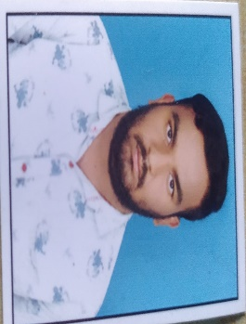SHAIK MOHAMMED RAHIL

Receiver 7396640585

Home shaikrahil280@gmail.com

VAYALPAD

**CAREER OBJECTIVE**

To have a career in a professional organization and put all my efforts into the

growth of the organization and have a great working environment.

**ACADEMIC QUALIFICATION:**

* 10thpassed from Sri Vivekananda English Medium High School in 2018.
* 12th passed from Sri Siddartha Jr College in 2020.

**PROFESSIONAL SKILLS:**

* Basic knowledge of computer.
* Typing

**PERSONAL DETAILS:**

Father’s name: SHAIK MIYA SAB Date of birth : 04 JANUARY 2003

Gender : Male Nationality : Indian

Marital status: Unmarried Languages known : English&telugu

Hobbies : Reading books, listening songs, playing games

Place: **SHAIK RAHIL**

Date: