| **Literature survey on In-cabin Child Detection** | |
| --- | --- |
| **TUSE - CapacityBuilding** | |
| Date/Version* | Check footnote. Filename provides this information. |
| Author(s) | Balaji Rangineni |

# Executive Summary

Literature Survey on

1. In-cabin Child Presence Detection with Machine/Deep Learning using Radar.
2. In-cabin Child Presence Detection without Machine/Deep Learning using Radar.

# Introduction

In-cabin child presence detection and vital sign detection systems are crucial for enhancing child safety and health. They help prevent heart stroke and hypothermia by alerting caregivers if a child is left in a vehicle, where temperatures can become dangerously high or low. Additionally, these systems monitor vital signs, enabling early detection of medical emergencies such as respiratory issues, allowing for timely intervention. This technology also provides parents with peace of mind, knowing their child's presence and well-being are continuously monitored, thereby reducing the risk of accidents and ensuring compliance with emerging safety regulations.

**Enhanced Child Safety:** The European New Car Assessment Programme (EuroNCAP) 2025 roadmap includes child presence detection to prevent heart stroke and hypothermia by alerting caregivers if a child is left in a vehicle. This is crucial for avoiding tragedies caused by extreme temperatures in enclosed vehicles. [[1]](https://cdn.euroncap.com/media/30700/euroncap-roadmap-2025-v4.pdf)

**Parental Assurance:** In the USA, the requirement for rear occupant alert systems underscores the importance of protecting vulnerable passengers. These systems provide peace of mind to parents and caregivers, ensuring that no child is unintentionally left behind in a car.

# Survey

## 3.1.In-cabin Child Presence Detection with Machine/Deep Learning With Radar.

### 3.1.1.Deep Learning-Based In-Cabin Monitoring and Vehicle Safety System Using a 4-D Imaging Radar Sensor [2]

Radar Used: MIMO(Multiple input and multiple output) radar

**Configuration and Parameters**

| **Characteristic** | **Specification** |
| --- | --- |
| Number of Tx | 20 |
| Number of Rx | 20 |
| Frequency Band | 62 - 69 GHz |
| Frame rate | 5 |
| Range Resolution | 7.5 cm |
| Angular Resolution | 6.7 deg |
| Number of frames | 300 |
| Number of Frequencies to scan | 192 |

**Methodology**

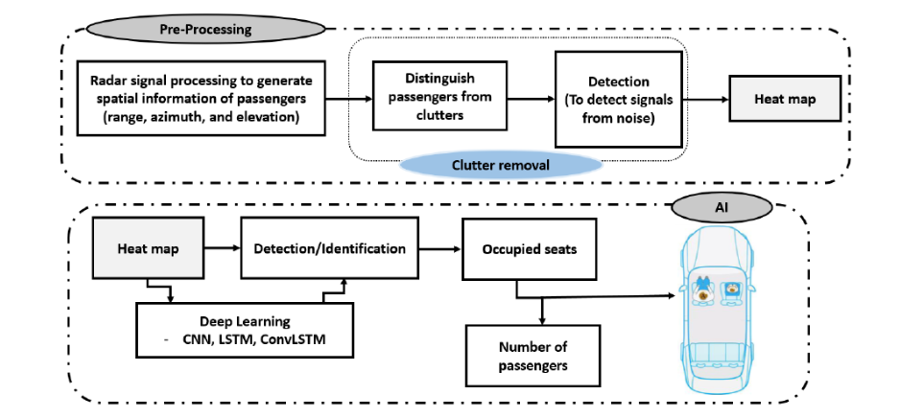

### 3.1.2.Machine Learning-Based Human Recognition Scheme Using a Doppler Radar Sensor for In-Vehicle Applications [3]

**Radar Sensor Utilization:** The study proposes a Doppler spectrum-based passenger detection scheme utilizing Continuous Wave (CW) radar sensors in vehicle applications. These sensors are chosen for their simplicity and ability to detect moving objects, making them suitable for passenger detection in vehicles.

**Feature Design:** The authors introduce new features to represent the characteristics of non-rigid human motion and the presence of vital signs. These features, including 'extended degree of scattering points' and 'presence of vital signs,' are designed to effectively capture human movements and breathing patterns within the vehicle.

**Machine Learning Approach**: A Binary Decision Tree (BDT) is employed for machine learning during both training and testing phases. The BDT utilizes the three extracted features to classify radar signals and determine the presence of passengers in the vehicle.

**Experimental Setup:** The study utilizes a 2.45 GHz CW radar front-end module with a single receive antenna and a real-time data acquisition module. Additionally, a test-bed resembling an actual vehicle interior is constructed to measure radar signals in various scenarios, providing a controlled environment for assessment.

**Classification Accuracy:** Through repeated assessments, the proposed algorithm achieves an impressive average classification accuracy rate of 98.6% for detecting human presence with or without motion.

**Methodology**

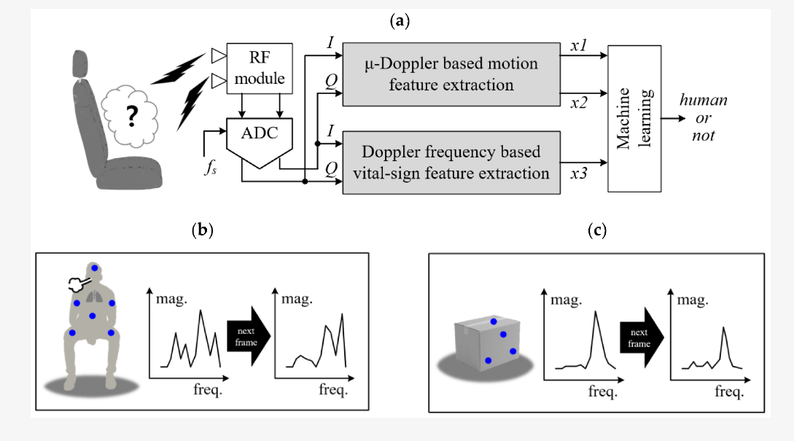

## 3.2. In-cabin Child Presence Detection without Machine/Deep Learning using Radar.

### 3.2.1.In-cabin UWB Radar to Ensure Everyone’s Out of a Parked Car [4]

**UWB Radar IC Solutions:** NXP's UWB Radar IC solutions utilize Ultra-Wideband technology for precise in-cabin sensing, enabling accurate detection of occupants within the vehicle.

**High Motion Sensitivity:** Leveraging advanced motion sensitivity capabilities, NXP's UWB Radar ICs can detect even subtle movements, ensuring reliable detection of occupants irrespective of their activity level.

**Gesture Recognition:** NXP's solutions incorporate gesture recognition technology, allowing for the detection of specific movements or gestures made by occupants within the cabin, enhancing the system's versatility.

**Kick Sensor Integration:** With integrated kick sensor functionality, NXP's UWB Radar ICs enable convenient trunk opening by detecting specific foot movements near the vehicle's rear, enhancing user experience and convenience.

**Seamless Compatibility:** NXP's Auto UWB Radar System seamlessly integrates with the vehicle's UWB-based smart access system, ensuring effortless incorporation into existing vehicle architectures while maximizing functionality.

**Note:** Can’t Find Any Research studies Completely Avoiding Machine/Deep Learning for in cabin child presence Detection.

# References

[1] Euro NCAP 2025 Roadmap: <https://cdn.euroncap.com/media/30700/euroncap-roadmap-2025-v4.pdf>

[2] Deep Learning-Based In-Cabin Monitoring and Vehicle Safety System Using a 4-D Imaging Radar Sensor <https://www.researchgate.net/publication/370378204_Deep_Learning-Based_In-Cabin_Monitoring_and_Vehicle_Safety_System_Using_a_4D_Imaging_Radar_Sensor>

[3] Machine Learning-Based Human Recognition Scheme Using a Doppler Radar Sensor for In-Vehicle Applications <https://www.mdpi.com/1424-8220/20/21/6202>

[4] In-cabin UWB Radar to Ensure Everyone’s Out of a Parked Car <https://www.nxp.com/docs/en/white-paper/RADAR-CHILD-DETECTION-WP.pdf>

