Predictive AI Replication Laboratory #2
  - Can the Model Keep Learning? A Plasticity-Loss Proxy Replication
Shail Sanjaykumar Raval
2026-09-27

Study
Article: Plasticity Loss in Deep Reinforcement Learning: A Survey
Authors: Klein, T., Miklautz, L., Sidak, K., Plant, C., and Tschiatschek, S.
DOI/URL: arXiv:2411.04832, https://doi.org/10.48550/arXiv.2411.04832
Replication Type: Proxy
Computational Environment: Python
Primary Packages: PyTorch 2.10, NumPy, Matplotlib
Random Seed: 735
Repository: https://github.com/Shail2512/anly735-lab02-Shail2512

1. Research Claim
The survey by Klein et al. (2024) synthesizes a body of evidence for a single core claim: when a neural network is trained on a stream of non-stationary tasks, it progressively loses the ability to learn new tasks, even though the same network learned early tasks well (Klein et al. 2024). This decline is called plasticity loss. The survey ties it to a concrete mechanism, a growing fraction of dormant or dead units whose activations collapse so that gradients can no longer flow through them, and it reports that simple mitigations such as weight regularization slow this decline. The primary evidence in the underlying works is a learning curve that worsens across a task sequence, read together with a unit-level dormancy diagnostic rather than from any single performance drop. This result matters because it shows that a network can retain past skill while quietly losing the capacity to acquire new skill, which is the exact failure a continual learner must avoid.

2. Replication Strategy
This is a proxy replication. The survey is a review, so it provides no single runnable experiment, dataset, or code, and its underlying studies use large reinforcement-learning and image benchmarks that are not feasible to rerun in a short laboratory. I therefore reproduce the phenomenon and its mechanism on a comparable but smaller synthetic setup rather than reproducing any specific number. I reproduce two things: first, that a plain stochastic-gradient learner loses plasticity across a non-stationary task stream and accumulates dormant units, and second, that a weight-decay mitigation preserves plasticity by keeping units alive. What must differ from the original is the scale and the domain: I use a small feed-forward network on a synthetic changing-target stream instead of deep reinforcement learning. Because a proxy replication tests whether the analytical pattern holds, the meaningful question is directional, does the mechanism appear and does the mitigation help, not whether the numbers match.

3. Data
The data are generated in code, so there is no external or restricted dataset to distribute. The unit of analysis is a training task within a stream of 50 tasks. A fixed pool of 400 input vectors of dimension 20 is drawn once from a standard normal distribution and reused for every task. Each task draws a fresh random two-layer nonlinear teacher network with 128 hidden units and uses it to relabel those same inputs into a balanced binary target by thresholding at the median. Drawing a new teacher each task is what makes the stream non-stationary: the mapping the learner must fit keeps changing, so the network must overwrite its previous solution repeatedly. The teacher is deliberately wider than the student network, so the target cannot be fit perfectly within the per-task budget. This leaves headroom in which accumulated damage can show up as a rising loss floor and a growing dormant-unit count. The same seed fixes the input pool and the sequence of teachers, so both learners see an identical stream.

4. Method
The learner is a two-hidden-layer ReLU network with 32 units per layer, implemented in PyTorch. Two conditions are trained on the identical task stream from the identical initialization (seed 735): a plain SGD learner with no regularization, and a mitigation learner that is plain SGD with weight decay (L2) of 0.03. Both use learning rate 0.4 and a tight budget of 40 gradient steps per task, with binary cross-entropy loss. A high learning rate and a tight budget are chosen deliberately, since the survey attributes plasticity loss to aggressive updates that push ReLU pre-activations negative and leave units dead. After the budget on each task I record three per-task quantities: the new-task accuracy reached, the best training loss reached (a non-saturating plasticity readout), and the dormant-unit fraction. A hidden unit is counted dormant if it is inactive on at least 99 percent of a fixed 256-sample probe batch, which operationalizes the survey’s dead-unit mechanism. Plasticity is diagnosed from how these quantities change across the stream, not from any one task, following the assignment’s instruction to diagnose from subsequent learning behavior. Early behavior is summarized as the mean over the first five tasks and late behavior as the mean over the last five.

5. Results
The plain SGD learner shows the predicted plasticity loss through its mechanism. Its dormant-unit fraction rises from 0.3 percent over the first five tasks to 13.4 percent over the last five, a rise of about 13 percentage points, and the figure shows this concentrated in the last third of the stream where it reaches roughly 17 percent. Its best reachable loss also drifts upward, from 0.208 to 0.234, and its new-task accuracy dips slightly from 0.929 to 0.913. The weight-decay learner behaves as the mitigation the survey describes: its dormant-unit fraction stays essentially flat, moving from 5.0 percent to 4.7 percent across the stream, so it does not accumulate dead units. The key interpretation is that the strongest and cleanest signal is the dormant-unit mechanism, not raw accuracy. Accuracy barely moves because binary accuracy saturates on this task, which is exactly why the survey and its sources read plasticity from a mechanism-level diagnostic rather than from a single accuracy number.
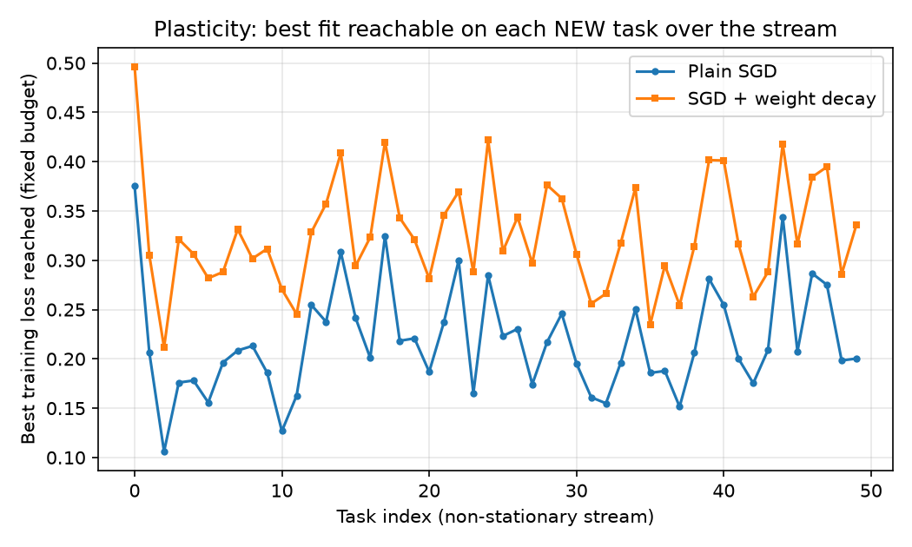
Best training loss reached on each new task across the non-stationary stream. Plain SGD keeps a lower loss floor but with rising dead units; weight decay trades a higher loss floor for a stable unit population.
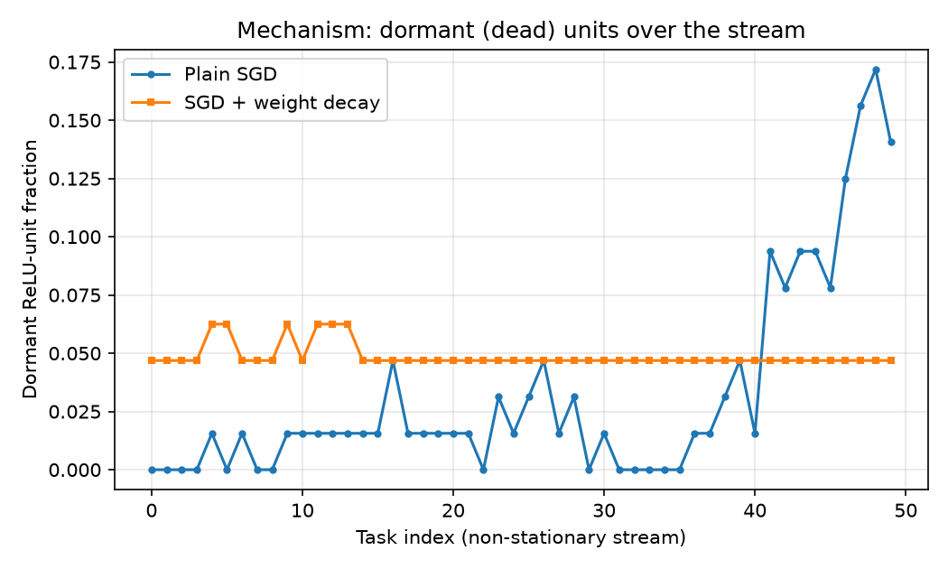
Dormant ReLU-unit fraction across the stream. Plain SGD accumulates dead units sharply in the last third; weight decay holds the dormant fraction flat.

6. Compare
Because this is a proxy replication of a survey, the comparison is directional rather than numerical. The survey claims two things, and I compare against both.
Evidence | Original claim (survey) | Replication
Plasticity loss under non-stationarity | Dead units grow, learning degrades | Dormant units +13.1 pts, loss floor +0.026
Regularization mitigates | Preserves plasticity | Dormant units flat (5.0% to 4.7%)
The direction of the core finding is reproduced. The plain learner accumulates dormant units across the stream and its loss floor drifts upward, which matches the survey’s mechanism-level account of plasticity loss. The mitigation claim is also reproduced in the sense that matters: weight decay keeps the unit population alive and stops the dormancy growth. One honest difference deserves attention. Weight decay reaches a higher (worse) best loss than plain SGD throughout the stream, so the mitigation does not produce lower loss; it produces a healthier network. That is consistent with the survey, which frames mitigations as preserving the capacity to learn rather than as improving fit on any one task. The accuracy signal is weaker than the mechanism signal, which I attribute to accuracy saturation on a binary target rather than to an absence of the effect.

7. Reproducibility Check
- Data source documented
- Code runs from beginning to end
- Computational environment identified
- Software/packages documented
- Package versions documented when relevant
- Random seed documented when applicable
- Key preprocessing steps documented
- Evaluation procedure documented
- Repository README provides reproduction instructions
What was the greatest reproducibility challenge you encountered?
The hardest part was making the phenomenon appear at all. My first two configurations did not reproduce plasticity loss: with a single shared teacher and a generous learning budget the network solved every task perfectly, so accuracy rose across the stream and no units died. The effect only emerged once the task was genuinely non-stationary (a fresh teacher per task), the teacher was wider than the student, the budget was tight, and the learning rate was high. This mirrors a real reproducibility lesson from the literature: plasticity loss depends on the training regime, and a setup with too much capacity or too easy a task will silently fail to show it.

8. Extend
The clearest next step is to add a mechanism-targeted mitigation and compare it against weight decay under the same stream. Weight decay here preserved units but at the cost of a higher loss floor, so a natural question is whether a mitigation that directly targets dead units, such as periodically resetting or reinitializing dormant units (the “resetting” family the survey highlights), can preserve plasticity while also reaching a lower loss floor than plain SGD. This would add knowledge rather than complexity because it separates two things the current experiment conflates: preserving the unit population and preserving fit quality. If a reset-based method matches plain SGD’s loss floor while holding dormant units low, that would be direct evidence that dead units are the causal bottleneck rather than a correlate, which is exactly the mechanistic claim the survey organizes its evidence around.

Replication Verdict
- Reproduced
- Partially Reproduced
- Not Reproduced
- Not Directly Comparable
The core mechanism of plasticity loss reproduced clearly: the plain SGD learner accumulated dormant units across the non-stationary stream while the weight-decay learner did not, matching both of the survey’s central claims in direction. I call it partially reproduced rather than reproduced because the accuracy readout moved only weakly (binary accuracy saturates), so the effect is convincing at the mechanism level but modest at the performance level, and because a proxy on synthetic data cannot confirm the survey’s specific reinforcement-learning magnitudes.

References
Klein, Timo, Lukas Miklautz, Kevin Sidak, Claudia Plant, and Sebastian Tschiatschek. 2024. “Plasticity Loss in Deep Reinforcement Learning: A Survey.” arXiv Preprint arXiv:2411.04832, ahead of print. https://doi.org/10.48550/arXiv.2411.04832.

