HOMELY
API Requirements Specification
Homemade food delivery · Kitchen · Customer · Rider · Payments · Settlement
Version 4.1 · 8 September 2026 · Base path /v1 · JSON camelCase
This is the build contract for HOMELY (Figma file name). It combines the kitchen-partner registration screens, the written OTP/admin note, locked product decisions, and the customer, rider, subscription, and settlement APIs.

Figma source reviewed
Prototype reviewed: https://www.figma.com/proto/av4dkBWxrZCYzp9kkEbYD3/Untitled?node-id=39-7
The Figma file and prototype title are HOMELY (earlier working name was RasoiMitra). Branding in this specification is updated to HOMELY. The prototype itself requires a Figma login, so individual screen copy beyond the file name could not be extracted automatically. API contracts, steps, and flows stay as previously locked unless a screen screenshot shows a different field.

1. Purpose and scope
HOMELY is a homemade food delivery platform. The welcome screen splits into Order Food (customer) and Start Selling Food (one HomeMade kitchen). A third role, Deliver (rider), picks up when a kitchen marks an order READY. Customers only see ACTIVE kitchens that deliver to their GPS pin. FSSAI licence is optional and must not block first kitchen submit.

1.1 In scope
Step 1. Mobile OTP authentication for customer, kitchen owner, and rider.
Step 2. Kitchen 4-step registration, admin KYC, menu listing, and activate.
Step 3. Customer profile, addresses, nearby discovery, cart, checkout, and rating.
Step 4. Online payment (UPI, card, netbanking, wallet) plus COD, with webhook as source of truth.
Step 5. Rider KYC, assignment, live tracking, and kitchen self-delivery fallback.
Step 6. HomelyPlus and Featured Kitchen subscriptions.
Step 7. Kitchen/rider ledgers and weekly bank settlement.

1.2 Out of scope
Customer-to-customer chat, multi-kitchen owners, cloud/restaurant types, and a separate logistics company integration beyond this rider fleet.

1.3 Locked product rules
Topic | Decision
Kitchen type | HOMEMADE only (Home Kitchen). Cloud / Restaurant chips are not implemented.
Kitchens | Exactly one kitchen per owner mobile.
Password | Owner-chosen (min 8, letter + number). MPIN is out of scope.
Cuisine | Multi-select, 1–8 codes from master list.
KYC | Kitchen: PAN Card. Rider: Aadhaar + DL + RC + selfie. Admin reviews.
FSSAI | Optional. Never blocks first submit. Admin may request later.
Listing gate | Menu APIs from APPROVED. Discovery only when ACTIVE.
Delivery | Rider first. Fallback KITCHEN_SELF after 5 minutes or 3 declined offers.
Commission | 15% of itemTotal + 18% GST on that commission.
Rider pay | 80% of deliveryFee + ₹5 after 3 km + ₹10 after 6 km.
HomelyPlus | ₹149 / ₹399 / ₹999 — free delivery ≥ ₹199 and 5% off items.
Featured kitchen | ₹499 / month — higher rank in nearby.
Settlement | Monday–Sunday IST; payout Tuesday to saved bank account.

2. End-to-end flow
The platform has three apps on one API. The same mobile number may hold all three profiles; OTP purpose must match the role.
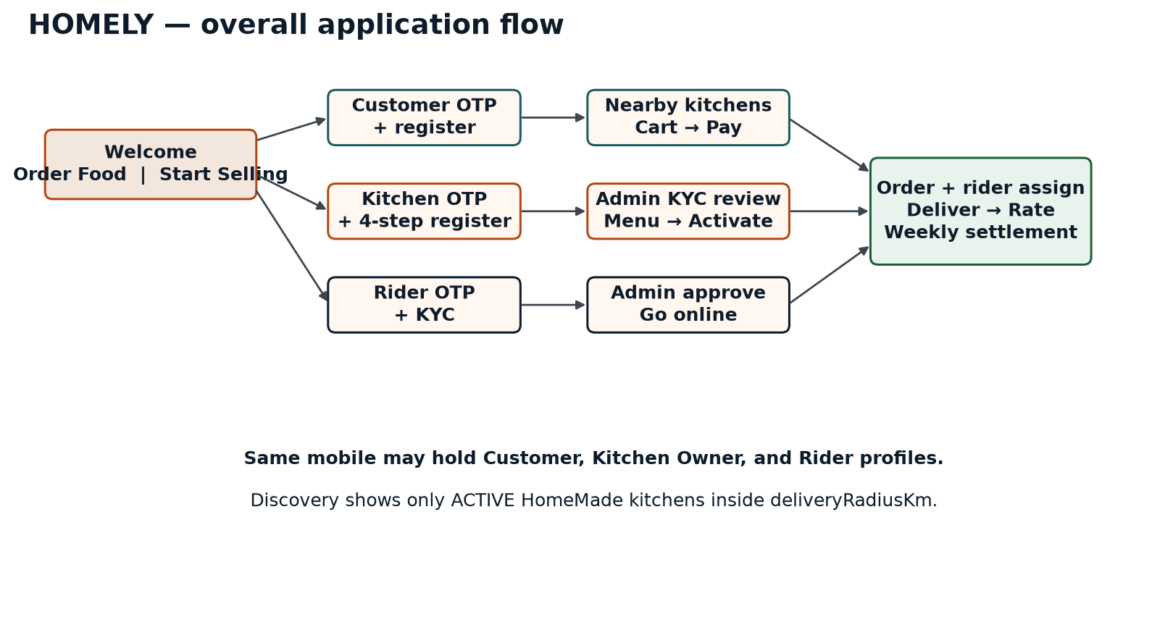
Figure — 01 overall

2.1 Steps — overall
Step 1. User opens HOMELY and chooses Order Food, Start Selling Food, or the rider Deliver app.
Step 2. System sends a 6-digit OTP (purpose CUSTOMER, KITCHEN_OWNER, or RIDER).
Step 3. New users receive a verificationToken and complete registration; existing users receive a role-scoped JWT.
Step 4. Kitchen owners finish onboarding and wait for admin approval before menu and go-live.
Step 5. Riders finish KYC and wait for admin approval before going online.
Step 6. Customers add a GPS address, browse ACTIVE kitchens in range, cart, pay, and track delivery.
Step 7. On DELIVERED, kitchen and rider ledgers are snapshotted and later paid in the weekly settlement.

3. Kitchen partner flow
Matches the HOMELY 10-screen partner UI (welcome → OTP → 4-step form → submitted → pending dashboard → Active home).
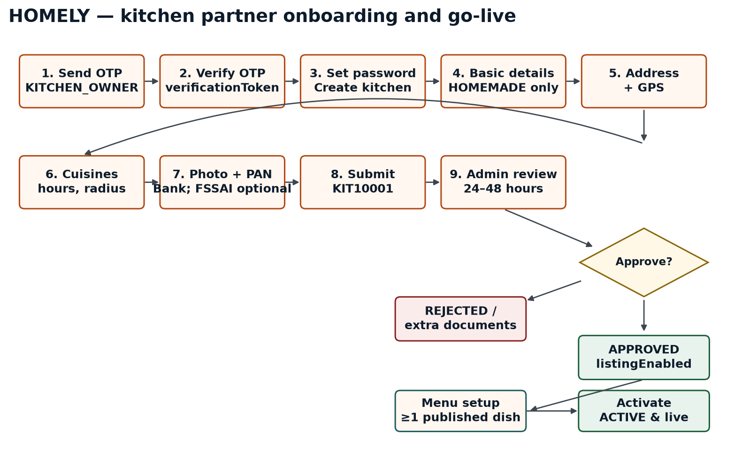
Figure — 02 kitchen onboarding

3.1 Steps — kitchen registration
Step 1. Tap Start Selling Food. Enter 10-digit mobile and call POST /v1/auth/otp/send with purpose=KITCHEN_OWNER.
Step 2. Enter the 6-digit OTP (5-minute expiry). POST /v1/auth/otp/verify returns verificationToken for a new seller.
Step 3. Set the owner-chosen password (POST /v1/auth/password).
Step 4. Step 1 of 4 — Basic details: kitchenName, ownerName, email. kitchenType is always HOMEMADE. POST /v1/kitchens creates KIT… and issues the seller JWT.
Step 5. Step 2 of 4 — Address line1, optional line2, state, city, pincode, and Use Current Location (lat/lng). PATCH /v1/kitchens/{kitchenId}.
Step 6. Step 3 of 4 — Multi-select cuisineTypes, openTime/closeTime, deliveryRadiusKm (default 10). PATCH the same kitchen.
Step 7. Step 4 of 4 — Upload KITCHEN_PHOTO and PAN_CARD (mandatory). FSSAI_LICENSE is optional. Save bankDetails (holder, account, IFSC, type).
Step 8. POST /v1/kitchens/{kitchenId}/submit. Success screen shows kitchenId (e.g. KIT10001) and 24–48 hour SLA. Status becomes SUBMITTED then DOCUMENT_VERIFICATION_PENDING.
Step 9. Dashboard GET /v1/kitchens/{kitchenId}/progress drives the checklist: Mobile Verified → Submitted → Documents Under Review → Approval Pending → Activate.
Step 10. Admin opens GET /v1/admin/kitchens/pending and either approve, reject with reason, or request additional documents.
Step 11. On APPROVE, listingEnabled=true. Owner creates categories and dishes (portions, add-ons, photos). At least one PUBLISHED item is required.
Step 12. POST /v1/kitchens/{kitchenId}/activate moves the kitchen to ACTIVE. It now appears in customer nearby search and can receive orders.

3.2 Kitchen workflow states
Status | Meaning
DRAFT | Session started before OTP completes.
MOBILE_VERIFIED | OTP success; kitchen draft may exist.
SUBMITTED | Owner submitted Step 4. Kitchen ID shown.
DOCUMENT_VERIFICATION_PENDING | Awaiting document / PAN checks.
UNDER_REVIEW | Admin opened the packet.
ADDITIONAL_DOCUMENTS_REQUIRED | Admin asked for files; owner can edit.
RESUBMITTED | Owner submitted again; back to queue.
REJECTED | Rejected with reason; owner may edit and resubmit.
APPROVED | KYC accepted. Menu APIs unlock.
MENU_SETUP | Owner adding dishes; not in customer feed.
ACTIVE | Live. Can receive orders.

3.3 Mandatory fields at kitchen submit
Field | UI step | Required
kitchenName, ownerName, email, password | 1 | Yes
mobileNumber | OTP | Yes — from verified session
kitchenType | 1 | Yes — HOMEMADE only
address + optional GPS | 2 | Yes
cuisineTypes, operatingHours, deliveryRadiusKm | 3 | Yes
bankDetails | 4 | Yes
KITCHEN_PHOTO, PAN_CARD | 4 | Yes
FSSAI_LICENSE | 4 | No — optional

4. Customer flow
Order Food path. A customer discovers kitchens by GPS, pays, and tracks delivery — similar to Swiggy, limited to HomeMade kitchens in radius.
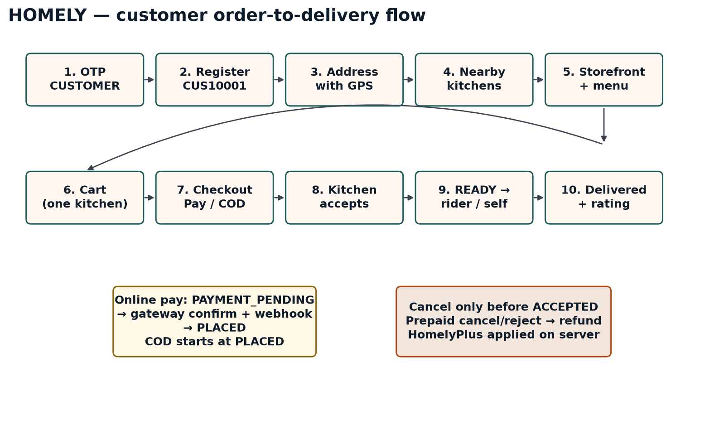
Figure — 03 customer order

4.1 Steps — customer
Step 1. Tap Order Food. POST /v1/auth/otp/send with purpose=CUSTOMER, then verify OTP.
Step 2. New customer: POST /v1/customers with name and password. Response includes customerId (CUS…) and JWT role=CUSTOMER.
Step 3. POST /v1/customers/me/addresses with label, address lines, and mandatory latitude/longitude.
Step 4. GET /v1/kitchens/nearby?latitude=&longitude=&openNow=true. Only ACTIVE kitchens with distance ≤ deliveryRadiusKm and at least one published item.
Step 5. Open GET /v1/kitchens/{kitchenId}/storefront for hours, deliversToAddress, categories, dishes, portions, and add-ons.
Step 6. PUT /v1/cart with kitchenId and lines. One kitchen per cart. HomelyPlus discounts are applied on the server.
Step 7. POST /v1/orders with addressId, paymentMethod (UPI | CARD | NETBANKING | WALLET | COD), optional tip and instructions, plus Idempotency-Key.
Step 8. If online: POST /v1/orders/{orderId}/payments, complete the gateway SDK, then POST /v1/payments/{paymentId}/confirm. Webhook POST /v1/webhooks/payments is authoritative.
Step 9. COD and successful online pay land on PLACED. Kitchen has 10 minutes to accept or the order auto-rejects.
Step 10. Customer may cancel only while PAYMENT_PENDING or PLACED. After ACCEPTED, only kitchen or admin may cancel. Prepaid paths start a refund.
Step 11. Track GET /v1/orders/{orderId} (timeline, eta, rider location). After DELIVERED, POST /v1/orders/{orderId}/rating (1–5, optional riderRating).

4.2 Order workflow states
Status | Meaning
PAYMENT_PENDING | Online checkout created; waiting for gateway.
PAYMENT_FAILED | Signature or webhook failed; retry allowed (max 3).
PLACED | Paid or COD — visible in kitchen inbox.
ACCEPTED | Kitchen accepted; cooking may start.
PREPARING | Food being cooked.
READY | Packed. Rider assignment starts.
OUT_FOR_DELIVERY | Rider picked up, or kitchen self-delivery fallback.
DELIVERED | Complete. Ledgers credited.
CANCELLED | Customer cancelled before accept.
REJECTED | Kitchen rejected; refund if prepaid.
REFUNDED | Gateway refund completed.

5. Rider and delivery flow
v4 uses a rider fleet. Kitchen self-delivery remains the fallback so homemade kitchens are never blocked if no rider is nearby.
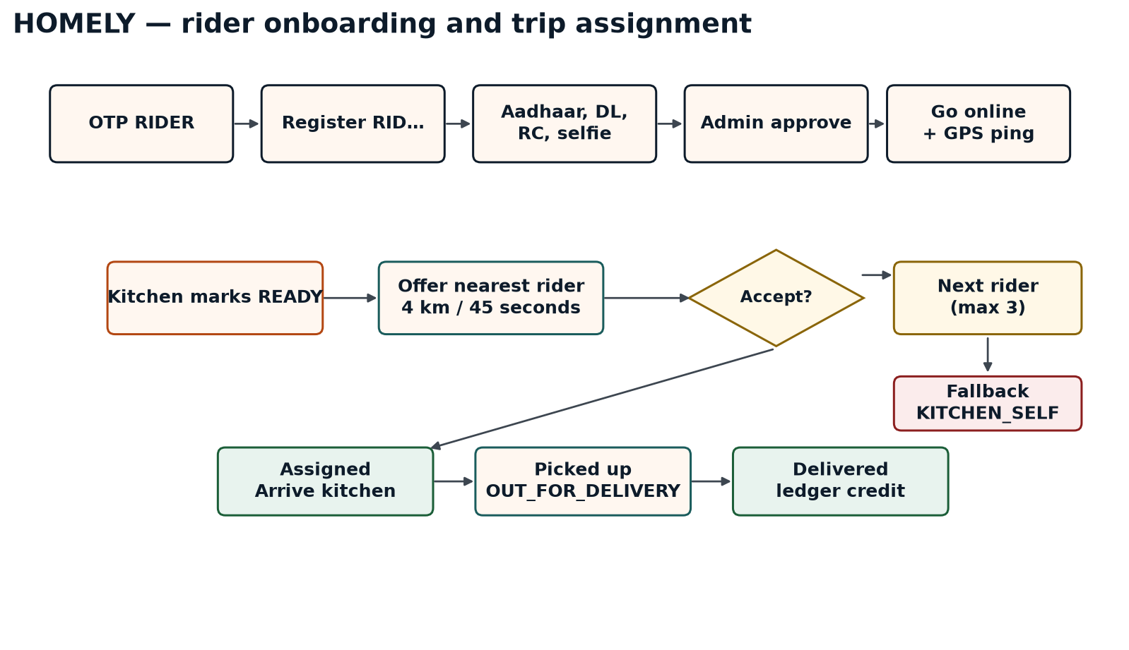
Figure — 04 rider assignment

5.1 Steps — rider
Step 1. Rider app: OTP with purpose=RIDER. POST /v1/riders with name, password, vehicleType (BIKE | SCOOTER | CYCLE).
Step 2. Upload AADHAAR, DRIVING_LICENCE, VEHICLE_RC, and SELFIE. Save bank details. POST /v1/riders/me/submit.
Step 3. Admin reviews POST /v1/admin/riders/{riderId}/review (APPROVE | REJECT).
Step 4. Approved rider goes online with PUT /v1/riders/me/presence { available, latitude, longitude }. Ping at least every 15 seconds on a trip.
Step 5. When kitchen sets READY, the platform offers the nearest available rider within 4 km. Offer TTL is 45 seconds. Up to 3 riders.
Step 6. GET /v1/riders/me/assignments/current then POST .../respond { ACCEPT | DECLINE }. Accept reveals the full drop address.
Step 7. Trip: ARRIVED_KITCHEN → PICKED_UP (order becomes OUT_FOR_DELIVERY) → DELIVERED.
Step 8. PUT /v1/orders/{orderId}/tracking publishes live GPS for the customer map.
Step 9. If three declines or 5 minutes pass with no accept, deliveryMode becomes KITCHEN_SELF and the kitchen finishes the trip.

6. Payment, subscriptions, and settlement
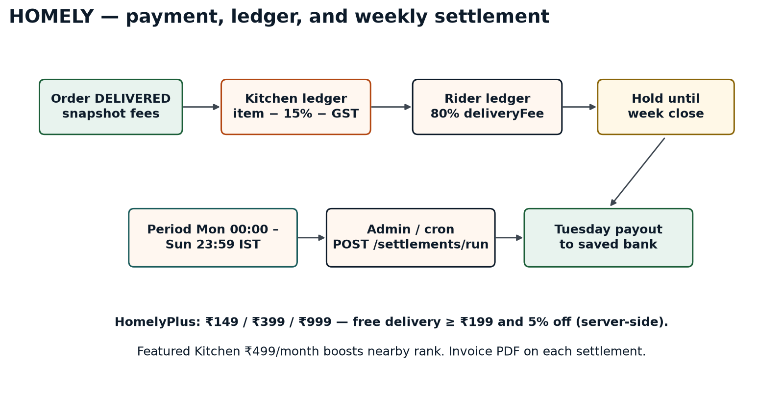
Figure — 05 settlement

6.1 Steps — payment
Step 1. Checkout locks item prices as a snapshot. Never trust a client-sent amount.
Step 2. COD: order status is PLACED immediately. Cash collected is a rider/kitchen liability, not earnings.
Step 3. Online: create gateway order, open SDK, confirm HMAC signature, and process the webhook. Either path can mark PLACED or PAYMENT_FAILED.
Step 4. HomelyPlus and Featured Kitchen purchases use the same gateway. COD is not allowed for subscriptions.

6.2 Steps — subscriptions
Step 1. GET /v1/subscriptions/plans?audience=CUSTOMER|KITCHEN.
Step 2. Customer HomelyPlus: HOMELY_PLUS_MONTHLY ₹149, QUARTERLY ₹399, ANNUAL ₹999. Benefits: free delivery when itemTotal ≥ ₹199, and 5% off items.
Step 3. Kitchen FEATURED_MONTHLY ₹499 boosts sort order on nearby.
Step 4. POST /v1/subscriptions then confirm payment. GET /v1/subscriptions/me returns validUntil and benefits.
Step 5. Cart and nearby ranking apply benefits server-side. Cancel keeps access until validUntil. No prorated refund unless unused and under 24 hours.

6.3 Steps — settlement
Step 1. On DELIVERED, snapshot: kitchen net = itemTotal − 15% − 18% GST on that commission. If KITCHEN_SELF, kitchen also keeps 100% of deliveryFee.
Step 2. Rider net = 80% of deliveryFee + ₹5 if distance > 3 km + ₹10 if distance > 6 km.
Step 3. Kitchen GET /v1/kitchens/{id}/ledger and rider GET /v1/riders/me/ledger show line items for the week.
Step 4. Period is Monday 00:00 to Sunday 23:59 IST. Admin or cron calls POST /v1/admin/settlements/run.
Step 5. Payout is the following Tuesday to the bank account collected at registration. GET /v1/settlements/{id} returns invoiceUrl and UTR when PAID.
Step 6. Failed transfers mark FAILED and can be retried.

7. Shared API conventions
HTTPS only. JSON request/response use camelCase. File uploads are multipart/form-data. After registration, send Authorization: Bearer {accessToken}. Roles: CUSTOMER, KITCHEN_OWNER, RIDER, ADMIN.
OTP: 6 digits, 5-minute expiry, 3 send/resend attempts per 15 minutes, 5 verify attempts, single-use. Public IDs: CUS, KIT, RID, ORD, SUB, SET + 5 digits.
Error envelope: { "success": false, "error": { "code": "...", "message": "...", "details": [] } }. Submit and checkout require Idempotency-Key.

8. API catalog

8.1 Authentication
Method | Path | Auth | Purpose
POST | /v1/auth/otp/send | Public | Send OTP (purpose CUSTOMER | KITCHEN_OWNER | RIDER)
POST | /v1/auth/otp/verify | Public | Verify OTP; token or session
POST | /v1/auth/password | Verification token | Set owner-chosen password
POST | /v1/auth/login | Public | Password or OTP login by role

8.2 Kitchen partner
Method | Path | Purpose
POST | /v1/kitchens | Start draft after mobile verification
PATCH | /v1/kitchens/{kitchenId} | Save address, cuisine, hours, radius, bank
GET | /v1/kitchens/{kitchenId} | Get kitchen packet
POST | /v1/kitchens/{kitchenId}/documents | Upload photo, PAN, optional FSSAI
GET | /v1/kitchens/{kitchenId}/documents | List docs; FSSAI never in missingRequired
POST | /v1/kitchens/{kitchenId}/submit | Submit for 24–48h review
GET | /v1/kitchens/{kitchenId}/progress | Pending dashboard checklist
POST | /v1/kitchens/{kitchenId}/activate | ACTIVE after ≥1 published item
GET | /v1/kitchens/{kitchenId}/dashboard | Today orders and earnings
GET | /v1/kitchens/{kitchenId}/menu/categories | List / seed categories
POST | /v1/kitchens/{kitchenId}/menu/categories | Create category
POST | /v1/kitchens/{kitchenId}/menu/items | Create dish (listingEnabled)
POST | /v1/menu/items/{itemId}/photos | 1–5 photos; one required to publish
GET | /v1/kitchens/{kitchenId}/menu/items | List dishes
PATCH | /v1/menu/items/{itemId} | Update / publish
DELETE | /v1/menu/items/{itemId} | Soft delete

8.3 Admin
Method | Path | Purpose
GET | /v1/admin/kitchens/pending | KYC / document queue
POST | /v1/admin/kitchens/{kitchenId}/approve | Unlock menu (listingEnabled)
POST | /v1/admin/kitchens/{kitchenId}/reject | Reject with reason
POST | /v1/admin/kitchens/{kitchenId}/request-documents | Ask for extra files
POST | /v1/admin/riders/{riderId}/review | Approve or reject rider
GET | /v1/admin/settlement/config | Commission and slabs
POST | /v1/admin/settlements/run | Close week and pay out

8.4 Customer, discovery, cart
Method | Path | Purpose
POST | /v1/customers | Register customer
GET / PATCH | /v1/customers/me | Profile
POST / GET | /v1/customers/me/addresses | Delivery address book (GPS required)
GET | /v1/kitchens/nearby | ACTIVE kitchens in radius
GET | /v1/kitchens/{kitchenId}/storefront | Public menu
GET / PUT | /v1/cart | One kitchen per cart

8.5 Orders and payments
Method | Path | Purpose
POST | /v1/orders | Checkout cart
GET | /v1/orders | Customer history
GET | /v1/orders/{orderId} | Tracking (customer or kitchen)
POST | /v1/orders/{orderId}/cancel | Customer cancel before accept
POST | /v1/orders/{orderId}/payments | Create gateway order
POST | /v1/payments/{paymentId}/confirm | Verify signature
POST | /v1/webhooks/payments | Gateway source of truth
GET | /v1/kitchens/{kitchenId}/orders | Kitchen inbox
POST | .../orders/{orderId}/accept | Kitchen accept
POST | .../orders/{orderId}/reject | Kitchen reject + refund
POST | .../orders/{orderId}/status | PREPARING | READY (rider does the rest)
POST | /v1/orders/{orderId}/rating | 1–5 after delivery

8.6 Riders, subscriptions, settlement
Method | Path | Purpose
POST | /v1/riders | Register rider
POST | /v1/riders/me/documents | KYC files
POST | /v1/riders/me/submit | Send to admin
PUT | /v1/riders/me/presence | Online + GPS
GET | /v1/riders/me/assignments/current | Current offer
POST | .../assignments/{id}/respond | Accept or decline
POST | /v1/riders/me/trips/{orderId}/status | Arrive / pickup / deliver
PUT | /v1/orders/{orderId}/tracking | Live rider GPS
GET | /v1/subscriptions/plans | HomelyPlus and Featured
POST | /v1/subscriptions | Purchase plan
GET | /v1/subscriptions/me | Active benefits
POST | /v1/subscriptions/{id}/cancel | Stop renew
GET | /v1/kitchens/{id}/ledger | Kitchen earnings lines
GET | /v1/riders/me/ledger | Rider trip lines
GET | /v1/settlements | Weekly batches
GET | /v1/settlements/{id} | Invoice + UTR
GET | /v1/master/cuisines | NORTH_INDIAN … OTHER

9. Sample contracts
Send OTP request: {"mobileNumber":"9876543210","purpose":"CUSTOMER","method_Name":"KYC-Verification"}
Send OTP response: {"success":true,"requestId":"OTP_REQ_123456"}
Verify OTP request: {"requestId":"OTP_REQ_123456","mobileNumber":"9876543210","otp":"123456","method_Name":"KYC-Verification"}
Verify OTP response (new user): {"success":true,"verificationToken":"mob_ver_abc123xyz","isNewUser":true}
Nearby: GET /v1/kitchens/nearby?latitude=19.12&longitude=72.85&openNow=true

10. Standard errors
HTTP | code | When
400 | VALIDATION_ERROR | Field-level validation failed
401 | UNAUTHORIZED | Missing token or invalid OTP
403 | FORBIDDEN / LISTING_NOT_ENABLED | Wrong role or menu before APPROVED
404 | NOT_FOUND | Kitchen, item, order, or requestId missing
409 | KITCHEN_ALREADY_EXISTS / CUSTOMER_ALREADY_EXISTS | Duplicate profile for that purpose
409 | CART_KITCHEN_MISMATCH / RIDER_BUSY | Cart mix or rider already on a trip
422 | OUT_OF_RANGE / KITCHEN_CLOSED | Address outside radius or kitchen shut
422 | REGISTRATION_INCOMPLETE / MENU_REQUIRED | Submit or activate too early
422 | NO_RIDER_AVAILABLE | Assignment timed out; KITCHEN_SELF
429 | RATE_LIMITED | OTP throttled

11. Document control
Version | Date | Notes
1.0–1.1 | 8 Sep 2026 | Kitchen onboarding from notes; password and multi-select cuisine locked.
2.0 | 8 Sep 2026 | Aligned to HOMELY screens; FSSAI optional; admin kitchen APIs.
3.0 | 8 Sep 2026 | Customer discovery, cart, pay, kitchen fulfilment.
4.0 | 8 Sep 2026 | Rider fleet, HomelyPlus, Featured Kitchen, weekly settlement.
4.1 | 8 Sep 2026 | Figma prototype brand HOMELY applied. Larger, higher-contrast Word formatting.

