Clustering

## Clustering the Subject based on Physiological, Activity and Psychometric Data.

## Determining Optimal Clusters

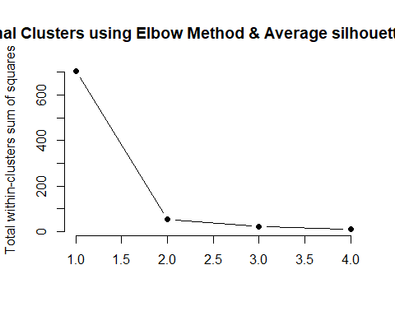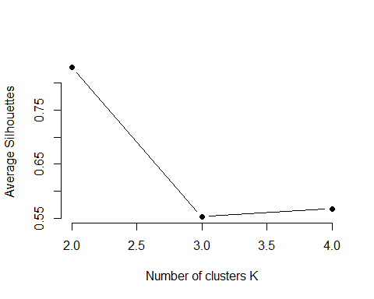

–>

## Final PP HR and Trait Anxiety

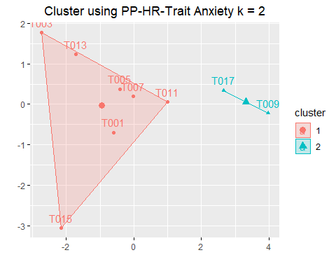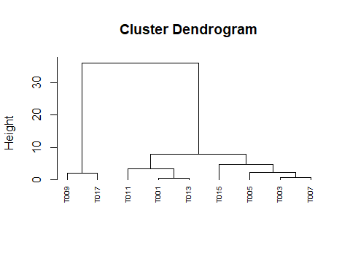

## [1] 0.9273947

## average single complete ward   
## 0.9147233 0.8870996 0.9273947 0.9469232

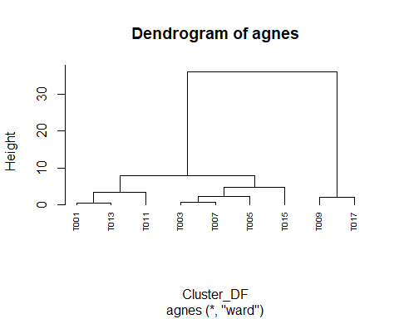

## [1] 0.9273947

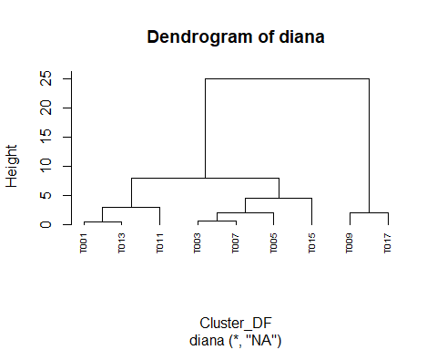

## sub_grp  
## 1 2   
## 7 2

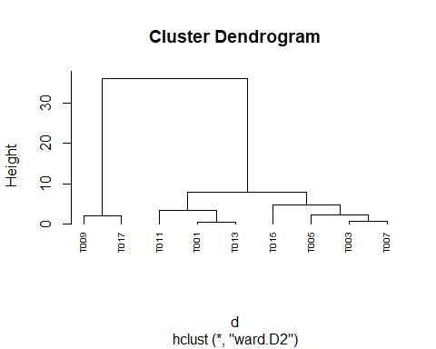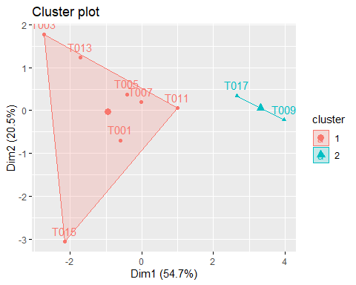 –>

## Clustering with PP HR and BFI

## Determining Optimal Clusters

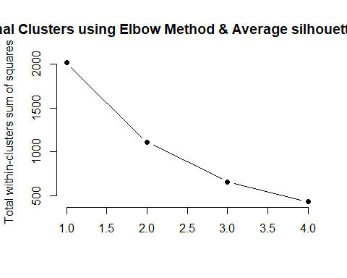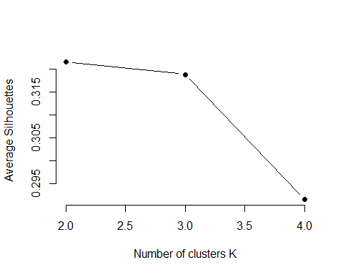

–>

## [1] 0.6640489

## average single complete ward   
## 0.4991558 0.3132629 0.6640489 0.6960683

## Final Clustering with PP HR and BFI

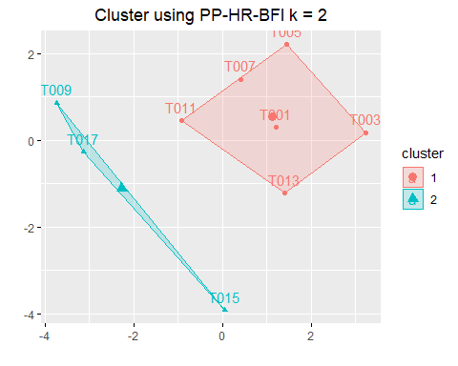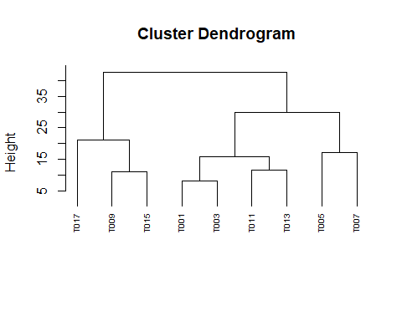

## Clustering with PP HR Trait Anxiety and BFI

## Determining Optimal Clusters

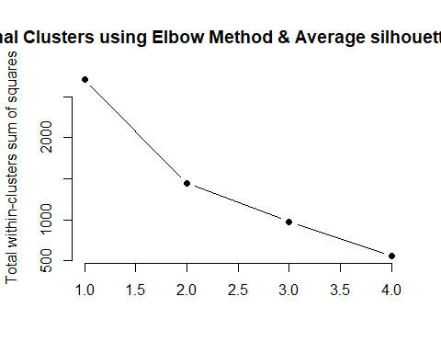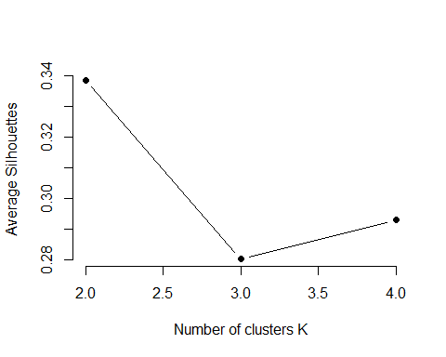

–> ## Final Clustering with PP HR Trait Anxiety and BFI

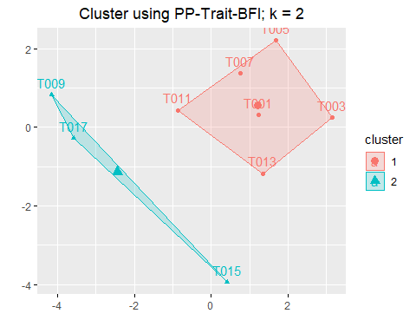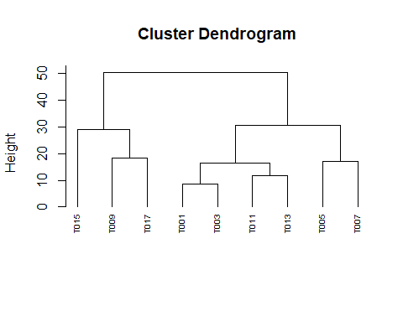

## Clustering Day1 on PP HR and Activity Data

## Determining Optimal Clusters

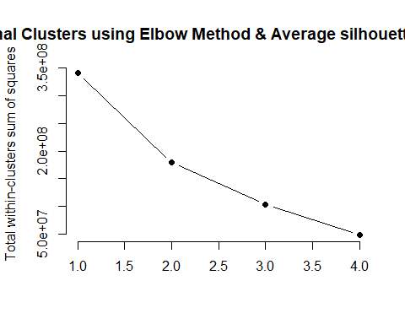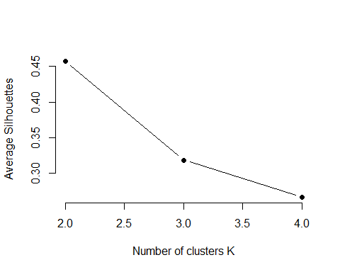

–>

## Final Clustering Day1 on PP HR and Activity Data

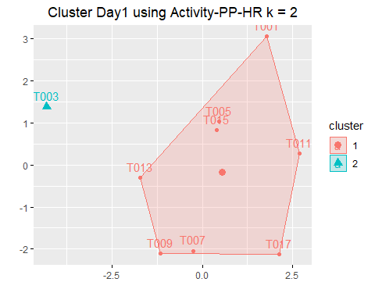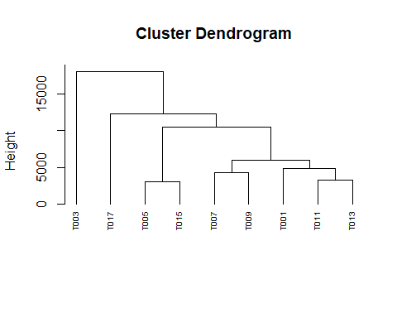

## Clustering Day2 on PP HR and Activity Data

## Determining Optimal Clusters

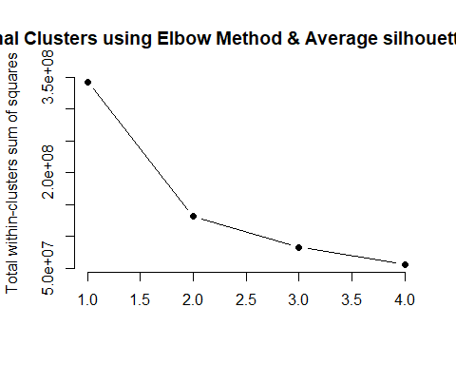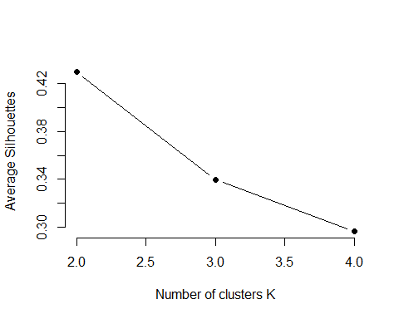

–> ## Final Clustering Day2 on PP HR and Activity Data

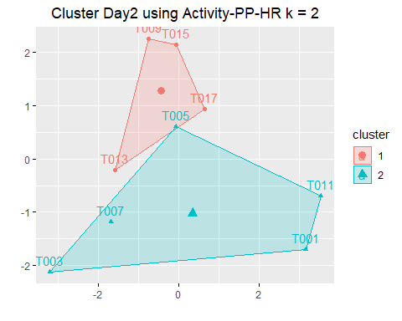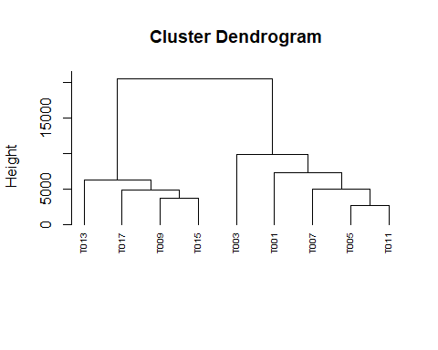

## Clustering Day3 on PP HR and Activity Data

## Determining Optimal Clusters

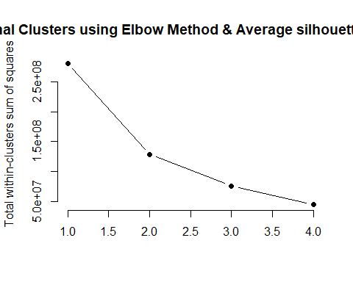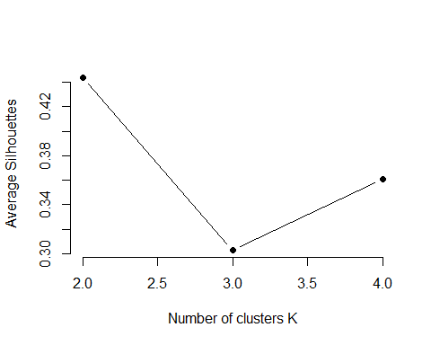

–>

## Final Clustering Day3 on PP HR and Activity Data

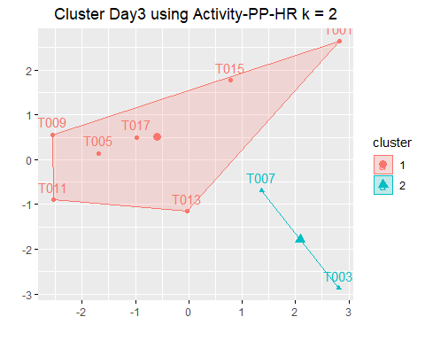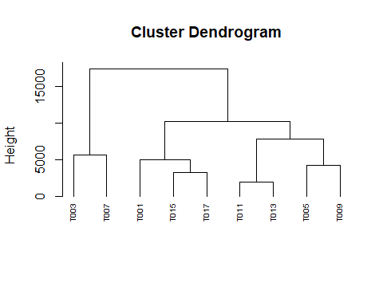

## Clustering Day4 on PP HR and Activity Data

## Determining Optimal Clusters

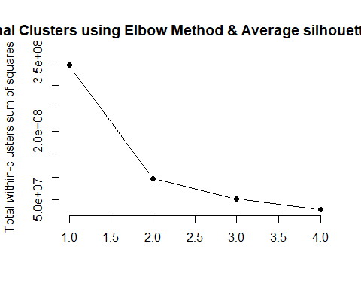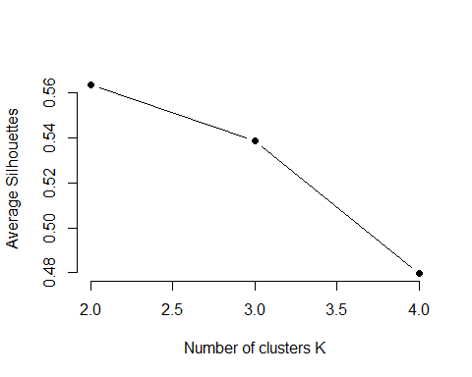

–>

## Final Clustering Day4 on PP HR and Activity Data

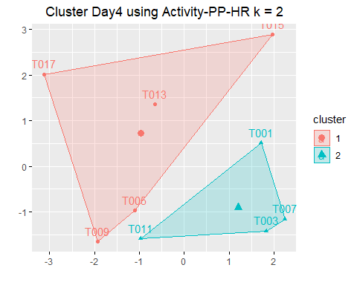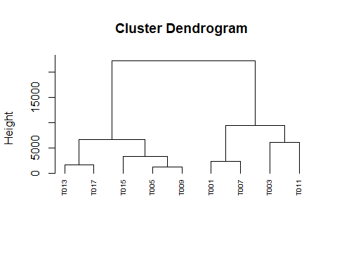

## Clustering All the Days on PP HR Activity Data Trait Anxiety and BFI

## Determining Optimal Clusters

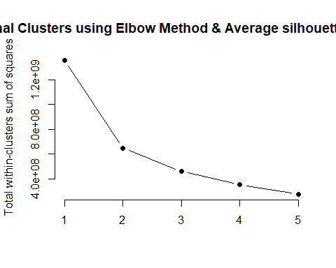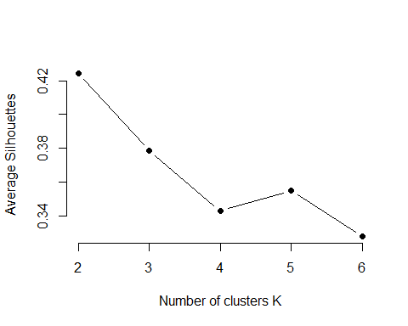

## K-means clustering with 2 clusters of sizes 23, 13  
##   
## Cluster means:  
## R W Out SA SP I Mental  
## 1 8473.826 1704.565 2224.783 32.08696 543.7826 485.8696 12.56522  
## 2 1846.615 8070.308 1367.077 57.69231 383.1538 467.9231 11.07692  
## Physically  
## 1 4.260870  
## 2 5.692308  
##   
## Clustering vector:  
## [1] 1 2 1 2 2 2 2 2 1 2 1 1 1 2 2 2 1 1 1 1 2 2 1 2 1 1 1 1 1 1 1 1 1 1 1  
## [36] 1  
##   
## Within cluster sum of squares by cluster:  
## [1] 407360613 241521868  
## (between_SS / total_SS = 52.2 %)  
##   
## Available components:  
##   
## [1] "cluster" "centers" "totss" "withinss"   
## [5] "tot.withinss" "betweenss" "size" "iter"   
## [9] "ifault"

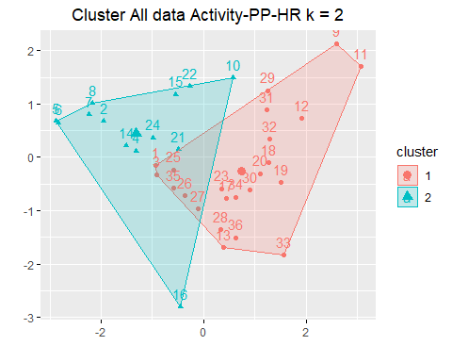

–>

## Determining Optimal Clusters

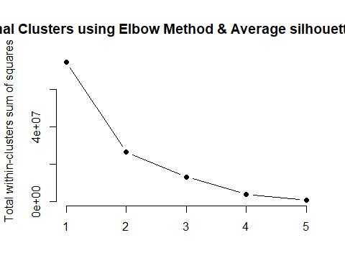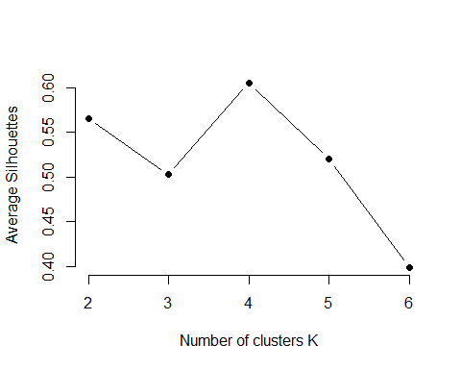 –>

## Final Clustering For all the Days

