**Fact Table –**

fact_table: employee_id, department_id, manager_employee_id,date_id, salary,fte

**Dimension tables -**

1. dim_employee: employee_id , manager_employee_id, first_name, last_name, employee_role, dob, cost_center, paycode , hours_worked
2. dim_manager: manager_employee_id, first_name, last_name
3. dim_department: department_id, department_name, location,salary
4. dim_date : date_id,punch_in_time, punch_out_time, punch_apply_date, hire_date, terminated_date

Logical model for the above fact and dimension:

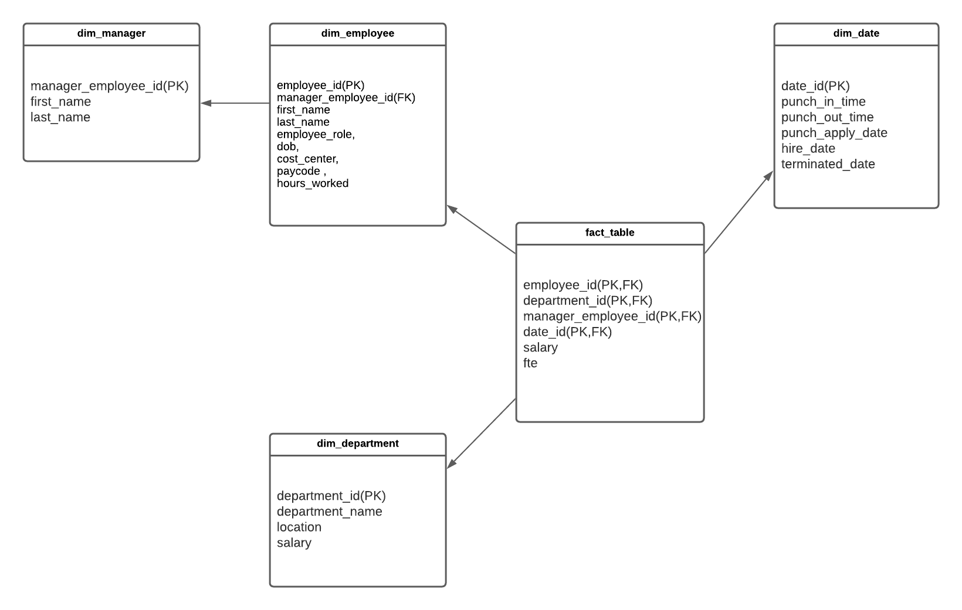

**Figure 1.0- Fact and dimension tables**

**Physical Model:**

    CREATE TABLE dim_date(

        date_id INT  NOT NULL PRIMARY KEY,

        punch_in_time TIMESTAMP,

        punch_out_time TIMESTAMP,

        punch_apply_date DATE,

        hire_date DATE,

        terminated_date DATE

    )

    CREATE TABLE dim_department(

        department_id INT NOT NULL PRIMARY KEY,

        department_name VARCHAR(100),

        location TEXT,

        salary INT

    )

    CREATE TABLE dim_department(

        department_id INT NOT NULL PRIMARY KEY,

        department_name VARCHAR(100),

        location TEXT,

        salary INT

    )

    CREATE TABLE dim_manager(

        manager_employee_id INT NOT NULL PRIMARY KEY,

        first_name,

        last_name TEXT

    )

    CREATE TABLE dim_employee(

        employee_id INT NOT NULL PRIMARY KEY,

        manager_employee_id INT,

        first_name TEXT,

        last_name TEXT,

        employee_role VARCHAR(100),

        dob DATE,

        cost_centre INT,

        paycode VARCHAR(50),

        hours_worked FLOAT

    )

    ALTER TABLE dim_employee

    ADD FOREIGN KEY (manager_employee_id) REFERENCES dim_manager(manager_employee_id);

    CREATE TABLE fact_table(

        employee_id INT NOT NULL,

        department_id INT NOT NULL,

        manager_employee_id INT NOT NULL,

        date_id INT NOT NULL,

        salary INT,

        fte FLOAT

    )

    ALTER TABLE fact_table

    ADD FOREIGN KEY (employee_id ) REFERENCES dim_employee(employee_id);

    ALTER TABLE fact_table

    ADD FOREIGN KEY (department_id ) REFERENCES dim_department(department_id);

    ALTER TABLE fact_table

    ADD FOREIGN KEY (manager_employee_id ) REFERENCES dim_manager(manager_employee_id);

    ALTER TABLE fact_table

    ADD FOREIGN KEY (date_id ) REFERENCES dim_date(date_id);