**MySql_Examination**

**Task- 1:**

Create two tables: users and orders.

Each user can have multiple orders.

-- Create the users table

-- Create the orders table

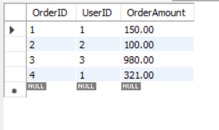

Users table

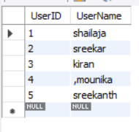

Write a SQL query to fetch the names of users along with the total number of orders they have placed.

**select username,count(orderid) as total from users join ordervalue on users.userid=ordervalue.userid group by orderid;**

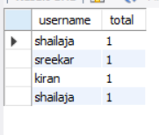

**Task-2:**

You are working with a database that stores information about students and their courses. There are three tables: students, courses, and enrollments.

Write a SQL query to display the names of students along with the courses they have enrolled in.

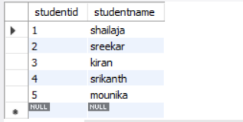

 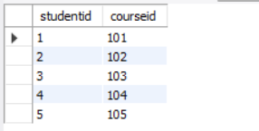

**select studentname,coursename from student join enrollment on student.studentid=enrollment.studentid join course on enrollment.courseid=course.courseid;**



**Task-3:**

You need to retrieve data from a database that tracks product sales. There are tables for products, sales, and customers.

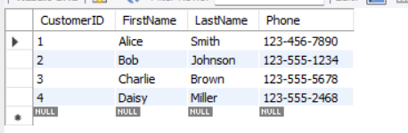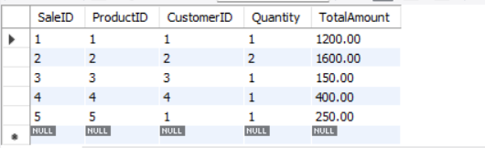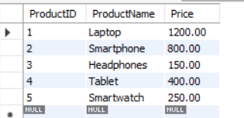

Write a SQL query to show the total sales amount for each product category.

**select productname,totalamount from sales join products on sales.productid=products.productid;**

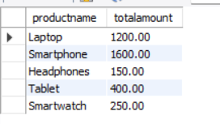

**Task-4:**

You have a database containing information about employees in a company.

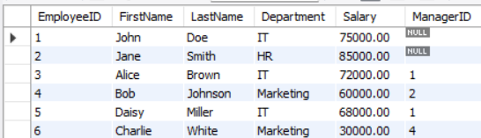

Write a SQL query to list the names of employees along with their respective managers' names.

**select employeeid,firstname,lastname,managerid from employees;**

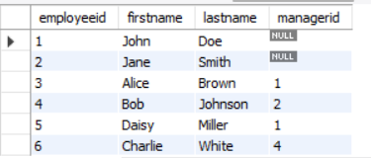

**Task-5:**

You are managing a database for an online store.

Create table store(productid int(10),productname varchar(10),price int(10),selling count int(10));

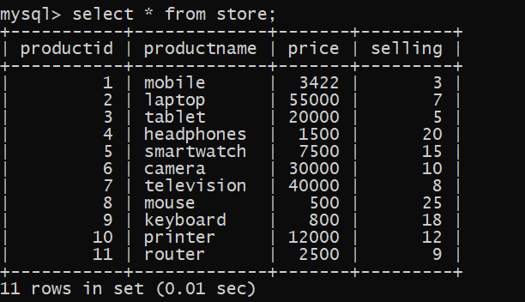

Write a query to retrieve the top 10 bestselling products based on the total number of units sold.

**SELECT productid, productname, price, selling_count FROM store ORDER BY selling_count DESC LIMIT 10;**



**Task-6:**

You have tables for students, courses, and grades.

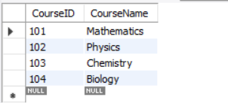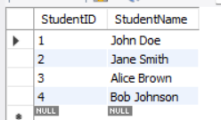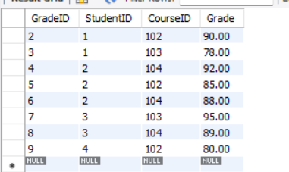

Write a SQL query to display the average grade for each student.

**select studentname, avg(grade) from grades join students on students.studentid=grades.studentid group by studentname;**

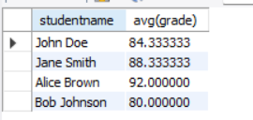

**Task-7:**

You are working with a database for a social media platform.

Create table socialmedia(medianame varchar(20),friends int(10),followers int(10),following int(10));



Write a query to show the users who have the most friends.

SELECT * FROM socialmedia WHERE friends = (SELECT MAX(friends) FROM socialmedia);



**Task-8:**

You have tables for employees and departments.

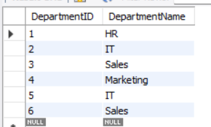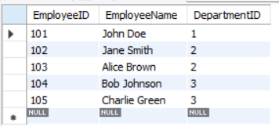

Write a query to display the department names along with the total number of employees in each department.

s**elect count(employeeid) as total,departmentname from departments join employee on employee.departmentid=departments.departmentid group by departments.departmentname;**

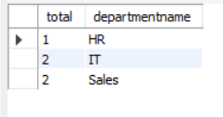

**Task-9:**

You need to retrieve data from a database tracking product inventory.

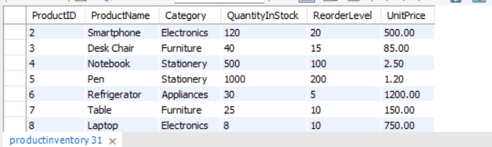

Write a query to display products with low stock (less than 10 units).

**select productname,productid from productinventory where quantityinstock<10;**



**Task-10:**

You have tables for customers and orders.

 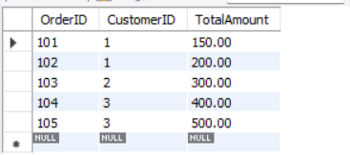

Write a query to show the average order value for each customer.

**select customername,avg(totalamount) from customer join orders on customer.customerid=orders.customerid group by customername;**

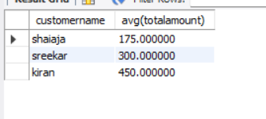

**Task-11:**

In a database storing movie information,

**Create table movie(moviename varchar(10),hero varchar(10),heroine varchar(10),rating int(10));**

**Insert into movie values(‘pushpa’,’fsghj’,’fgweu’,5),(‘amaran’,’hjgq’,’fghwf’,6),(‘ffeq’,’wtfd’,’iquvc’,8),(‘uyfdv’,’geyvge’,’tfgweuq’,5),(‘ujhdk’,’hgwe’,’jkewg’,4),(‘jhwef’,’hhjqk’,’jhrk’,7),(‘hjrr’,’jkrg’,’uryt’,3);**

**select * from movie;**



Write a query to show the top 5 highest-rated movies by users.

SELECT * FROM movie ORDER BY rating DESC LIMIT 5;

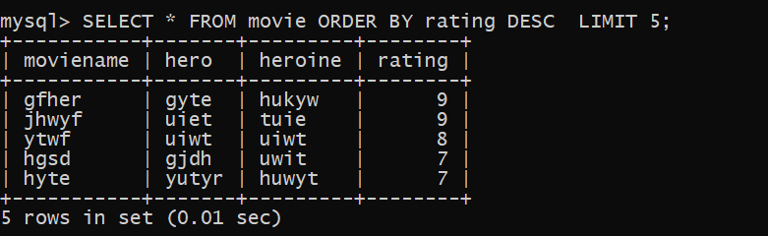

**Task-12:**

You have tables for invoices and payments.

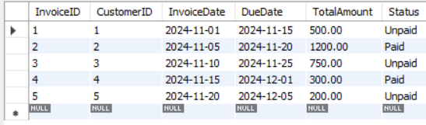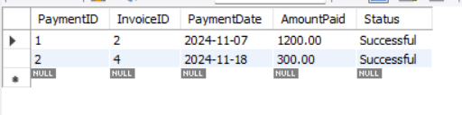

Write a query to show the unpaid invoices and their total amount.

**select invoiceid,customerid,totalamount from invoices where status='unpaid';**

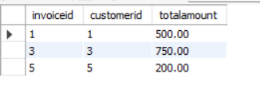

use exam;

show tables;

show tables;

create table student(studentid int(10) primary key,studentname varchar(20));

insert into student values(1,'shailaja'),(2,'sreekar'),(3,'kiran'),(4,'srikanth'),(5,'mounika');

select * from student;

create table course(courseid int(10) primary key,coursename varchar(20));

insert into course values(101,'IT'),(102,'CSE'),(103,'B PHARM'),(104,'ECE'),(105,'EEE');

select * from course;

CREATE TABLE ENROLLMENT(STUDENTID INT(10),COURSEID INT(10),FOREIGN KEY (STUDENTID) REFERENCES STUDENT(STUDENTID),FOREIGN KEY (COURSEID) references COURSE(COURSEID));

select * from enrollment;

**/*Write a SQL query to display the names of students along with the courses they have enrolled in.*/**

select studentname,coursename from student join enrollment on student.studentid=enrollment.studentid join course on enrollment.courseid=course.courseid;

select * from customers;

select * from sales;

select * from products;

**/*Write a SQL query to show the total sales amount for each product category.*/**

select productname,totalamount from sales join products on sales.productid=products.productid;

select * from employees;

**/*Write a SQL query to list the names of employees along with their respective managers' names.*/**

select employeeid,firstname,lastname,managerid from employees;

select * from productinventory;

**/*Write a query to display products with low stock (less than 10 units).*/**

select productname,productid from productinventory where quantityinstock<10;

select * from invoices;

select * from payments;

**/*Write a query to show the unpaid invoices and their total amount.*/**

select invoiceid,customerid,totalamount from invoices where status='unpaid';

-- Create Departments Table

CREATE TABLE departments (DepartmentID INT(10) PRIMARY KEY, DepartmentName VARCHAR(100) );

CREATE TABLE employee(

EmployeeID INT(10) PRIMARY KEY, EmployeeName VARCHAR(100) , DepartmentID INT(10),FOREIGN KEY (DepartmentID) REFERENCES departments(DepartmentID) );

INSERT INTO departments values (1,'HR'),(2,'IT'),(3,'Sales'),(4,'Marketing');

insert into departments values(5,'IT'),(6,'Sales');

select * from departments;

INSERT INTO employee values (101,'John Doe', 1),(102,'Jane Smith', 2),(103,'Alice Brown', 2),(104,'Bob Johnson', 3),

(105,'Charlie Green', 3);

**/*Write a query to display the department names along with the total number of employees in each department.*/**

select count(employeeid) as total,departmentname from departments join employee on employee.departmentid=departments.departmentid group by departments.departmentname;

CREATE TABLE students (StudentID INT(10)PRIMARY KEY, StudentName VARCHAR(100));

CREATE TABLE courses (CourseID INT(10)PRIMARY KEY, CourseName VARCHAR(100) );

CREATE TABLE grades (

GradeID INT(10) PRIMARY KEY,StudentID INT(10),CourseID INT(10),Grade DECIMAL(5, 2),FOREIGN KEY (StudentID) REFERENCES students(StudentID),

FOREIGN KEY (CourseID) REFERENCES courses(CourseID)

);

INSERT INTO students values(1,'John Doe'),(2,'Jane Smith'),(3,'Alice Brown'),(4,'Bob Johnson');

INSERT INTO courses VALUES(101,'Mathematics'),(102,'Physics'),(103,'Chemistry'),(104,'Biology');

INSERT INTO grades VALUES (1,1, 101, 85.00), (2,1, 102, 90.00), (3,1, 103, 78.00), (4,2, 104, 92.00), (5,2, 102, 85.00), (6,2, 104, 88.00), (7,3, 103, 95.00),

(8,3, 104, 89.00), (9,4,102, 80.00);

select * from grades;

select * from students;

select * from courses;

**/*Write a SQL query to display the average grade for each student.*/**

select studentname, avg(grade) from grades join students on students.studentid=grades.studentid group by studentname;

show tables;

CREATE TABLE customer (CustomerID INT(10) PRIMARY KEY, CustomerName VARCHAR(100));

CREATE TABLE orders (OrderID INT(10) PRIMARY KEY,CustomerID INT(10), TotalAmount DECIMAL(10, 2),FOREIGN KEY (CustomerID) REFERENCES customers(CustomerID) );

INSERT INTO customer VALUES (1,'shaiaja'),(2,'sreekar'),(3,'kiran');

INSERT INTO orders VALUES (1, 101,150.00), (1,102, 200.00), (2,103, 300.00), (3,104, 400.00), (3,105, 500.00);

select * from customer;

select * from orders;

select customername,avg(totalamount) from customer join orders on customer.customerid=orders.customerid group by customername;

CREATE TABLE users (UserID INT(10) PRIMARY KEY,UserName VARCHAR(100));

CREATE TABLE ordervalue(OrderID INT(10) PRIMARY KEY, UserID INT(10), OrderAmount DECIMAL(10, 2),FOREIGN KEY (UserID) REFERENCES users(UserID));

insert into users value(1,'shailaja'),(2,'sreekar'),(3,'kiran'),(4,',mounika'),(5,'sreekanth');

insert into ordervalue values(1,1,150.0);

insert into ordervalue values(2,2,100.00),(3,3,980.0),(4,1,321.0);

select * from ordervalue;

select * from users;

**/*Write a SQL query to fetch the names of users along with the total number of orders they have placed.*/**

select username,count(orderid) as total from users join ordervalue on users.userid=ordervalue.userid group by orderid;

show tables;

SELECT * FROM EMPLOYEE;