**Linux Operating System**

Linux is an operating system and open source

Operating System: It interface between user and computer.

It provide a perfect environment to create run and access many applications.

Types of OS:

1.Windows:90% are used because it is user friendly Os.It is invented by Microsoft.

2.Android:It mainly used for mobile application but not system application. It is invented by Google.

3.Linux:It is mainly used for IT Industrial purposes. It is not developed by any company

4.Unix:It is similar to linux

5.Mac:It is mainly used for mobile/Tab applications .It is developed by Apple

6.IOS:It is for complete system application and developed by apple.

**Windows:**

· It is developed by Microsoft in 1985

· It is having GUI(Graphical user interface)

· It is a commercially used for os(paid)

· It is single user based operating system.(i.e,, Only one person can use to connect data).

· Windows has less security features.

· It is totally used for personal but not used for IT Industrial applications.

**Linux**

· It is Developed by Linus Tordvalds in 1991 but not by any compancy.

· Linux is a type of OS that is similar to Unix and and it is built upon the Linux kernel.

· Linux Kernel is like brain of os because it is going to manage how computer interacts with its hardware, resources and peripherals(mouse, keyboard).

· Linux provides for multiple users can access this os.

· Linux is highly security than other os.

· Linux is a distributed application system.(Boot linux,Redhat,ubuntu,centros,fedora,amazon linux,kali linux,suse linux)

· Linux is a user friendly and network friendly os.

· Linux provides privacy of the users.

· It provides high stability(There is no need to install complete linux suite.What are the components required that can be installed)

· Linux is compatible with large number of file formats.

· Advantage:Linux can perform all the tasks properly and evenly though it is having less space on its hard disk.

**Disadvantages**

· It is not very user friendly because it may be confusing for begineers.

· It has smaller peripheral hardware drivers compared with windows.

**ls:** It lists all the files and directories.

**Command**:ls

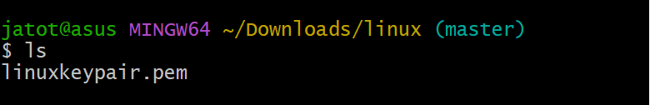

If you add a folder name or path, it will print that folder contents

**Command**: ls /bin

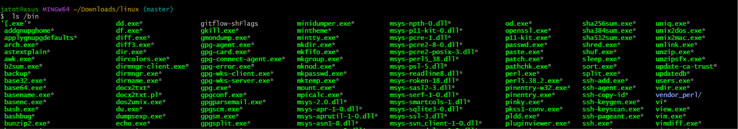

**Cd**: cd means change directory. You invoke it specifying a folder to move into. You can

specify a folder name, or an entire path.

**Command:**

mkdir foldername #creating new folder

cd foldername



cd .. #back to the home folder



**pwd:**It displays the current directory.

**Command:**pwd

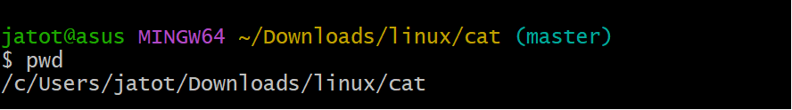

**Mkdir:**It is used to create new folders.

**Command:**mkdir foldername

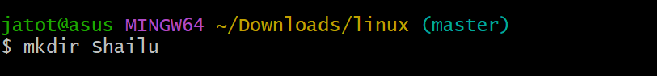

You can create multiple folders with one command

**Command:**mkdir foldername1 foldername2

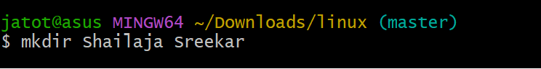

You can also create multiple nested folders by adding the -p option:

**Command**  mkdir -p folder1/folder2

**rmdir:**It will remove/delete the folder.If you want to delete multiple files you can remove it.

**Command:**rmdir foldername

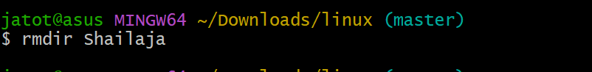

rmdir folder1 folder2

To delete folders with files in them, we'll use the rm command which deletes files and folders,using the -rf

**Command**:rm -rf folder1

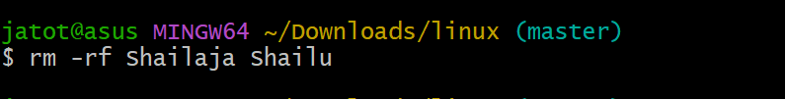

**Mv**: If you have a file, you can move it around using the mv command. You should specify the file current path,and its new path.

**Command** :mv file1 newfile

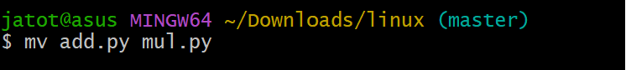

Here file1 is moved to newfile

If you want to move a file into a particular folder then you need to specify the folderpath

**Command:** mv file1 folder1

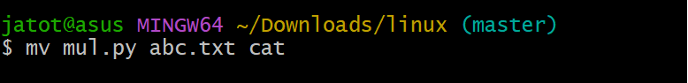

**Cp:**For copying a file we will using cp command.

**Command:** **cp file1 anotherfile**

To copy a folder and all its contents (files and subfolders), use the -r option with the cp command, like this:

Command: cp -r source_folder destination_folder

-r tells copy everything in the folder

**Open:It opens a file ,directory or application**

**Command:**open <file> or open <directory> or open <application>

**Touch:**It is used to create an empty file

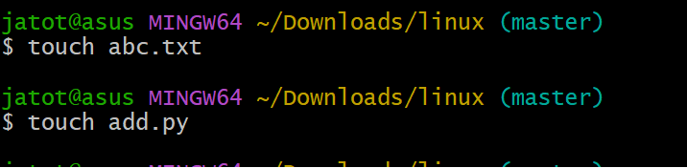

**Command:**touch filename

If the file already exists, it opens the file in write mode,and the timestamp of the file is updated.

**find:**

**ln:**It used to create the links between the files.

There are 2 types of links

1. hard links

2.soft links.

**Gzip:** if you want to compress a file we use gzip compression.

**Command:** gzip filename

This compresses files and adds a .gz extension. To compress and keep the original file, we will be using

**Command:** gzip -c filename > filename.gz

Or gzip -k filename

To Compress multiple files we specify files

**Command:**gzip filename1 filename2

Compress all files in a folder recursively

**Command:**gzip -r a_folder

To decompress the file

**Command:**gzip -d filename.gz

**Gunzip:** gunzip command decompresses .gz files

To Decompress a file to a different filename

**Command** :gunzip -c filename.gz > anotherfilename

**Tar:** The tar command is used to create and manage archives.

**Cat:**It displays and manipulates file content

**Command:** cat file

To view multiple files together

**Command:** cat file1 file2

Combine files into a new file. > concatenate the content of multiple files into a new file.

**Command:**cat file1 file2 > file3

By using >> you can append the content of multiple files into a new file,creating it if it does not exist:

**Command:**cat file1 file2 >> file3

To see the line numbers in the source code you can print by using cat and -n command:

Cat -n filename

**Less:**The less command is indeed a very useful tool for viewing file content interactively in a terminal.

Command: less <filename>

**For Exiting less**

Press q to quit the session.

**Editing the File**

Press v to open the file in the system's default text editor, typically vim.

**Follow Mode**

Press F to enter "follow mode," where the file is updated live, similar to the tail -f command. Exit with Ctrl+C.

**Navigating Multiple Files**

To Open multiple files with less, and use :n to go to the next file and :p to go to the previous one.

**Tail:** The tail command is commonly used to display the last few lines of a file, and it's especially useful for monitoring logs and other growing files in real-time.

By default it displays last 10 lines from the file

**Command**:tail <filename>

It display the last N lines of a file

**Command:**tail -n N <filename>

To see for new content in a file as it is appended

**Command:**tail -f <filename>

To print the content of a file starting from a specific line number

**Command:**tail -n +<line_number> <filename>

**wc :**wc command is used for word count and is used to count the number of lines, words, and characters in a file or input.

It will display three numbers:

**Lines**: Number of lines in the file.

wc -l <filename>

**Words**: Number of words in the file.

wc -w <filename>

**Characters**: Number of characters in the file.

wc -c <filename>

**grep**

**sort:** sort command helps us sorting them by name when list is unordered.

**Command:**sort filename

r is used to reverse the order

**Command:**sort -r filename

Sorting is case sensitive by alphabetically if you want to sort in numerical order you need to mention -n

**Command:**Sort -n filename

-u is used to remove the duplicates in the file.

**Command:**Sort -u filename

**Uniq:** It is used to sort lines of text.

**Command**:uniq filename

**Diff:** It is used for comparing two files to see the differences between them. It outputs the lines that differ and provides context about where and how they differ.

diff file1 file2

-y option will compare the 2 files line by line

diff -yfile1.txt file2.txt

**echo:** It is used to display text or the result of commands in the terminal.

**Chown:** The owner (and the root user) can change the owner to another user by using the chown.

**command:** chown <owner> <file>

If you want to change the ownership of a directory, and recursively all the files contained, plus all the subdirectories and the files then you need to include -r in it.

Command:chown -R <owner> <file>

You can also just change the group of a file using the chgrp command.

command:chgrp <group> <filename>

**Umask:**When a file or directory is created, the operating system assigns default permissions, but the umask value modifies these permissions by subtracting permissions.