**MYSQL**

**Database:** It is an application that stores the collection of data.

Each database has one or more distinct APIs.

**API**: It is used to create, manage, store, search, and replicate data.

**Files:** Unchanged, cannot update/cannot organize the data in the files.

**Excel:**

* It is less secure than files.
* By storing more data it works slower.
* For security and storage purposes we are not going for Excel.

**DBMS(Database Management System):** It can store data in the form of tables.

**Challenges of DBMS:**

* Relations are not possible for accessing the data.

**The database is of 2 types:**

1. **RDMS(Relational Database Management System):** It stores the data in the form of tables and map the data from one location to another location.

**Advantages:**

* It will retrieve data very quickly.
* Operations are also very effective.

**2.Non-RDMS(Non-Relational Database Management system):** It stores the data in the form of key values format.

MySQL Database(Mysql with SQL) which stores data in organized manner in rows and columns.

Mysql refers to the server platform SQL Language.

**To create a project we need**

1.frontend-- >To view the data

2. Back end---->Interaction between the data and programming.

3. Database: To store the data and provide space to store applications.

Database Components

1. Client

2. Server

MySql uses 2 types of commands

**1.DDL(Data Definition Language):**

DDL commands create, modify, and delete the database's structure like table, and schemas.

**Commands**

**1. Create:** Used to create databases, tables.

**2. Alter:** Add a row or column to the existing table.

**3. Drop:** delete records from the database.

**4. Truncate:**It will remove the records from the table.

**2.DML(Data Manipulation Language):**It deals with the manipulation of the data present in the database.

**Commands**

**Insert:** Used to insert data into the table.

**Update:** Update the existing data in a table.

**Delete** Deletes the records from the database.

**Call:** Call a PL/SQL or Java subprogram.

**Explain call:** Describe the access path to the data**.**

**Data Types:**

**Char(size):** Fixed lengths of characters are allowed.

**Varchar(size):** Variable length string is allowed.

**Binary(size):** Equal to char but stores binary values by default it is 1.

**Text(size):** Holds a string with a max length of 65 to 535 bytes.

**TINYTEXT**: Holds a string of a maximum of 255 characters.

Steps and syntax:

1. create a database as create **database name;**

2. Enter into the database as **use database name;**

3. To view the tables in the database use **show tables;**

4. create a table as

**Create table table name(col1 datatype(size),col2 datatype(size)……));**

5. Insert the data into the table as

**Insert into table name values(‘value1’,’value2’,’value3’…….);**

1. To delete a row from the table

**delete from tablename where condition;**

1. To delete the records from the database

**Drop table tablename;**

1. To delete all records in the table

**Truncate table tablename;**

1. To add a new column into the table

**Alter table tablename add column columnname datatype(size);**

10.To rename the columnname

**alter table tablename rename columnname to newcolumnname;**

11.To update a particular value in the table

**Update tablename set columnname=”new value” where condition;**

12.To drop a column from the table

**Alter table tablename drop cloumn columnname;**

**Clauses and operators**

1. **Where:**It is used to exact particular record in the table.Mainly used for filtering

Select colname from tablename where condition;

**2.AND,OR,NOT:** if all the conditions are satisfied then the result will be true.(AND).

T T T

T F F

F T F

F F F

If any one of the condition satisfy then the result will be true.(OR)

T T T

T F T

F T T

F F F

Display the records when condition fails.

T F

F T

1. **ORDERBY:**used for sorting the records in the table

Select col1,col2 from tablename orderby col1,col2.

1. **INSERT INTO:U**sed to insert new records into already existing records.

**Insert into tablename(col1,col2,col3……..)values(val1,val2.val3..);**

1. **SELECT :**To display /to obtain the data from particular table.

Select * from tablename;

1. **UPDATE:**modify/change the existing value

**Update table_name det col1=new value where condition;**

1. **DELETE:**deletes the existing record from the table

Delete from table where condition;

1. **MIN AND MAX:**returns minimum value in a record

Max is used to return maximum value in a record

**Select max(colname) from tablename where condition;**

**Select min(colname) from tablename where condition;**

1. **LIKE:**used in where clause if we want to obtain a specific pattern or search for a specific pattern in a col

Select col1,col2 from tablename where col1 like pattern

%a ->finds pattern ending with a

A%->find pattern starting with a

_a%->find value a in 2nd position is a

1. **IN:**allow you to specify multiple values in the where clause

Select colname from tablename where colname in(val1,val2);

1. **BETWEEN:**used to select the middle value from range of values.

Select name from tablename where colname between val1 and val2;

1. **GROUPBY:**groups the data present in the rows with same value

Select column name from tablename where condition groupby colname orderby colname;

1. **COUNT:**Returns the number of records which satisfy the condition

Select count(colname)from tablename where condition;

1. **AVG:**average value of a particular column.

Select avg(colname) from tablename where condition;

1. **SUM:**gives the total of the numbers present in a column

Select sum(coname)from tablename where condition;

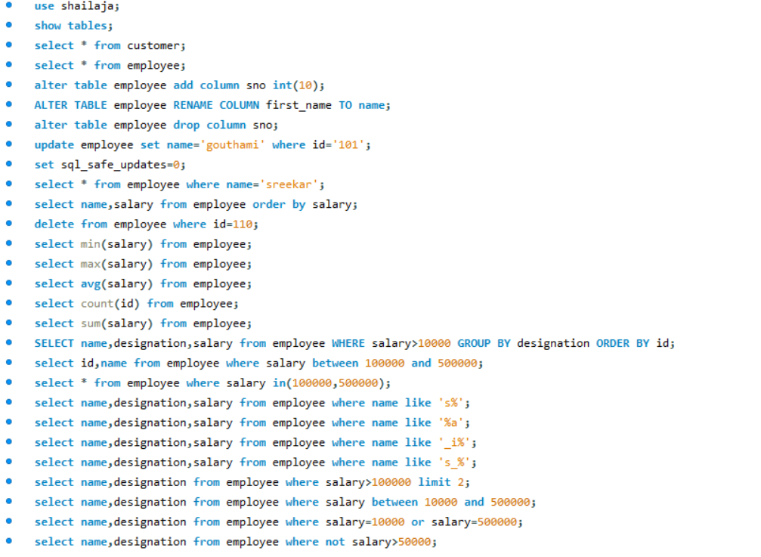

**Joins**:

* Joins are used with select statement.
* It is used to retrieve data from multiple tables from same database.
* Two Tables should be in single database.
* It is used to fetch records from different tables easily.

**There are 3 types of MySql Joins**

1. **Inner join:**

It is also known as simple join.In order to return all the rows from multiple tables where join condition is satisfy.This is most commonly used join in mysql.

**Syntax**:**select columns from table1 innerjoin table2 on table1.column=table2.column;**

1. **Outer join: Left outer join**

**Right outer join**

**Outer Left Join:**Returns all rows from left hand side and all the rows from right hand side table by satisfying the join condition

**Syntax**:

Select columns from table1 Left Join table2 on table1.col=table2.col;

**Outer Right Join:(Right join)**Returns all the rows from right hand side and all the rows from left hand side by satisfying the join condition;

**Syntax**:

SELECT COLUMNS FROM TABLE1 RIGHT JOIN TABLE2 ON TABLE1.COL=TABLE2.COL;

**SELF JOIN:**Data/rows in the table or combined/joined with the same data/rows in the same table;

**Syntax**:SELECT COLUMNNAME FROM TABLE1,TABLE2 WHERE CONDITION;

**CROSS JOIN:**It will return all the rows /records from both tables (table1,table2).

**Syntax:**

SELECT COLUMNNAME FROM TABLE1 CROSS JOIN TABLE2 ON TABLE1.COL=TABLE2.COL

**Having Clause**:It is used to filter the results after the group by clause based on conditions applied on aggregate data.

**Syntax**:SELECT COLUMN_NAMES FROM TABLENAME WHERE CONDITION GROUP BY COLUMN_NAMES HAVING CONDITION ORDER BY COLUMN_NAMES;

**ALL AND ANY:**

ALL is like and operation returns the value only if all the subquery is values meet the condition.

**Syntax**:SELECT ALL COLUMN_NAMES FROM TABLE_NAME WHERE CONDITION;

ANY is like or operation if any one of the subquery meets the condition it returns the value.

**Syntax**:SELECT ANY COLUMN_NAMES FROM TABLE_NAME WHERE CONDITION;

**CONSTRAINTS:**It is used to specify the rules for the data

**NOT NULL**:A column not to accept null values

**UNIQUE**:all the columns values in a table should be unique.

**PRIMARY KEY**:It uniquely identifies a record in the table.All the values should be unique and also it should not be null.

**FOREIGN KEY**:It is a field in one table that refers primary key of another table.

create database shailu;

use shailu;

create table student(student_id int(10) primary key,name varchar(20),dept varchar(20),gendar varchar(10));

Insert into student values(1,'Shailaja','IT','Female'),(2,'Sreekar','CIVIL','Male'),(3,'kiran','B pharm','Male'),(4,'Mounika','ECE','Female'),(5,'Srikanth','EEE','Male'),(6,'pravalika','ECE','Female'),(7,'Priyanka','CSE','Female'),(8,'Gouthami','B.SC','Female');

select * from student;

create table grade(grade_id int(10) primary key,student_id int(10),course varchar(20),marks decimal(10,2),foreign key (student_id) references student(student_id));

insert into grade values(101,1,'Maths',98.0),(102,2,'Science',99.0),(103,3,'Hindi',87.5),(104,4,'english',95),(105,5,'Maths',87),(106,8,'Social',76);

**select grade_id,dept,marks from grade inner join student on grade.student_id=student.student_id;**

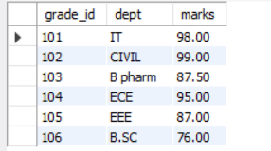

**select grade_id,dept,marks,gendar,name from grade left join student on grade.student_id=student.student_id;**

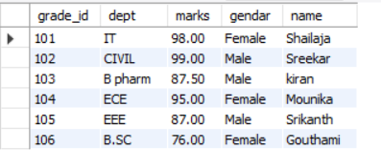

It is returning all the rows from grade table and values which are satisfying the condition records will be return

**select grade_id,dept,marks,gendar,name from grade right join student on grade.student_id=student.student_id;**

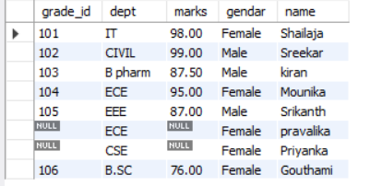

**select grade_id,dept,marks,gendar,name from grade cross join student;**

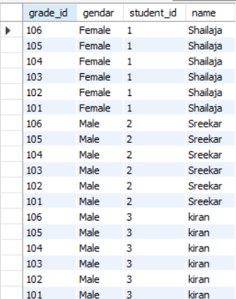

**select * from grade self join grade;**

