**Slicing**

Slicing in Python allows you to extract specific portions of a sequence (like strings, lists, tuples) using flexible syntax. It is commonly used for obtaining substrings, sublists, or sub-tuples.

Syntax : sequence[start:stop:step]

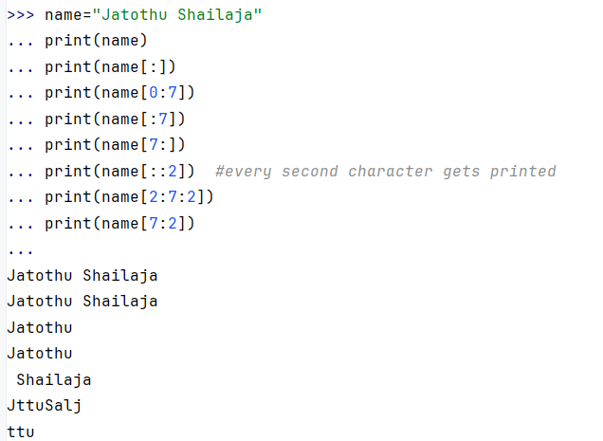

**2. Negative Indices:** Negative indices count from the end of the sequence.

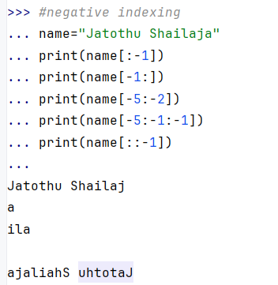

**Nested Slicing:**You can apply slicing to the results of other slicing operations.

