**Strings**

String is collection of one or more characters

**Methods in Strings**

**str.upper():** Converts all characters to uppercase

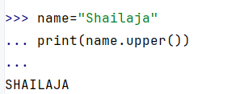

**str.lower():** Converts all characters to lowercase

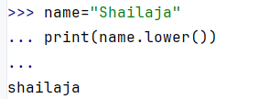

**str.capitalize()**: Capitalizes the first character of the string.

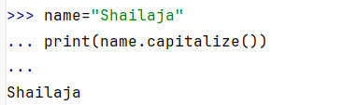

**str.title()**: Converts the first character of each word to uppercase.

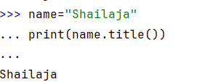

**str.swapcase()**: Swaps the case of all characters.

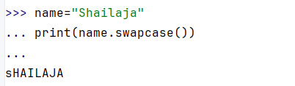

**str.find(sub[, start[, end]])**: Returns the lowest index of the substring, or -1 if not found.

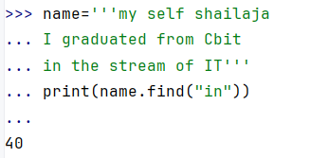

**str.index(sub[, start[, end]])**: Similar to find(), but raises a ValueError if not found.

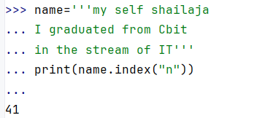

**str.replace(old, new[, count])**: Replaces occurrences of a substring with another substring.

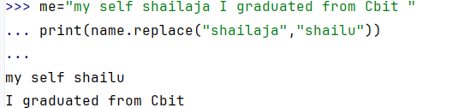

**str.join(iterable)**: Concatenates an iterable of strings with the string as a separator.

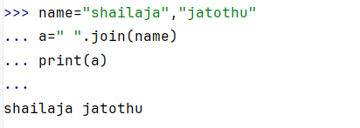

**str.split([sep[, maxsplit]])**: Splits the string into a list at the separator.

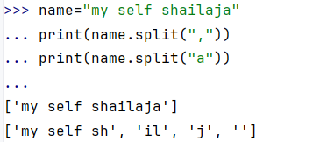

**str.strip([chars])**: Removes leading and trailing characters (default: whitespace).

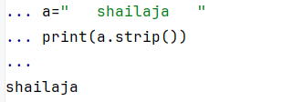

**str.isalpha()**: Checks if all characters are alphabetic.

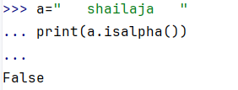

**str.isalnum()**: Checks if all characters are alphanumeric

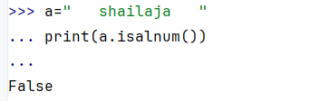

**Len**():Returns the number of characters in a string, including spaces and special characters.

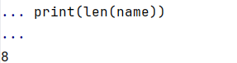

**max():**Returns the highest (largest) character in a string based on Unicode values.

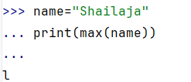

**Min():**Returns the smallest character in a string based on Unicode values.

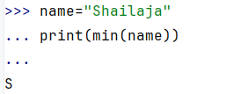

**Single quotes**: Used for simple strings without special characters like apostrophes.

**Double quotes:** Useful for strings that contain single quotes ('), such as contractions.

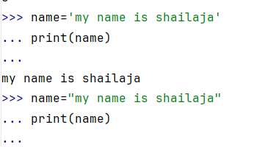

**Triple Quotes (''' or """)**

Multi-line strings.Including both single and double quotes in the string.

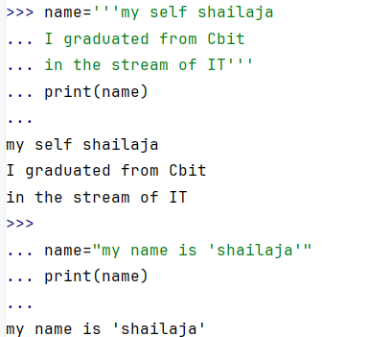

**Slicing in Strings**

Slicing allows you to extract parts of a string using the syntax:

**Syntax**:: string[start:end:step]

**start**: The starting index (inclusive, default is 0).

**end**: The stopping index (exclusive, default is the length of the string).

**step**: The step size (default is 1).

