**1. Local Variables**

* **Definition**: A local variable is declared inside a function or block and is only accessible within that function or block.
* **Scope**: Limited to the function or block in which it is defined.

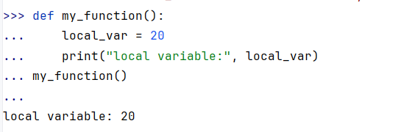

**2. Global Variables**

* **Definition**: A global variable is declared outside any function or block and can be accessed and modified from any part of the program (within the same module).
* **Scope**: Accessible across functions and throughout the file where it is defined.

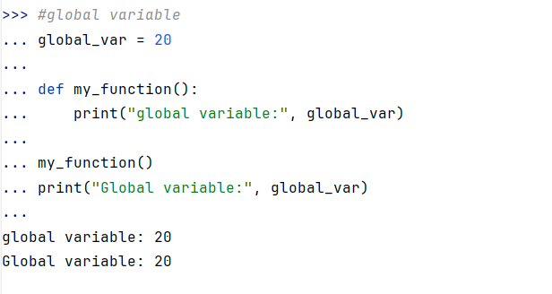

**3.Modification of global variable**

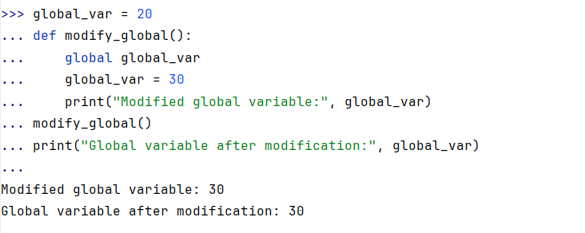

· **Lifetime**:

* Local variables exist only during the execution of the function/block in which they are defined.
* Global variables exist for the entire duration of the program.

· **Accessibility**:

* Local variables are only accessible within the function/block they are defined in.
* Global variables can be accessed anywhere in the program (unless shadowed by a local variable with the same name).