**Operators**

Operators in Python are special symbols or keywords used to perform operations on values and variables. It supports several types of operators:

1. **Arithmetic Operators**:

**Addition (+):** Adds two values.

**Subtraction (-):** Subtracts the second value from the first.

**Multiplication (*):** Multiplies two values.

**Division (/):** Divides the first value by the second, returning a float.

**Modulus (%):** Returns the remainder of the division.

**Exponentiation (**):** Raises the first value to the power of the second.

**Floor Division (//):** Divides the first value by the second and truncates the result to an integer.

Example:

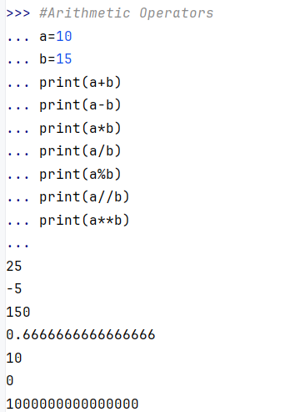

1. **Comparison (Relational) Operators**: Used to compare two values. These operators return True or False.

**(==) Equal to:** Returns True if both values are equal.

**(!=)Not equal to:** Returns True if values are not equal.

**>: Greater than:** Returns True if the left value is greater than the right.

**(<) Less than:** Returns True if the left value is less than the right.

**(>=)Greater than or equal to:** Returns True if the left value is greater than or equal to the right.

**Less than or equal to(<=):** Returns True if the left value is less than or equal to the right.

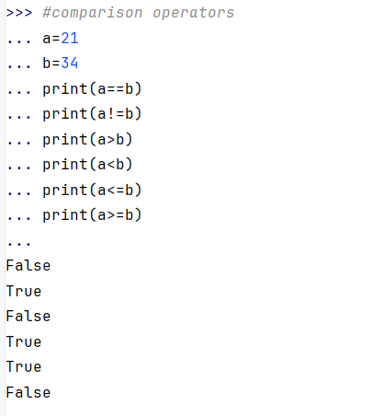

3. **Logical Operators**:

**Logical AND:** Returns True if both conditions are true.

**Logical OR:** Returns True if at least one condition is true.

**Logical NOT:** Returns True if the condition is false.

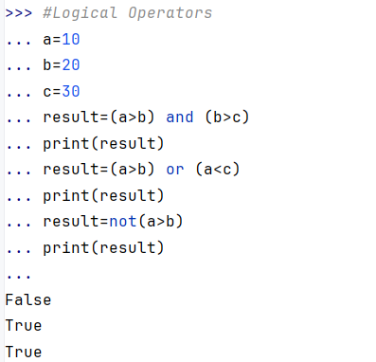

4. **Bitwise Operators**: Perform operations on bits.

**Bitwise AND(&):** Performs a binary AND.

**Bitwise XOR(^):** Performs a binary XOR.

**Bitwise NOT(~):** Inverts all bits.

**Left Shift(<<):** Shifts bits to the left, adding zeros.

**Right Shift(>>):** Shifts bits to the right.

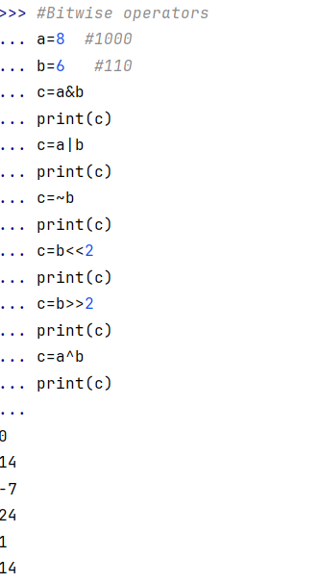

5. **Assignment Operators**: Used to assign values to variables.

**Assign(=):** Assigns the value on the right to the variable on the left.

**Add and assign(+=):** Adds the right value to the left variable.

**Subtract and assign(-=):** Subtracts the right value from the left variable.

**Multiply and assign**(*=): Multiplies the left variable by the right value.

**Divide and assign(/=):** Divides the left variable by the right value.

**Modulus and assign(%=):** Finds the remainder and assigns.

**//=**: Floor divide and assign.

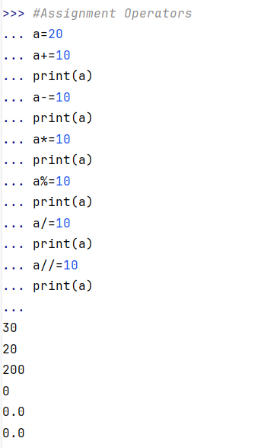

6. **Membership Operators**: Check for membership in a sequence.

**Membership in:** Returns True if the value exists in the sequence.

**Membership not in:** Returns True if the value does not exist in the sequence.

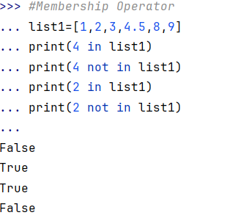

7. **Identity Operators**: Check if two objects refer to the same memory location. **Identity is:** Returns True if both variables refer to the same object.

**Identity is not:** Returns True if both variables do not refer to the same object.

