**Linux Operating System**

Linux is an operating system and open source

**Operating System:** It interface between user and computer.

It provide a perfect environment to create run and access many applications.

Types of OS:

**1.Windows**:90% are used because it is user friendly Os.It is invented by Microsoft.

**2.Android**:It mainly used for mobile application but not system application. It is invented by Google.

**3.Linux**:It is mainly used for IT Industrial purposes. It is not developed by any company

**4.Unix:**It is similar to linux

**5.Mac**:It is mainly used for mobile/Tab applications .It is developed by Apple

**6.IOS**:It is for complete system application and developed by apple.

**Windows:**

· It is developed by Microsoft in 1985

· It is having GUI(Graphical user interface)

· It is a commercially used for os(paid)

· It is single user based operating system.(i.e,, Only one person can use to connect data).

· Windows has less security features.

· It is totally used for personal but not used for IT Industrial applications.

**Linux**

· It is Developed by Linus Tordvalds in 1991 but not by any company.

· Linux is a type of OS that is similar to Unix and and it is built upon the Linux kernel.

· Linux Kernel is like brain of os because it is going to manage how computer interacts with its hardware, resources and peripherals(mouse, keyboard).

· Linux provides for multiple users can access this os.

· Linux is highly security than other os.

· Linux is a distributed application system.(Boot linux,Redhat,ubuntu,centros,fedora,amazon linux,kali linux,suse linux)

· Linux is a user friendly and network friendly os.

· Linux provides privacy of the users.

· It provides high stability(There is no need to install complete linux suite.What are the components required that can be installed)

· Linux is compatible with large number of file formats.

· Advantage:Linux can perform all the tasks properly and evenly though it is having less space on its hard disk.

**Disadvantages**

· It is not very user friendly because it may be confusing for begineers.

· It has smaller peripheral hardware drivers compared with windows.

**ls:** It lists all the files and directories.

**Command**:ls

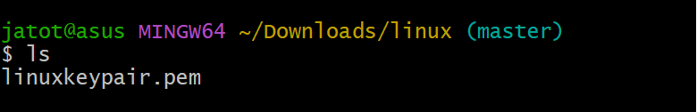

If you add a folder name or path, it will print that folder contents

**Command**: ls /bin

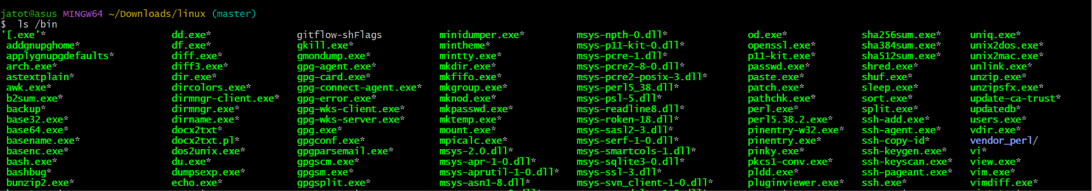

**Cd**: cd means change directory. You invoke it specifying a folder to move into. You can

specify a folder name, or an entire path.

**Command:**

mkdir foldername #creating new folder

cd foldername



cd .. #back to the home folder



**pwd:**It displays the current directory.

**Command:**pwd

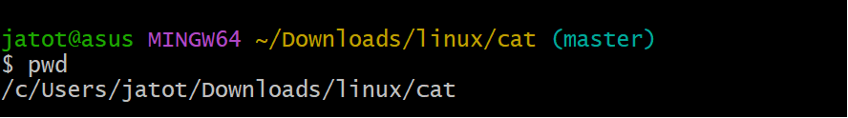

**Mkdir:**It is used to create new folders.

**Command:**mkdir foldername

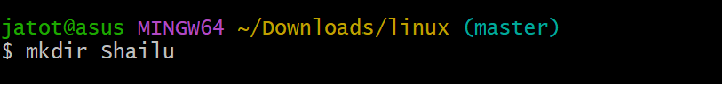

You can create multiple folders with one command

**Command:**mkdir foldername1 foldername2

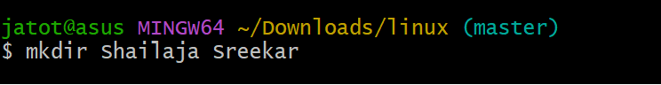

You can also create multiple nested folders by adding the -p option:

**Command**  mkdir -p folder1/folder2

**rmdir:**It will remove/delete the folder.If you want to delete multiple files you can remove it.

**Command:**rmdir foldername

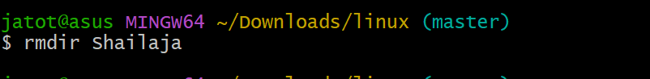

rmdir folder1 folder2

To delete folders with files in them, we'll use the rm command which deletes files and folders,using the -rf

**Command**:rm -rf folder1

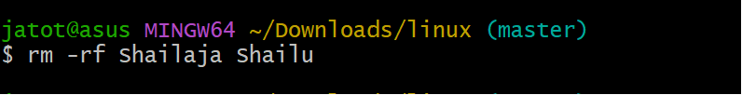

**Mv**: If you have a file, you can move it around using the mv command. You should specify the file current path,and its new path.

**Command** :mv file1 newfile

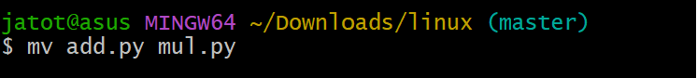

Here file1 is moved to newfile

If you want to move a file into a particular folder then you need to specify the folderpath

**Command:** mv file1 folder1

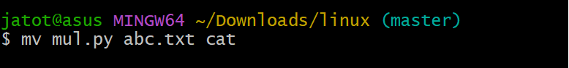

**Cp:**For copying a file we will using cp command.

**Command:** **cp file1 anotherfile**

To copy a folder and all its contents (files and subfolders), use the -r option with the cp command, like this:

Command: cp -r source_folder destination_folder

-r tells copy everything in the folder

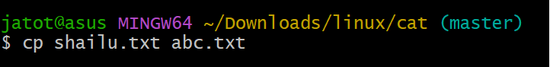

**Open:It opens a file ,directory or application**

**Command:**open <file> or open <directory> or open <application>

**Touch:**It is used to create an empty file

**Command:**touch filename

If the file already exists, it opens the file in write mode,and the timestamp of the file is updated.

Alias: alias command in Linux is used to create shortcuts or custom commands for other commands, making them easier to use or remember.

**find:** find command in Linux is used to search for files and directories within a specified location in the filesystem.

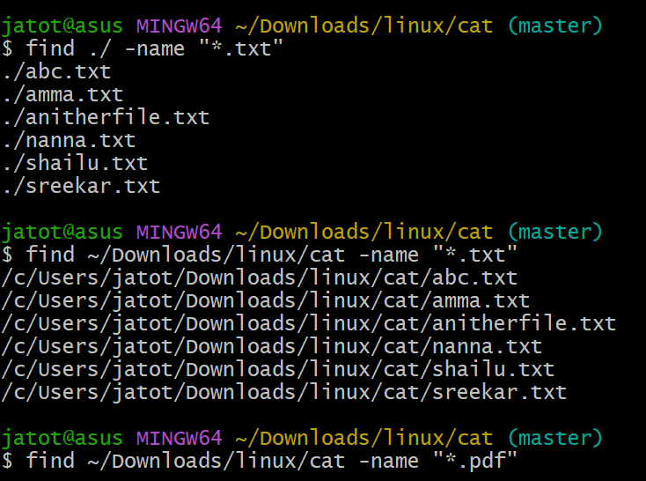

**ln:**It used to create the links between the files.

There are 2 types of links

1. hard links

2.soft links: You create soft links using the -s  option of ln

**Gzip:** if you want to compress a file we use gzip compression.

**Command:** gzip filename

This compresses files and adds a .gz extension. To compress and keep the original file, we will be using

**Command:** gzip -c filename > filename.gz

Or gzip -k filename

To Compress multiple files we specify files

**Command:**gzip filename1 filename2

Compress all files in a folder recursively

**Command:**gzip -r a_folder

To decompress the file

**Command:**gzip -d filename.gz

**Gunzip:** gunzip command decompresses .gz files

To Decompress a file to a different filename

**Command** :gunzip -c filename.gz > anotherfilename

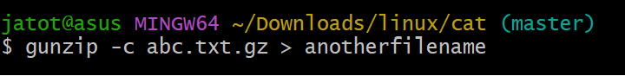

**Tar:** The tar command is used to create and manage archives.

**Cat:**It displays and manipulates file content

**Command:** cat file

To view multiple files together

**Command:** cat file1 file2

Combine files into a new file. > concatenate the content of multiple files into a new file.

**Command:**cat file1 file2 > file3



By using >> you can append the content of multiple files into a new file,creating it if it does not exist:

**Command:**cat file1 file2 >> file3

To see the line numbers in the source code you can print by using cat and -n command:

Cat -n filename

**Less:**The less command is indeed a very useful tool for viewing file content interactively in a terminal.

Command: less <filename>

**For Exiting less**

Press q to quit the session.

**Editing the File**

Press v to open the file in the system's default text editor, typically vim.

**Follow Mode**

Press F to enter "follow mode," where the file is updated live, similar to the tail -f command. Exit with Ctrl+C.

**Navigating Multiple Files**

To Open multiple files with less, and use :n to go to the next file and :p to go to the previous one.

**Tail:** The tail command is commonly used to display the last few lines of a file, and it's especially useful for monitoring logs and other growing files in real-time.

By default it displays last 10 lines from the file

**Command**:tail <filename>

It display the last N lines of a file

**Command:**tail -n N <filename>

To see for new content in a file as it is appended

**Command:**tail -f <filename>

To print the content of a file starting from a specific line number

**Command:**tail -n +<line_number> <filename>

**wc :**wc command is used for word count and is used to count the number of lines, words, and characters in a file or input.

It will display three numbers:

**Lines**: Number of lines in the file.

wc -l <filename>

**Words**: Number of words in the file.

wc -w <filename>

**Characters**: Number of characters in the file.

wc -c <filename>

**sort:** sort command helps us sorting them by name when list is unordered.

**Command:**sort filename

r is used to reverse the order

**Command:**sort -r filename

Sorting is case sensitive by alphabetically if you want to sort in numerical order you need to mention -n

**Command:**Sort -n filename

-u is used to remove the duplicates in the file.

**Command:**Sort -u filename

**Uniq:** It is used to sort lines of text.

**Command**:uniq filename

**Diff:** It is used for comparing two files to see the differences between them. It outputs the lines that differ and provides context about where and how they differ.

diff file1 file2

-y option will compare the 2 files line by line

diff -yfile1.txt file2.txt

**echo:** It is used to display text or the result of commands in the terminal.

**Chown:** The owner (and the root user) can change the owner to another user by using the chown.

**command:** chown <owner> <file>

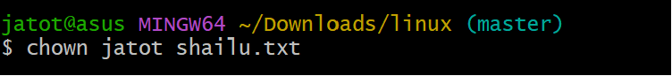

If you want to change the ownership of a directory, and recursively all the files contained, plus all the subdirectories and the files then you need to include -r in it.

Command:chown -R <owner> <file>

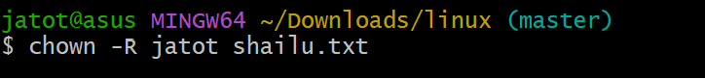

You can also just change the group of a file using the chgrp command.

command:chgrp <group> <filename>

**Umask:**When a file or directory is created, the operating system assigns default permissions, but the umask value modifies these permissions by subtracting permissions.

1. read, write, execute
2. read and write 2  read and execute 3 read only 4  write and execute 5  write only 6  execute only 7  no permissions

**Chmod:** It is to change the permissions of a file or directory. Permissions determine who can read, write, or execute a file.

History:

**Du:** The du  command will calculate the size of a directory.

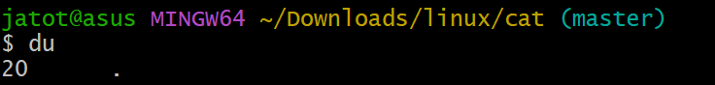

du *  will calculate the size of each file individually

**Df:** df  command is used to get disk usage information. Its basic form will print information about the volumes mounted.

-h  ( df -h ) will show those values in a human-readable format

**Type:** The type command helps you find out what kind of command you are using. When you type something in the terminal like ls, echo, or python, the computer needs to know where to find it and what it is.

**Which:** which command in Linux is used to locate the absolute path of an executable file that would run if the command is entered in the terminal.

**Nano:** It is designed to allow users to create, edit, and manage text files directly from the command line without needing a graphical interface.



**Whoami:**It will print the user name currently logged in to the terminal session.

**Ping:** ping  command pings a specific network host, on the local network or on the Internet.

**Traceroute:** It allows you to trace the path that packets take from your computer to a remote destination, such as a website or server.

**Clear**: clear  to clear all the previous commands that were ran in the current terminal.

**Uname:** uname  without any options will return the Operating System codename

