Report
Of
SOCIAL MEDIA MARKETING AND MANAGEMENT
INTERNSHIP AT SATVIFY, GURGAON
Submitted
To
School of Computer Science and Engineering
IILM University, Greater Noida, U.P.
In partial fulfilment of the requirement of degree of
B.Tech CSE


By
Roll Number of Student: 2410030676
Name of Student: SHAILENDRA SINGH
Batch: 2024-2028
2026-27

CANDIDATE'S DECLARATION
I, Shailendra Singh, do hereby declare that the internship report titled “Social Media Marketing and Management – Internship at Satvify, Gurgaon” has been completed by me to fulfil the requirement for the award of the degree of Bachelor of Technology in CSE. All the references have been quoted and I have not taken as such any material from any other source. I affirm to you that this report is my own and has not been submitted to any other institute for any degree/diploma requirement and further I shall be solely responsible for any kind of copyright violation in this regard.

Signature
Student Name: SHAILENDRA SINGH
Roll No.: 2410030676

ACKNOWLEDGEMENT
I am using this opportunity to express my gratitude to everyone who supported me throughout the Internship Program. I am thankful for their aspiring guidance, invaluably constructive criticism and friendly advice during this work. I am sincerely grateful to them for sharing their truthful and illuminating views on a number of issues related to this work.
I express my sincere thanks to Ms. Yukti Setia, Founder & CEO of Satvify, for giving me the opportunity to work as a Social Media Marketing Intern, for trusting me with real responsibilities, and for her guidance and feedback throughout the internship. I also thank the Satvify team for their cooperation and support.
I am equally grateful to the School of Computer Science and Engineering, IILM University, Greater Noida, and my faculty members for their encouragement and for providing the platform to gain industry exposure as part of my programme.
I express my gratitude to my parents for their blessings.

Signature
Student Name: SHAILENDRA SINGH
Roll No.: 2410030676

INTERNSHIP COMPLETION CERTIFICATE
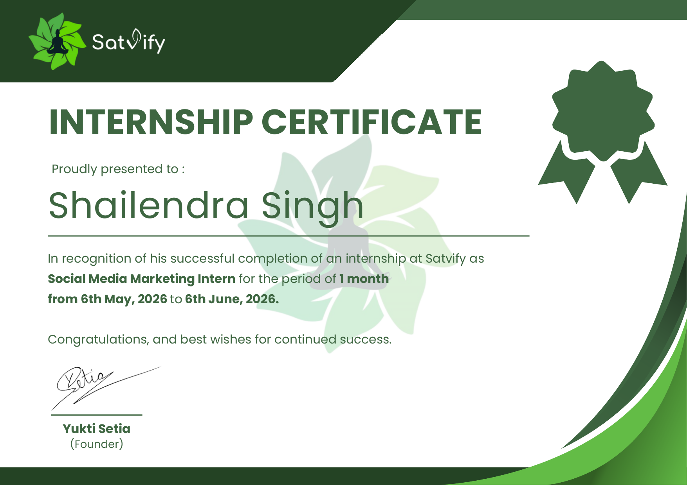
Certificate issued by Satvify to Shailendra Singh, Social Media Marketing Intern, 6 May 2026 to 6 June 2026

TABLE OF CONTENTS
Cover Page ---
Candidate's Declaration i
Acknowledgement ii
Internship Completion Certificate ---
List of Tables and List of Figures iv
4. Project Description 1
4.1 Introduction 1
4.2 Organization Profile 2
4.2.1 Internship Terms 2
4.3 Problem Statement 2
4.4 Project Objectives 3
4.5 Scope of the Project 3
4.6 Technologies and Tools Used 4
4.7 System Architecture 4
4.7.1 Content Pillars 5
4.7.2 Marketing Funnel 6
4.8 Methodology 6
4.8.1 Research and Social Media Audit 7
4.8.2 Goal Setting and Strategy 8
4.8.3 Content Planning and Calendar 8
4.8.4 Content Creation 8
4.8.5 Scheduling and Publishing 9
4.8.6 Community Management and Engagement 9
4.8.7 Collaboration and Influencer Outreach 9
4.8.8 Paid Promotion Basics 9
4.8.9 Analytics and Reporting 10
4.8.10 Trend and Competitor Monitoring 10
4.8.11 Reputation and Crisis Management 10
4.8.12 Ethics, Confidentiality and Compliance 11
4.9 Expected Outcomes 11
4.9.1 Outcomes for the Organisation 11
4.9.2 Learning Outcomes for the Intern 11
4.9.3 Limitations and Future Scope 12
4.9.4 Conclusion 12
4.10 Certificates of Completion and Communication Proof 13
5. Bibliography / References 15

LIST OF TABLES
Table 4.1: Summary of the internship engagement 1
Table 4.2: Tools and platforms used, by function 4
Table 4.3: Weekly working plan followed during the internship 7
Table 4.4: Week-wise summary of the internship 7
Table 4.5: Key performance indicators (KPIs) tracked 10
Table 4.6: Challenges faced and how they were handled 11
Table 4.7: Skills developed during the internship 12

LIST OF FIGURES
Figure 4.1: Social media management workflow followed during the internship 5
Figure 4.2: Planned content-pillar mix used for monthly planning 6
Figure 4.3: Social media marketing funnel and metrics mapped to each stage 6
Figure 4.4: Internship Completion Certificate issued by Satvify 13
Figure 4.5: Internship Offer Letter issued by Satvify (page 1) 14

4. PROJECT DESCRIPTION

4.1 Introduction
Social media has changed the way organisations communicate with people. Platforms such as Instagram, Facebook, LinkedIn and YouTube are no longer only places to share photographs; they are where customers discover brands, compare options, ask questions, and decide what to buy. For a young brand, a well-managed social media presence is often the most affordable and measurable way to build awareness, earn trust and reach the right audience (Kaplan and Haenlein, 2010; Chaffey and Ellis-Chadwick, 2019).
Social media marketing is the practice of using social platforms to promote a brand, product or service, and to build a relationship with an audience. Social media management is the day-to-day discipline that makes this possible: planning content, creating it, publishing it at the right time, replying to the community, watching the numbers, and improving the next round of posts. A social media manager therefore combines the skills of a strategist, a writer, a designer, a community moderator and a data analyst.
This report documents my one-month internship as a Social Media Marketing Intern at Satvify, a Gurgaon-based organisation, from 6 May 2026 to 6 June 2026. The internship was offered on a hybrid, part-time basis and allowed me to take part in the complete social media management cycle: audit, strategy, content planning, creation, scheduling, community management, analytics and reporting. The summary of the engagement is given in Table 4.1.
Table 4.1: Summary of the internship engagement
Particular | Details
Organisation | Satvify
Location | Gurgaon, Haryana, India
Designation | Social Media Marketing Intern
Duration | 1 month (6 May 2026 to 6 June 2026)
Mode | Hybrid (remote and onsite)
Working days | Monday to Saturday
Working hours | Part time, 2-3 flexible hours per day
Reporting to | Yukti Setia, Founder & CEO

Although the duration was short, the internship gave me practical exposure to how a real brand operates online, the discipline required to publish consistently, and the importance of connecting every post to a clear business objective. As a B.Tech CSE student, I also found that my technical background helped me understand platform analytics, automation, data tracking and the role of algorithms in content distribution.

4.2 Organization Profile
Satvify is a brand based in Gurgaon, Haryana, India, led by its Founder and CEO, Yukti Setia. By engaging a dedicated Social Media Marketing Intern, the organisation shows the importance it gives to its digital presence and to direct communication with its audience. Its brand identity, visible in the logo of a meditating figure surrounded by green leaves and in the deep and fresh greens used on its documents, suggests calmness, nature and wellbeing, and this visual language guided the look of the content I created.
The organisation engages interns and contractors for specialised tasks, as reflected in the terms of my own engagement. For the social media function, this meant a direct line to the founder, the freedom to propose ideas, and the chance to see them go live quickly. Working at this scale gave exposure to many tasks which, in a large organisation, would be divided among several departments.

4.2.1 Internship Terms
The internship was governed by an offer letter dated 6 May 2026. The engagement was for one month, with the designation of Social Media Marketing Intern, hybrid mode, six working days a week (Monday to Saturday) and flexible part-time hours of two to three hours a day. A stipend was provided, together with travel expenses when working onsite. The offer letter also carried terms on confidentiality, ownership of work created during the internship and professional conduct, which I followed throughout (see Section 4.8.12). A copy of the offer letter is attached in Section 4.10.

4.3 Problem Statement
Many small and growing brands post on social media irregularly, without a defined audience, content plan or measurement method. This leads to inconsistent branding, low engagement, wasted effort and no clear understanding of what is working. Limited time and a small team make it harder to produce high-quality content and respond to the audience promptly.
The problem addressed during this internship can be stated as follows: how can a brand with limited resources build a consistent, engaging and measurable social media presence that increases visibility, strengthens its identity and supports business goals? Within this broader question, the specific challenges were to plan content systematically, maintain brand consistency, increase audience interaction, and create a simple method for tracking performance and learning from it.

4.4 Project Objectives
The objectives of the internship project were:
1. To understand the brand, its products, audience and competitors, and to audit the existing social media presence.
2. To define clear and measurable goals for social media activity, aligned with the organisation's wider objectives.
3. To design a monthly content calendar based on well-defined content pillars and a consistent posting frequency.
4. To create engaging posts, carousels, stories and short videos, with captions and hashtags that suit each platform.
5. To manage publishing and scheduling, and to build a daily routine for responding to comments and messages.
6. To track performance using platform analytics, to interpret the key metrics, and to report insights with recommendations.
7. To learn professional practices such as confidentiality, brand safety, ethical advertising and teamwork.

4.5 Scope of the Project
The scope of the project covered the organic (unpaid) social media activities of the brand and the supporting tasks required to manage them. Specifically, the work included profile optimisation, research, content planning, creative production, copywriting, scheduling, community engagement, collaboration outreach, analytics and reporting. Basic awareness of paid promotion, such as boosting posts and defining target audiences, was part of the learning, but the budgeting and approval of paid campaigns remained with the founder.
The project did not cover website development, product pricing, legal contracts or any decision that could bind the company, as the offer letter reserves these for the directors and founders. Further, because the internship lasted only one month, the results are best understood as early observations and a base for long-term work, not as final conclusions about audience behaviour.

4.6 Technologies and Tools Used
A social media manager works with a stack of tools instead of a single application. I used free and widely available tools so that the workflow could be continued easily by the team after the internship. The tools are listed against their function in Table 4.2.
Table 4.2: Tools and platforms used, by function
Function | Tools / Platforms
Social platforms | Instagram, Facebook, LinkedIn, YouTube Shorts, WhatsApp Business
Graphic design | Canva (posts, carousels, stories, covers)
Video editing | CapCut, InShot, Instagram in-app editor
Scheduling and publishing | Meta Business Suite, native platform schedulers
Planning and tracking | Google Sheets, Google Docs, Google Drive
Analytics | Instagram Insights, Facebook Insights, Meta Business Suite reports
Research and listening | Platform search, hashtag and trend explore pages, Google Trends
Link and bio management | Link-in-bio pages, UTM-tagged links
Communication | WhatsApp, e-mail, video calls

Canva was used to design templates for posts, carousels and story frames, so that colours, fonts and layouts stayed consistent. Short-form videos were edited with mobile and desktop editors, with attention to the first three seconds, subtitles and sound. Meta Business Suite allowed posts for Instagram and Facebook to be scheduled in advance and gave a single inbox for comments and messages. Google Sheets was used as the content calendar and as a simple performance tracker, since it can be shared and updated by everybody involved. Link tracking with UTM parameters was learnt as a method of identifying which post or platform sent a visitor to the website.

4.7 System Architecture
In a social media context, the "system" is the repeatable workflow that moves an idea from research to published content and then back into research through performance data. Figure 4.1 shows the eight-stage workflow that I followed and refined during the internship. The stages form a loop and not a straight line, because the analysis of one cycle becomes the research for the next.
The workflow depends on three layers. The first is the strategy layer, which contains the goals, audience profile, brand voice and content pillars. The second is the production layer, which covers the calendar, design, copywriting, video editing and approval. The third is the performance layer, which covers publishing, engagement, analytics and optimisation. Clear separation of these layers prevented the common mistake of posting without a purpose.
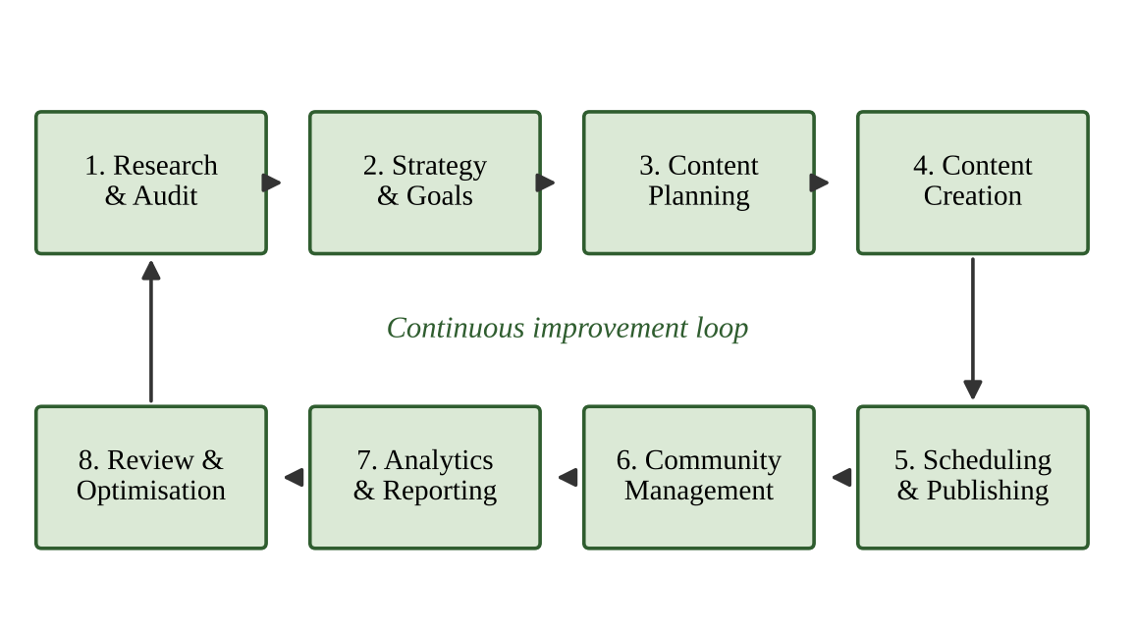
Figure 4.1: Social media management workflow followed during the internship

4.7.1 Content Pillars
Content pillars are the core themes that a brand returns to regularly. They give the audience a reason to follow the account and give the manager a ready source of ideas. The planned mix used for monthly planning is shown in Figure 4.2. Educational posts form the largest part, because content that teaches or helps is the most likely to be saved and shared. Product and brand posts remain important, but they are balanced with interactive, trend-based and community content so that the account does not read as only promotional.
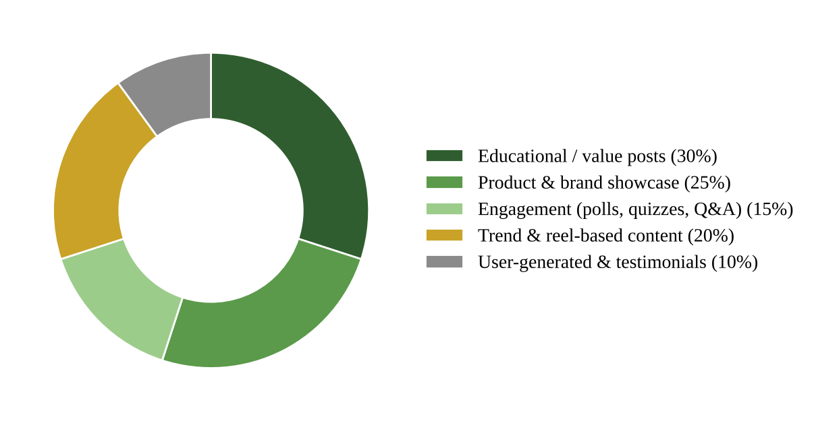
Figure 4.2: Planned content-pillar mix used for monthly planning

4.7.2 Marketing Funnel
Every piece of content was linked to a stage of the marketing funnel. Awareness content introduces the brand to new people; interest content gives them a reason to stay; consideration content answers doubts; and action content invites them to enquire or buy. Mapping metrics to each stage, as in Figure 4.3, made it clear which numbers to examine for which type of post, and avoided judging a post only by the number of likes.
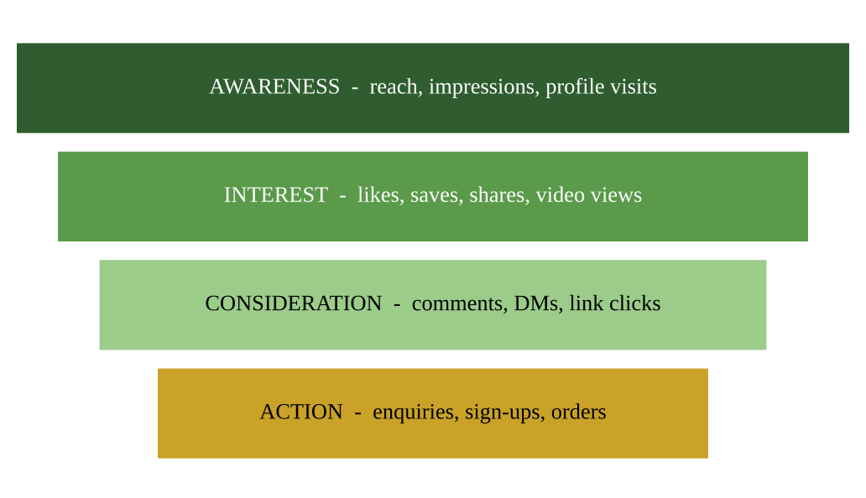
Figure 4.3: Social media marketing funnel and metrics mapped to each stage

4.8 Methodology
The internship followed a structured, step-wise method. The weekly working rhythm is given in Table 4.3, and the week-wise summary of the month is given in Table 4.4. The following sub-sections describe each activity in detail, which together represent the responsibilities of a social media manager as practised during the internship.
Table 4.3: Weekly working plan followed during the internship
Day | Primary activity
Monday | Review last week's insights; confirm the week's content list; assign creative tasks
Tuesday | Design and caption creation; short-video shooting and editing
Wednesday | Approval from the founder; scheduling of posts and stories
Thursday | Engagement hour, community replies; collaboration and outreach messages
Friday | Trend and competitor check; preparation of next-week ideas
Saturday | Weekly performance snapshot; learning and documentation

Table 4.4: Week-wise summary of the internship
Week | Focus | Key activities
1 | Orientation and audit | Studied brand, products and audience; audited all profiles; listed competitors; set up shared folders and sheets
2 | Strategy and planning | Defined goals, content pillars and posting frequency; prepared first monthly content calendar; created templates
3 | Execution | Designed posts, carousels and reels; wrote captions and hashtags; scheduled content; began daily engagement routine
4 | Analysis and optimisation | Compiled insights; compared formats; documented learnings; prepared recommendations and handover notes

4.8.1 Research and Social Media Audit
The first week was used to understand the brand before creating anything. I studied the products and values of Satvify, the target audience, and the tone in which the founder wished to speak. An audit of every social profile was then carried out, covering the profile photo and bio, highlights, link placement, posting history, visual consistency, and the engagement on earlier posts. Competitor and peer accounts were also reviewed to see which formats, topics and hashtags earned interaction, and to find gaps that the brand could fill. The outcome was a short document of strengths, weaknesses and opportunities that guided the strategy.

4.8.2 Goal Setting and Strategy
Goals were written in the SMART form: specific, measurable, achievable, relevant and time-bound. For example, a goal such as "improve awareness" was converted into measurable targets for reach, profile visits and follower growth over the month. Audience personas were prepared to describe who the followers are, what they care about, and when they are online. The platform choice followed from this analysis: Instagram for visual storytelling and short videos, Facebook for community and information, and LinkedIn for professional credibility.

4.8.3 Content Planning and Calendar
A monthly content calendar was prepared in Google Sheets with the date, platform, content pillar, format, topic, caption status, design status, approval and publishing link. Planning ahead made it possible to align posts with festivals, awareness days and seasonal themes, to keep the mix of content balanced, and to avoid last-minute pressure. The calendar was reviewed with the founder each week and changed whenever a trend or an opportunity appeared.

4.8.4 Content Creation
Content creation formed the largest part of the work and involved several skills together.
- Graphic design: single-image posts, multi-slide carousels, story templates and highlight covers were designed in Canva using the brand's colours, fonts and logo.
- Short-form video: reels and shorts were scripted with a strong hook, edited with captions and music, and exported in the correct size and ratio for each platform.
- Copywriting: captions were written in the brand's tone, beginning with a hook, giving value in the middle, and ending with a clear call to action.
- Hashtags and keywords: a mix of broad, niche and branded hashtags was selected, along with keywords in captions and the bio, to help the content be found through search.
- Accessibility: alternative text, readable fonts, adequate contrast and subtitles were used so that content could reach all users.
Each caption followed a simple structure that I called the four-part caption: a hook of one line that stops the scroll; a value section that teaches, entertains or informs; a short brand touch that connects the post to Satvify; and a clear call to action such as saving, sharing, commenting or visiting the link in the bio. Reels followed a similar pattern, with the hook placed in the first three seconds, the main message delivered quickly, and a closing prompt. This structure kept the content consistent even when different ideas were being used.

4.8.5 Scheduling and Publishing
Once approved, content was scheduled through Meta Business Suite or posted directly. Posting times were selected using audience insights and tested across the month. Every post was checked for spelling, tagging, links, cover image and cropping before it went live. Stories were used for daily, informal updates, while feed posts and reels carried the planned, higher-effort content. Consistency was treated as more important than volume.

4.8.6 Community Management and Engagement
Social media is a two-way channel. A fixed daily engagement slot was kept to reply to comments and direct messages, thank people for feedback, answer questions about products and direct complex queries to the founder. Engagement also meant going outside the brand's own account: liking, commenting thoughtfully on relevant accounts, taking part in conversations around related topics, and re-sharing user-generated content with permission. Interactive features such as polls, quizzes, question boxes and countdowns were used to invite participation.

4.8.7 Collaboration and Influencer Outreach
Part of the work was to identify creators, pages and communities whose audience matched the brand. I prepared lists of possible collaborators, studied the quality of their engagement and not merely follower counts, and drafted polite outreach messages for approval. Any commitment, payment or agreement was left to the founder, in line with the terms of the internship. I also learnt about disclosure norms for sponsored content, as set out by the Advertising Standards Council of India (ASCI, 2021).

4.8.8 Paid Promotion Basics
Although paid campaigns were outside the scope of independent work, I studied how boosting works: defining an objective, selecting the audience by location, age and interest, setting a budget and duration, and testing different creatives. I understood that paid reach is most effective when it supports content that has already proven itself organically, and that results must be read together with cost-related metrics.

4.8.9 Analytics and Reporting
Each week, performance data from the platform insights was exported to a tracking sheet. Metrics were grouped by objective, as shown in Table 4.5, and compared across formats, topics and posting times. The weekly snapshot answered three questions: what worked, what did not, and what should be done next. A short monthly report with simple tables and recommendations was prepared at the end of the internship.
Table 4.5: Key performance indicators (KPIs) tracked
Objective | KPI | How it is read
Awareness | Reach, impressions, profile visits, follower growth | Higher reach per post shows content is being discovered
Engagement | Likes, comments, shares, saves, engagement rate | Saves and shares indicate high-value content
Traffic | Link-in-bio clicks, story link taps, website visits | Shows interest moving beyond the platform
Conversion | Enquiries, DMs, sign-ups, orders | Links social activity to business results
Community | Response time, sentiment of comments | Shows the quality of relationship with audience

4.8.10 Trend and Competitor Monitoring
Social media trends move quickly, and a manager must decide which ones suit the brand and which should be ignored. I kept a running list of trending audios, formats and topics, and tested only those that matched the brand's values and audience. Competitor monitoring was done lightly and regularly, to learn from their successes and avoid their mistakes without copying their content.

4.8.11 Reputation and Crisis Management
A social media manager is also the first person to see a complaint, a negative comment or a misleading rumour. The practice followed was to respond calmly and quickly, to acknowledge the concern, to move sensitive conversations to private messages, and to escalate serious matters to the founder without delay. Negative comments were not deleted unless they were abusive or spam, as transparent handling builds more trust than silence.

4.8.12 Ethics, Confidentiality and Compliance
The offer letter required the intern to keep business plans, marketing strategies, customer information and internal details confidential, to use company data only for company purposes, and to recognise that all work created during the internship belongs to the company. I followed these terms strictly. Beyond this, I respected copyright by using only licensed or original images, music and fonts; avoided exaggerated or unverifiable claims in posts; and kept in mind the principles of personal data protection under the Digital Personal Data Protection Act, 2023, when dealing with messages and enquiries from the public.
The challenges met during the internship, and the ways in which they were handled, are summarised in Table 4.6.
Table 4.6: Challenges faced and how they were handled
Challenge | Approach taken
Limited working hours (2-3 hours/day) | Batched tasks by day, used templates and a content calendar to avoid last-minute work
Constantly changing algorithms and trends | Followed platform updates, studied trending formats and adapted them to the brand's tone
Keeping a consistent brand voice | Prepared a simple tone-of-voice note and a caption checklist
Low initial reach on new content types | Tested formats, posting times and hooks; reviewed insights weekly
Hybrid coordination | Shared sheets, clear deadlines and short daily updates

4.9 Expected Outcomes

4.9.1 Outcomes for the Organisation
The work of the internship was expected to give the organisation a more consistent and organised social media presence. The specific deliverables were an audited and optimised set of profiles, a monthly content calendar with reusable templates, a bank of designed and written content, an established engagement routine, a performance tracking sheet and a final set of recommendations. Together these allow the team to continue the work after the internship without starting from the beginning.

4.9.2 Learning Outcomes for the Intern
The main skills developed are summarised in Table 4.7. In addition, the following outcomes were achieved:
Table 4.7: Skills developed during the internship
Skill area | What I practised
Strategy and planning | Audience personas, SMART goals, content pillars, monthly calendars
Creative production | Template-based design, short-video editing, storytelling, visual consistency
Copywriting | Hooks, brand-voice captions, calls to action, hashtag and keyword research
Community management | Timely replies, tone handling, escalation of sensitive issues
Analytics | Reading insights, comparing formats, weekly snapshots, recommendations
Professional skills | Time management, feedback handling, confidentiality, teamwork in hybrid mode

- Understanding of the full social media management cycle, from strategy to analytics.
- Practical skills in design, short-video editing, copywriting and scheduling tools.
- Ability to read platform insights and convert them into decisions.
- Professional habits: meeting deadlines, taking feedback, confidentiality and clear communication.
- Awareness of how a computer-science background can be applied to marketing through data, automation and an understanding of algorithms.

4.9.3 Limitations and Future Scope
The internship lasted for one month and part-time hours, so long-term effects such as sustained follower growth, brand recall and sales impact could not be fully observed. In future, the work could be extended with A/B testing of captions and creatives, a structured influencer programme, paid campaigns with cost tracking, email and WhatsApp integration with social channels, and the use of analytics dashboards and AI-assisted tools to improve planning and reporting.

4.9.4 Conclusion
The internship at Satvify gave me a clear, practical picture of what a social media manager does. The role is much wider than posting pictures: it asks for research, planning, creativity, discipline, communication and the ability to learn from data. I learnt that consistent and valuable content, an authentic brand voice and genuine conversation with the audience are more powerful than shortcuts. I am grateful for the opportunity, and I will carry the habits and skills gained here into my academic and professional journey.

4.10 Certificates of Completion and Communication Proof
The Internship Completion Certificate issued by Satvify, signed by the Founder, Yukti Setia, confirms that I completed the internship as Social Media Marketing Intern for the period 6 May 2026 to 6 June 2026. The offer letter dated 6 May 2026 is attached as the communication proof of the engagement. The certificate is also placed in the front pages of this report as required.
Figure 4.4: Internship Completion Certificate issued by Satvify
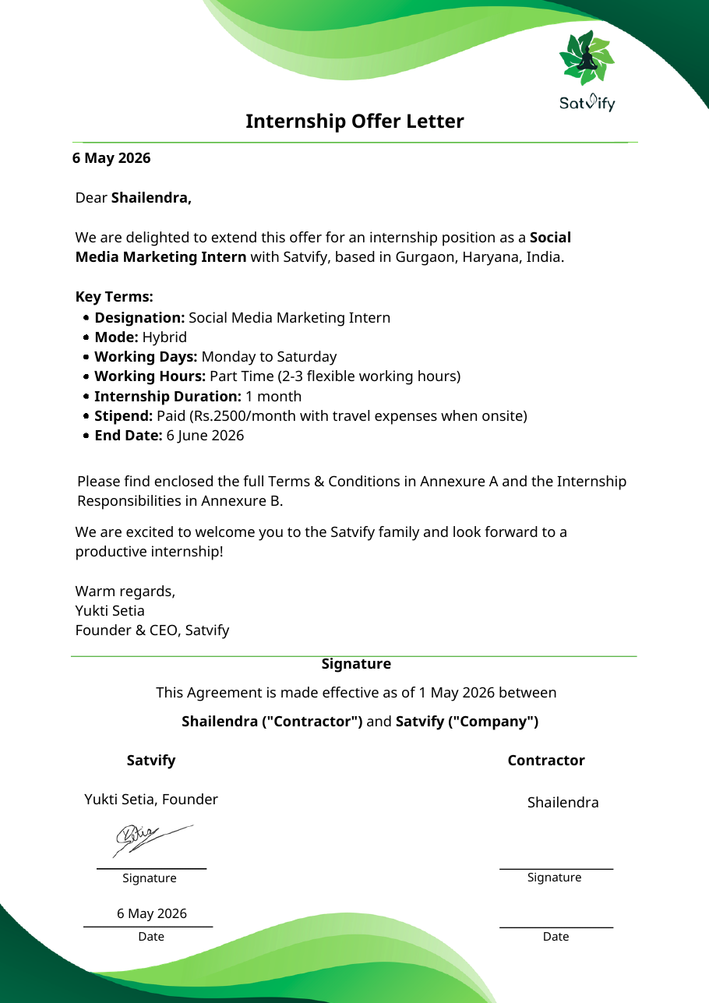
Figure 4.5: Internship Offer Letter issued by Satvify (page 1)

5. BIBLIOGRAPHY / REFERENCES
Advertising Standards Council of India (2021) Guidelines for Influencer Advertising in Digital Media. Mumbai: ASCI.
Chaffey, D. and Ellis-Chadwick, F. (2019) Digital Marketing. 7th edn. Harlow: Pearson Education.
Government of India (2023) The Digital Personal Data Protection Act, 2023. New Delhi: Ministry of Law and Justice.
Kaplan, A.M. and Haenlein, M. (2010) 'Users of the world, unite! The challenges and opportunities of social media', Business Horizons, 53(1), pp. 59-68.
Kotler, P., Kartajaya, H. and Setiawan, I. (2017) Marketing 4.0: Moving from Traditional to Digital. Hoboken, NJ: John Wiley & Sons.
Meta Platforms (n.d.) Meta Business Help Centre. Available at: https://www.facebook.com/business/help.
Canva (n.d.) Canva Design School. Available at: https://www.canva.com/designschool/.
Tuten, T.L. and Solomon, M.R. (2017) Social Media Marketing. 3rd edn. London: SAGE Publications.
Satvify (2026) Internship Offer Letter and Internship Certificate issued to Shailendra Singh. Gurgaon: Satvify.

