Report Submission – Project 2

Name: Shailendra Singh Verma / 48A

Trimester: 3rd Tri Sem

Subject: Regression and Time Series Models

Professor: Dr. Amarnath Mitra

Project: Time Series Analysis of Stock

**Introduction:**

In the dynamic landscape of financial markets, understanding the behavior of stock prices is pivotal for informed decision-making. Adani Enterprises Ltd stands as a prominent entity in this realm, its stock performance subject to various economic, industry-specific, and internal factors. In pursuit of uncovering insights into the trajectory of Adani Enterprises Ltd stocks, this report embarks on a journey through time series analysis.

**Importance of time series analysis in stock market forecasting:**

* Trend Identification: Time series analysis helps identify trends, cycles, and seasonal patterns in stock price data, offering insights into market dynamics.
* Forecasting Future Trends: By analyzing historical data, time series models can forecast future price movements, aiding investors in anticipating market trends and adjusting strategies accordingly.
* Risk Management: Time series analysis quantifies volatility and correlation, enabling investors to manage risk effectively by identifying potential sources of uncertainty.
* Portfolio Optimization: By diversifying portfolios based on insights from time series analysis, investors can optimize risk-adjusted returns by selecting assets with low correlation and high potential returns.
* Market Sentiment Analysis: Studying patterns in trading volumes and price movements helps analyze market sentiment, aiding in understanding investor behavior and influencing stock prices.
* Algorithmic Trading: Time series analysis is essential for developing quantitative trading strategies, leveraging historical data and statistical techniques to identify profitable trading opportunities automatically.

**Objectives:**

Develop time series models to forecast future stock prices of Adani Enterprises Ltd, enabling investors to anticipate potential market trends and adjust their investment strategies accordingly.

**Data Collection and Preprocessing**

**Source of data:** Yahoo

**Stock Symbol:** stock_symbol <- 'ADANIENT.BO'

**Time period covered:** start_date <- '2019-01-01’: end_date <- '2023-12-31'

**Frequency of Data**: Daily

**Data Cleaning**: Using Omit Function ,*adani_prices <- na.omit(adani_prices)*

**Exploratory Data Analysis (EDA)**

* Visualizations of the stock price over time

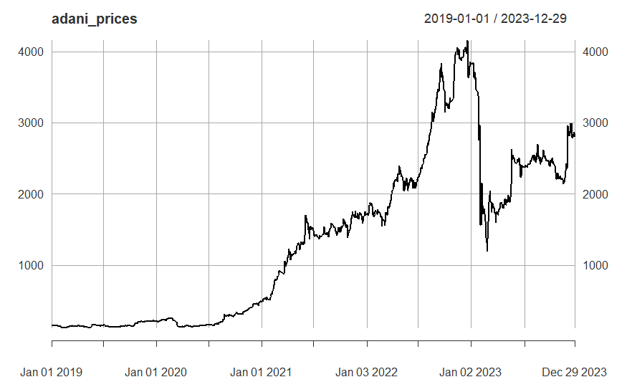

**Methodology:**

* We created an environment stock_data to store the fetched stock data.
* We specified the stock symbol ADANIENT.BO for Adani Enterprises Ltd.
* We defined the start date as January 1, 2019, and the end date as December 31, 2023.
* We fetched the stock data using the getSymbols function from the Yahoo Finance source and stored it in the stock_data environment.
* We extracted the closing prices (Cl) from the fetched data.
* We removed any missing values from the closing prices using the na.omit function.

**Test and Hypothesis:**

# Augmented Dickey-Fuller (ADF) Test for Stationarity with Adani Enterprises Ltd on BSE Data

We utilized the adf.test function to perform the Augmented Dickey-Fuller (ADF) test.

The ADF test is a statistical test used to determine whether a unit root is present in a time series dataset, indicating non-stationarity.

**Results:**

ADF Test Statistic: -2.4007

Lag Order: 10

P-value: 0.4087,

With a p-value of 0.4087, we fail to reject the null hypothesis at the 5% significance level.

Therefore, we do not have sufficient evidence to conclude that the time series of Adani Enterprises Ltd's closing prices is stationary.

***This suggests that the closing prices exhibit non-stationary behavior, indicating the presence of trends or other non-random patterns in the data.***

# Adani Enterprises Ltd (First)return Difference Time-Series

The code provided calculates the first differences of the log-transformed closing prices of Adani Enterprises Ltd (ADANIENT.BO) and then plots the resulting time series. This transformation is commonly used in time series analysis to achieve stationarity, which is a key assumption for many statistical models and analyses.

adani_ds = diff(adani_prices);

ADF Test Statistic: -9.532

Lag Order: 10

P-value: 0.01,

Based on the ADF test results, we conclude that the first differences time series of the log-transformed closing prices of Adani Enterprises Ltd is stationary. **This implies that the transformation has successfully removed trends and seasonality from the data, making it suitable for further time series analysis and modeling.**

# Ljung-Box Test for Autocorrelation - Data

Test Statistic: X-squared = 16.087

Degrees of Freedom (df): 1

P-value: 6.049e-05 (approximately 0.00006049),

Based on the Ljung-Box test results, we reject the null hypothesis of no autocorrelation. **This suggests that there is significant autocorrelation present in the first differences time series.** Autocorrelation can impact the accuracy and reliability of statistical models, so it's important to consider and potentially address autocorrelation when analyzing time series data.

acf(adani_ds) # ACF of adani Series

pacf(adani_ds) # PACF of adani Difference (Stationary) Series

This code will generate a plot showing the partial autocorrelation function (PACF) of the Adani Enterprises Ltd closing prices series. The PACF plot helps identify the direct relationship between each observation and its lagged values, while controlling for the influence of intervening observations.

arma_pq_adani_ds = auto.arima(adani_ds); arma_pq_adani_ds

Here's the interpretation of the results:

Model: ARIMA(1,0,1) with non-zero mean

This indicates that the ARIMA model has a Moving Average (MA) component of order 1 (ma1) and have AutoRegressive (AR) or Integrated (I) components (order 1).

Null Hypothesis (H0):

The coefficient for the Moving Average (MA) term (ma1) is equal to 0, and the coefficient for the non-zero mean term (mean) is equal to 0.

Alternative Hypothesis (HA):

At least one of the coefficients (ma1 or mean) is not equal to 0.

Result: we accept HA.

adani_ds_fpq = forecast(arma_pq_adani_ds, h = 500)

plot(adani_ds_fpq)

This Further forecast the trend to get the output.

# Test for Volatility Clustering or Heteroskedasticity: ARCH Test

adani_ret_arch_test = ArchTest(arma_pq_adani_ds$residuals^2,lag = 1) # H0: No ARCH Effects

adani_ret_arch_test # Inference : Return Series is Heteroskedastic (Has Volatility Clustering)

ARCH Test:

Null Hypothesis (H0): No ARCH Effects (i.e., the squared residuals do not exhibit heteroskedasticity or volatility clustering).

Alternative Hypothesis: There are ARCH effects present in the squared residuals.

The extremely low p-value (< 2.2e-16) indicates strong evidence against the null hypothesis of no ARCH effects.

Therefore, we reject the null hypothesis and conclude that the squared residuals exhibit heteroskedasticity or volatility clustering.

# Test for Volatility Clustering or Heteroskedasticity: ARCH Test

ARCH LM-test; Null hypothesis: no ARCH effects

data: arma_pq_adani_ds$residuals^2

Chi-squared = 8.8783, df = 1, p-value = 0.002886

P value less than 0.05 which means there is Heteroskedastic(Has Volatility Clustering)

# GARCH Model

garch_model1 = ugarchspec(variance.model = list(model = 'sGARCH', garchOrder = c(1,1)), mean.model = list(armaOrder = c(1,1), include.mean = TRUE))

adani_ret_garch1 = ugarchfit(garch_model1, data = arma_pq_adani_ds$residuals^2); adani_ret_garch1

The key findings to assess whether the GARCH model is a good fit for the data:

**Model:**

* **Conditional Variance Dynamics:** Describes the type of GARCH model used: sGARCH(1,1) which means it uses past errors (1) and past conditional variances (1) to predict the current conditional variance.
* **Mean Model:** ARFIMA(1,0,1) specifies the model for the mean of the data, using past values (1) and differencing (1).
* **Distribution:** Indicates the data is assumed to be normally distributed (norm).

**Optimal Parameters:**

* This table shows the estimated values for each parameter in the model, their standard errors, t-values, and p-values.
* A significant p-value (less than 0.05) suggests the parameter is statistically different from zero and contributes to the model.
* Both standard and robust standard errors are provided and the results are similar.

**Log-Likelihood:**

* This value measures how well the model fits the data, with lower values indicating a better fit. The specific value (-12321.53) is not directly interpretable on its own.

**Information Criteria:**

* These criteria (Akaike, Bayes, Shibata, Hannan-Quinn) are used to compare different models for the same data. Lower values indicate a better fit, while considering model complexity. No single criterion is definitive, but they can help identify preferred models.

**Ljung-Box Tests:**

* These tests check for serial correlation in the residuals (errors) of the model.
* The p-values for standardized residuals are not significant, suggesting no serial correlation in the mean.
* The p-value for standardized squared residuals is significant for Lag[1], indicating possible serial correlation in the volatility.

**ARCH LM Tests:**

* These tests check for ARCH (Autoregressive Conditional Heteroskedasticity) effects, meaning past squared errors can help predict future volatility.
* None of the p-values are significant, suggesting no ARCH effects present.

**Nyblom Stability Test:**

* This test checks for stationarity, meaning the model's parameters don't change over time.
* The joint statistic is not significant, suggesting the model is stable.
* Individual statistics are also provided for each parameter, along with critical values. All individual statistics are below the 10% critical value, further supporting stability.

**Sign Bias Test:**

* This checks if there's a bias towards positive or negative signs in the residuals.
* The results indicate a statistically significant **negative sign bias**, meaning the model tends to underpredict positive residuals and overpredict negative residuals.

**Adjusted Pearson Goodness-of-Fit Test:**

* This tests if the distribution of the residuals matches the assumed normal distribution.
* The p-values for all groups are not significant, suggesting the residuals are consistent with the normal distribution.

**Elapsed Time:**

* This shows the time it took to fit the model (0.336 seconds in this case).

**Overall Interpretation:**

This output suggests that the sGARCH(1,1) model provides a good fit to the data based on various diagnostic tests. However, there's a potential issue with negative sign bias and possible serial correlation in the volatility (squared residuals). It's important to consider these aspects and potentially explore alternative models or adjustments to improve the fit further.

Please note that this is a simplified interpretation, and a deeper understanding of GARCH models and their diagnostics would be needed for a more comprehensive analysis.

plot(adani_ret_garch_forecast1, which = 1)

The forecast shows that the conditional variance is expected to be relatively low and stable over the next 500 steps. The shaded area around the forecast is a 1-sigma confidence interval, which shows the range of values that the actual conditional variance is likely to fall within.

It is important to note that this is just a forecast, and the actual conditional variance may be higher or lower than the forecast values.