**Installing MEAN Stack (MongoDB, Express.JS, Angular.JS, Node.JS)**

Table of Contents

1 Introduction: 2

1.1 Node.js 2

1.2 Express.js 2

1.3 MongoDB.js 2

1.4 Angular.js 2

2 Install Dependencies 2

3 Install MongoDB 3

3.1 Import Package Installation Public key 3

3.2 Create MongoDB source list file 4

3.3 Update Repo 4

3.4 Installing MongoDB 4

4 Installing Node JS 5

4.1 Version check 5

4.2 Installing dependencies 6

4.3 Installing Yarn and Gulp 6

5 Installing Mean-cli 6

6 Testing By Running the First App 7

6.1 MEAN Stack Start 7

6.2 Showing databases in the mongod server 7

6.3 Switch to the mean-dev database 8

6.3.1 Display the users collection in the mean-dev database **Error! Bookmark not defined.**

7 References 8

# Introduction:

Mean.JS is a full JavaScript stack that contains MongoDB, Express.JS, Angular.JS, and Node.JS (Amir, 2018). This JavaScript framework accelerates the web application development using JavaScript as backend.

Using the MEAN Stack, we can rapidly build easy-maintainable web applications based on JavaScript.

I’ll use here “sudo” to run commands with root privileges (Ostryzhko, 2018).

## Node.js

Node.js is a server-side JavaScript execution environment. It’s a platform built on Google Chrome’s V8 JavaScript runtime. It helps in building highly scalable and concurrent applications rapidly.

## Express.js

Express.js is a lightweight framework used to build web applications in Node. It provides several features for building single and multi-page web applications.

## MongoDB.js

MongoDB is a schema less NoSQL database system. MongoDB saves data in binary JSON format which makes it easier to pass data between client and server.

## Angular.js

Angular.js is a JavaScript framework developed by Google. It provides some awesome features like the two-way data binding. It’s a complete solution for rapid and awesome front-end development.

# Install Dependencies

I decided to start with the installation of some of the dependencies to proceed. For that I used these commands which installed some of the required dependencies for me (Amir, 2018).

* sudo apt-get install build-essential git fontconfig libpng-dev ruby ruby-dev
* sudo gem install sass

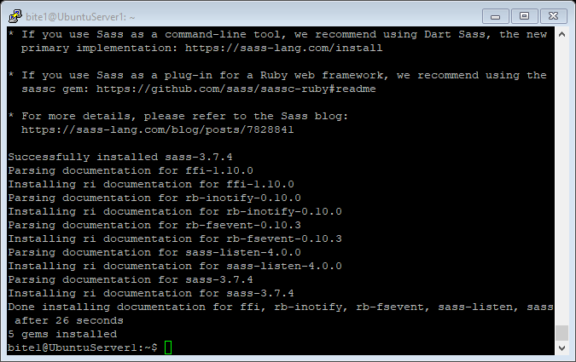

# Install MongoDB

In this section, I’m going to install MongoDB as my Database, to install the latest stable version of MongoDB I decided to add the official repository.

## Import Package Installation Public key

The first step is importing the public key for the package. To ensure consistency and maintain authenticity, the Ubuntu package management tools (apt) requires GPG keys to be provided by the distributors. So, to import MongoDB keys, I run the following command (MongoDB, 2019).

* sudo apt-key adv – -keyserver hkp: // keyserver.ubuntu.com:80 – - recv 9DA31620334BD75D9DCB49F368818C72E52529D4

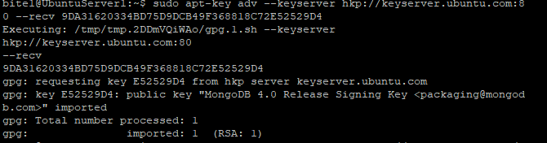

Here, it may prompt for password if we are not logged in as root user, so we need to add root user password if requested, but as I’m logged in as root user it didn’t prompt.

## Create MongoDB source list file

In this step I created the file list based on my machine Ubuntu 16.04 but can be different for different version of Ubuntu. A MongoDB list will be created in /etc/apt/sources.list.d/. Here, I executed the following command to add the above repository data in the proper path:

* sudo echo “deb [ arch=amd64,arm64 ] [http://repo.mogodb.org/apt/ubuntu xenial/mongodb-org/3.4](http://repo.mogodb.org/apt/ubuntu%20xenial/mongodb-org/3.4) multiverse” | tee /etc/apt/sources.list.d/mongodb-org-3.4.list

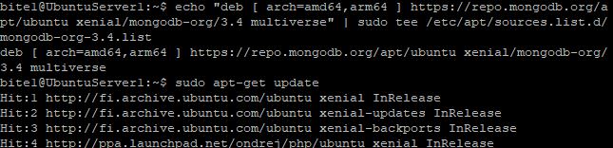

## Update Repo

Here, before installing MongoDB I decided to update the repository by running the following command.

* sudo apt-get update

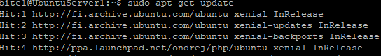

## Installing MongoDB

Now, by using this line of command below I can install MongoDB files.

* sudo apt-get install -y mongodb-org

Here, “apt-get” will upgrade the packages when a newer version becomes available.

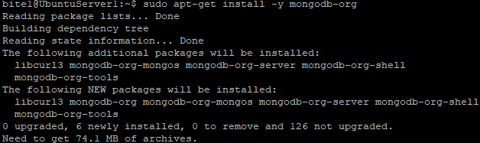

**Some related commands for starting, enabling and so on.**

* sudo systemctl start mongod ( To start MongoDB)
* sudo systemctl enable mongod ( To ensure the is started anytime we boot our machine) (Ostryzhko, 2018)

# Installing Node JS

Node JS is a JavaScript execution environment that acts as a server-side. Installing NODE.JS is done by running the following commands:

curl -sL <https://deb.nodesource.com/setup_8.x> | sudo -E bash –

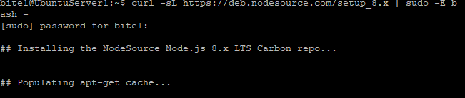

**Then after that, I executed this command to install node.js**

sudo apt-get install -y nodejs

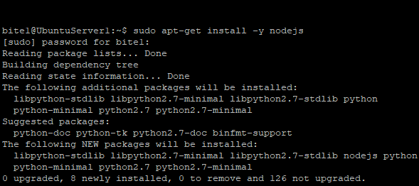

To avoid errors from npm packages while compiling I run the following command.

sudo apt-get install build-essential

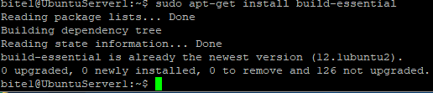

## Version check

node -v



## Installing dependencies

To install all dependencies following command is executed.

# npm install

## Installing Yarn and Gulp

These are components of the mean stack. I used global installation standards here (-g) (Ostryzhko, 2018). These commands executed to install Yarn and Gulp respectively.

Yarn is a package management tool for client-side programming and it depends on NodeJS and NPM.

# npm install -g yarn

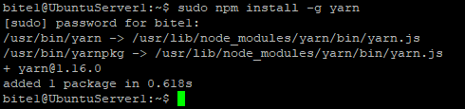

Gulp is a JavaScript task runner that can be automate many tasks, we can install it with NPM command as well.

# npm install -g gulp

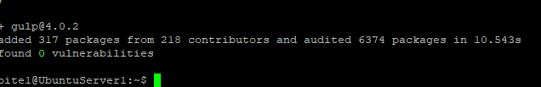

For verifying that Yarn and Gulp are installed successfully we can execute the following command:

# npm list -g - - depth=0

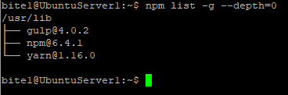

# Installing Mean-cli

Mean.io framework will be used for creation of apps. It will use Mean-cli as the core package. To install Mean-cli, we can run the following command:

# npm install -g mean-cli

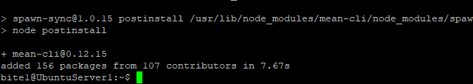

# Testing by Running the First App

## MEAN Stack Start

We started our MEAN stack project with the following command:

# npm start

Then we look up our MEAN stack default page through the following address:

http: //10.208.0.130:3000

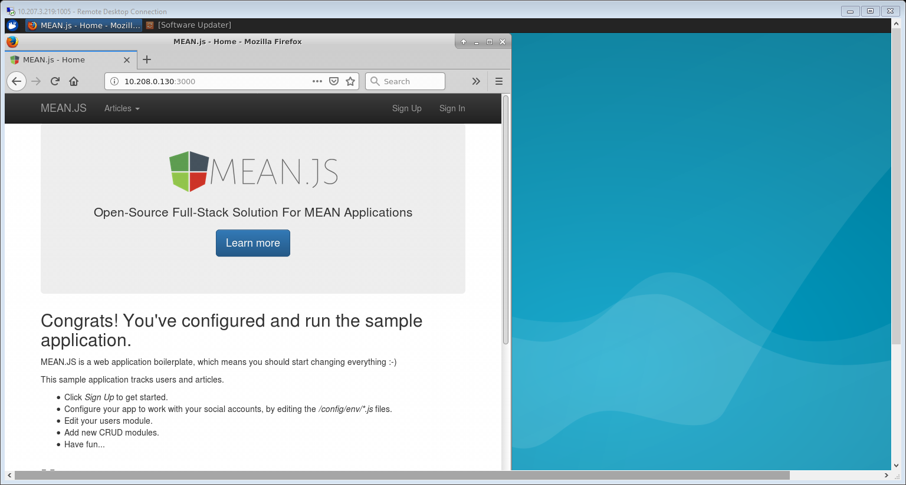

## Showing databases in the mongod server

We can open mongo shell by this command (Ho, 2018).

# mongo

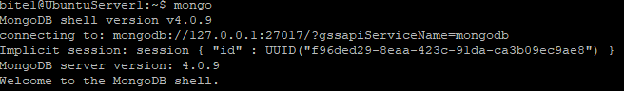

To show databases in mongod server we can execute this command:

# show dbs

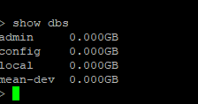

## Switch to the mean-dev database

We can switch to the mean-dev database and display the collections by executing following commands:

# use mean-dev

# show collections

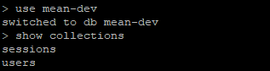

# References

Amir. (2018, 11 08). *HugeServer knowlegebase*. Retrieved from HugeServer: www.hugeserver.com

Ho, L. (2018, Jan 11). *Install MEAN.JS*. Retrieved from WebDataTutorial: www.webdatatutorial.com

HO, L. (2018, Jan11). *Install Mean.js in Ubuntu*. Retrieved from WebDataTutorial.

MongoDB. (2019, 05 14). *MongoDB Documentation*. Retrieved from MongoDB: www.docs.mongodb.com

Ostryzhko, M. (2018, 05 30). *Mean stack installation*. Retrieved from hostadvice: www.hostadvice.com