**Steps to do the migration from SQL Server to PostgreSQL**

**SCT Assessment**

* First will be doing the SCT (Schema conversion tool) Assessment to understand the complexity of the given SQL Assessment.
* SCT is the tool which will do the assessment and will convert the schema to PostgreSQL Compatible.
* For doing the SCT I have downloaded the SCT tool in my machine and configure and did the assessment as shown in the below screenshot.
  + - * 1. First will click on the file ad click on new project wizard.

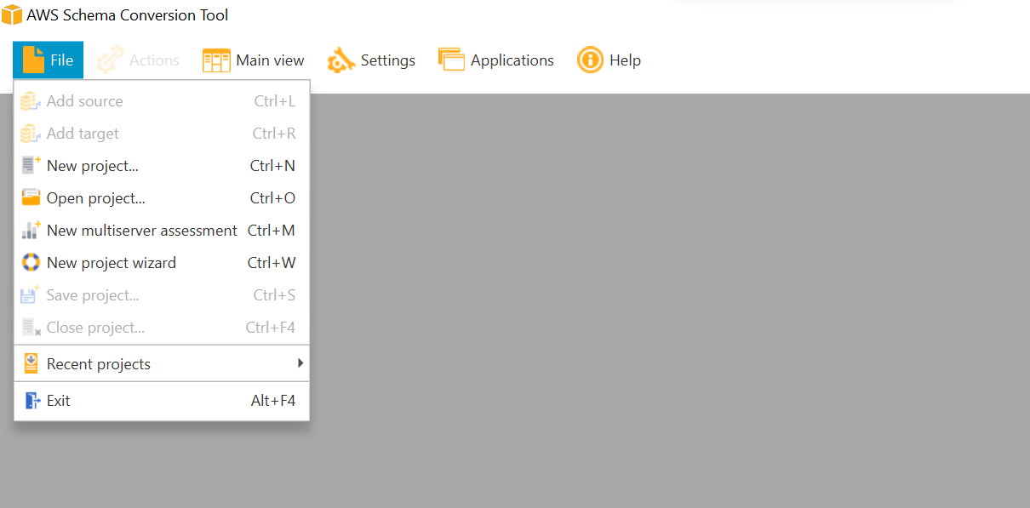

* + - * 1. Will select source as Azure SQL DB

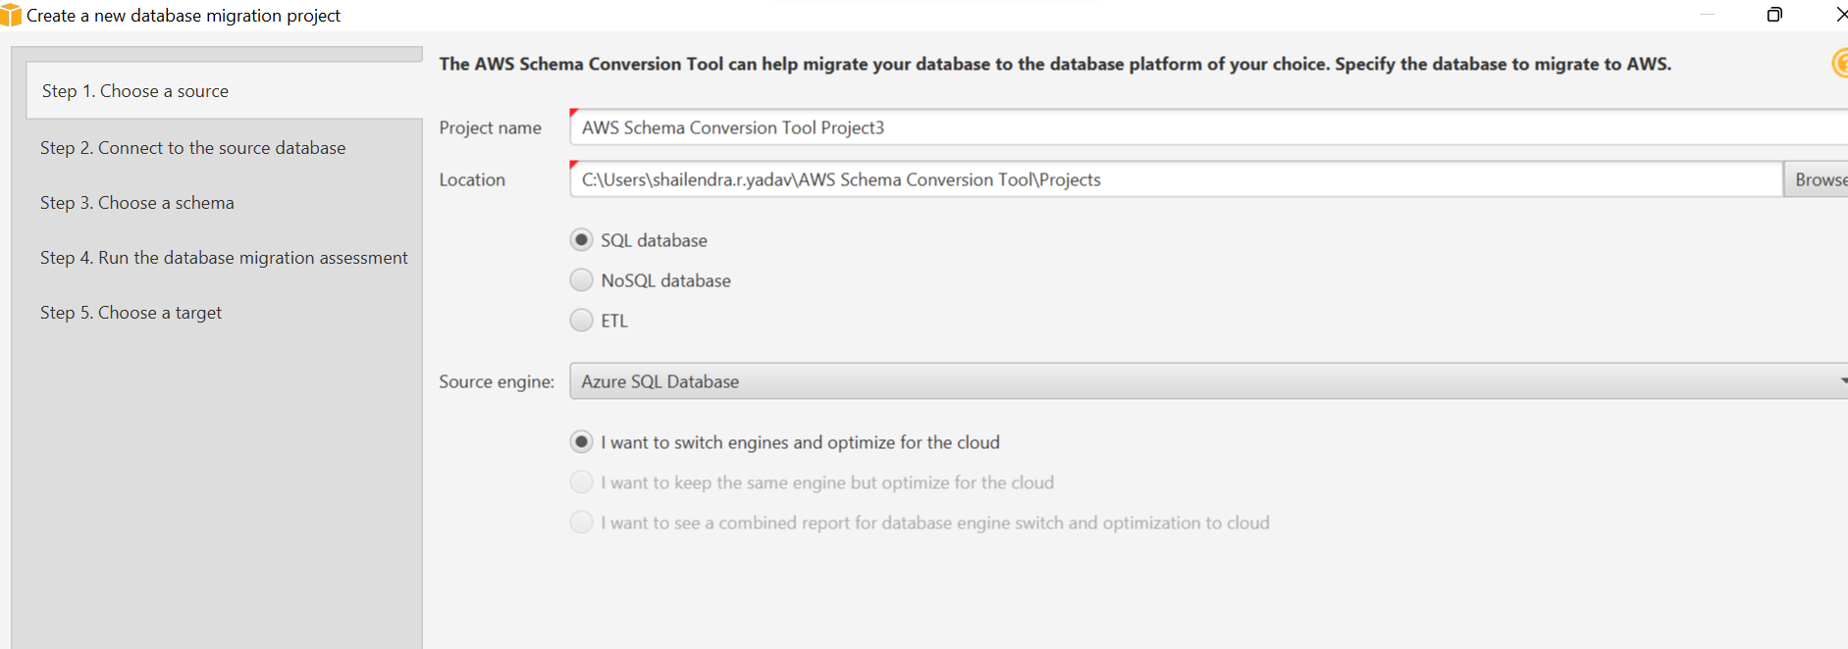

* + - * 1. Will provide the source DB credentials and click on the test Connection.

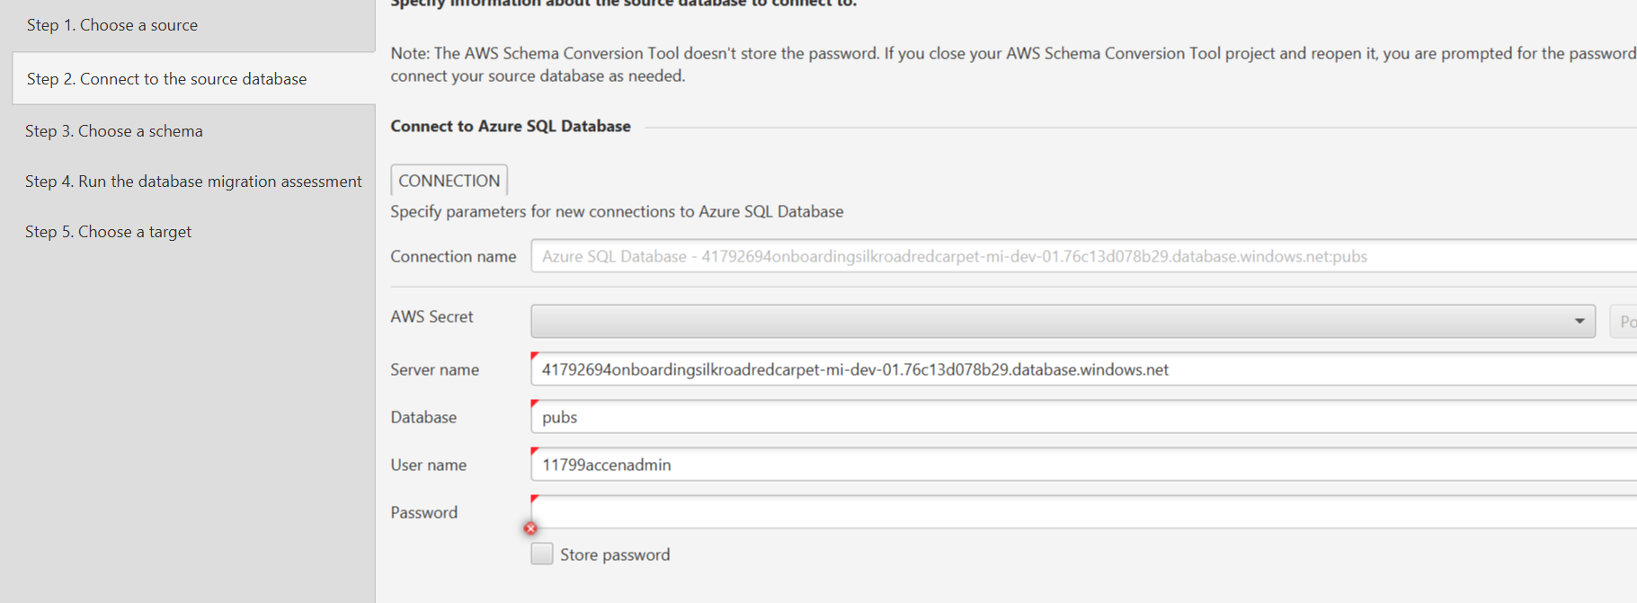

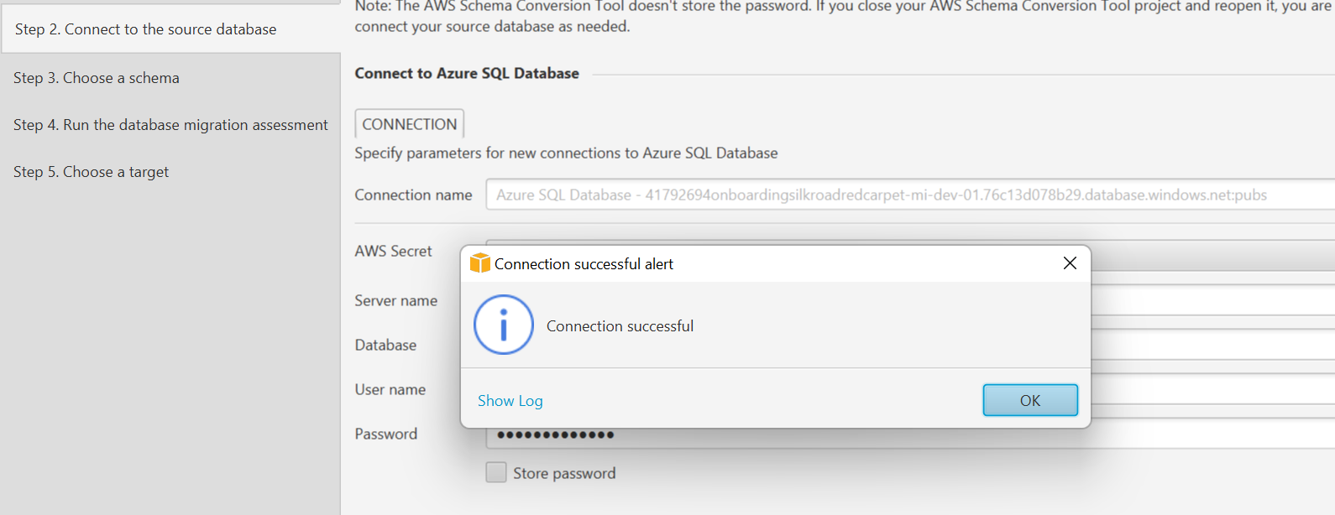

* + - * 1. Once the connection is successful will be selecting the selecting the DB and schema and will proceed with the migration assessment which will give us the Assessment summery.
* I have done the SCT assessment for the given DB ‘Pubs’, please find the summery of the assessment.

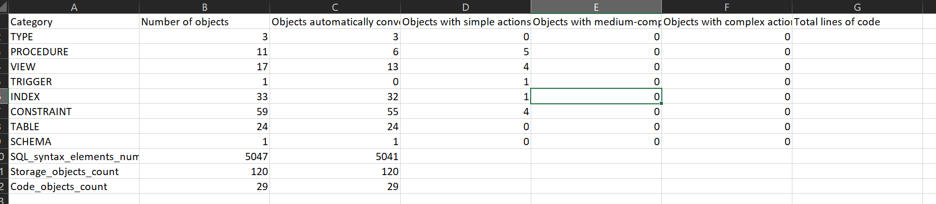

* By looking at the assessment summery report we can see that Complexity of migrating the DB to PostgreSQL is simple, since majority of the conversion is automatically done by the SCT.
* Please find the SCT report and converted schema.



**Data Migration service**

* After the Assessment is completed will be doing the DMS for doing DMS will be using the AWS console and its inhouse tool.
* For the Doing the DMS there are four main sections.
  + **Replication Instance**: Replication instance works as an engine to move data from the Source to target.
  + **Source Endpoint**: Source endpoint will have the connection of source in our case it will be Azure SQL DB.
  + **Target Endpoint**: Target endpoint will have the connection of target in our case it will be Aurora PostgreSQL.
  + **Task**: Once above three are created will create a task for migrating the data from SQL server to PostgreSQL.
* Once the migration is completed will be deploying other scripts such as indexes, constraints, Sequence, Stored procedure, functions, and views.

Migration strategy

* Will Understand the database schema, including tables, indexes, stored procedures, and SSIS packages.
* Will be using SCT for doing the assessment and complexity.
* Manually convert SSIS packages to a format compatible with PostgreSQL. This may involve rewriting some components, as SSIS is specific to Microsoft SQL Server.
* PostgreSQL does not have a direct equivalent to SQL Server's Service Broker. we may need to redesign and implement message queuing using tools like RabbitMQ, Apache Kafka, or PostgreSQL's native features for asynchronous messaging.
* Will be using data replication solution to keep the PostgreSQL database synchronized with the SQL Server database during the migration process.
* Will conduct thorough testing on a non-production environment to validate the data integrity, application functionality, and performance of the migrated database.