FoodLens: AI-Powered Food
Freshness Inspection
Deep Learning • Computer Vision • Reinforcement Learning
PROJECT DOMAIN  Agriculture and Food Technology | COURSE OUTCOME  CO-2
PROJECT REPOSITORY  github.com/Shailesh-0305/food-freshness-detector | PRIMARY SDG  SDG 12 - Responsible Consumption and Production

1. Abstract
FoodLens is an AI-enabled web application designed to assess the visible freshness condition of fruits and vegetables from an uploaded image or a camera capture. The system combines image identification, deep-learning classification, a freshness score, explainability and a recommendation layer. A CLIP-based zero-shot image-text model first checks whether the input resembles a supported fruit or vegetable. A ResNet-based classifier then predicts one of four deterioration stages: Fresh, Early Deterioration, Moderate Deterioration or Spoiled. The predicted class probabilities are converted into a 0-100 freshness indicator. A Deep Q-Network (DQN) reinforcement-learning agent uses the score, prediction confidence and observation age to recommend an action such as continuing storage, consuming soon or discarding. The web interface provides image upload/camera inspection and an inspection-history view. FoodLens is intended as a decision-support prototype based on visual appearance, not as a laboratory food-safety test.

2. Problem Statement and Objectives
Consumers often find it difficult to judge gradual food deterioration from appearance alone. This uncertainty can lead either to premature disposal of edible produce or to delayed action when quality is declining. FoodLens addresses this problem by providing a consistent, image-based indication of produce freshness and a simple next-step recommendation.
- Identify whether an input image contains a supported fruit or vegetable.
- Classify produce into four visual deterioration stages and estimate model confidence.
- Calculate an interpretable freshness score and generate a recommended action.
- Provide a simple web interface for image upload or camera capture and inspection history.
- Support responsible consumption and help raise awareness of avoidable food waste.

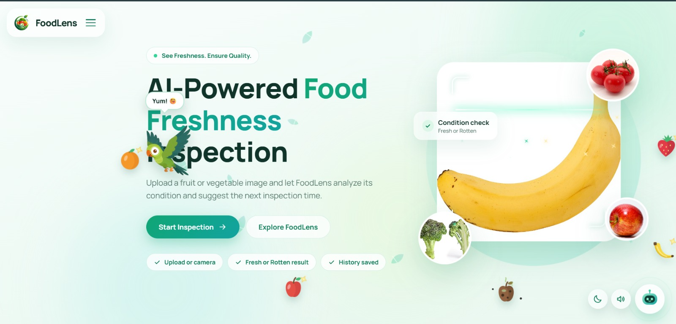
Figure 1. FoodLens landing page showing the project overview and the “Start Inspection” entry point.

3. System Design and Methodology
The system follows a sequential image-analysis pipeline. The uploaded image is read as RGB and resized to 224 × 224 pixels. Pixel values are converted to tensors and normalized using ImageNet channel statistics before freshness inference.
1. Image input | User selects an image file or captures a frame through the browser camera.
2. Produce identification | CLIP (openai/clip-vit-base-patch32) compares the image with text labels for supported produce and non-food categories. Inputs identified as non-produce or below the confidence threshold are rejected.
3. Freshness classifier | A ResNet image-classification model, adapted with a four-output classification head, predicts the freshness stage. The repository loads the saved weights from models/freshness_model.pt when available.
4. Score and explanation | The classifier probabilities are converted to a freshness score. Grad-CAM is attempted to highlight image regions that contributed to the prediction.
5. Recommendation | A DQN agent receives [freshness score, confidence, days observed] and selects one of three actions: Continue Storage, Consume Soon or Discard.
6. Result display | The API returns the detected item, visual condition, confidence and a detailed insight/recommendation for display in the web interface.

4. Core AI Techniques

4.1 Produce identification using CLIP
The project uses OpenAI CLIP ViT-B/32 as a zero-shot image-to-text matching component. It compares the input image with descriptions of supported produce (including apple, banana, mango, orange, strawberry and tomato) and a set of non-food categories. This stage is used as an input filter and produce identifier; it is distinct from the freshness classifier.

4.2 Four-stage freshness classification
The FreshnessModel wraps a pretrained ResNetForImageClassification model and replaces its final classifier layer with four output classes. The class mapping in the inference pipeline is: 0 - Fresh, 1 - Early Deterioration, 2 - Moderate Deterioration and 3 - Spoiled. The predicted class is selected from the output probabilities using the highest probability.

4.3 Freshness score and Grad-CAM
A weighted probability score is calculated using class weights of 100, 70, 40 and 0 respectively. In other words, Score = 100P(Fresh) + 70P(Early) + 40P(Moderate) + 0P(Spoiled). The score is a model-derived visual indicator, not a measured remaining shelf life. Grad-CAM is optionally generated to provide a heatmap of the image regions influencing the classification.

4.4 Reinforcement-learning decision layer
The recommendation component is implemented with Stable-Baselines3 DQN and a custom Gymnasium environment. Its observation contains the freshness score (0-100), model confidence (0-1) and days observed (0-30). Its discrete actions are Continue Storage, Consume Soon and Discard. The simulated reward encourages sensible actions for high, medium and low freshness scores, and penalizes continued storage when confidence is low. The trained policy is loaded from models/rl_policy.zip when available.

5. Application Implementation
The repository contains a multi-page frontend in FrontEnd/, a Python inference backend in src/, and an optional Node.js/Express bridge. The frontend uses HTML, CSS and JavaScript and presents a clean, responsive glassmorphism interface. The inspection screen includes upload and camera tabs, a preview, an analyze action and a results panel. A separate history screen provides totals, search, condition filters and sorting options.

LAYER | IMPLEMENTATION
Frontend | HTML5, CSS3 and JavaScript; landing, inspection, history and project-information pages.
Python AI | PyTorch, Torchvision, Transformers, CLIP, ResNet and Grad-CAM.
Decision layer | Gymnasium with Stable-Baselines3 DQN.
API / server | FastAPI provides POST /api/analyze and serves the frontend; optional Express + Multer bridge invokes Python inference.
Image / packages | Pillow and OpenCV; Python requirements.txt and Node package.json.

6. Application Workflow
- Open the FoodLens home page and select “Start Inspection”.
- Choose the Upload Image tab to select a JPG, JPEG, PNG or WEBP image, or use the Camera tab to capture an image.
- Preview the selected image and start analysis.
- The backend validates the image, identifies the produce, predicts the freshness stage and computes the score and confidence.
- The decision layer selects a recommendation and the interface displays the inspection result.
- Use the history page to review previous inspection entries and filter or sort them.

7. CO-2: Course Outcome Mapping
CO-2: Apply relevant computing / AI concepts and development tools to analyse a practical problem and implement a software-based solution.
The project demonstrates CO-2 by translating the practical problem of visual food-freshness assessment into an end-to-end software solution. The team applies computer vision and transfer learning, integrates pretrained CLIP and ResNet models, preprocesses images, computes classification probabilities and a freshness score, and implements a DQN-based recommendation layer. The models are connected to a web interface through an API, showing the application of programming, machine-learning libraries, model integration and interface design to a real-world problem.

8. Results, Scope and Limitations
The repository contains the application pages, inference pipeline, classifier and RL-agent code, as well as model checkpoint files. The supplied screenshots illustrate the FoodLens landing page and the intended inspection workflow. The repository README describes the intended four-stage classification and key application features. No verified test-set accuracy, precision, recall, F1-score or benchmark table was available in the reviewed project files; such numerical performance values should be added only after running evaluation on a separate test set.
The system estimates visible condition from images and can be affected by lighting, camera quality, background clutter, produce variety and training-data coverage. Grad-CAM generation is optional and may not be available if the required package or target layer is missing. The RL environment currently uses simulated observations and a simple reward design. Therefore, outputs should be treated as advisory and should not replace physical inspection, expiry information or established food-safety guidance.

9. Conclusion and Future Enhancements
FoodLens combines deep learning, computer vision and reinforcement learning in a practical web-based prototype for visual food-freshness assessment. It guides users from image capture through produce identification and four-stage freshness classification to a score and an actionable recommendation. Its user interface and history view make the workflow accessible, while Grad-CAM offers a route toward explainability. The project supports the intent of UN Sustainable Development Goal 12 by encouraging more informed consumption decisions and awareness of food waste.
Future work can focus on collecting a larger, balanced and consistently labelled dataset; reporting standard test metrics; validating the model across lighting and camera conditions; improving confidence calibration; storing inspection history persistently; and evaluating the RL policy with realistic longitudinal data. Sensor inputs such as temperature and humidity, mobile deployment and improved remaining-shelf-life modelling could also extend the system.

