**OUTDOOR PARKING GUIDANCE SYSTEM**

Vijaykumar Bhanuse, Shailesh Amane

Department of Instrumentation and Control Engineering, Vishwakarma Institute of Technology.

[1] ***Abstract* –** Time and time-relevant problems are linearly tied to technological advancements. It has been observed that as time passes, the number of difficulties that mankind encounter grows. However, as technology improves, so does the ability to tackle these issues. Parking was one of the first issues that arose with the development of autos. The ease with which technology may be used to tackle this problem has improved throughout time, yet the problem of parking remains unresolved. The major reason for this is that parking is a collection of challenges in and of itself. One of these difficulties is parking place occupancy monitoring in a dispersed parking environment. Users would locate superior parking locations in a distributed system rather than random parking spaces. In this research, we present a web-based application for detecting parking vacancies in various parking spaces. The solution is based on Computer Vision (OpenCV) and is built using Python 3.7. The method addresses the problem of occupancy detection while also allowing the user to view available parking spaces. Other related parking difficulties might be solved using the suggested solution.

**Keywords: computer vision, smart parking system, parking space detection**

# **INTRODUCTION**

With the creation of automated automobiles and the expanding technology circling around it, it is reasonable to conclude that in the near future, practically everyone will possess a manual or automatic vehicle. As the degree of innovation rises, so does the challenge of keeping old solutions up to date in order to adapt to new developments that are coming or may be coming in the future. The parking management system is one such approach. Furthermore, for everyone, time is of the importance. So, for practically anybody who owns a vehicle, spending a significant amount of time figuring out the parking spot before moving on to the next activity is unsatisfying. When a dispersed parking management system is used, this problem becomes much more frustrating. When it comes to dispersed parking, the number of parking blocks and slots that must be checked before parking grows significantly. Sensor-based devices are used in the vast majority of existing systems for occupancy detection. Malls and enormous arenas with scattered parking places are common examples of this type of construction. It normally comes with a one-to-one module, which means that each parking place is assigned to a single sensor. As a result, the connection between parking spots and sensors becomes linear. Furthermore, each sensor comes with the cost of putting it up, recharging it, and maintaining the sensor in various places or situations, making it wasteful across broad regions. The technique proposed in this research uses fixed cameras in specified areas to recognise parking spaces. It is assumed that a camera's spatial placement can cover all parking spots and that each individual has preferred parking slots rather than being content to park anywhere within the parking system's dispersed range.

# **LITERATURE SURVEY**

To solve the problem of parking in congested regions, several strategies and procedures have been offered. Ming-Yee Chiu et al. created a method for determining the number of available parking places by counting the number of automobiles passing through the checkpoint. Installation of induction loop sensors beneath the road surface is used to count the vehicles. Although sensors are less expensive, are not impacted by environmental conditions, and detect precisely, they are difficult to install and cause road damage. In the event of a malfunction, it was also difficult to maintain. Furthermore, the precise locations of free parking areas cannot be ascertained since the counting method does not provide detailed information; instead, it just records the number of cars going through checkpoints.

The other detection systems relied on the employment of ultrasonic, infrared, and microwave sensors to detect cars. These sensors are put beneath each parking space. Wan-Joo Park et al. recommended that automobiles be equipped with ultrasonic sensors to seek for available parking spaces. The sensors in this system are easily impacted by weather conditions such as rain, temperature, snow, and a strong air wind. Vamsee K. Boda et al. offered another technique based on wireless sensor nodes. This approach was less expensive, because it relied on wireless sensor nodes installed at key locations such as lane turns, parking lot entry and departure points. The difference between arriving and exiting automobiles may be used to calculate the total number of cars in the parking lot.

Every parking space has these sensors installed. Wan-Joo Park et al. proposed using ultrasonic sensors installed on automobiles to look for available parking spaces. The problem of this technology is that weather conditions such as rain, temperature, snow, and a strong breeze may readily damage the sensors. Vamsee K. Boda et al. developed an approach based on wireless sensor nodes. This approach was less expensive, and it relied on wireless sensor nodes installed at important locations such as lane turns, parking lot entry and departure points. The difference between arriving and exiting automobiles may be used to calculate the overall number of cars in the parking space.

On the basis of vision-based approaches, the different types of detection methods are provided. Using vision-based technology, the whole parking space that is available for parking may be inspected and the data analysed, and the result obtained determines the precise number and position of free parking spots. Vision-based parking spot detection systems, according to Zhang Bin et al., are simple to set up, minimal in cost, and the detector may be quickly changed to meet specific needs. Furthermore, picture data is quite rich. The vision approach, on the other hand, has a flaw in that the precision is heavily reliant on the camera's position.

Thomas Fabian proposed a vision-based unsupervised approach for detecting parking place occupancy. The suggested approach requires fewer picture frames per minute and has a low computational complexity. He says that occlusions and shadows are a big issue in picture detection.

Advanced clustering methods are employed in unsupervised learning. According to H. Ichihashi et al., a vision-based parking place detection system, is mostly impacted by weather and lighting conditions, such as raindrops falling on the camera lens during heavy rain. Lighting settings range from dim to bright. As a result, the cameras are usually utilised to identify automobiles in indoor parking lots rather than in outdoor parking lots.

# **ALGORITHM**

The algorithm that underpins our suggested solution may be divided into two subtopics:

Space identification algorithm:

With the use of a image of the parking space, the technical support person must indicate the slots that exist in the parking space. The person would be able to manually mark the different parking places one by one using cursors.

Occupancy detection algorithm:

When it comes to occupancy, the solution must address two different scenarios. The slot should be displayed with green when it becomes available, and red when it becomes busy. The occupancy is determined by the intensity of the pixels in each frame of the video. The open-source computer vision packages created for Python 3.0 were used to programme this method.

**IV. TOOLS**

Python:

Python is a dynamic programming language with a high degree of abstraction that is widely utilised.

The language has elements that allow for both tiny and large-scale applications to be written clearly.

It offers a vast and extensive standard library as well as a dynamic type system and intelligent memory management.

OpenCV:

OpenCV (Open-Source Computer vision) is permitted for both Education and commercial use. It's a programming function library geared mostly at real-time computer vision.

OpenCV's application has wide areas which includes 2D and 3D feature toolkits, Face recognition system, Gesture recognition, Motion understanding, Object identification Segmentation and recognition and Motion tracking.

OpenCV contains libraries of pre-defined functions supportive in image processing. Since it is open source, it was chosen as the platform to test the project.

I implemented image processing processes such as RGB to grayscale conversion, erosion, and dilation using OpenCV libraries.

**V. RESULTS**

The proposed method is implemented in python. The system's output reveals that the provided algorithms were successful in detecting available parking spaces. The proposed algorithm is implemented on the model parking lot having space for 69 cars.

Manually mark the different parking places one by one using cursors as shown in the Fig 1.

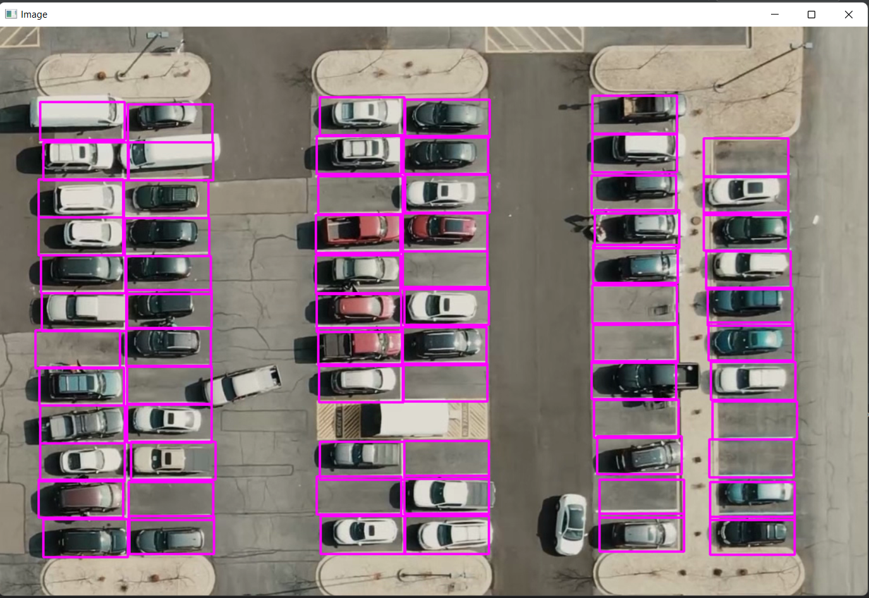

Fig 1

The Slots having no car are shown as green colour the Slots having car in it are shown as red colour as shown in Fig 2.

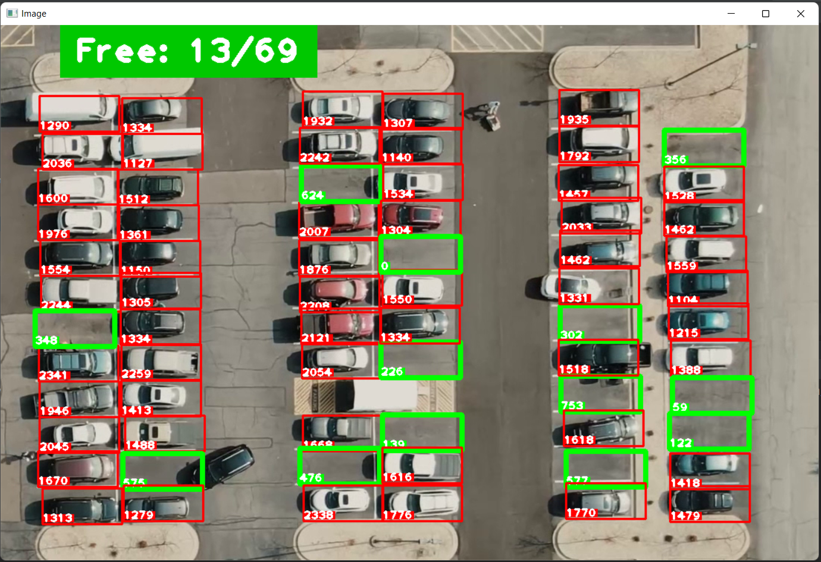

Fig 2

# **VI. Conclusion**

The study's major contribution is to improve the identification of available parking spots in order to potentially lessen parking arena congestion.

Due to advancement in vision base technology cost effective automatic parking systems facilitate the drivers to locate available spaces at parking arena.

Future researchers can focus on allocation specific location to customers already registered from online parking management system.

# VII. references

[1] Ming-Yee Chiu; Depommier, R.; Spindler, T.; , "An embedded realtime

vision system for 24-hour indoor/outdoor car-counting applications," Pattern Recognition, 2004.

[2] Zhang Bin; Jiang Dalin; Wang Fang; Wan Tingting; , "A design of

parking space detector based on video image," Electronic Measurement & Instruments, 2009.

[3] T. Mar; N. Marcel;, “ Video-based parking space detection,” 2012 [Online].Available:http://www.ini.rub.de/data/documents/

tschentscherneuhausen_parking_space_fbi2012.pdf

[4] Boda, V.K.; Nasipuri, A.; Howitt, I; "Design considerations for a

wireless sensor network for locating parking spaces," SoutheastCon,

2007.

1.