Research Paper  
  
Topic :

Text to Image Generation using Latent Diffusion Models (LDM’s)

Submitted By

Shailesh Ashok Tagadghar

Roll No: 31031523034

MSc CS – Part II

**Department Of Computer Science**

**Somaiya Vidyavihar University**

**SK Somaiya college**

**Abstract :**

One major subtopic of generative AI research has been text-to-image synthesis, thereby developing the image creation technique using a text input. Representative of this class of models is the Latent Diffusion Models (LDMs), which have built this field by proposing a computationally efficient scheme working in the latent space rather than the pixel space. Stable Diffusion, one of the most famous implementations of LDMs, has the same idea as the given model with additional optimizations that enhance the general stability and usability of the model for text-to-image generation.

The purpose of this paper is to explain the theoretical foundation for LDMs and their implementation in practice by the Stable Diffusion model while focusing on their capability of creating a variety of notably realistic images without overwhelming computational demands. To explain the idea, an intuitive GUI enables simple interaction with the generative model for non-professional users. Some important contributions are understanding the comparative cost in terms of speed and quality, improving the performance on CUDA devices, and guiding future text-to-image tasks.

It demonstrates that these models could revolutionize such endeavors across digital art and multimedia design. This work shows how enhanced machine learning models can benefit and work in conjunction with user-oriented design and illustrates how generative AI technologies can advance in the future.

To this end, this work assesses the performance of text-to-image generation using LDMs with specific reference to the Stable Diffusion model. This is to provide visually improved images based on the textual description given by the user to evaluate the model’s capacity to understand the prompt. The stable diffusion pipeline and the CLIP model are used to generate images from text inputs. This paper describes the overall strategies employed, the difficulties faced, and the improvements made to improve the model’s effectiveness.

**Introduction :**

Generative AI has progressed at a fast pace within the last few years and text-to-image AI is a topic that has attracted much interest recently. This field is done in the reconstruction of images from text and it has the following uses in art, education, sales, and all other categories. A major development in this regard is Latent Diffusion Models (LDMs) that revolutionize image synthesis algorithms by carrying out their computations in a latent space rather than in a high-dimensional pixel space. This approach helps to decrease greatly the amount of computing that has to be done while still generating excellent results.

Stable Diffusion, identified as a stable implementation of LDMs, advances this basis by incorporating new features improving the stability, scalability, generalizability, and steady performance of LDMs for various applications in the real world. By this, it has been able to transform the way many creative industries use it by providing natural images from natural language descriptions.

This paper will analyze the theoretical concept of LDMs, as well as how the placement of LDMs fulfilled both the framework of Stable Diffusion and the flexibility and capacity of the models. In addition, the paper will proceed to present a GUI interface that has been designed to enable users with no coding ability to generate text-to-image models. Altogether, this work is going to investigate the possibilities of these models in contributing to ‘generative AI’ in creativity and analyze the problematic areas.

Text-to-image generation has become popular recently owing to the innovations in deep learning and generative models. Out of the new generation models, Latent Diffusion Models (LDMs) are unique in their ability to function in a latent space, which saves computational time and resources without sacrificing quality. To achieve this, a text-to-image generation system has been proposed in this project to be built using the Stable Diffusion model and would allow a user to create images through simple textual instructions. As shown below this technology can be applied to creating art, in a virtual environment and it can be used in any content that may be required.

**Background and Related Work :**

Text-to-image synthesis is one of the most popular trends in the generative AI subfield because it is used to generate attention-catching and high-quality images based on textual descriptions. The deep learning applied to this technology uses novel architectures of models to act on natural language and provide output in the form of visually meaningful structures. As a result of this, demonstrated methods have provided the field with computationally efficient solutions without compromising the image quality and this has been done through the introduction of the Latent Diffusion Models (LDMs). LDMs have formed the basis of an extension to this line of work known as Stable Diffusion which has become one of the most widely adopted methods in text-to-image synthesis.

**1. Diffusion Models**

Diffusion models are generative models that estimate probabilities of images and involve a series of noise interpolations to generate meaningful images. They operate by simulating a diffusion process: applying noise to data samples during the training and learning and then learning how to remove this noise during the test phase.

* Efficiency in Latent Space:

The major distinction between Latent Diffusion models compared to prior models is that Latent Diffusion operates in the latent space as opposed to Pixel space. This eliminates computational complexity while allowing a wide range of random outputs of high quality and resolution.

* Generative Capabilities:

The diffusion models are very flexible and can generate detailed patterns and structures in depth and density. Depending on the training and stimulus given to them they can create realistic, fantastical, or abstract visuals.

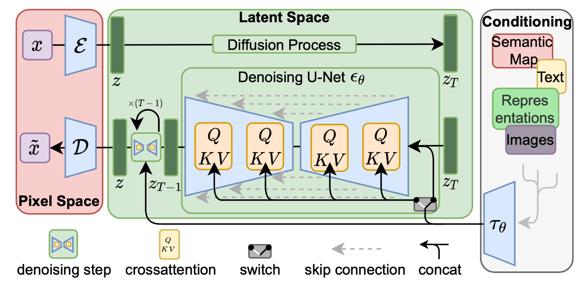

**2.** **Latent Diffusion Models (LDMs)**

LDM also extends previous techniques of diffusion by utilizing a VAE to encode images into Latent representations. This approach offers:

* Computational Efficiency:

Encoding data in the lower-dimensional latent space is less memory and computationally intensive than in high dimensions, making them plausible for large databases.

* High-Quality Outputs:

Because LDMs primarily operate over the latent representation of data, the trade-off between the time to generate images and the quality of the output for visually coherent and rather detailed images is optimized.

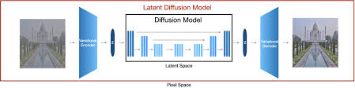

**3.** **Stable Diffusion**

Stable Diffusion is designed as an improved version of LDMs for better effectiveness and versatility in the area of text-image synthesis.

* Pre-trained on Diverse Datasets:

Stable Diffusion is built to generate outputs within a broad range of styles and contexts from the LAION-5B knowledge synthesis model.

* Optimized for Hardware:

Optimized for preemptive resource allocation, Stable Diffusion includes half-precision floating-point computations on fp16, helping more users benefit from faster inference and lighter GPU memory consumption.

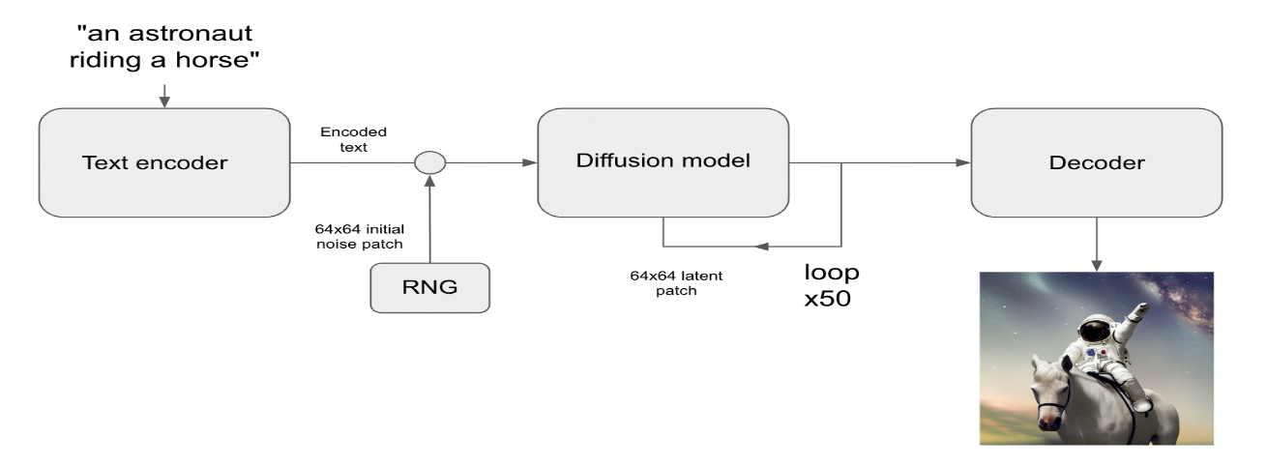

**4.** **Importance of User Interfaces**

While these models are highly capable of generation, their often intricate architectures and engineering result in general user access being restricted to those with strong technical skills. To this end, a ‘Graphical User Interface’ (GUI), is required in order to make it more accessible to a wider group of users.

* Simplified Interaction:

The GUI developed for the model means that for text prompts the users do not need to have any knowledge of programming or deep learning and they can only input the string prompts on the GUI and get the corresponding images.

* Enhancing Usability:

GUIs play an important role in closing the gap between complex AI models such as Stable Diffusion and the user so that such tools can be implemented in art, education, and business by everyone without necessarily requiring the skills of an engineer.

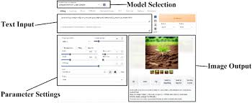

**Methodology :**

The methodology for this project encompasses three core components: system integration, appearance structure, and system deployment. All of them combine to provide a stable diffusion base. UI for the generation of images for text inputs.

**1.** **Backend Implementation**

The backend is closely connected with the application model, and it is responsible for its creation, prediction, and image creation.

* Model Setup:

The Stable Diffusion model is built with Hugging Face’s diffusers for which the details are mentioned below.

The model pipeline is loaded and initialized either on CPU or CUDA-enabled GPU depending upon the existence of the hardware.

* Text-to-Image Generation:

In the model, the input prompts go through the process of producing images by gradually optimizing the noise in terms of latent space.

A guidance scale is introduced to ensure moderate levels of both fidelity and creativity are achieved. The higher guidance values assume that it is needed to stick to the input prompt more strictly while the lower ones mean that the variation can be more creative.

* Error Handling:

Input validation makes sure the user supplies a nonempty text prompt for the program.

The appropriate exceptions are managed to maintain stability especially when during the execution.

**2.** **Frontend Design**

The frontend part offers a friendly graphical user interface to cover up the discrepancy between the user and the model.

* Technology Stack:

The GUI is built with the use of the Tkinter package in Python, with the help of the CustomTkinter for broader looks.

The dark mode decision is made to enhance the look feel and functionality of the site.

* Key Features:

Input Field: A text area where users type in a description or the image they want to be created.

Generate Button: One click of a button allows the model to read the input text and generate the corresponding image.

Image Display Area: This is an ‘image holder’ that changes to show the created image instantaneously.

* Ease of Use:

Overall, the design maintains basic installation, as it is intended for frequent use by non-computer literate individuals.

He noted that tooltips or labels can be incorporated into the interface to help direct how the user communicates with the object.

**3.** **Optimization**

It is in this optimization area that the performance and scalability of the system are most crucial for different classes of hardware.

* Precision Adjustment:

The model takes advantage of half-precision floating point arithmetic (torch.float16) on CUDA-enabled machines. This cuts down memory usage to a great extent and also increases the inference time without any analysis of the quality of images that are created.

* Hardware Compatibility:

It identifies available hardware and then adapts its workings in real-time, making it work well on both GPU and CPU.

* Response Time Improvement:

It is achieved by minimizing the size of intermediate data and optimizing the tensor operations so the pipeline is capable of providing such images within a short time frame.

**4. Implementation**

The application of this project Combines several libraries for deep learning graphical Operator Connection (GUI) creation and image methods. The workflow is organic to check coherent fundamental interaction betwixt the Check port and Operators. The important parts and steps are detailed below.

* Libraries Used:

The project leverages the following libraries to achieve its Goals:

1. flashlight and diffOperators:

The flashlight depository library is old for Check trading operations and Calculator hardware quickening (cuda for GPU)

The diffOperators depository library from caressing look is old to approach and Use the sound dissemination line simplifying Check low-level formatting and Conclusion.

1. PIL and ImageTk:

The Python Imaging Library (PIL) is used for image manipulation tasks such as saving and resizing images.

ImageTk a module of PIL enables the rendering of Produced images within the GUI.

1. tkinter and custom winter:

The tkinter depository library serves arsenic the base for the graphical Operator Connection provision base widgets care buttons labels and stimulus fields.

custom winter Improves the Connection's esthetics with contemporary styles and themes including amp blue way

* Code Workflow:

The execution is done in a series of steps which are as follows:

1. Model Initialization:

The pipelines of Stable Diffusion are imported using the diffusers library.

The hardware configuration is set in such a way that the model runs on a CPU or a CUDA-enabled GPU. This makes the device usable on all models.

Performance and memory usage are optimized by applying precision settings i.e. torch.float16 for GPU and torch.float32 for CPU.

1. Input Handling:

The GUI provides a textbox for the user to input their desired picture, which users must describe in detail.

The input is checked for any nulls in the prompt and if there is, an error prompt is shown in the system requesting the user to type in a valid description.

1. Image Generation:

The input text of the user is fed into the stable diffusion pipeline. The inference of the model is further guided by a scale so that a balance between faithfulness and imagination of the rendered image is reached.

The model takes the input in solely the latent space in an iterative manner to ultimately output a presentable image.

1. Output Display:

The output image is produced and kept as a local copy in a .png format for record purposes.

The image is adjusted to the size of the GUI and presented using ImageTk.PhotoImage. The placeholder on the interface is updated in real-time to reflect the image.

1. Error Handling:

Standard errors like empty inputs and hardware-related errors are dealt with effectively. Support instructions are provided to the users to help them work out the problems.

**5. Results**

The system successfully Produces high-quality images based on textual descriptions. Name observations include:

* Effectiveness:

The unit demonstrates fast illation along GPU with mean propagation multiplication low x seconds for amp 512x512 image

* Usability:

The visceral graphical Operator Connection allows Operators to interact with the Check without requiring abstract expertise output.

* Quality:

The images produced muse the synchronic prompts in effect highlight the Representation's robustness.

* Example prompt:

"A serene sunset over a mountain range with a clear lake in the foreground"

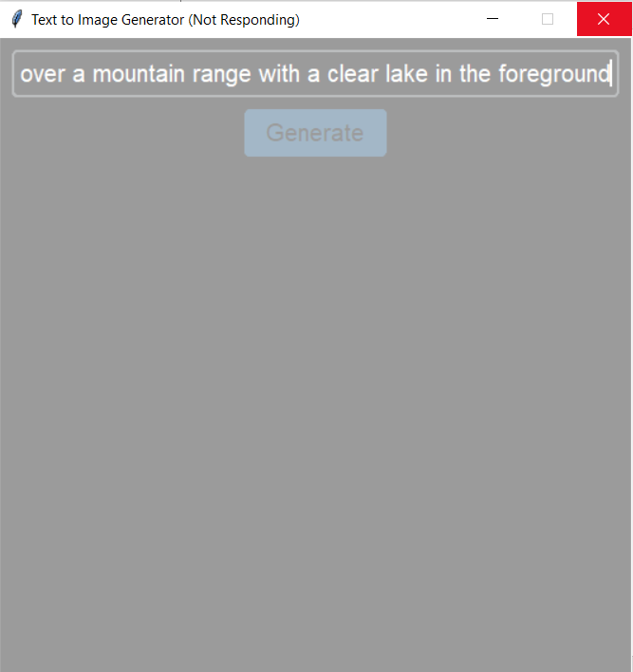

* Output:

A photorealistic depiction of the described scene

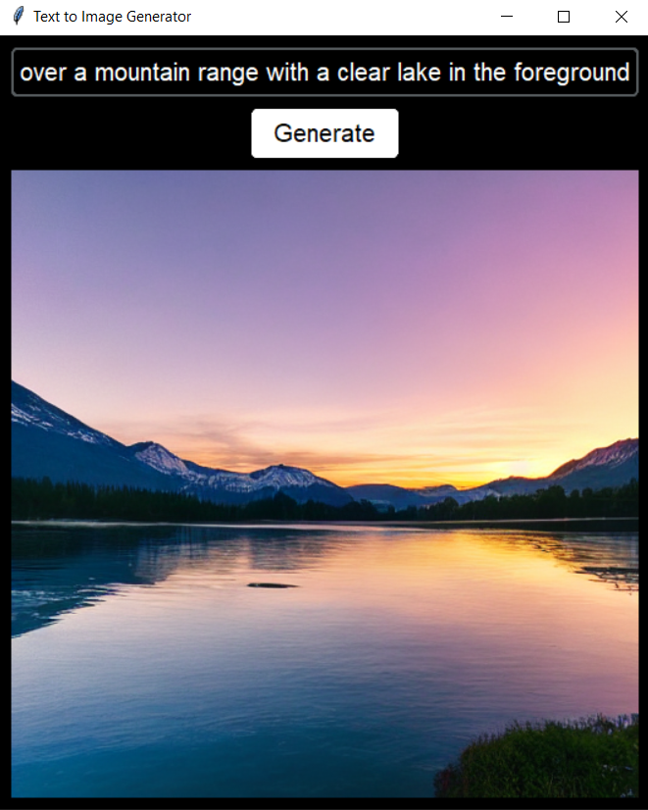

**6. Challenges and Solutions**

* Resource Constraints:

It takes a lot of computational resources to generate high-resolution images. Optimizing the model for half-precision on CUDA devices mitigates this issue.

* User Experience:

To make the system work for non-technical users, it was necessary to redesign the GUI repeatedly, concentrating on the ease of use and the error handling aspects.

* Model Limitations:

The model is not very effective when it comes to vaguely defined concepts or high-level yet complicated prompts. Fine-tuning and mixing several models may help solve this issue in future work.

**7. Conclusion and Future Work**

The project at hand demonstrates that users can be creative with the help of state-of-the-art AI technologies. This system lays the groundwork for subsequent applications such as, but not limited to, educational aids, the creation of digital art, and multimedia content development.

The project could be extended in the following ways:

1. Developing the functionality of supporting prompts in several languages.
2. Enabling the possibility for the generation of several images at once.
3. Enhancing the GUI to provide the user with the means of controlling styles, and adjusting the resolution.

**8. References**

[1] Guillaume Alain, Yoshua Bengio, Li Yao, Jason Yosinski, Eric Thibodeau-Laufer, Saizheng Zhang, and Pascal Vincent. GSNs: generative stochastic networks. Information and Inference: A Journal of the IMA, 5(2):210–249, 2016.

[2] Florian Bordes, Sina Honari, and Pascal Vincent. Learning to generate samples from noise through infusion training. In International Conference on Learning Representations, 2017.

[3] Andrew Brock, Jeff Donahue, and Karen Simonyan. Large scale GAN training for high fidelity natural image synthesis. In International Conference on Learning Representations, 2019.

[4] Tong Che, Ruixiang Zhang, Jascha Sohl-Dickstein, Hugo Larochelle, Liam Paull, Yuan Cao, and Yoshua Bengio. Your GAN is secretly an energy-based model and you should use discriminator driven latent sampling. arXiv preprint arXiv:2003.06060, 2020.

[5] Tian Qi Chen, Yulia Rubanova, Jesse Bettencourt, and David K Duvenaud. Neural ordinary differential equations. In Advances in Neural Information Processing Systems, pages 6571–6583, 2018.

[6] Xi Chen, Nikhil Mishra, Mostafa Rohaninejad, and Pieter Abbeel. PixelSNAIL: An improved autoregressive generative model. In International Conference on Machine Learning, pages 863–871, 2018.

[7] Rewon Child, Scott Gray, Alec Radford, and Ilya Sutskever. Generating long sequences with sparse transformers. arXiv preprint arXiv:1904.10509, 2019.

[8] H. Li, J. Tang, G. Li, and T.-S. Chua, ‘‘Word2Image: Towards visual interpreting of words,’’ in Proc. 16th ACM Int. Conf. Multimedia, 2008, pp. 813–816.

[9] B. Coyne and R. Sproat, ‘‘WordsEye: An automatic text-to-scene conversion system,’’ in Proc. 28th Annu. Conf. Comput. Graph. Interact. Techn., Aug. 2001, pp. 487–496.

[10] M. E. Ma, ‘‘Confucius: An intelligent multimedia storytelling interpretation and presentation system,’’ School Comput. Intell. Syst., Univ. Ulster, Coleraine, U.K., Tech. Rep., 2002.

[11] Y. Jiang, J. Liu, and H. Lu, ‘‘Chat with illustration,’’ Multimedia Syst., vol. 22, no. 1, pp. 5–16, Feb. 2016, doi: 10.1007/s00530-014-0371-3.

[12] D. Ustalov, ‘‘A text-to-picture system for Russian language,’’ in Proc. 6th Russian Young Scientists Conf. Inf. Retr., Aug. 2012, pp. 35–44.

[13] P. Jain, H. Darbari, and V. C. Bhavsar, ‘‘Vishit: A visualizer for Hindi text,’’ in Proc.

[14] Zhang, Y.; Han, S.; Zhang, Z.; Wang, J.; Bi, H. CF-GAN: Cross-domain feature fusion generative adversarial network for text-to-image synthesis. Vis. Comput. 2022, 1–11. [[Google Scholar](https://scholar.google.com/scholar_lookup?title=CF-GAN:+Cross-domain+feature+fusion+generative+adversarial+network+for+text-to-image+synthesis&author=Zhang,+Y.&author=Han,+S.&author=Zhang,+Z.&author=Wang,+J.&author=Bi,+H.&publication_year=2022&journal=Vis.+Comput.&pages=1%E2%80%9311&doi=10.1007/s00371-022-02404-6)] [[CrossRef](https://doi.org/10.1007/s00371-022-02404-6)]

[15] Zhang, H.; Xu, T.; Li, H.; Zhang, S.; Wang, X.; Huang, X.; Metaxas, D.N. Stackgan: Text to photo-realistic image synthesis with stacked generative adversarial networks. In Proceedings of the IEEE International Conference on Computer Vision, Venice, Italy, 22–29 October 2017; pp. 5907–5915.

[16] Zhang, H.; Xu, T.; Li, H.; Zhang, S.; Wang, X.; Huang, X.; Metaxas, D.N. Stackgan++: Realistic image synthesis with stacked generative adversarial networks. IEEE Trans. Pattern Anal. Mach. Intell. **2018**, 41, 1947–1962.

[17] Zhang, H.; Xu, T.; Li, H.; Zhang, S.; Wang, X.; Huang, X.; Metaxas, D.N. Stackgan: Text to photo-realistic image synthesis with stacked generative adversarial networks. In Proceedings of the IEEE International Conference on Computer Vision, Venice, Italy, 22–29 October 2017; pp. 5907–5915.

[18] Zhang, H.; Xu, T.; Li, H.; Zhang, S.; Wang, X.; Huang, X.; Metaxas, D.N. Stackgan++: Realistic image synthesis with stacked generative adversarial networks. IEEE Trans. Pattern Anal. Mach. Intell. **2018**, 41, 1947–1962.

[19] Zhang, Z.; Xie, Y.; Yang, L. Photographic text-to-image synthesis with a hierarchically-nested adversarial network. In Proceedings of the IEEE Conference on Computer Vision and Pattern Recognition, Salt Lake City, UT, USA, 18–23 June 2018; pp. 6199–6208.

[20] Cai, Y.; Wang, X.; Yu, Z.; Li, F.; Xu, P.; Li, Y.; Li, L. Dualattn-GAN: Text to image synthesis with dual attentional generative adversarial network. IEEE Access **2019**, 7, 183706–183716.