Spring Boot

* Spring MVC
* MVC -> Model View Controller

Data Template Class of Data

* Spring Boot = Spring – Configuration + Tomcat(Embedded)
* ORM => Object Relational Mapping
* JPA => Java Persistance API

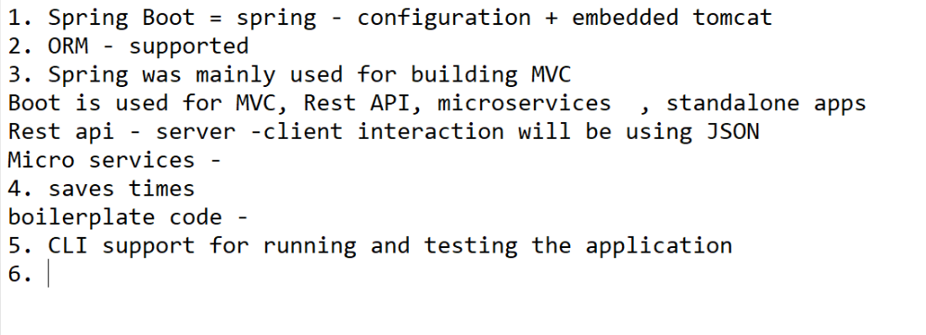

Open Spring Initializr : <https://start.spring.io/>

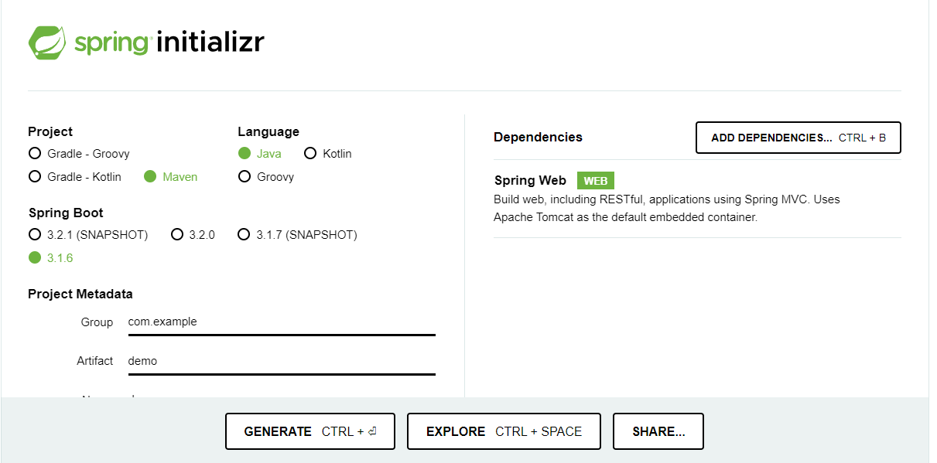

Select All this thing then  
-> Add Dependencies -> Spring Web -> Generate

* Open Download folder -> extract demo folder -> open in cmd ->
* Type command : mvnw spring-boot:run (it will start the server)

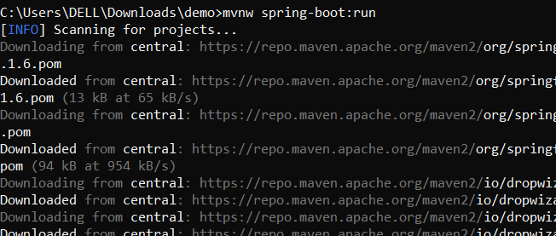

To start the server - > localhost:8080

Check the environment variables :

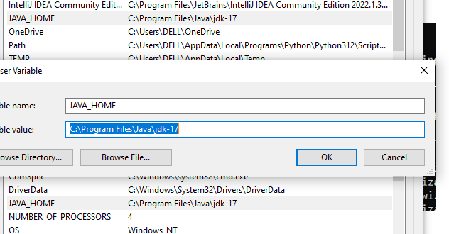

To Restart the server : ctrl + c

Then Yes

Re-type the command :- mvnw spring-boot:run

Page will look like this :

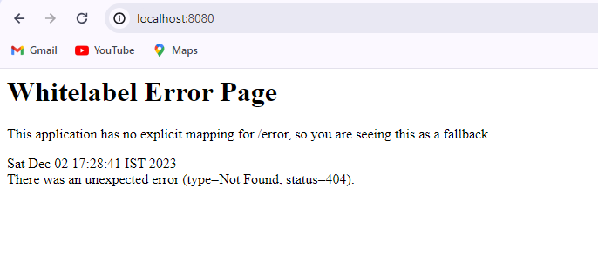

Steps :

Go to : spring.io -> projects -> Spring Tool 4 -> download the tool as per your convenience

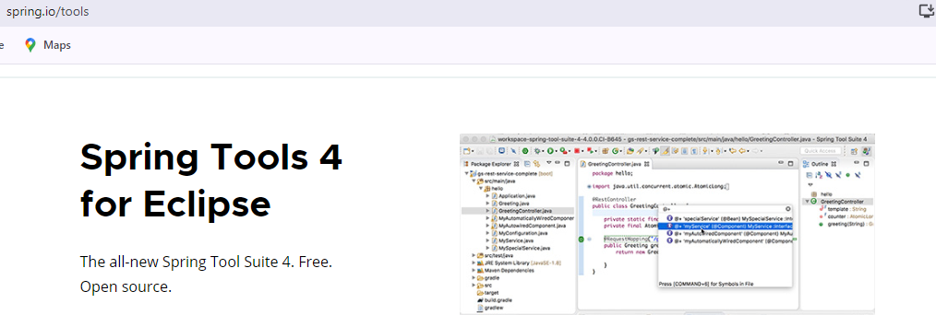

After Installing :

1. Open that Jar File
2. It will create new folder of STS like this
3. Open -> it will has the STS exe file
4. Open it and Path to Launch project

Steps to create project :

1. New Tab -> Spring starter project
2. select data -> name -> lang-> jar -> next
3. if want any dependencies add it or click to finish.
4. It will create a project -> wait for some time to create folder.
5. In Boot Dashboard -> start the server.