Spring Boot

* Spring MVC
* MVC -> Model View Controller

Data Template Class of Data

* Spring Boot = Spring – Configuration + Tomcat(Embedded)
* ORM => Object Relational Mapping
* JPA => Java Persistance API

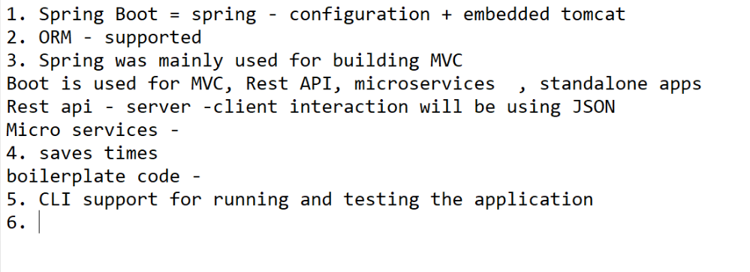

Open Spring Initializr : <https://start.spring.io/>

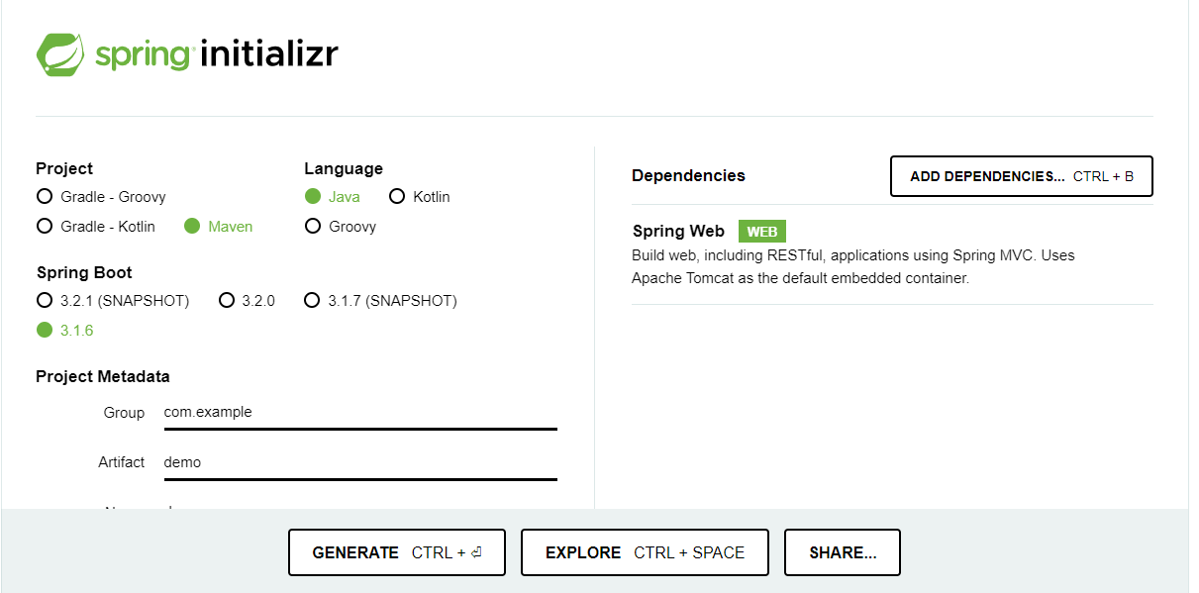

Select All this thing then  
-> Add Dependencies -> Spring Web -> Generate

* Open Download folder -> extract demo folder -> open in cmd ->
* Type command : mvnw spring-boot:run (it will start the server)

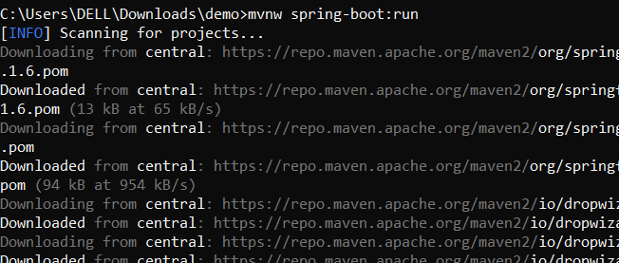

To start the server - > localhost:8080

Check the environment variables :

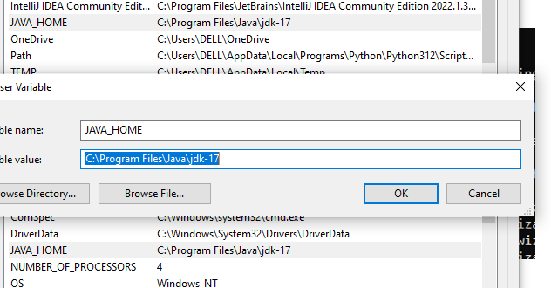

To Restart the server : ctrl + c

Then Yes

Re-type the command :- mvnw spring-boot:run

Page will look like this :

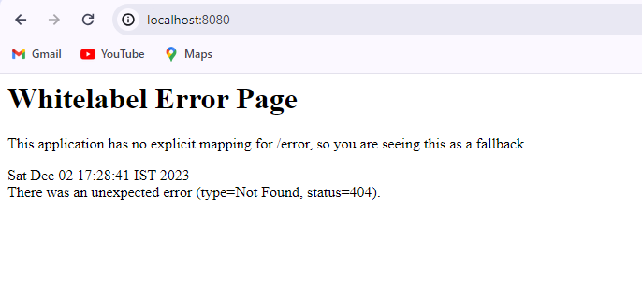

Steps :

Go to : spring.io -> projects -> Spring Tool 4 -> download the tool as per your convenience

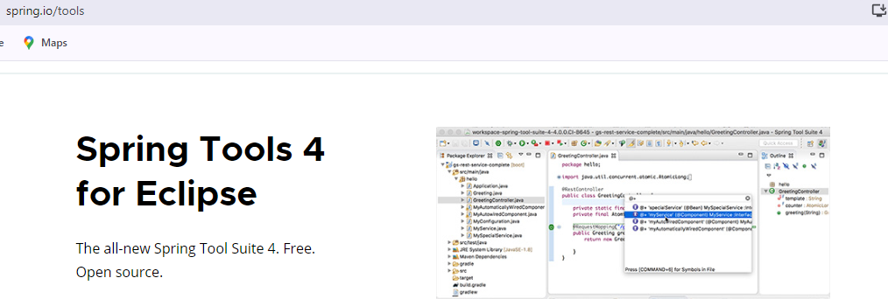

After Installing :

1. Open that Jar File
2. It will create new folder of STS like this
3. Open -> it will has the STS exe file
4. Open it and Path to Launch project

Steps to create project :

1. New Tab -> Spring starter project
2. select data -> name -> lang-> jar -> next
3. if want any dependencies add it or click to finish.
4. It will create a project -> wait for some time to create folder.
5. In Boot Dashboard -> start the server.

#Bean => Spring configured object

-All beans are stored within the spring container

-To use this beans we have add Dependency Injection (DI).

-Way to implement the IOC

#IOC => Inversion of control :- Framework will take care of creation and management of object / bean lifecycle

#Important Annotations :

1. @Component :

- Class level annotation

- Bean will created by spring for this class

Child Annotations of @Component :

1. @Controller
2. @RestController
3. @Service
4. @Repository

2. @Autowired : field injection

- It will use in Dependency Injection (DI)

-# Dependency - depending on something

Eg : Car is depend on its engine if there is no engine car won’t work.

-# Injection :- Injecting something into class

Eg : Serine injects medicine into our body.

# Dependency Injection (DI).-Way to implement the IOC

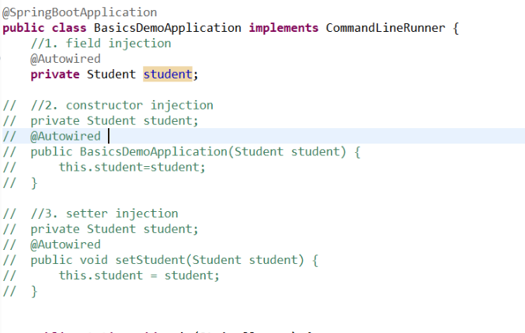

This are some types of injection we can use   
But spring preferred Field Injection – it is popular way

1. @Bean and @Configuration

Bean is required for In build classes

-method level annotation

- used on top of the methods which returns the bean of some inbuild classes

Whenever we use @Bean, we need to use @Configuration (class level annotation)

@Configuration – THIS indicates to spring framework that there are some methods will returns the bean.

Spring will execute all @Bean methods from @Configuration class and keeps the beans ready for injection

1. @ComponentScan :

-base package to be scanned for components / base

1. @SpringBootApplication