BJS

BHARATIYA JAIN SANGHATANA’S

Arts, Science & Commerce College

A Project Report On
“ CompNex E-commerce Website ”

Submitted to

SAVITRIBAI PHULE UNIVERSITY

In partial fulfilment of the Requirement of

Bachelor of Business Administration (Computer Application)
(Semester – III)

Submitted By
Mr. Shailesh S. Mourya

Under the guidance of
Prof.

DEPARTMENT OF B.B.A(C.A)

CERTIFICATE

This is to certify that Mr. Shailesh S. Mourya of class B.B.A (C.A) (Semester III) have Completed the Project Work on

“CompNex E-commerce Website for Computer Components” Under my guidance & supervision in a satisfactory manner for the Practical fulfilment of BBA(CA) Sem (III) examination for the academic year 2025-2026.

Dr. B.B. Landge Dr.Sanjay Gaikwad
(Incharge) (Principal )

Project Guide Internal Examiner External Examiner Prof.

Date: Place:

INDEX

Sr. No | Name | Page
1) | Abstract:  A concise Summary of Project | 01
2) | Introduction  2.1) Background of Project  2.2) Problem Statement  2.3) Objective and Goals  2.4)Scope and Limitations | 02
3) | System Analysis  3.1) Existing System and their limitation  3.2) Project Prespective and Features  3.3) Requirement Analysis  ( Functional , Performance , Security ) | 03
4) | System Design  4.1) Design Constraints  4.2) Flow Chart  4.3) User Interfaces ( Design Screens) | 09
5) | Implementation Details  5.1) Software and Hardware Specification  5.2) Screenshots of Working System and  Reports | 11

6) | Testing  6.1) Input, Expected Output  6.2) Screens With Validations  6.3)Error / Success Message Window | 21
7) | Conclusion and Recommendation | 22
8) | Future Scope
9) | Bibliography and References
10) | Abbreviation

Project Report

CompNex Store - Online Computer Hardware

E-commerce Platform (Prototype)

 
- Abstract
         

The CompNex Store E-commerce Prototype offers an easy and detailed online shopping experience for high-performance computer hardware. It lets users browse, compare, and explore products like the RTX 5090 and AMD Ryzen 9 9000. Each item has a dedicated page with key specifications. Features like Add to Cart and User Login/Sign-up simulate a real shopping experience. The prototype helps users quickly find and compare PC components for their custom builds.

1

      2. INTRODUCTION

2.1) Background of Project

The CompNex Store was created with a simple goal — to build an online shop focused purely on high-end computer hardware like advanced GPUs, CPUs, and ultra-fast RAM. Unlike typical stores that feel cluttered or too general, CompNex aims to make comparing complex specs and finding the right parts for custom PC builds easy and clear.
This project is a front-end prototype, meaning it looks and functions like a real e-commerce site but doesn’t have a working database yet. Basic features like pop-up alerts simulate interactions. The main purpose is to showcase how a clean, focused store for true PC enthusiasts could work when done right.

2.2) Problem Statement
Many online stores make it hard to find and compare the right PC parts. Key issues include:
- Missing important product details.
- Confusing or mixed-up categories.
- No help checking part compatibility.
- Little to no performance comparison.
- Poor design for mobile users.

2.3) Objective And Goals

Create a modern, eye-catching website for selling high-performance computer hardware, where users can clearly see product details and enjoy a smooth shopping experience.

Goals
- Design the Look: Use a dark theme with red highlights for a sharp, modern feel across all pages — home, products, and sign-up.
- Show Off the Parts: Display clear, detailed specs (like 48 Cores / 96 Threads) right beside each product.
- Make Things Click: Include working sign-in, sign-up, and “Buy” buttons to simulate a real shopping experience.

2.4) Scope & Limitation

Scope:
- Develop the front end using HTML5, CSS3, and JavaScript.
- Create a responsive design that works smoothly on all devices.
- Build a product catalog with easy search and filter options.
- Set up user registration and login pages.
- Develop a basic order management system to track user actions.

Limitation :

- Payment system is only for demo purposes — no real transactions.
- Inventory management is basic and limited.
- Works with fixed product categories only.
- No advanced product recommendations yet.
- Stock levels don’t update in real time.

3) System Analysis

3.1) Existing System and Their Limitation:

- Too messy: PC parts are mixed with unrelated products.
- Hard to read: Key specs are hidden or unclear.
- Slow to compare: Users can’t quickly see or check compatibility.
CompNex Store solves this by focusing only on computer parts and showing all specs clearly.
.3.2) Project Perspective and Features :

Project Perspective :
This project is the front window and sales area of the store.
- It uses clean HTML and CSS to look good.
- It's built to work well on any screen (computer or phone).
- It's designed to be super easy to connect to a real database later.

Features :
The website shows the following main things:
- Product Pages: Clear pages for each part with all key specs.
- Shopping Buttons: “Add to Cart” and “Buy Now” simulate shopping with pop-up alerts.
- Account Screens: Sign Up and Log In pages for users.
- Easy Browsing: Main page lists all products for smooth scrolling and quick access.
1. Functional Requirements:
- View Products: Browse homepage and click to see product details.
- See Specs: Show all key specs for each item.
- Manage Account: Sign Up for new users and Log In for existing users.
- Shop: Buttons like “Add to Cart” and “Buy Now” simulate shopping.

2. Performance Requirements:
- Fast Loading: Pages should open quickly.
- Responsive Design: Works well on computers and mobile phones.
3. Security Requirements:
- Form Checks: Ensure Sign Up/Login fields are not empty.
- Password Match: Verify both password entries are identical during sign-up.
(Full security like encryption will be added in the complete system.)

4) System Design

Design Constraints:
- Look and Feel: Use a dark theme with bright red (#ff4444) highlights for a high-tech, premium look.
- No Server Code: Only HTML, CSS, and basic JavaScript; no real database or server connections. Actions like login or “Add to Cart” use pop-up messages.
- Fonts: Use specific fonts (Montserrat, Open Sans, or Poppins) for a consistent professional appearance.

4.2) Flow Chart

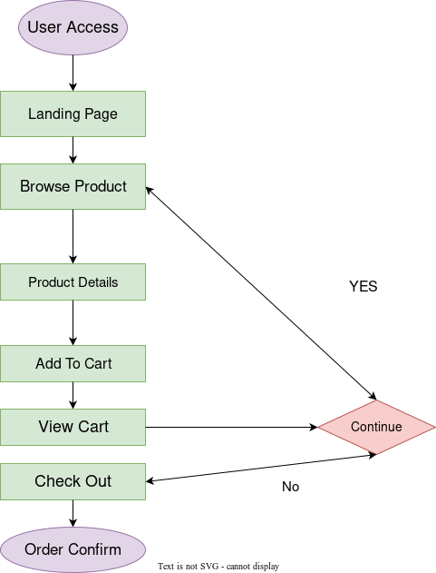

4.3) User interface
- Dark-themed interface with red highlights for buttons and key details.
- Homepage displays products in a clean, easy-to-navigate grid layout.
- Product pages show images and detailed specifications clearly.
- “Add to Cart” and “Buy Now” buttons simulate shopping actions.
- Sign Up and Login forms include validation alerts for user input.
- Shopping cart displays selected items and simulates checkout.
- Responsive design ensures smooth use on desktops, tablets, and phones.
- Fonts like Montserrat, Open Sans, and Poppins maintain a professional look.

5) Implementation Details

Software and Hardware Specifications
Software Requirements:
- Web Browser: Chrome, Firefox, Edge, or Safari (latest versions)
- Development Tools:
  - Code Editor: VS Code, Sublime Text, or Atom
  - Browsers’ Developer Tools for testing
- Languages Used: HTML5, CSS3, JavaScript
- Optional Tools: Photoshop, Figma, or Canva for design/mockups
Hardware Requirements:
- Processor: Intel i3 or equivalent and above
- RAM: Minimum 4 GB (8 GB recommended for smooth development)
- Storage: 500 MB free space (for project files)
- Display: Any standard monitor (1080p recommended for design clarity)
- Internet Connection: Required for testing online resources and libraries

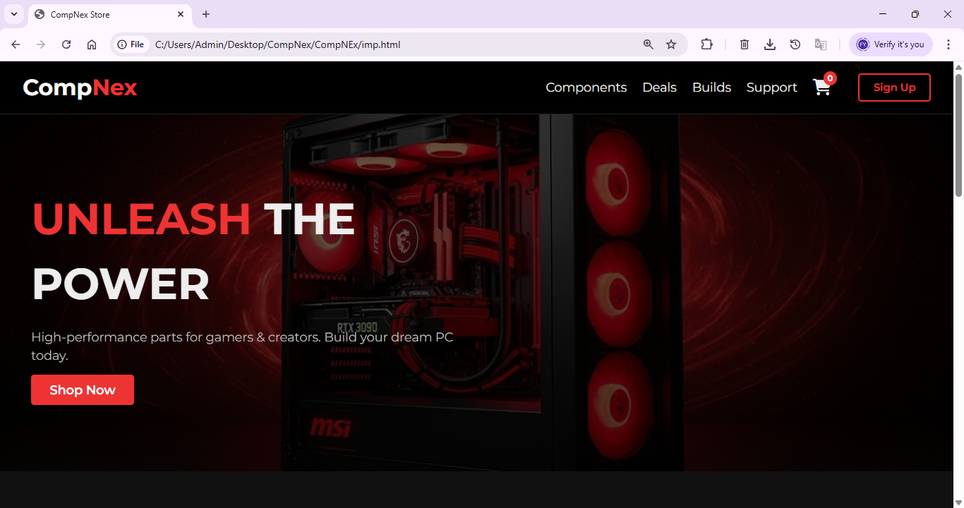

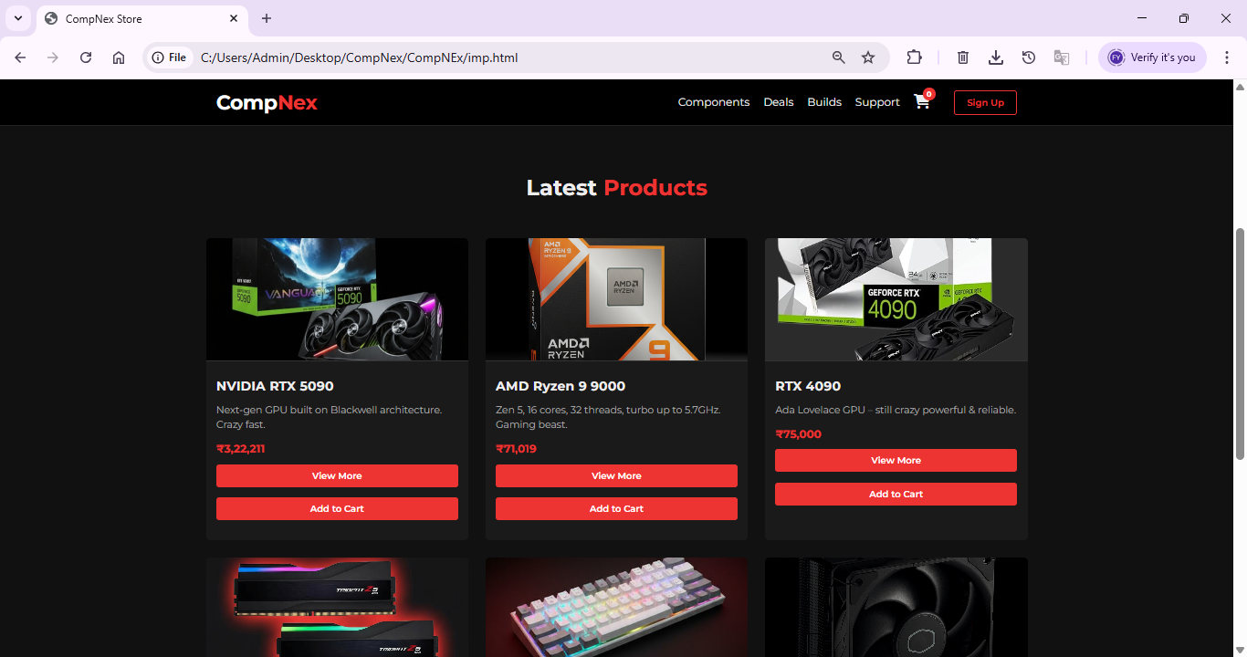

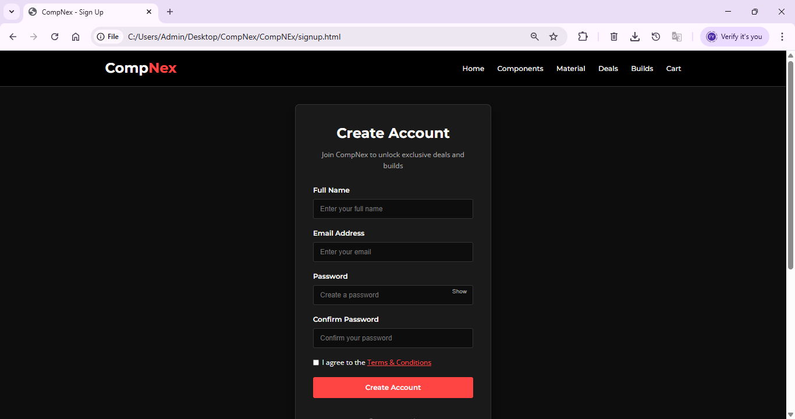

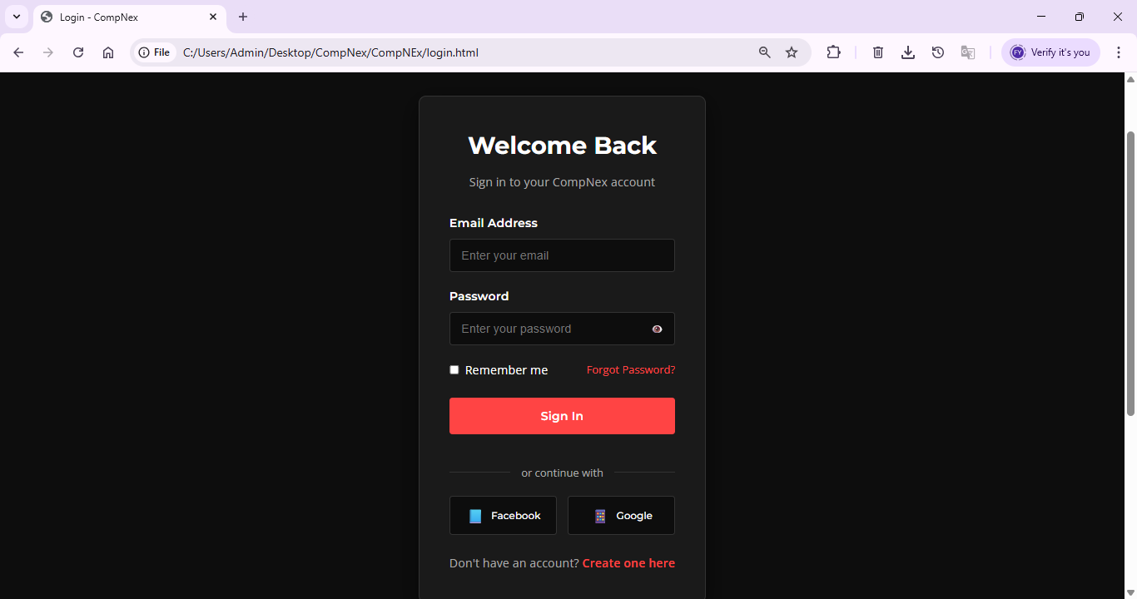

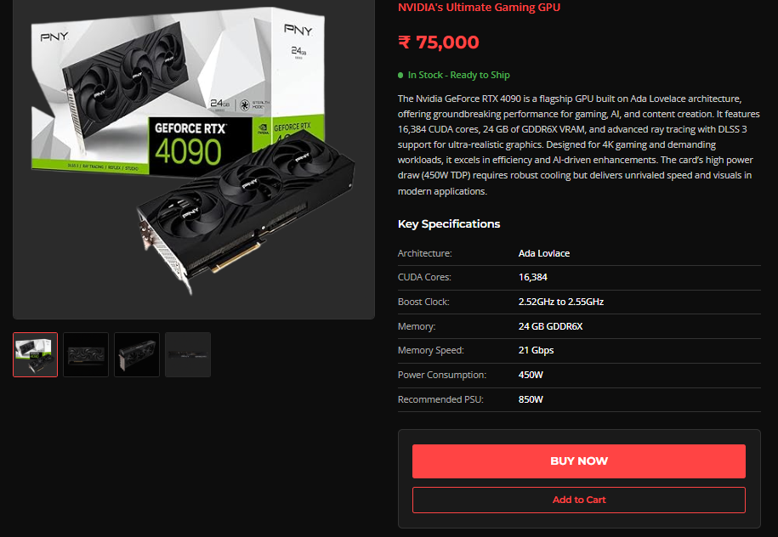

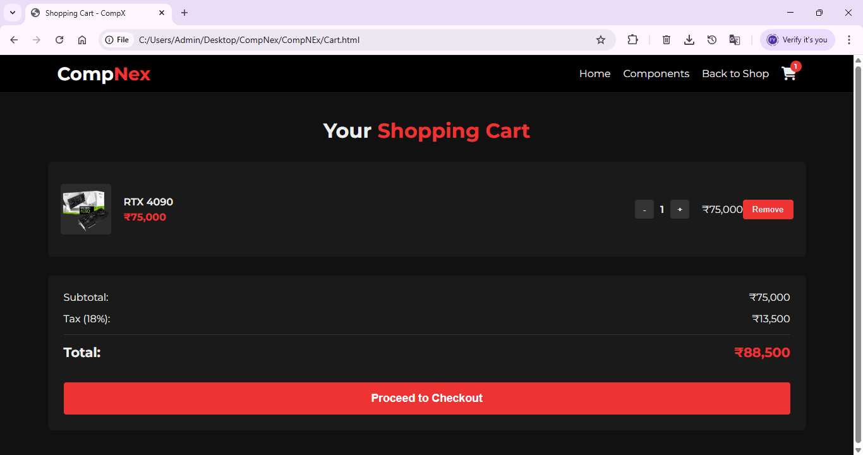

6) Testing

6.1) Input, Expected Output
The following test cases confirm that the core navigation and simulated user interactions function as designed:
Screen/Component | Input (Action) | Expected Result | Actual Result
Homepage (imp.html) | Click on any product card. | Opens the correct product details page (e.g., Product1.html). | Works correctly
Product Page | Click “Add to Cart” / “Buy Now” button. | Shows a success alert message or visual confirmation (e.g., button text changes to "Added to Cart!"). | Works correctly
Responsive Design | Open site on a mobile device (by resizing the browser window). | Layout adjusts properly to fit the smaller screen size. | Works correctly

6.2) Screens With Validations
These tests confirm the basic client-side form validation is correctly implemented on the user authentication screens:
Screen/Component | Validation Performed | Expected Result | Actual Result
Sign Up Form (signup.html) | Leave any required field empty (Full Name, Email, or Password). | Shows “Please fill in all fields” alert. | Works correctly
Sign Up Form (signup.html) | Passwords entered in the two fields do not match. | Shows “Passwords do not match!” alert. | Works correctly
Login Form (login.html) | Enter valid credentials (non-empty Email and Password fields). | Shows “Login successful! Redirecting...” alert message. | Works correctly

6.3)
Screen / Action | User Input / Condition | Type of Message | Message Displayed | Status
Sign Up Form | Any required field (Email, Password, etc.) left empty. | Error | “Please fill in all fields.” | ✅ Working
Sign Up Form | Password and Confirm Password entries do not match. | Error | “Passwords do not match!” | ✅ Working
Sign Up Form | All details correctly entered and passwords match. | Success | “Account created successfully! Redirecting to login…” | ✅ Working
Login Form | Empty email or password field upon submission. | Error | “Please enter your email and password.” | ✅ Working
Login Form | Correct email and password entered (simulated success). | Success | “Login successful! Redirecting to homepage…” | ✅ Working
Product Page | Click the “Add to Cart” button. | Success (Visual Change) | The button text briefly changes to “Added to Cart!” | ✅ Working
Product Page | Click the “Buy Now” button. | Success (Simulated Action) | Alert stating: “Redirecting to checkout for | ✅ Working

Conclusion :
The CompNex Store E-commerce Prototype successfully meets its main goal — creating a clean, modern, and easy-to-use front-end for a computer hardware shop. Built with HTML, CSS, and JavaScript, it includes detailed product pages, responsive design, and working form validation for login and sign-up. All key features like browsing, account access, and simulated cart actions work smoothly, showing how a real online store could look and function.
Recommendation
The prototype is stable and ready for the next stage — backend integration. The next steps include:
- Add a Database: Store real user accounts, product info, and prices.
- Add Server Logic: Replace alert messages with real authentication and transaction processing.
- Enable Real Checkout: Connect a secure payment system for real purchases.
This will turn CompNex from a visual demo into a fully functional e-commerce platfor

Core System Development & Future Enhancements
Backend & Database Integration
The next step for the CompNex Store is to build a strong backend using frameworks like Node.js, Django, or Spring, connected to a database such as MySQL or MongoDB.
Goal: Store real user data, product inventory, and order history securely.
Secure Authentication
Replace the current pop-up alerts with proper server-side login and sign-up systems using methods like JWT (JSON Web Tokens). All passwords should be encrypted (hashed) to ensure user safety.
Real Shopping Cart
Add backend logic to manage items in the cart, update inventory in real time, calculate shipping, and display total costs on the cart page.

Advanced E-commerce Features
Payment Gateway
Integrate secure payment systems like Stripe or PayPal to handle real credit card transactions and complete the checkout process.
Dynamic Search & Filtering
Build a search API so users can filter products by specs like GPU memory, CPU cores, or price range — making browsing faster and more user-friendly.
User Reviews & Ratings
Allow logged-in users to post reviews and ratings, showing average scores to help others make informed choices.
Admin Dashboard
Create a private admin panel for the CompNex team to manage products, update prices, and view user or order details easily.

        Bibliography :

Books Referred:-
        - VB Black Book
        - Web Technology Book
        - Software Engineering Book
        - Node-Js Book
        - Operating System
www.google.com

22

THANK YOU

23

