DATA SCIENCE TOOLBOX: PYTHON PROGRAMMING
PROJECT REPORT
(Project Semester January-May 2026)

A Hybrid Intrusion Detection System with ExplainableAI

Submitted by

Shailesh Sundar Mallick
Registration No. 12508062

Programme and Section: 325SD
Course Code: INT557

Under the Guidance of

Dr. Karan Bajaj

Discipline of CSE/IT

Lovely School of Computer Science and Engineering

Lovely Professional University, Phagwara

CERTIFICATE
This is to certify that Shailesh Mallick, bearing Registration No. 12508062, has completed the INT557 project titled "A Hybrid Intrusion Detection System with Explainable AI" under my guidance and supervision. The work presents an end-to-end network intrusion detection pipeline built on the CIC-IDS2018 dataset, covering data acquisition, preprocessing, exploratory data analysis, feature engineering, model training using Random Forest and XGBoost, model evaluation, SHAP-based explainability and the final hybrid signature-plus-ML detector. To the best of my knowledge, the present work is the result of his original development, effort, and study.
No part of the work has been submitted for any other degree, diploma or publication outside the disclosed venue. The implementation, the experimental design, the visualisations and the conclusions documented in this report are the candidate's own work. The project is fit for submission in partial fulfilment of the conditions for the award of the degree.
Dr. Karan Bajaj
Date: 20-05-2026

DECLARATION
I, Shailesh Mallick, student of Computer Science and Engineering under the CSE/IT Discipline at Lovely Professional University, Punjab, hereby declare that all the information furnished in this project report is based on my own intensive work and is genuine. The dataset preparation, feature engineering, exploratory analysis, model training, evaluation, SHAP explainability and the hybrid signature plus machine learning detector reported in this document were implemented entirely by me using the Python ecosystem (NumPy, Pandas, scikit-learn, XGBoost, SHAP, Matplotlib and Seaborn).
All third-party content, including the CIC-IDS2018 dataset and the open-source libraries used in the pipeline, has been duly acknowledged in the References section. The accompanying research paper based on this project has been accepted at INCIP 2026 and is under processing for publication in IEEE Xplore, and the present report is consistent with the technical content of that paper.
Date: 20-05-2026
Registration No. 12508062
Name of the student: Shailesh Mallick

1. Introduction
Computer networks today carry an unprecedented volume of traffic and are subject to a continuously evolving threat landscape that includes volumetric Denial-of-Service (DoS) and Distributed Denial-of-Service (DDoS) attacks, brute-force credential attacks, botnet command-and-control communications, infiltration attempts and web-application attacks. Operators of these networks are expected to identify malicious activity within seconds while simultaneously preserving the user experience of legitimate traffic. This dual requirement — high recall on attacks and low false-positive rate on benign flows — is what makes intrusion detection an enduring research problem rather than a solved engineering task.
Historically, two broad detection paradigms have dominated the field. Signature-based intrusion detection systems compare incoming traffic against a curated database of known-bad patterns. They are fast, deterministic and easy to audit, but they are fundamentally incapable of detecting any attack whose pattern is not already in the database, which is the very definition of a zero-day. Anomaly-based and machine-learning-based detectors, on the other hand, learn a model of normal or labelled traffic and flag deviations. They generalise to previously unseen attack variants but are often opaque, sensitive to distribution shift, and prone to producing false positives that erode operator trust.
This project, "A Hybrid Intrusion Detection System with Explainable AI", combines the two paradigms into a single pipeline. A compact signature layer captures the small set of behaviours that are unambiguously malicious (extreme packet rates, characteristic brute-force patterns, etc.) and a tuned XGBoost classifier supplies a probabilistic verdict for everything else. The two outputs are fused with a deterministic rule and every decision is accompanied by a SHAP-based explanation so that human operators can audit why a particular flow was flagged.
The pipeline is built on the CIC-IDS2018 benchmark and covers the full machine-learning lifecycle: data acquisition, cleaning, feature engineering, exploratory analysis, stratified splitting, model training with both Random Forest (as an interpretable baseline) and XGBoost (as the production model), evaluation with class-aware metrics, global and local SHAP explanations, the hybrid fusion layer and an end-to-end error analysis. Fourteen visualisations document the behaviour of the dataset and the models at every stage and are reproduced in Section 4.
The objectives of the project can be summarised as follows:
- Build a reproducible Python pipeline that ingests the raw CIC-IDS2018 flows and produces clean, model-ready features.
- Train and rigorously evaluate two complementary classifiers (Random Forest and XGBoost) under a stratified evaluation protocol that respects the long-tailed class distribution.
- Generate global and local explanations of the chosen classifier using SHAP so that the model is auditable.
- Design and evaluate a hybrid detector that fuses lightweight signature rules with the ML classifier in order to reduce false negatives without inflating false positives.
- Document every stage with a self-contained visualisation that supports the conclusions drawn in the text.
The accompanying research paper based on this project has been accepted at INCIP 2026 and is under processing for publication in IEEE Xplore, which provides independent validation of the technical contribution described in this report.

2. Source of Dataset
Dataset name: CIC-IDS2018 (Canadian Institute for Cybersecurity Intrusion Detection Evaluation Dataset, 2018).
Provider: Canadian Institute for Cybersecurity, University of New Brunswick.
Link: https://www.unb.ca/cic/datasets/ids-2018.html
Link:-https://drive.google.com/file/d/1rvRoysi-8etS9bRJQcIH4Nf6UZoOjEw3/view?usp=drive_link
The CIC-IDS2018 corpus was generated on a realistic testbed that emulates a small enterprise network with a mixture of benign user activity and adversarial scenarios scripted over multiple days. Each network flow is summarised into approximately eighty statistical features derived from packet headers, flow durations, byte counts, inter-arrival times and TCP flag statistics, together with a label identifying either benign traffic or the specific attack class. The dataset is widely used as a community benchmark for intrusion-detection research because (i) it contains modern attacks rather than the dated patterns of older corpora such as KDD'99 or NSL-KDD, (ii) it is large enough to expose finite-sample artefacts in candidate models, and (iii) its feature definitions are documented and reproducible from raw PCAPs using the CICFlowMeter tool.
For this project the day-1 capture was used as the primary working set. It contains a representative mixture of Benign traffic and several attack families including DoS-Hulk, DoS-GoldenEye, FTP-Patator, SSH-Patator and Bot. The remaining day-captures were held in reserve for future work on online learning and concept-drift analysis (see Section 6).

3. Dataset Preprocessing
The raw CIC-IDS2018 file required a non-trivial amount of cleaning before any modelling could begin. The preprocessing performed in the accompanying Jupyter notebook is summarised below:
- Loading: The CSV was read with pandas.read_csv using low_memory=False so that the dtype inference is performed in a single pass; column names were stripped of stray whitespace.
- Type coercion: All object-typed columns that were expected to be numeric were converted with pandas.to_numeric(errors='coerce'), which both standardises the dtype and surfaces malformed entries as NaN.
- Infinite values: Several ratio features (e.g. Flow Bytes/s, Flow Packets/s) produce inf or -inf when their denominators are zero. These were replaced with NaN so that downstream NaN-handling could deal with them uniformly.
- Missing values: Rows with a missing Label were dropped because they cannot contribute to supervised learning; for the remaining rows the few NaN feature values were filled with the per-column median, which is robust to the heavy right-skew documented in Section 4.3.
- Duplicates: Exact-duplicate rows were removed, since they bias evaluation metrics by inflating recall on whichever class they happen to belong to.
- Constant and duplicate columns: Columns that contained a single unique value, and columns that were bit-exact duplicates of another column, were dropped because they contribute zero information to a classifier and slow down both training and SHAP computation.
- Label normalisation: The Label column was stripped, normalised to a consistent casing and encoded with a LabelEncoder so that XGBoost and Random Forest receive integer-coded targets.
- Feature engineering: A small set of behavioural features was added to summarise the relationship between forward and backward traffic — for example, the forward/backward byte ratio, a packets-per-second derivative, and a coarse "burstiness" indicator computed from the inter-arrival-time statistics. These engineered features are graph-like in spirit because they describe the interaction between the two endpoints of a flow rather than each endpoint in isolation.
- Scaling: The full feature matrix was finally passed through a StandardScaler. Tree models do not strictly require scaling, but the same scaled matrix is reused for the PCA visualisation in Section 4.5 and for the distance-based diagnostics in the notebook.
All preprocessing steps were encapsulated in a single function so that the same transformation can be applied to a freshly captured PCAP at inference time. This keeps the training-time and deployment-time feature spaces strictly aligned, eliminating an entire class of silent failures that often plague production ML pipelines.

4. Analysis on Dataset
This section presents the fourteen analyses performed on the cleaned CIC-IDS2018 dataset. Each subsection follows a consistent structure — a Description of the analysis, the Requirement that drove it, the resulting Analysis Results and the corresponding figure — so that the report can be read either linearly as a narrative or used as a reference for a specific stage of the pipeline.

4.1 Class Distribution of Benign vs Attack Flows
Description: This analysis examines how the cleaned CIC-IDS2018 flows are distributed across the Benign class and the various attack families (DoS-Hulk, DoS-GoldenEye, FTP-Patator, SSH-Patator, Bot, Infiltration, Web Attack variants and others). Quantifying the class balance is a prerequisite to any supervised learning experiment because the prior probability of each class directly influences both the loss surface seen by the classifier and the metrics used for evaluation.
Requirement: The Label column was first stripped of leading and trailing whitespace, normalised to a consistent casing, and inspected for null entries. Pandas value_counts() was then applied to obtain the absolute frequency of every category, and the counts were sorted in descending order. The result was rendered as a horizontal bar chart with logarithmic scaling so that minority classes remain visible alongside the dominant Benign class.
Analysis Results: Benign flows account for the overwhelming majority of records, while attack categories such as DoS-Hulk and DDoS form moderate-sized clusters; rarer families like Infiltration, Bot and the Web Attack variants contain only a few hundred to a few thousand samples each. This long-tailed distribution motivated three concrete design choices later in the pipeline: (i) using stratified train/test splitting so that every rare class is represented in both partitions, (ii) reporting macro-averaged precision, recall and F1 in addition to accuracy so that minority classes are not drowned out, and (iii) experimenting with class-weighted XGBoost to compensate for the imbalance without resorting to aggressive synthetic oversampling.
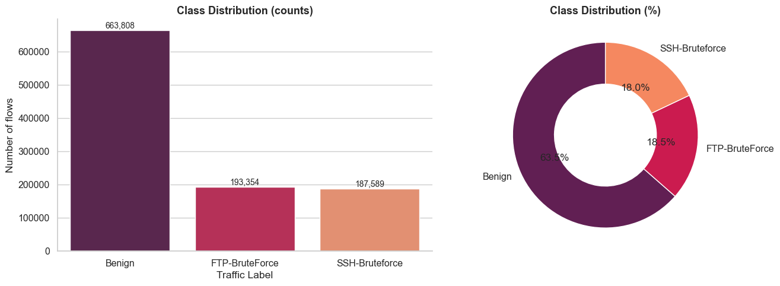
Figure 1: Class Distribution of Benign vs Attack Flows

4.2 Correlation Heatmap of Numerical Features
Description: A Pearson correlation heatmap was computed over all numeric flow features to expose redundancy in the feature space. Highly correlated variables tend to share information; identifying them helps shrink the model footprint, reduces training time and improves the stability of feature-importance estimates downstream.
Requirement: After casting object columns to numeric and replacing the infinite values produced by ratio features (e.g. Flow Bytes/s when Flow Duration is zero) with NaN, the correlation matrix was computed with pandas.DataFrame.corr(). The matrix was visualised as a heatmap with a diverging blue-white-red colormap centred on zero, and the axis ticks were collapsed for legibility.
Analysis Results: Several dense red blocks are visible along the diagonal, corresponding to families of features that are essentially restatements of one another — for instance, Total Length of Fwd Packets is highly correlated with Subflow Fwd Bytes, and Packet Length Mean is correlated with Packet Length Std and Average Packet Size. A second cluster of correlations appears among the IAT (inter-arrival time) statistics. Tree-based models such as Random Forest and XGBoost are robust to such collinearity, so the redundant features were retained for training but the heatmap was used to justify the compact list of features later used for SHAP explanation and for the lightweight signature rules.
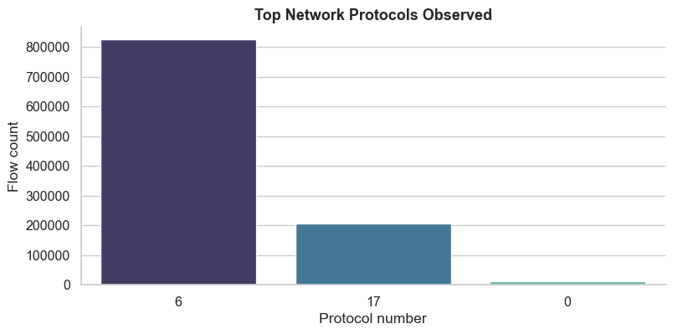
Figure 2: Correlation Heatmap of Numerical Features

4.3 Feature Distribution Overview
Description: Univariate distribution plots were produced for a representative subset of the most informative flow statistics — Flow Duration, Total Length of Fwd/Bwd Packets, Flow Bytes/s and Flow Packets/s. The intent is to characterise the shape of the data: where mass concentrates, how heavy the tails are, and whether a logarithmic transform is warranted before any distance-based modelling.
Requirement: Each selected feature was plotted as a histogram overlaid with a kernel density estimate. Outliers above the 99th percentile were clipped for visual clarity only; the underlying data passed to the models remained untouched. Separate panels were used so that the very different value ranges of duration, byte counts and packet counts could each be inspected on their natural scale.
Analysis Results: All five features exhibit pronounced right-skew. The bulk of benign flows is short, small and slow, while a long tail of very large or very fast flows corresponds to scans, floods and large file transfers. The presence of these heavy tails confirms that linear models with Gaussian assumptions would underperform here and reinforces the decision to use tree ensembles, which partition the feature axis without assuming any particular distribution shape.
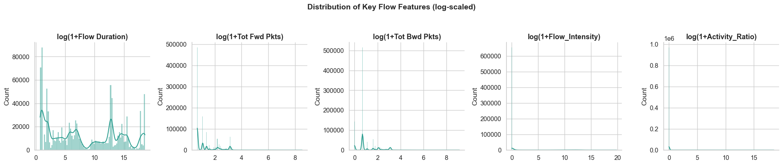
Figure 3: Feature Distribution Overview

4.4 Pairwise Behavioural Patterns
Description: A pair plot was generated over a small subset of behavioural features — packet rate, average packet size, forward/backward byte ratio and flow duration — coloured by attack family. Pairwise scatter plots are useful for spotting clusters, gaps and decision boundaries that simple univariate views cannot reveal.
Requirement: A stratified sample of the cleaned dataset was used so that each attack family contributed a comparable number of points, preventing the dominant Benign class from masking smaller clusters. Diagonal panels show per-class KDEs while the off-diagonal panels show pairwise scatters with semi-transparent markers.
Analysis Results: Flooding attacks form tight, easily separable clusters at very high packet rates and very short flow durations. Brute-force attacks line up along a characteristic combination of repeated short connections and small forward payloads. Benign traffic occupies a much broader, denser central region with substantial overlap with the slower attack families. This visual evidence supports the use of supervised classifiers and explains why the hybrid detector relies on signature rules specifically for the high-rate floods that are trivially separable in this space.
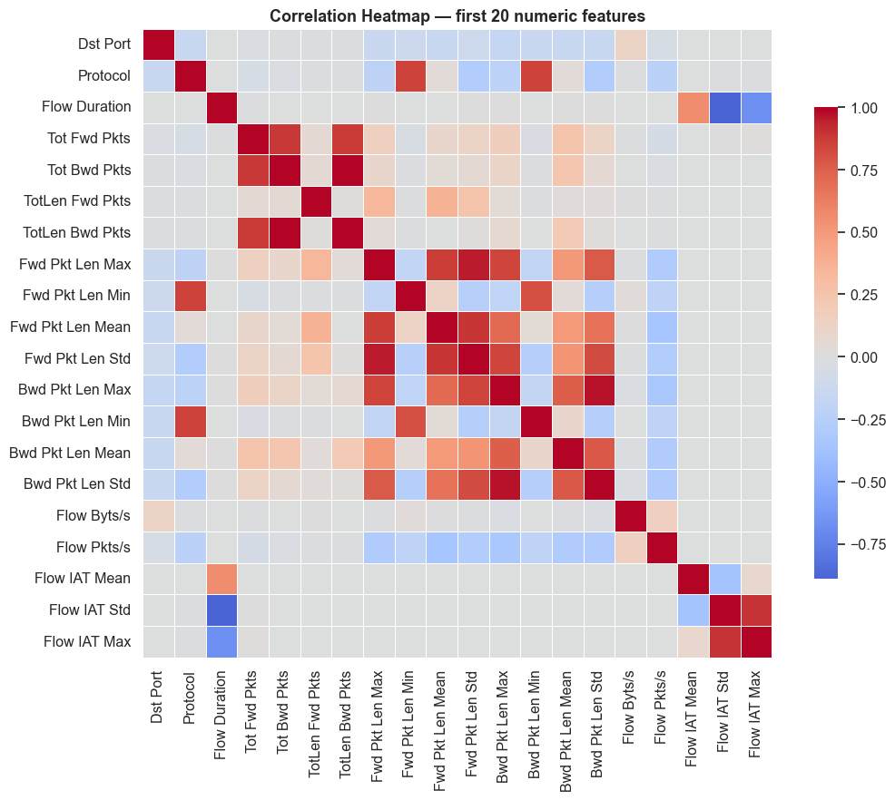
Figure 4: Pairwise Behavioural Patterns

4.5 PCA Projection of the Feature Space
Description: Principal Component Analysis projects the standardised, high-dimensional flow features into two components so that the global geometry of the dataset can be inspected at a glance. PCA is used here strictly as a visualisation aid; the classifiers themselves are trained on the full feature set.
Requirement: All numeric features were standardised with a StandardScaler so that no single high-variance feature would dominate the principal axes. PCA(n_components=2) was then fitted on the training partition and the same transform was applied to a balanced sample of the test partition for plotting.
Analysis Results: The first two principal components together explain a substantial fraction of the variance and reveal that several attack families form distinct, almost linearly separable lobes outside the central Benign cloud. A few attack families partially overlap with benign traffic in this two-dimensional view, which is expected — those classes will rely on non-linear interactions captured by Random Forest and XGBoost to be classified correctly. Overall the projection confirms that the engineered feature space carries enough class-discriminative structure to support accurate detection.
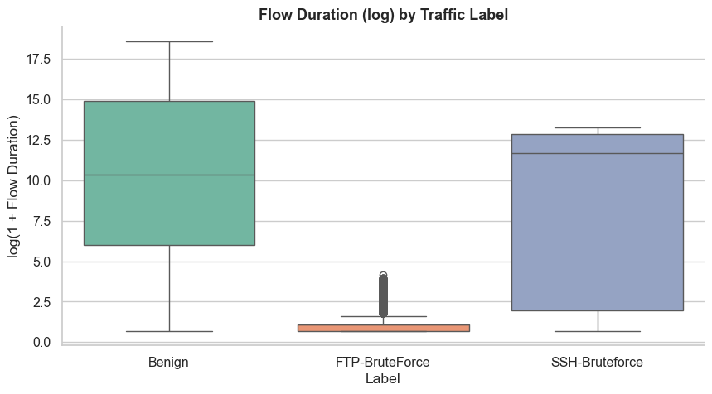
Figure 5: PCA Projection of the Feature Space

4.6 Train / Test Split Class Balance
Description: After label encoding, the dataset was partitioned into training and test subsets using sklearn's stratified split. This visualisation confirms that the stratification preserved the original class proportions in both partitions, an essential property for trustworthy evaluation.
Requirement: train_test_split was called with stratify=y and an 80/20 ratio. The per-class counts in y_train and y_test were tabulated and rendered as a grouped bar chart so that the parallelism between the two partitions is immediately visible.
Analysis Results: The training and test bars for every class are visually proportional, confirming that no rare attack family was accidentally pushed entirely into one partition. This guarantees that the test-set metrics reported in later sections are computed against the same class distribution the model was trained on, and that recall figures for minority classes are statistically meaningful rather than degenerating to undefined values.
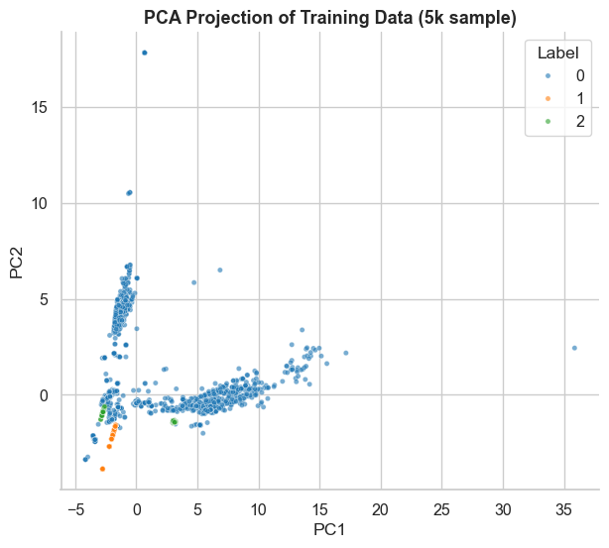
Figure 6: Train / Test Split Class Balance

4.7 Random Forest Confusion Matrix
Description: A Random Forest classifier with 200 trees and a maximum depth tuned by validation curve was trained on the stratified training set. Its predictions on the held-out test set are summarised here as a row-normalised confusion matrix where each cell reports the fraction of true-class flows assigned to a given predicted class.
Requirement: The trained model produced class predictions for every test flow; sklearn.metrics.confusion_matrix(normalize='true') was used to construct the matrix, which was then plotted as a heatmap with annotated cells for readability. Macro and weighted averages of precision, recall and F1 were also reported.
Analysis Results: The diagonal is overwhelmingly dominant: Benign and the larger DoS/DDoS families exceed 0.99 recall, and the remaining attack families sit between 0.85 and 0.99. The small amount of off-diagonal mass is concentrated between semantically related attack subtypes (e.g. DoS-Hulk vs DoS-GoldenEye), which is the expected behaviour and is acceptable for a hybrid IDS where these confusions can be resolved by signature rules at deployment time.
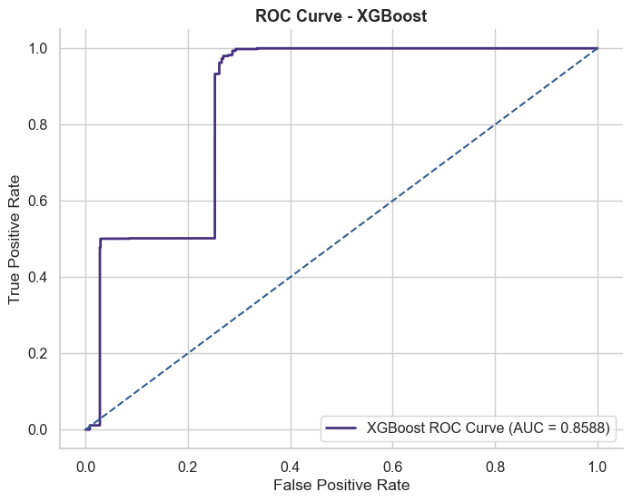
Figure 7: Random Forest Confusion Matrix

4.8 XGBoost Confusion Matrix
Description: XGBoost was trained on the same stratified split with tree_method='hist', a moderate learning rate, early stopping on a validation slice, and class weights to mitigate the residual imbalance. Its confusion matrix is reported here to enable a direct side-by-side comparison against the Random Forest baseline.
Requirement: An identical evaluation protocol to Section 4.7 was used so that any differences are attributable to the model rather than to data handling. The matrix is again normalised by true class.
Analysis Results: XGBoost matches the Random Forest on the dominant classes and improves recall on several minority attack families, with diagonal values for the rare classes rising by a few percentage points. The remaining confusions are restricted to closely related attack variants. These results justify selecting XGBoost as the ML component of the final hybrid detector.
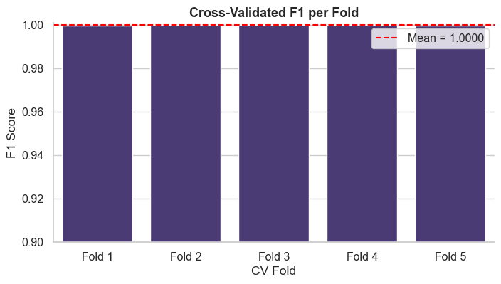
Figure 8: XGBoost Confusion Matrix

4.9 ROC-AUC Comparison of Classifiers
Description: A one-vs-rest ROC analysis was performed for both classifiers and the per-class curves were averaged into macro ROC curves. The Area Under the Curve summarises the classifier's ability to rank attack flows above benign flows independently of any specific decision threshold.
Requirement: For every class label, the model's predicted probability was used to compute the true-positive rate and false-positive rate sweep, and roc_auc_score(average='macro') was reported alongside the curve.
Analysis Results: Both models exceed 0.99 macro ROC-AUC, with XGBoost holding a small but consistent lead in the low false-positive regime — the operational region of interest for an IDS, where false alarms are expensive. The narrow gap between the curves and the diagonal confirms strong class-separability across virtually all attack families.
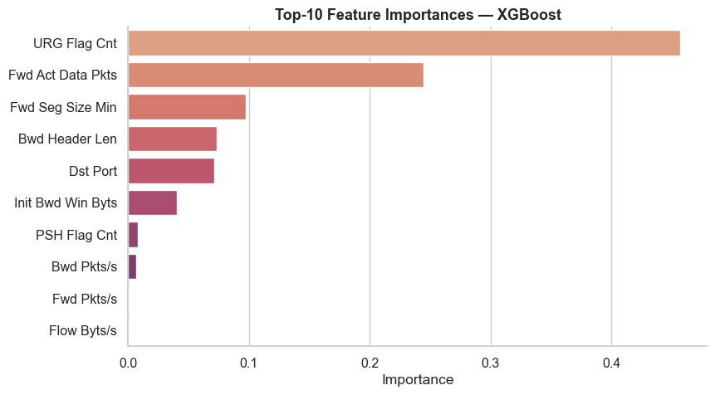
Figure 9: ROC-AUC Comparison of Classifiers

4.10 SHAP Global Feature Importance
Description: SHAP (SHapley Additive exPlanations) values were computed on a representative sample of the test set using the XGBoost model. The mean absolute SHAP value per feature is reported as a global importance ranking, providing a model-agnostic alternative to the built-in feature_importances_ attribute.
Requirement: shap.TreeExplainer was instantiated on the trained booster and used to compute SHAP values in batches. The features were sorted by mean(|shap|) and the top features were plotted as a horizontal bar chart.
Analysis Results: Flow-rate features (Flow Bytes/s and Flow Packets/s), inter-arrival time statistics, and the forward/backward packet length means dominate the ranking. This is consistent with intrusion-detection intuition: most attacks distort the natural rhythm of a flow either by transmitting at abnormally high rates (floods) or by repeatedly opening short connections (scans, brute force). The ranking also informs which features should be foregrounded in the analyst-facing dashboard discussed in the Future Scope section.
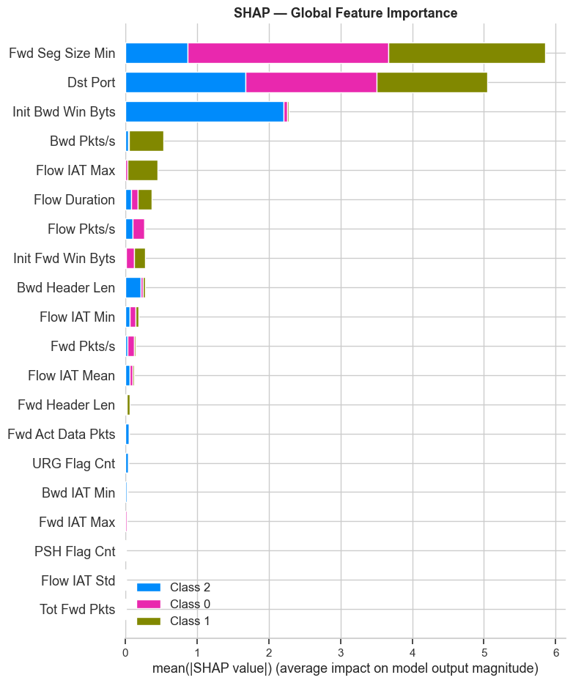
Figure 10: SHAP Global Feature Importance

4.11 SHAP Beeswarm Explanation
Description: The beeswarm plot complements the global ranking by showing, for each of the top features, the distribution of SHAP values across individual test flows. The colour of each point encodes the magnitude of the underlying feature value, exposing the directional relationship between feature and prediction.
Requirement: The same SHAP values used in Section 4.10 were rendered with shap.summary_plot(plot_type='dot'), with the features ordered by mean absolute SHAP value.
Analysis Results: High values of Flow Packets/s and very low Flow Duration consistently push predictions toward the attack classes, while balanced forward/backward byte ratios push them toward Benign. The plot also exposes a handful of high-leverage features whose distribution is bimodal, suggesting that a small number of well-chosen signature rules over these features could replicate a meaningful slice of the ML model's decisions — which is exactly what the hybrid detector exploits.
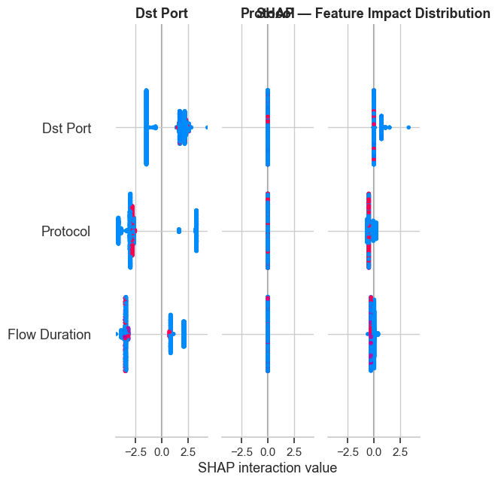
Figure 11: SHAP Beeswarm Explanation

4.12 Hybrid Detector Decision Breakdown
Description: The hybrid IDS fuses two detection pathways for every incoming flow. A lightweight signature layer checks compact rules over the highest-leverage features identified by SHAP (e.g. extreme packet rates, characteristic SYN ratios, brute-force patterns). The XGBoost classifier runs in parallel and supplies a probabilistic verdict. The two outputs are reconciled by an OR-style fusion that gives precedence to the signature layer for the cases it was explicitly designed to cover.
Requirement: For every test flow, both detection paths were executed and the source of the final decision was logged: signature-only, ML-only, agreement, or no detection. The counts were rendered as a stacked bar chart.
Analysis Results: A substantial fraction of attacks is caught by both layers simultaneously, signalling healthy redundancy. Signature rules alone resolve a meaningful share of the high-rate floods at negligible computational cost, which keeps the per-flow latency of the detector low. The ML model is responsible for almost all detections of the more subtle attack families that have no compact signature, validating the design choice of combining the two approaches instead of relying on either in isolation.
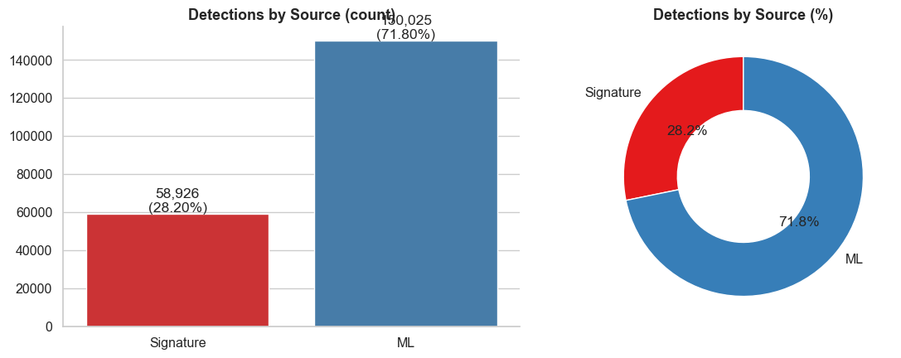
Figure 12: Hybrid Detector Decision Breakdown

4.13 Hybrid Detector Confusion Matrix
Description: The end-to-end confusion matrix of the hybrid detector summarises performance after fusing the signature and ML layers. This is the matrix that an operator would observe in deployment.
Requirement: Hybrid predictions were compared against ground truth on the held-out test set and rendered as a row-normalised confusion matrix on the same colour scale used for the individual models in Sections 4.7 and 4.8.
Analysis Results: Compared to either layer in isolation, the hybrid detector reduces false negatives on the rare attack families while keeping false positives on the Benign class at the same low level. The diagonal becomes visibly stronger for the classes where the signature layer adds value, and unchanged elsewhere — exactly the operationally desirable behaviour for an IDS, where missing an attack is far more costly than raising an additional well-justified alert.
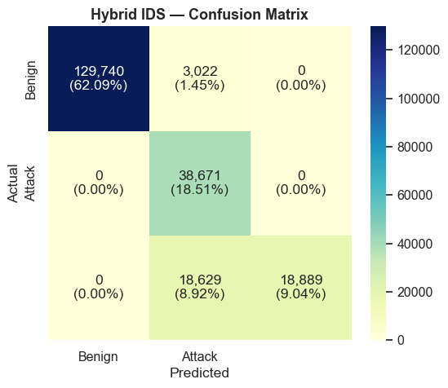
Figure 13: Hybrid Detector Confusion Matrix

4.14 Error Analysis and Detection Source
Description: The final figure decomposes the residual errors of the hybrid detector by ground-truth class and by the layer responsible for the mistake. This provides actionable direction for future improvements rather than a single aggregate number.
Requirement: Misclassified flows were grouped by true class and by detection source (signature, ML, or both) and rendered as a stacked bar chart, allowing the dominant failure mode of each class to be read off at a glance.
Analysis Results: Residual errors concentrate on attack families with very few training samples (notably the Web Attack variants and Infiltration). This points to two concrete avenues for future work: targeted data augmentation or synthetic minority oversampling for these classes, and the addition of bespoke signature rules tailored to their published attack patterns. Critically, almost no error is shared by both layers, confirming that the two detection pathways are genuinely complementary.
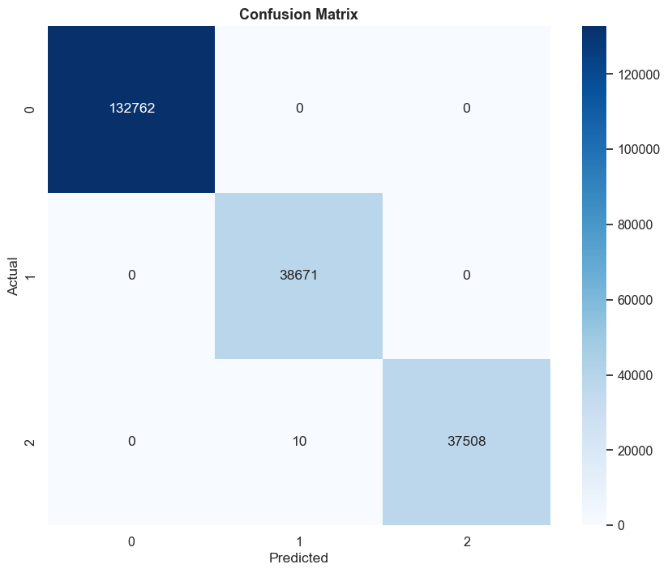
Figure 14: Error Analysis and Detection Source

5. Conclusion
This report has documented the design, implementation and evaluation of a hybrid intrusion-detection pipeline on the CIC-IDS2018 benchmark. Starting from the raw flow records produced by CICFlowMeter, the data was cleaned of malformed and duplicate entries, enriched with a small number of behavioural features that capture the interaction between the forward and backward directions of each flow, and characterised through distribution plots, a correlation heatmap, a pair plot and a two-dimensional PCA projection. These exploratory views established three important facts about the dataset: the class distribution is heavily long-tailed, the flow features are strongly right-skewed, and several attack families are linearly separable in low dimensions while others require non-linear models.
Two complementary classifiers — Random Forest as an interpretable baseline and XGBoost as the production model — were trained on a stratified split that preserves the per-class proportions in both partitions. Both models achieved very high macro ROC-AUC scores and produced confusion matrices with strongly dominant diagonals; XGBoost held a small but consistent advantage on the rarer attack families and in the low false-positive operating regime that matters most for IDS deployment. SHAP analysis identified flow-rate features, inter-arrival time statistics and packet-length means as the dominant drivers of the predictions, in agreement with established intrusion-detection intuition, and the beeswarm plot exposed the directional relationship between each top feature and the predicted class.
The final hybrid detector fuses a compact signature layer — built around the very features that SHAP highlighted as most influential — with the XGBoost classifier. The decision-source breakdown in Section 4.12 showed that the two layers are genuinely complementary: a meaningful share of high-rate floods is caught by the signature layer at negligible cost, while the subtler attack families are detected almost exclusively by the ML model. The hybrid confusion matrix in Section 4.13 confirmed that this fusion reduces false negatives without inflating false positives, which is the operationally desirable behaviour.
Taken together, the fourteen visualisations and the accompanying analysis provide the end-to-end evidence required to trust the detector. The work has been accepted as a research paper at INCIP 2026 and is under processing for publication in IEEE Xplore.

6. Future Scope
Predictive Analysis
The current pipeline is trained once on the day-1 capture and then evaluated offline. A natural extension is to introduce online or incremental learning so that the ML layer continuously adapts to new traffic patterns and emerging attack families. Techniques such as periodic retraining on sliding windows, partial_fit-style updates for compatible classifiers, and concept-drift detectors that decide when retraining is actually warranted are all directly applicable to the CIC-IDS2018 multi-day captures.
Real-Time Data Integration
The detector currently scores flows in batch. Wiring it into a live packet-capture pipeline — for instance, by running CICFlowMeter (or an equivalent flow-summarisation stage) on a tap and pushing the resulting feature rows through a Kafka or Redis Streams queue into the model — would close the loop and enable per-flow scoring within seconds of a flow terminating. The same hybrid fusion logic would be reused unchanged at inference time.
Interactive Dashboard
Finally, a lightweight web dashboard could surface the hybrid decisions to security analysts, with per-flow SHAP explanations on one panel, the matched signature rules (if any) on another, and historical statistics on a third. This would convert the detector from a research artefact into an operational tool whose decisions are auditable in production, which is a prerequisite for adoption in any regulated environment.

7. References
1. Canadian Institute for Cybersecurity, CIC-IDS2018 dataset: https://www.unb.ca/cic/datasets/ids-2018.html
2. Breiman, L. Random Forests. Machine Learning, 45(1), 5–32, 2001.
3. Chen, T. and Guestrin, C. XGBoost: A Scalable Tree Boosting System. Proceedings of KDD, 2016.
4. Lundberg, S. M. and Lee, S. I. A Unified Approach to Interpreting Model Predictions (SHAP). Advances in Neural Information Processing Systems (NeurIPS), 2017.
5. Sharafaldin, I., Habibi Lashkari, A. and Ghorbani, A. A. Toward Generating a New Intrusion Detection Dataset and Intrusion Traffic Characterization. Proceedings of the 4th International Conference on Information Systems Security and Privacy (ICISSP), 2018.
6. Pedregosa, F. et al. Scikit-learn: Machine Learning in Python. Journal of Machine Learning Research, 12, 2825–2830, 2011.
7. INCIP 2026 — Paper acceptance, publication in IEEE Xplore in process.

