E-Commerce Customer Segmentation
& Behavioral Analysis
Data Analytics Assignment Report
Dataset: eCommerce_Customer_Segmentation_Excel_Project.xlsx
Source worksheet analyzed: Customer_Data
Records analyzed: 100

1. Executive Summary
This report presents a practical customer segmentation analysis for an eCommerce business using a simulated/small customer dataset containing 100 records from the uploaded Excel workbook. The objective is to group customers with similar characteristics and purchasing behavior so that marketing, retention, and customer experience activities can be more targeted.
The analysis combines commonly used retail segmentation ideas—customer value, purchase frequency, recency where available, and demographic/contextual characteristics—with a simple, interpretable segment framework. The resulting segments are then compared using customer counts and behavioral metrics.

2. Task Objective
The objective of this assignment is to explore customer data analytics by creating a segmented analysis of different customer groups for an eCommerce platform. Publicly available customer segmentation theories and retail analytics practices are used as a conceptual foundation, while the uploaded dataset is used to simulate the practical analysis process.

3. Research: Customer Segmentation in eCommerce
Customer segmentation divides a broad customer base into smaller groups that share similar characteristics or behaviors. In eCommerce, segmentation is commonly used for personalized campaigns, customer retention, cross-selling, product recommendations, pricing decisions, and budget allocation.
Segmentation dimension | Typical variables | Business use
Demographic | Age, gender, income, location | Target audience definition
Value / purchasing | Spend, order value, purchase frequency | VIP and value-based marketing
Behavioral | Recency, product/category preference, response to offers | Retention and personalized offers
Digital / channel | Device, channel, website/app activity | Channel optimization
Lifecycle | Tenure, new vs. repeat customer, inactive period | Lifecycle campaigns

4. Data Source and Dataset Description
The analysis was performed using the uploaded Excel workbook 'eCommerce_Customer_Segmentation_Excel_Project(1).xlsx'. The worksheet selected for analysis was 'Customer_Data', containing 100 customer records.
Key Dataset Fields
Field | Role in analysis
Customer ID | Customer identifier or customer attribute
Age | Customer characteristic / behavioral measure
Gender | Customer characteristic / behavioral measure
Location | Customer characteristic / behavioral measure
Preferred Category | Customer characteristic / behavioral measure
Orders | Customer characteristic / behavioral measure
Average Order Value | Customer characteristic / behavioral measure
Total Spend | Customer characteristic / behavioral measure
Days Since Last Purchase | Customer characteristic / behavioral measure
Website Visits | Customer characteristic / behavioral measure

5. Methodology
The analysis followed a structured data analytics workflow: understand the available fields, validate numeric variables, define segmentation criteria, assign customers to interpretable groups, compare segment sizes and behavioral measures, and translate the results into business actions.
- Data understanding – reviewed worksheet structure, columns, and number of customer records.
- Data preparation – converted relevant numeric fields into numeric format and handled unavailable measures without inventing values.
- Segmentation framework – prioritized customer value and purchasing behavior, with recency used where available.
- Segment profiling – compared customer counts, percentage contribution, spending, and purchase activity.
- Behavioral interpretation – identified which groups appear valuable, growth-oriented, or at risk.
- Marketing recommendations – connected each segment to practical eCommerce strategies.

6. Segmentation Framework Development
For a small eCommerce dataset, an interpretable value-and-behavior framework is preferable to an overly complex clustering model. Customers are classified into three practical groups:
Segment | General criteria | Rationale
High Value / Loyal | Higher spend and/or purchase activity; strong relationship with the platform | Protect revenue and strengthen loyalty
Regular / Growth | Moderate engagement and value; potential to increase frequency or basket size | Convert promising customers into high-value customers
Low Value / At Risk | Lower value/activity and/or signs of reduced engagement where recency is available | Reduce churn risk and reactivate customers

7. Segmentation Results
Segment Size
Segment | Customers | Share of customers (%)
Regular / Growth | 42 | 42.0
Low Value / At Risk | 31 | 31.0
High Value / Loyal | 27 | 27.0

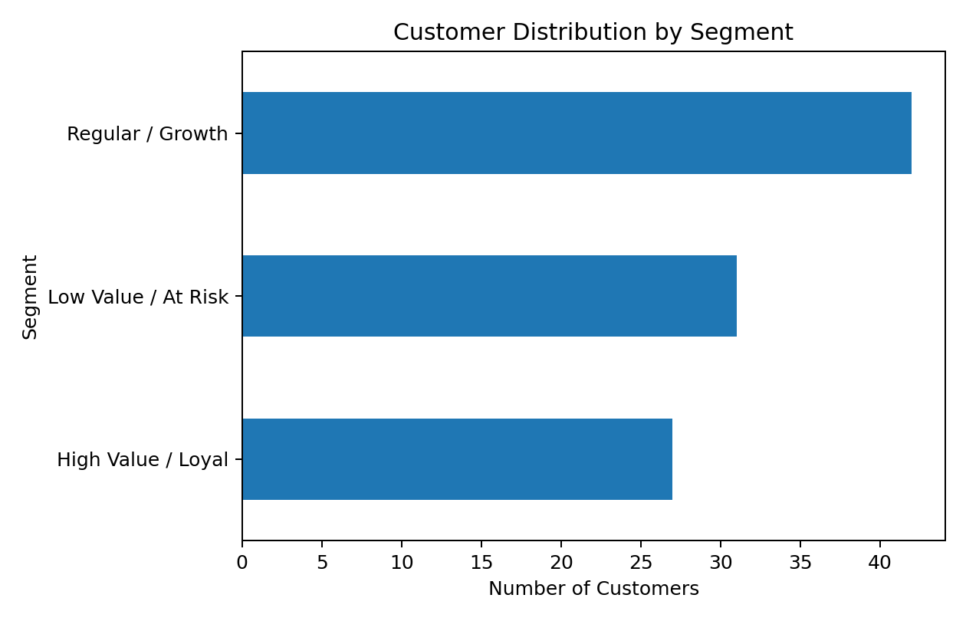

8. Behavioral Analysis and Interpretation
Spend Profile by Segment
Segment | Average Spend | Median Spend | Total Spend
High Value / Loyal | 34954.96 | 33943.0 | 943784
Low Value / At Risk | 5634.71 | 3304.0 | 174676
Regular / Growth | 19185.52 | 17002.5 | 805792

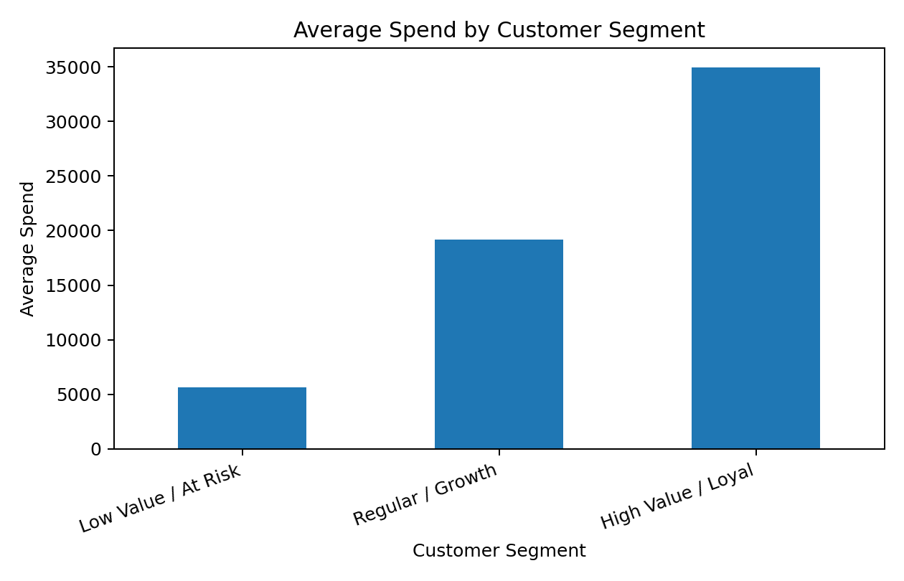
Purchase Activity by Segment
Segment | Average Orders/Purchases | Median Orders/Purchases | Total Orders/Purchases
High Value / Loyal | 11.81 | 12.0 | 319
Low Value / At Risk | 2.94 | 3.0 | 91
Regular / Growth | 7.6 | 7.5 | 319

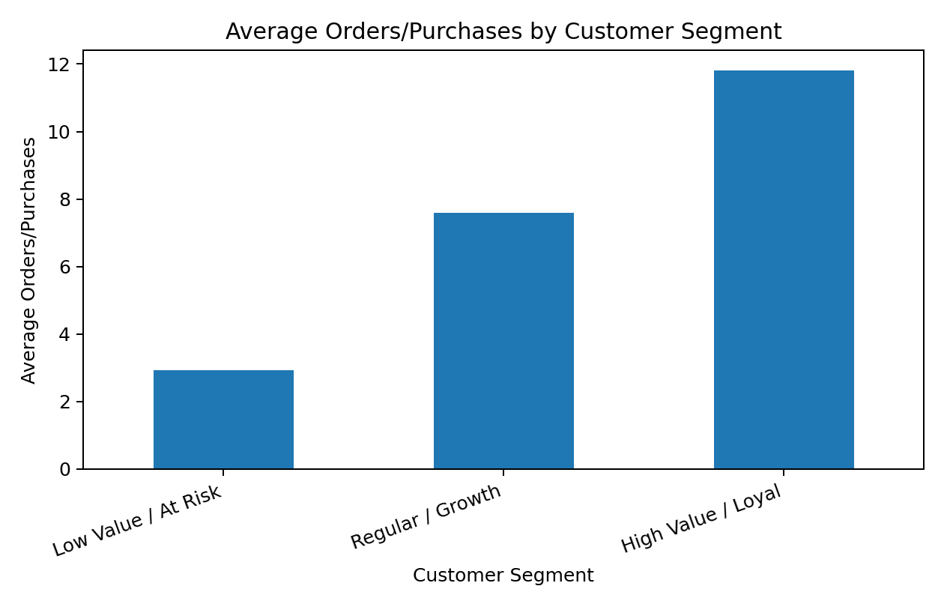

9. Demographic and Customer Profile Analysis
Age Profile by Segment
Segment | Average Age | Median Age
High Value / Loyal | 36.63 | 35.0
Low Value / At Risk | 38.23 | 39.0
Regular / Growth | 39.36 | 41.0

Gender Distribution by Segment
segment | Female | Male
High Value / Loyal | 11 | 16
Low Value / At Risk | 13 | 18
Regular / Growth | 16 | 26

Location Distribution by Segment
segment | Bengaluru | Delhi | Hyderabad | Mumbai | Patna | Pune
High Value / Loyal | 4 | 5 | 3 | 3 | 8 | 4
Low Value / At Risk | 7 | 2 | 4 | 6 | 6 | 6
Regular / Growth | 7 | 1 | 6 | 13 | 6 | 9

10. Key Findings
The largest customer segment is 'Regular / Growth', representing 42.0% of the dataset. The smallest segment is 'High Value / Loyal', representing 27.0%.
'High Value / Loyal' has the highest average spend among the identified segments, making this group particularly important for retention and value expansion.
'High Value / Loyal' has the highest average purchase/order activity, suggesting stronger engagement and a greater opportunity for loyalty or cross-sell initiatives.
Because the dataset is intentionally small and simulated for learning purposes, these findings should be treated as directional rather than as statistically representative of a real eCommerce customer base.

11. Hypotheses and Simulation
- H1: Customers with higher purchase activity are more likely to belong to the high-value segment.
- H2: Higher customer value can be used to prioritize retention and loyalty investment.
- H3: Regular/growth customers can increase future value through personalized recommendations and incentives.
- H4: Lower-activity customers can be targeted with reactivation campaigns before they become permanently inactive.

12. Recommended Marketing Strategies
Segment | Recommended actions | Primary KPI
High Value / Loyal | VIP benefits, loyalty rewards, early access, premium support, cross-sell | Retention rate / CLV
Regular / Growth | Personalized recommendations, bundles, threshold-based offers, loyalty points | Repeat purchase rate / AOV
Low Value / At Risk | Reactivation emails, limited-time offers, product reminders, feedback surveys | Reactivation rate / churn

13. Suggested eCommerce Dashboard
The analysis can be converted into an interactive Excel or Power BI dashboard. A recommended layout is:
- Top KPI cards: Total Customers, Total Spend/Revenue, Average Spend, Average Orders, and Segment Count.
- Segment distribution chart: number and percentage of customers by segment.
- Value comparison: average/total spend by segment.
- Purchase behavior: average orders or transactions by segment.
- Demographic slicers: age group, gender, income group, location, or other available attributes.
- Customer-level table: customer ID, segment, spend, purchase frequency, and recency where available.

14. Limitations
- The dataset is small and intended for educational simulation rather than production decision-making.
- Public benchmark theories are used as conceptual guidance; they are not direct measurements of this specific business.
- Customer segmentation quality depends on the availability and quality of behavioral variables.
- More advanced projects could use RFM scoring, K-means clustering, cohort analysis, CLV, churn modeling, and statistical validation.

15. Conclusion
Customer segmentation helps an eCommerce business move from one-size-fits-all marketing toward targeted customer strategies. In this project, the customer base was divided into interpretable groups based on value and purchasing behavior, and the groups were profiled using available customer attributes.
The main practical lesson is that segmentation is not only about creating groups; the real business value comes from understanding why groups behave differently and deciding what action should be taken for each group. High-value customers should be retained and rewarded, growth customers should be developed, and lower-value or at-risk customers should receive relevant reactivation efforts.

Appendix A: Technical Notes
Tools used: Microsoft Excel for the source dataset and analysis structure; Python was used only to generate this formatted report and its charts from the uploaded workbook.
Workbook sheets detected: Customer_Data, Segmentation, Analysis, Dashboard, Methodology, README
Analyzed worksheet: Customer_Data
Number of customer records analyzed: 100
Available fields: Customer ID, Age, Gender, Location, Preferred Category, Orders, Average Order Value, Total Spend, Days Since Last Purchase, Website Visits

