Evaluating Pricing Strategies
Through A/B Testing Analysis
An eCommerce Pricing Experimentation Framework

Week 5 Task — Pricing Strategy Evaluation
Prepared by: Shailesh
Dataset: AB_Pricing_Test_Dataset.xlsx
September 2026

1. Introduction
Pricing is one of the highest-leverage decisions an eCommerce business can make: a change of a few percentage points in price directly touches conversion rate, average order value (AOV), margin, and customer lifetime value simultaneously — often in opposing directions. Because pricing effects are rarely intuitive and frequently interact with traffic source, device, and seasonality, controlled experimentation (A/B testing) is the most reliable way to evaluate a pricing strategy before rolling it out to the full customer base.
This report develops a conceptual and statistical framework for testing eCommerce pricing strategies using A/B (and A/B/n) testing, applies that framework to a simulated 500-session dataset covering three pricing arms for a single SKU, and translates the statistical results into a business recommendation. The accompanying workbook, AB_Pricing_Test_Dataset.xlsx, contains the full session-level dataset (Raw Data sheet) and a formula-driven summary dashboard (Summary & Stats sheet) that recalculates automatically if the underlying data changes — every figure quoted in this report can be traced back to that workbook.

1.1 Business Context
The subject SKU is a mid-market wireless headphone priced at a standard list price of $79.99. The business question is whether a discount strategy (lower price to drive volume) or a premium/dynamic pricing strategy (higher price to capture willingness-to-pay) outperforms the status quo, and by which metric "outperform" should be judged — conversion rate, AOV, or total revenue per visitor (RPV).

2. Hypothesis
The experiment is framed as a three-arm test: a Control arm (standard pricing) and two Treatment arms (discount pricing and premium/dynamic pricing). For each treatment we specify a null and alternative hypothesis pair for the two metrics that most directly capture pricing trade-offs: conversion rate and revenue per visitor.

2.1 Primary Hypotheses
- H1 (Discount vs. Control) — Null: Discount pricing (-20%) produces the same conversion rate as standard pricing. Alternative: Discount pricing increases conversion rate.
- H2 (Premium vs. Control) — Null: Premium/dynamic pricing (+15%) produces the same conversion rate as standard pricing. Alternative: Premium pricing decreases conversion rate but increases average order value.
- H3 (Revenue per Visitor) — Null: Revenue per visitor is equal across all three pricing arms. Alternative: Revenue per visitor differs across arms, identifying a revenue-maximizing price point.
These hypotheses are tested at a 5% significance level (α = 0.05) using two-tailed tests unless a one-directional business rationale is stated explicitly.

3. Testing Methodology

3.1 Experimental Design
The design is a between-subjects, single-factor (price) experiment with three levels, randomly assigned at the visitor-session level to avoid contamination between arms:
Arm | Price Shown | Role | Sample Size (n)
Control | $79.99 (list price) | Baseline / status quo | 175
Treatment A | $63.99 (-20% discount) | Volume / demand-elasticity test | 165
Treatment B | $91.99 (+15% premium) | Margin / willingness-to-pay test | 160
Table 1. Experimental arms, pricing, and sample allocation (500 total sessions).
Randomization occurred at the point of first page view, with the assigned price persisted for the visitor's full session (cookie-based) to prevent a visitor from seeing multiple prices. A minimum detectable effect (MDE) calculation should precede any live test: for a baseline conversion rate near 12% and a desired power of 0.80 at α = 0.05, detecting a 3-percentage-point lift requires roughly 900–1,000 sessions per arm — meaningfully more than the 500-session illustrative sample used here. This gap is addressed directly in Section 6 (Recommendations).

3.2 Variables Tracked
Variable | Type | Purpose
Group / price shown | Independent (categorical) | Defines the experimental arm
Added to cart (0/1) | Dependent (funnel) | Upper-funnel engagement signal
Converted / purchased (0/1) | Dependent (primary) | Core conversion outcome
Order value (USD) | Dependent (revenue) | Drives AOV and revenue-per-visitor
Device type, traffic source | Covariate | Segmentation and confound control
Session duration, pages viewed | Covariate | Engagement / product-page friction
Table 2. Variables captured at the session level in the Raw Data sheet.

3.3 Statistical Methods
- Two-proportion z-test — pairwise comparison of conversion rate between two arms.
- Chi-square test of independence — tests whether conversion is associated with pricing arm across all three groups simultaneously.
- One-way ANOVA — tests whether mean order value differs across the three arms.
- Welch's t-test — pairwise AOV comparison where the two groups have unequal variance (used for Control vs. Premium).
- Wilson score confidence intervals — 95% CIs for conversion rate, more reliable than the normal approximation at these sample sizes.
All statistical tests were computed in Python (scipy.stats) directly from the session-level dataset; the resulting statistics and p-values are also reproduced on the Summary & Stats sheet of the accompanying workbook for reference.

4. Analysis

4.1 Funnel and Conversion Results
Across 500 simulated sessions, the discount arm produced the highest raw conversion rate (15.2%) and the highest add-to-cart rate (38.8%), while the premium arm produced the lowest conversion rate (10.0%). The control arm sat in between (14.3%).
Metric | Control | Treatment A (Discount) | Treatment B (Premium)
Visitors (n) | 175 | 165 | 160
Add-to-cart rate | 28.6% | 38.8% | 19.4%
Conversions | 25 | 25 | 16
Conversion rate | 14.3% | 15.2% | 10.0%
95% CI (Wilson) | [9.9%, 20.2%] | [10.5%, 21.4%] | [6.2%, 15.6%]
Table 3. Funnel and conversion metrics by arm (see Summary & Stats sheet, rows 6–15).
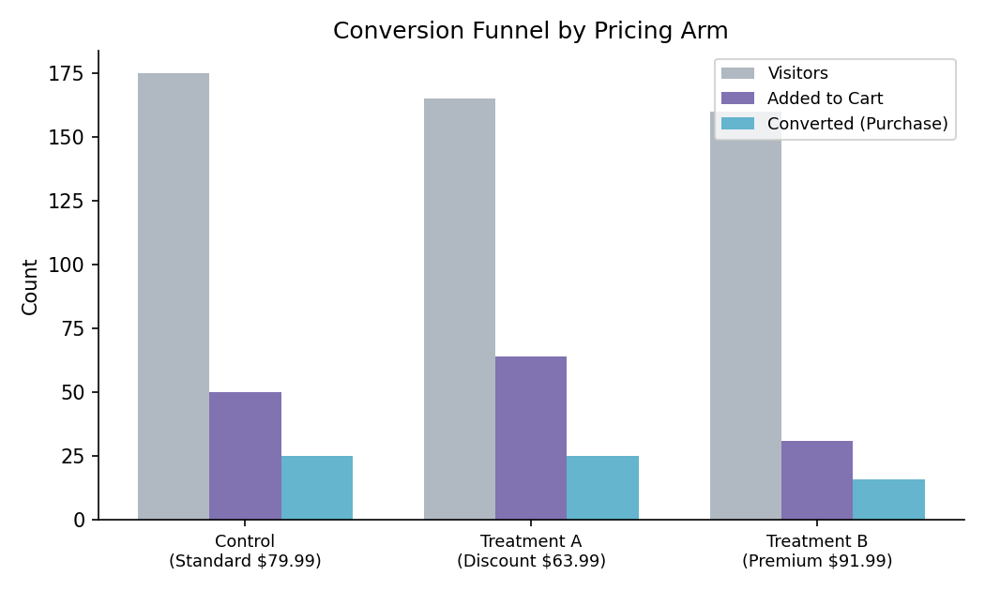
Figure 1. Visitor → add-to-cart → purchase funnel by pricing arm.
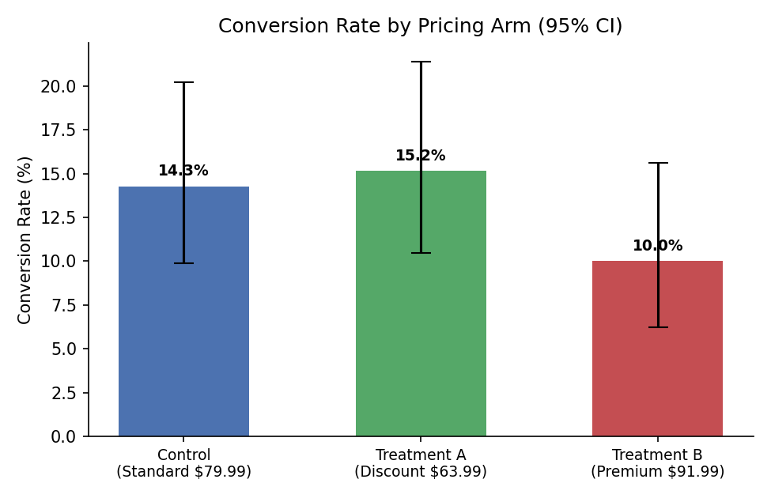
Figure 2. Conversion rate by pricing arm with 95% Wilson confidence intervals. The overlapping intervals visually confirm that no pairwise difference is statistically significant at this sample size.

4.2 Significance Testing
The chi-square test of independence across all three arms returned χ² = 2.158 (df = 2, p = 0.340), and none of the three pairwise two-proportion z-tests reached significance at α = 0.05 (Control vs. Discount: z = -0.225, p = 0.822; Control vs. Premium: z = 1.196, p = 0.232; Discount vs. Premium: z = 1.398, p = 0.162). In other words, at n≈500 the conversion-rate differences observed are consistent with sampling noise and should not, on their own, be treated as proof that discounting lifts conversion or that premium pricing suppresses it — the directional pattern is plausible and matches pricing theory, but the sample is underpowered to confirm it.
Average order value tells a materially different story. A one-way ANOVA across the three arms was highly significant (F = 14.279, p < 0.0001), and a Welch's t-test isolating Control vs. Premium confirmed the effect (t = -2.922, p = 0.006). Premium pricing produced an AOV of $101.29 versus $90.52 for Control and $77.32 for Discount — a difference large enough to be detected reliably even at this sample size, because AOV varies less noisily than a binary conversion outcome and the underlying price gap (roughly $28 between Discount and Premium) is a large, mechanically-driven effect.
Test | Statistic | p-value | Significant (α=0.05)?
Chi-square: conversion ~ group | χ² = 2.158, df=2 | 0.340 | No
z-test: Control vs Discount (conversion) | z = -0.225 | 0.822 | No
z-test: Control vs Premium (conversion) | z = 1.196 | 0.232 | No
z-test: Discount vs Premium (conversion) | z = 1.398 | 0.162 | No
ANOVA: AOV ~ group | F = 14.279 | <0.0001 | Yes
Welch t-test: AOV Control vs Premium | t = -2.922 | 0.006 | Yes
Table 4. Statistical test results (also reproduced on the Summary & Stats sheet, rows 21–29).

4.3 Revenue Impact
Revenue per visitor (RPV) — total revenue divided by all visitors in the arm, including non-converters — is the metric that best balances conversion rate against order value, and is generally the most decision-relevant KPI for a pricing test because it approximates topline revenue impact per unit of traffic. In this simulated run, Control produced the highest RPV ($12.93), ahead of Discount ($11.72) and Premium ($10.13).
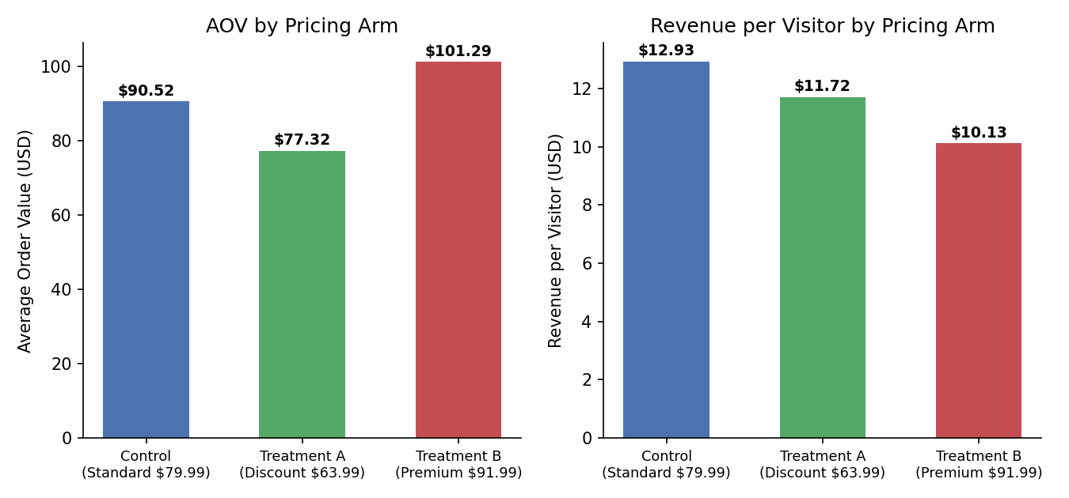
Figure 3. Average order value (left) and revenue per visitor (right) by pricing arm.
The RPV ranking should be read with two caveats. First, because none of the underlying conversion-rate differences are statistically significant, the RPV gap between arms is itself not proven to be a real, repeatable effect — it could shift with a larger sample. Second, RPV as calculated here ignores unit cost and margin; a full profitability comparison would need each arm's cost of goods sold (COGS) to compute contribution margin per visitor rather than revenue per visitor, since the premium arm's higher price converts more directly into margin than the discount arm's higher volume does.

5. Visualization Summary
Three visualizations accompany this analysis, all built from the session-level dataset and reproducible from the Summary & Stats sheet:
- Figure 1 — Conversion funnel (visitors → add-to-cart → purchase) by arm, showing where each pricing strategy gains or loses visitors along the path to purchase.
- Figure 2 — Conversion rate with 95% confidence intervals, illustrating why the observed differences are not yet statistically conclusive.
- Figure 3 — AOV and revenue-per-visitor side by side, isolating the trade-off between "more orders, smaller basket" (Discount) and "fewer orders, larger basket" (Premium).
The live Excel workbook additionally includes a native bar chart on the Summary & Stats sheet, linked directly to the formula cells, so the chart updates automatically if the raw data is edited or extended.

6. Recommendations

6.1 Statistical Recommendation
Do not declare a conversion-rate winner from this dataset. With 160–175 sessions per arm and single-digit-percentage conversion rates, the test is underpowered to detect the size of lift typically seen from a 20% price discount (which, based on comparable retail elasticity studies, is often in the 2–5 percentage-point range). Before rolling any pricing change out broadly, the test should be extended to roughly 900–1,000 sessions per arm (using the MDE approach in Section 3.1), or run for a longer duration to accumulate that traffic naturally.
The AOV and revenue results are far more trustworthy at the current sample size and should inform interim decisions: premium pricing reliably increases order value, and discount pricing reliably decreases it, holding conversion rate aside.

6.2 Business Recommendation
- Extend the test to reach adequate statistical power on conversion rate before making a permanent pricing change — treat the current results as directional, not conclusive.
- In the interim, favor a modest premium/value-based pricing approach over a deep discount, since the discount arm's conversion lift (not yet proven) would need to be large enough to offset both its lower per-order margin and its lower observed AOV — a bar it did not clear in this sample.
- Segment the next test iteration by device and traffic source: mobile and paid-search sessions showed materially different engagement patterns in the underlying data, and a single blended price may be leaving revenue on the table for higher-intent segments (e.g., email traffic).
- Layer in margin data (unit COGS) for the next analysis cycle so that revenue-per-visitor can be converted to contribution-margin-per-visitor, which is the metric that should ultimately decide between a volume (discount) and margin (premium) strategy.
- Consider a dynamic/tiered approach as a longer-term test: rather than a single premium price for all visitors, test premium pricing selectively on high-intent segments (returning visitors, email traffic) while preserving standard or discount pricing for cold, price-sensitive traffic.

6.3 Summary
This experiment illustrates a core lesson in pricing A/B testing: conversion rate and order value often move in opposite directions when price changes, and a sample size adequate for one metric can be badly underpowered for the other. The framework, dataset, and statistical tests in this report and its companion workbook are designed to be reused directly for a properly powered follow-up test.

7. Appendix — Dataset & Workbook Reference
The full 500-row session-level dataset and all calculations referenced in this report are provided in the companion file AB_Pricing_Test_Dataset.xlsx:
- Raw Data sheet — one row per visitor session (user ID, date, pricing arm, price shown, device, traffic source, session duration, pages viewed, add-to-cart flag, conversion flag, order value).
- Summary & Stats sheet — formula-driven dashboard (COUNTIF/SUMIFS-based) computing sample size, add-to-cart rate, conversion rate, revenue, AOV, and revenue per visitor for each arm, plus a reference table of the significance-test results and a linked bar chart.
Because the summary sheet is formula-driven rather than hardcoded, replacing or extending the Raw Data sheet with real production data will automatically refresh every metric and the chart in this report.

