CUSTOMER MARKETING ANALYSIS
Final Project Report
Data Cleaning • SQL Exploratory Analysis • Power BI Dashboard • Business Insights

Prepared by: Shailesh Kumar Verma
Dataset: Customer Marketing Campaign Data (2,240 customers)
September 2026

Problem Statement & Objectives

Business Context

A retail-style business runs periodic marketing campaigns and needs a clear, data-driven understanding of who its customers are, what they buy, and how they respond to marketing efforts. Without a clear understanding of customer behaviour, it can be difficult to identify relevant customer segments and evaluate campaign response effectively.

Problem Statement
The organisation has raw customer marketing data containing demographic details, purchase history and campaign response records, but the data has quality issues (missing income values, potential outliers) and has never been structured into a format that supports quick, visual decision-making. There is a need to clean this data, analyse it, and present it through an interactive dashboard that management can use to understand customer behaviour and campaign performance at a glance.

Objectives
- Clean and validate the raw dataset so it is reliable for analysis (handle missing values, check duplicates and anomalies).
- Use SQL to explore the data and answer key business questions about customers, spending and campaigns.
- Build an interactive, multi-page Power BI dashboard with KPIs, charts and slicers for self-service exploration.
- Translate the numbers into written business insights that non-technical stakeholders can act on.
- Document the full workflow — from raw data to final insight — as a complete, presentable project.

Dataset Information

The project uses a customer marketing campaign dataset containing 2,240 customer records and 29 columns. The data was prepared and validated before being analyzed in MySQL and visualized in Power BI.

Column Groups
Category | Example Columns
Identifiers | ID
Demographics | Year_Birth, Age, Education, Marital_Status, Income
Household | Kidhome, Teenhome, Dt_Customer
Product Spending | MntWines, MntFruits, MntMeatProducts, MntFishProducts, MntSweetProducts, MntGoldProds
Purchase Behaviour | NumDealsPurchases, NumWebPurchases, NumCatalogPurchases, NumStorePurchases, NumWebVisitsMonth
Campaign Response | AcceptedCmp1–5, Response
Other | Recency, Complain, Z_CostContact, Z_Revenue

Key Facts
- Total records: 2,240 customers
- Total columns: 29
- Formats used across the project: CSV, Excel (.xlsx), and a SQL database table
- Project workflow: Data Preparation → SQL Exploratory Analysis → Power BI Dashboard

Data Cleaning & Data Quality
Before any analysis, the dataset was loaded into MySQL and checked systematically for structural and quality issues.

Cleaning Steps Performed
- Verified the full row count on import to confirm all 2,240 customer records loaded correctly.
- Checked for duplicate customers by grouping on ID and flagging any ID appearing more than once.
- Checked the Income column for missing or blank values (empty strings and whitespace-only entries).
- Temporarily converted Income to text (VARCHAR) so blank/whitespace values could be identified and standardised.
- Updated blank Income entries to proper NULLs, then converted the column back to a numeric DECIMAL(12,2) type.
- Re-checked the row count and the missing-Income count after cleaning to confirm no records were lost.
- Screened for anomalies such as unrealistic ages (Age > 100) and unusually high Income values.

Result
After cleaning, the dataset retained all 2,240 customer records. The 24 missing Income values were converted to proper NULL values rather than being replaced with an estimated value. The Income column was then converted back to a numeric DECIMAL format for analysis, making it reliable for the exploratory analysis and dashboard that followed.

Data Quality Summary
Check |  |  |  |  |  |  |  |  |  |  |  |  |  |  |  |  |  |  |  |  |  |  |  |  |  |  |  |  |  |  |  |  |  |  |  |  |  |  | Result
Total Customers |  |  |  |  |  |  |  |  |  |  |  |  |  |  |  |  |  |  |  |  |  |  |  |  |  |  |  |  |  |  |  |  |  |  |  |  |  |  | 2,240
Duplicate IDs |  |  |  |  |  |  |  |  |  |  |  |  |  |  |  |  |  |  |  |  |  |  |  |  |  |  |  |  |  |  |  |  |  |  |  |  |  |  | 0
Missing Income |  |  |  |  |  |  |  |  |  |  |  |  |  |  |  |  |  |  |  |  |  |  |  |  |  |  |  |  |  |  |  |  |  |  |  |  |  |  | 24
Age > 100 |  |  |  |  |  |  |  |  |  |  |  |  |  |  |  |  |  |  |  |  |  |  |  |  |  |  |  |  |  |  |  |  |  |  |  |  |  |  | 3 records
Highest Income |  |  |  |  |  |  |  |  |  |  |  |  |  |  |  |  |  |  |  |  |  |  |  |  |  |  |  |  |  |  |  |  |  |  |  |  |  |  | 666,666
Income Data Type |  |  |  |  |  |  |  |  |  |  |  |  |  |  |  |  |  |  |  |  |  |  |  |  |  |  |  |  |  |  |  |  |  |  |  |  |  |  | DECIMAL
Customer Records Lost |  |  |  |  |  |  |  |  |  |  |  |  |  |  |  |  |  |  |  |  |  |  |  |  |  |  |  |  |  |  |  |  |  |  |  |  |  |  | 0

The unusual age and income values were treated as potential anomalies rather than automatically deleted because their correctness could not be independently verified.

SQL Exploratory Analysis
Once the data was clean, a structured set of SQL queries was written in MySQL to answer core business questions before any visualisation was built.

Areas Covered by the SQL Analysis
- Customer counts, average/min/max age, and overall dataset size checks.
- Customer segmentation by Education and Marital Status.
- Income analysis — average, minimum and maximum income across customers.
- Total spending per product category (Wines, Fruits, Meat, Fish, Sweets, Gold).
- Purchase channel totals — Web, Catalog and Store purchases.
- Website behaviour — average, minimum and maximum monthly web visits.
- Campaign response counts and the overall campaign response rate.
- Acceptance counts for each of the five individual campaigns.
- Total and average spending per customer, plus a Top-10-spenders query.
- Segmentation by age group (Under 30 to 60+) and by income group (Low/Medium/High) against average spending.
- Anomaly checks (e.g., Age > 100) and a comparison of web visits versus web purchases.

Sample SQL Queries Used
A few representative queries from the MySQL analysis illustrate the approach used for data-quality checks, segmentation and campaign metrics. The full query file contains the complete set used across the project.
Missing Income check (data-quality)
SELECT COUNT(*) AS missing_income
FROM marketing_campaign
WHERE Income IS NULL OR Income = '' OR TRIM(Income) = '';

Campaign response rate
SELECT ROUND(SUM(CASE WHEN Response = 1 THEN 1 ELSE 0 END)
* 100.0 / COUNT(*), 2) AS response_rate
FROM marketing_campaign;

Age group segmentation
SELECT
CASE
WHEN Age < 30 THEN 'Under 30'
WHEN Age BETWEEN 30 AND 39 THEN '30-39'
WHEN Age BETWEEN 40 AND 49 THEN '40-49'
WHEN Age BETWEEN 50 AND 59 THEN '50-59'
ELSE '60+'
END AS age_group,
COUNT(*) AS customer_count
FROM marketing_campaign
GROUP BY age_group
ORDER BY customer_count DESC;

Income group vs. average spending
SELECT
CASE
WHEN Income < 30000 THEN 'Low Income'
WHEN Income < 60000 THEN 'Medium Income'
ELSE 'High Income'
END AS income_group,
COUNT(*) AS customers,
ROUND(AVG(MntWines + MntFruits + MntMeatProducts
+ MntFishProducts + MntSweetProducts + MntGoldProds), 2) AS average_spending
FROM marketing_campaign
WHERE Income IS NOT NULL
GROUP BY income_group
ORDER BY average_spending DESC;

Top 10 customers by total spending
SELECT ID, Age, Income,
(MntWines + MntFruits + MntMeatProducts + MntFishProducts
+ MntSweetProducts + MntGoldProds) AS total_spending
FROM marketing_campaign
ORDER BY total_spending DESC
LIMIT 10;

This SQL-first approach helped validate the key metrics before they were presented in the Power BI dashboard, creating a clear connection between the analysis and the final visualisation — the dashboard visualises findings that were already understood, rather than being the first place the data was explored.

Customer & Demographic Insights

Overall Customer Profile
The dataset covers 2,240 customers with an average age of approximately 56 years, average income of around 52,247, and average total spending of 605.80. These KPIs give a quick baseline before looking at individual segments.

Education Distribution
Graduate customers form the largest group with 1,330 customers, followed by PhD holders (486) and Master's degree holders (370). Basic education is the smallest group at 54 customers — the customer base is concentrated among Graduate-level customers.

Age Group Distribution
Customers aged 60+ are the largest age group (860 customers), followed by the 50–59 group (685). Only 2 customers are under 30, showing the dataset is heavily skewed toward older customers.

Marital Status
Married customers are the largest group (1,444), while Widowed customers are the smallest (77) — the majority of the customer base is married.

Income vs. Spending
Average spending varies substantially across income groups: High-income customers spend 1,210.37 on average, versus 298.24 for Medium-income and just 97.51 for Low-income customers.
Page insight: the customer base is mainly older, married, Graduate-educated customers, and spending varies considerably across income groups.

Product & Purchase Insights

Product Spending
Wines recorded the highest total spending at 680,816, followed by Meat at 373,968. Fruits recorded the lowest spending at 58,917 — Wine alone accounts for roughly half of all spending across the six product categories.

Purchase Channels
Store purchases were the highest channel at 12,970, followed by Web purchases (9,150) and Catalog purchases (5,963) — Physical stores are the largest purchase channel in this dataset.

Website Visits vs. Web Purchases
A scatter comparison of monthly website visits against web purchases helps identify whether customers who browse the site more often also tend to buy more online, highlighting variation in online engagement across the customer base.

Top 10 Customers
A dedicated view highlights the ten highest-spending customers across all product categories, giving a quick way to identify the highest-spending customers in the dataset.
Page insight: Wine is the dominant product category and stores are the largest purchase channel, while customer-level views highlight high spenders and online purchasing patterns.

Campaign Analysis

Campaign Response
The overall campaign response rate is 14.91%, with 334 customers responding out of 2,240. The majority — 1,906 customers — did not respond to campaigns.

Campaign Acceptance
Acceptance counts varied across the five campaigns: Campaign 4 recorded the highest raw acceptance count at 167, while Campaign 2 recorded the lowest at 30. These are raw acceptance counts rather than effectiveness rates, so they should not be read as a direct ranking of campaign performance.

Response by Education
Graduate customers show the largest number of both responders and non-responders, which is partly a reflection of Graduates being the largest segment overall. Comparing response rates within each group (rather than raw counts) would give a more direct measure of responsiveness.

Response by Income Group
Medium-income customers have the largest number of customers overall and therefore also the largest absolute number of responses, while the chart allows response patterns to be compared across Low, Medium and High income segments.
Page insight: the dataset shows a 14.91% overall response rate, with acceptance varying across campaigns; segmenting by education and income adds useful context to response patterns.

Power BI Dashboard — Page 1

Customer Marketing Overview
2,240  Total Customers | 56  Average Age | 52,247  Average Income | 605.80  Average Spending
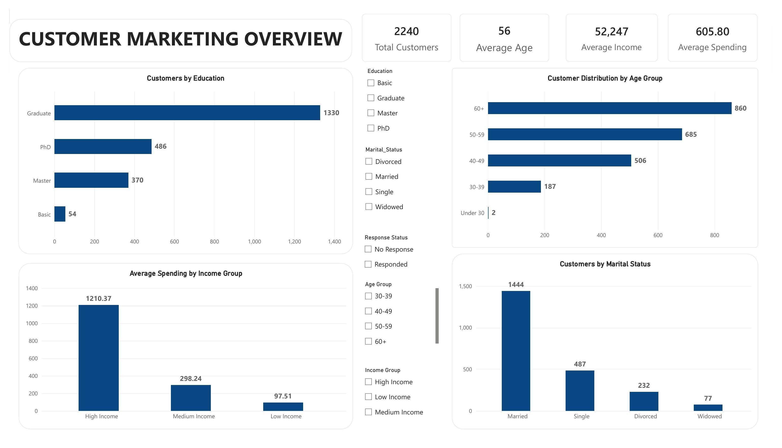
Dashboard Page 1 — customer demographics: education, age group, marital status, and spending by income group, with interactive slicers.

Power BI Dashboard — Page 2

Product & Purchase Analysis
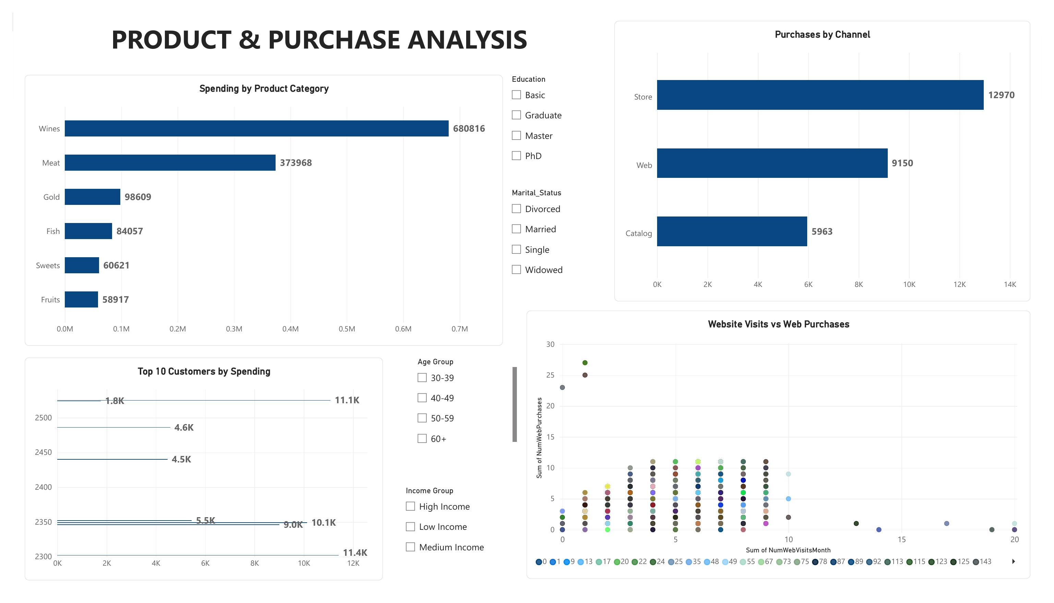
Dashboard Page 2 — spending by product category, purchases by channel, website visits vs. web purchases, and the Top 10 customers by spending.

Power BI Dashboard — Page 3

Campaign Performance
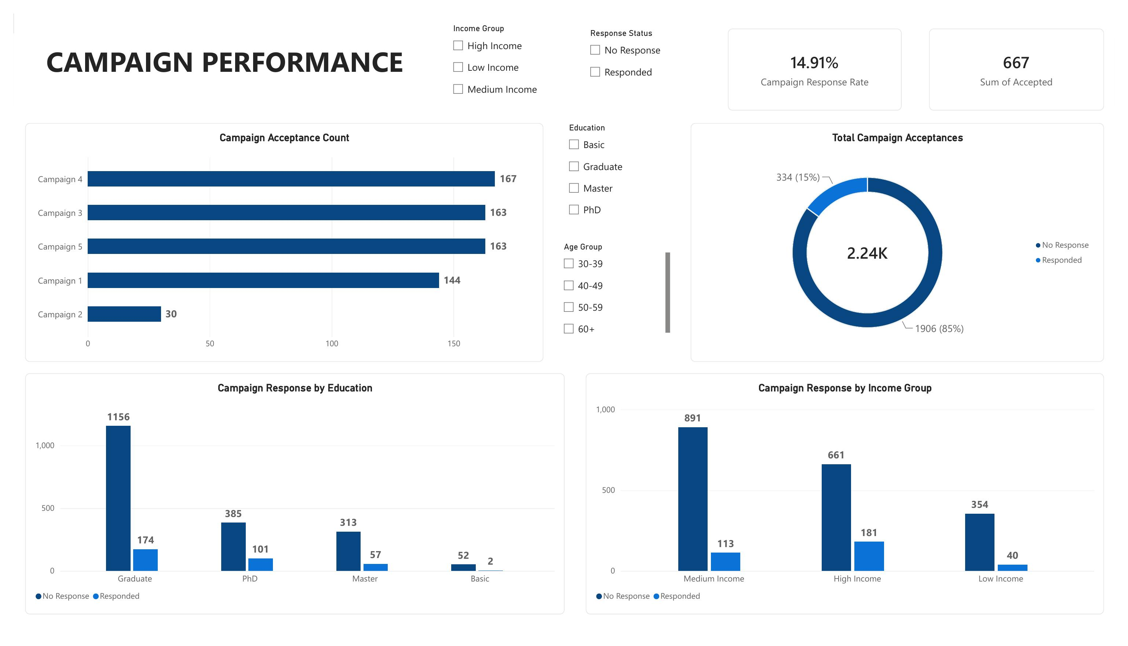
Dashboard Page 3 — campaign response rate, acceptance by campaign, and response broken down by education and income group.

Key Business Insights
1. Customer age profile
Approximately 69% of customers are aged 50 or above, making older customers a major segment in the dataset.
2. Education profile
Graduate customers represent the largest education group with 1,330 customers, approximately 59% of the dataset.
3. Income and spending
High-income customers have average spending of 1,210.37, compared with 298.24 for
medium-income and 97.51 for low-income customers.
4. Product spending
Wines recorded the highest spending at 680,816, representing roughly half of spending across the six product categories.
5. Purchase channels
Store purchases were highest at 12,970, followed by Web at 9,150 and Catalog at 5,963.
6. Campaign response
The overall campaign response rate was 14.91%, with 334 customers responding out of 2,240.
7. Campaign acceptance
Campaign acceptance counts ranged from 30 to 167. Campaign 4 had the highest raw count, but campaign effectiveness cannot be determined from raw counts alone.

Overall Findings & Business Story
The three dashboard pages together tell a simple, connected analytical story that moves from understanding the customer, to understanding their behaviour, to understanding how they respond to marketing:
- Page 1 — Who are the customers? The customer base is mainly older, married, and has a large Graduate-educated segment, with average spending varying substantially across income groups.
- Page 2 — What do they buy and how do they purchase? Wine and Meat have the highest product spending, while Store is the largest purchase channel.
- Page 3 — How do they respond to marketing campaigns? An overall campaign response rate of 14.91%, with response patterns varying by campaign, education, and income group.

The analysis identifies high-spending customers as a distinct customer segment, while higher-income customers show substantially higher average spending overall. These patterns could be explored further through customer-level segmentation and retention analysis.

Tools & Skills Learned

Tools Used
- MySQL — data cleaning, validation, and exploratory SQL analysis
- Power BI Desktop — data modelling, DAX measures, KPI cards, charts, and slicers
- Microsoft Excel — supporting data checks and the cleaned dataset export
- Microsoft Word — compiling and documenting the final project report

Skills Practised
- Data cleaning: identifying and handling missing values, duplicates, and anomalies
- SQL querying: aggregations, CASE-based segmentation, filtering, grouping, and derived calculations
- Dashboard design: building a clear, multi-page, interactive report with KPIs and slicers
- DAX and data modelling within Power BI
- Translating raw numbers into written business insights for a non-technical audience
- End-to-end project documentation, from problem statement to final conclusions
This project moved beyond simply calculating numbers in SQL to presenting those findings visually and interactively in Power BI — combining technical analysis with clear business communication.

Limitations & Further Analysis
This analysis is based on the available customer marketing dataset and therefore reflects only the information contained in the dataset. The analysis identifies associations and patterns but does not establish causal relationships between variables.

Campaign acceptance counts were compared as raw counts because campaign exposure or audience size was not available. Therefore, campaign effectiveness cannot be directly compared using acceptance counts alone.

Further analysis could include campaign-level response rates, customer lifetime value, customer segmentation, retention analysis, purchase frequency, and statistical correlation analysis.

Conclusion
This project took a raw, imperfect customer marketing dataset through a complete analytics workflow: cleaning and validating the data in SQL, exploring it to answer concrete business questions, building an interactive three-page Power BI dashboard, and translating the results into clear, actionable business insights.
The analysis shows a customer base that is primarily older, married and Graduate-educated, with average spending varying substantially across income groups and Wine as the largest product spending category. The overall campaign response rate was 14.91%, with response patterns varying across campaigns and customer segments.
Beyond the specific findings, the project provided hands-on experience with the full data analytics lifecycle — from data quality checks and SQL analysis to dashboard design and business storytelling — skills that are directly transferable to future data analysis work.

— End of Report —

