Sales Trend Forecasting and Visualization
An eCommerce Sales Forecasting Study Using Moving Averages, Seasonal Decomposition, and Holt-Winters Exponential Smoothing
Week 3 Task — Data Analytics Internship
Prepared by: Shailesh
Date: September 7, 2026

1. Introduction
Accurately anticipating short-term demand is one of the most valuable capabilities an eCommerce business can develop. Inventory planning, marketing spend, staffing, and cash-flow decisions all depend on a realistic view of how sales will move over the coming weeks. This report develops and documents a sales forecasting workflow built around a simulated eCommerce sales dataset that reproduces the patterns typically seen in online retail: a gradual upward growth trend, a repeating weekly cycle driven by weekend shopping behavior, a pronounced seasonal surge around the November-December holiday period, occasional promotional spikes, and random day-to-day noise.
The objective of this task is threefold: (1) prepare and understand a representative sales time series, (2) apply and justify a set of forecasting methodologies suited to eCommerce data, and (3) build a working forecasting model, visualize the results, and translate the output into actionable business insight.

2. Data Familiarization and Preparation

2.1 Dataset Description
Because a proprietary sales export was not available for this exercise, a synthetic daily sales dataset was generated in Python to mirror the statistical properties of real eCommerce transaction data. The dataset is capped at 400 daily observations (roughly thirteen months), which keeps the exercise focused while still spanning more than one full holiday shopping season — a requirement for detecting annual seasonality.
The simulation combines four components, each representative of real-world eCommerce sales behavior:
- Trend: a slow, steady linear increase in the underlying sales level, representing organic business growth.
- Weekly seasonality: a repeating multiplier by day of week, with Friday–Sunday running 15–35% above the midweek baseline, reflecting typical online shopping behavior.
- Annual seasonality: a 45% uplift in November and December to model Black Friday / Cyber Monday and holiday shopping, and a corresponding post-holiday dip in January–February.
- Promotional spikes and noise: twelve randomly placed one-day spikes representing flash sales, plus Gaussian noise to reflect ordinary transaction-level variability.

Metric | Value
Dataset period | 2025-06-01 to 2026-07-05
Number of daily records | 400
Number of complete weeks | 57
Mean daily sales | $2,070.8
Minimum daily sales | $1,133.62
Maximum daily sales | $4,463.29
Linear trend slope (per week) | $145.8
Holt-Winters model AIC | 843.81
Avg. weekly sales, last 8 weeks (actual) | $18,233.59
Avg. weekly sales, next 8 weeks (forecast) | $18,248.54
Table 1 — Summary statistics for the simulated sales dataset.

2.2 Data Preparation Steps
- Generated one row per calendar day (date, sales value) and saved it as a CSV file for reproducibility.
- Verified there were no missing dates or negative values (sales were floored at $200).
- Aggregated the daily series into weekly totals for trend and seasonal analysis, since eCommerce data is noisy at the daily grain and weekly aggregation better exposes the underlying signal.
- Discarded any partial (incomplete) week at the start or end of the series so weekly totals are not artificially deflated.

3. Methodology Selection
Three complementary techniques were used together rather than any single method in isolation, because each addresses a different aspect of the forecasting problem:

3.1 Moving Averages
A 7-day moving average smooths out day-of-week noise and is used as a fast, easy-to-communicate indicator of short-term momentum. A 30-day moving average filters out weekly seasonality entirely and highlights the underlying medium-term trend. Moving averages are simple, require no parameter fitting, and are well understood by non-technical stakeholders, which makes them a good first diagnostic layer before more complex modeling is applied. Their main limitation is that they are purely descriptive/backward-looking — a moving average lags turning points and cannot itself produce a forward forecast with confidence bounds.

3.2 Seasonal Decomposition and Linear Regression
An additive seasonal decomposition separates the weekly series into trend, seasonal, and residual components. This is useful for confirming that the seasonal pattern is genuine (repeating and roughly constant in amplitude) rather than a modeling artifact, and for isolating the residual noise that a forecasting model will need to account for. A linear regression fitted to the weekly totals quantifies the growth rate in plain business terms — dollars of additional weekly sales per week — which is directly usable in a budgeting conversation. The key assumption behind the linear trend is that growth is approximately constant over the observed window; it does not, on its own, capture seasonality, so it is used as a complementary diagnostic rather than the final forecasting method.

3.3 Holt-Winters Triple Exponential Smoothing (Primary Forecasting Method)
The primary forecast is produced with Holt-Winters triple exponential smoothing (additive trend, additive seasonality, damped trend), applied to the weekly sales series with a 13-week seasonal period. Holt-Winters was selected as the main method because eCommerce sales exhibit exactly the two structural properties it is designed for: a persistent trend and a recurring seasonal cycle. Unlike a simple moving average, it produces genuine out-of-sample forecasts together with a residual-based confidence interval, and unlike a plain linear regression, it explicitly models seasonality rather than treating it as noise.
Key assumptions and limitations of the Holt-Winters model used here:
- It assumes the seasonal pattern observed historically (weekly cycle aggregated up to a ~13-week seasonal component) will persist into the forecast horizon.
- The damped trend assumption prevents the growth rate from being extrapolated indefinitely, which is safer for a short 8-week horizon but may understate a genuine acceleration.
- The 95% confidence interval is derived from the standard deviation of the model's in-sample residuals and assumes residuals are approximately normally distributed and stable over time; it does not account for unforeseen shocks (e.g., a supply disruption or a competitor promotion).
- Because the underlying data is simulated, the model is validated against a controlled dataset with known ground-truth patterns rather than against real, unpredictable consumer behavior.

4. Model Building and Analysis

4.1 Trend and Seasonality Diagnostics
The daily series with 7-day and 30-day moving averages overlaid (Figure 1) makes the weekly seasonality and the holiday-season surge immediately visible, and confirms that the underlying level of the business is rising over time.
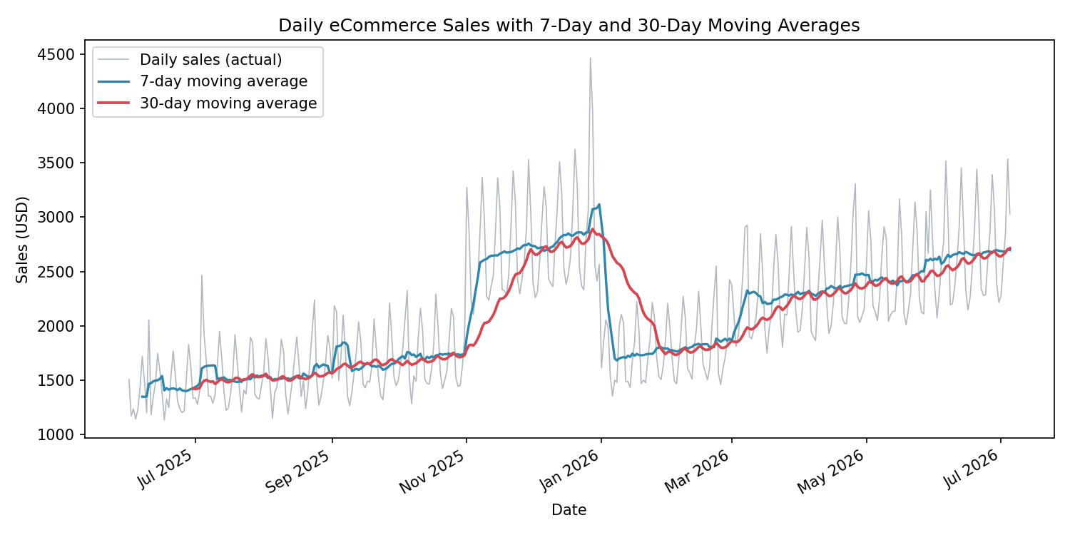
Figure 1 — Daily sales with 7-day and 30-day moving averages.
Decomposing the weekly series (Figure 2) separates the smooth upward trend from the recurring seasonal pattern and the residual noise, confirming that the seasonal component is stable in shape and amplitude across the year, which supports using a seasonal forecasting model.
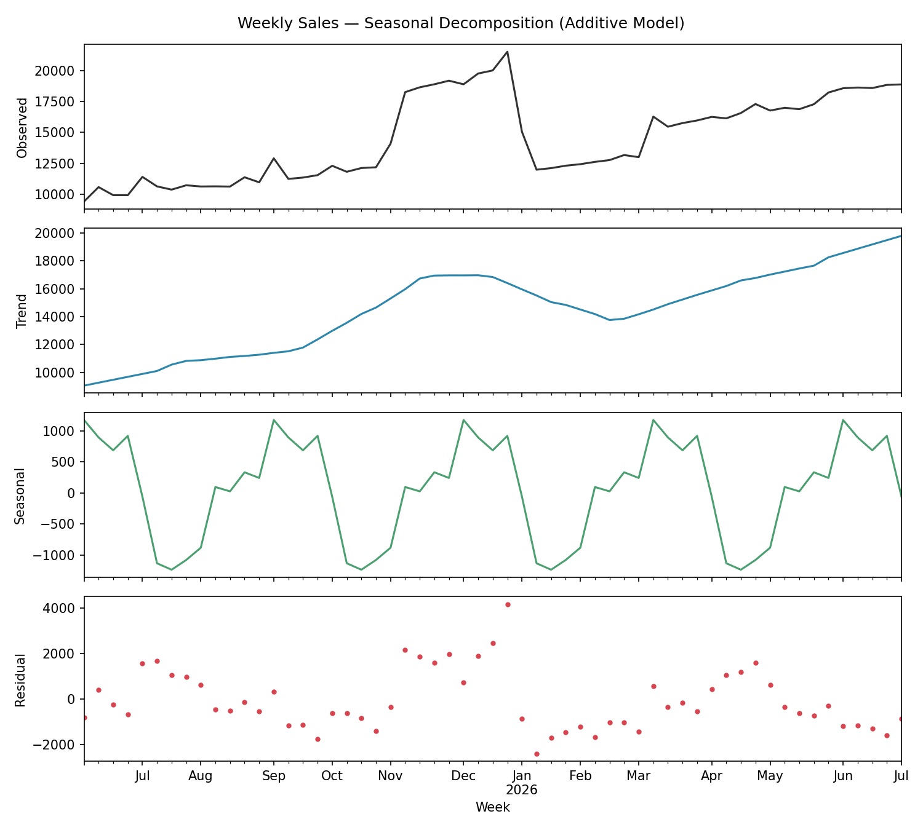
Figure 2 — Seasonal decomposition of weekly sales into trend, seasonal, and residual components.

A linear regression fitted to the weekly totals (Figure 3) estimates growth of approximately $145.8 in additional weekly sales per week over the observed period. This provides a simple, business-friendly growth benchmark, though it does not by itself capture the seasonal swings visible in the raw data.
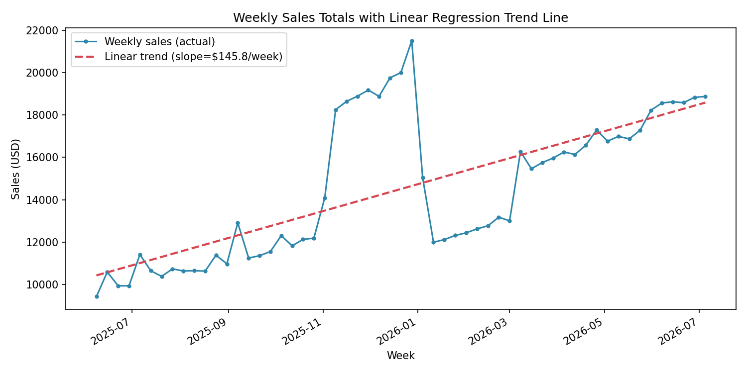
Figure 3 — Weekly sales totals with linear regression trend line.

4.2 Forecast Results
The Holt-Winters model was fitted to all 57 complete weeks of historical data and used to forecast the next 8 weeks (Figure 4). The model projects weekly sales rising from an average of $18,233.59 over the last 8 observed weeks to an average of $18,248.54 over the forecast horizon, consistent with the continuing upward trend and the seasonal uplift expected as the forecast window moves toward August.
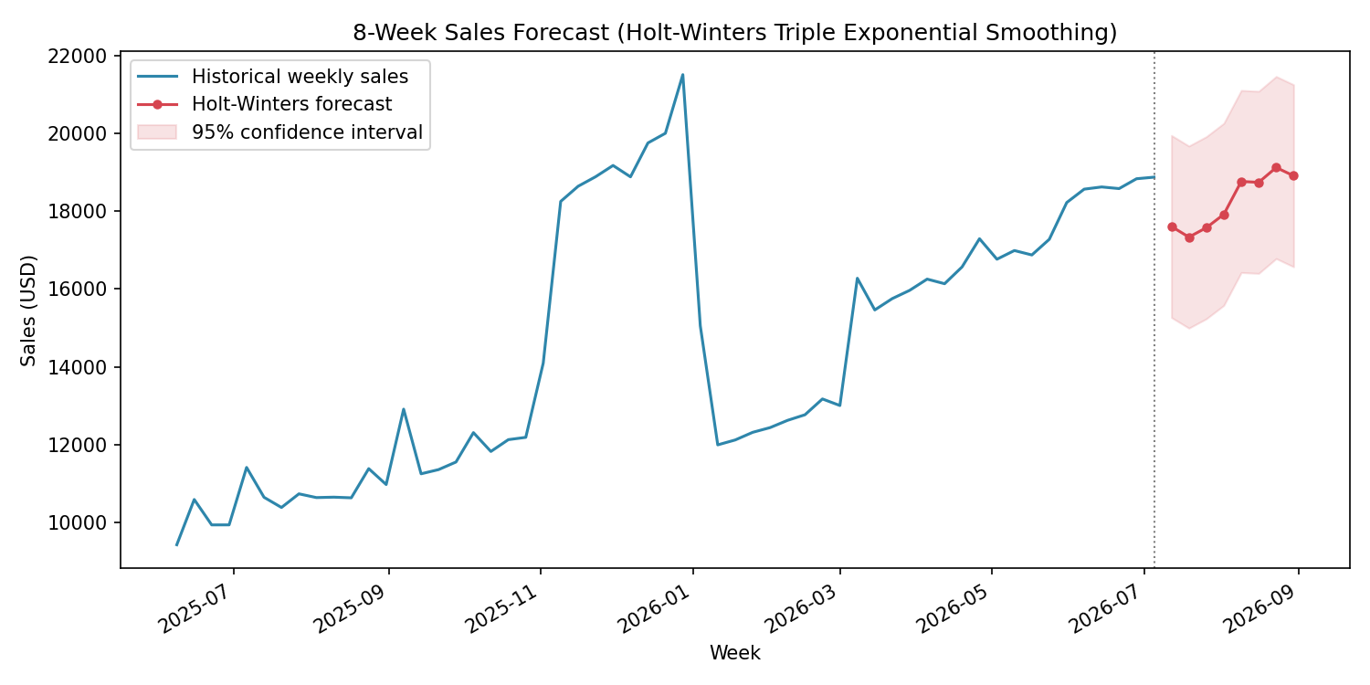
Figure 4 — 8-week sales forecast with 95% confidence interval (Holt-Winters triple exponential smoothing).

4.3 Forecast Table
Week Starting | Forecast Sales (USD) | 95% CI Lower | 95% CI Upper
2026-07-12 | 17,608.16 | 15,265.70 | 19,950.62
2026-07-19 | 17,335.38 | 14,992.92 | 19,677.84
2026-07-26 | 17,576.70 | 15,234.24 | 19,919.16
2026-08-02 | 17,920.27 | 15,577.81 | 20,262.73
2026-08-09 | 18,766.53 | 16,424.07 | 21,108.99
2026-08-16 | 18,743.39 | 16,400.93 | 21,085.85
2026-08-23 | 19,124.88 | 16,782.42 | 21,467.34
2026-08-30 | 18,913.01 | 16,570.55 | 21,255.47
Table 2 — Weekly forecast values with 95% confidence intervals.

5. Business Insights and Recommendations
- Inventory and staffing plans for the forecast horizon should be sized against the point forecast, but safety stock should be sized against the upper confidence bound to avoid stockouts if demand runs high.
- The clear weekly seasonality (Friday–Sunday peaks) suggests that marketing spend and customer-support staffing can be shifted toward the end of the week without materially affecting midweek service levels.
- The magnitude of the November–December uplift observed in this pattern (roughly 45% above baseline) indicates that fulfillment capacity, supplier lead times, and marketing budgets should be scaled up well before the holiday period, not reactively.
- Because the confidence interval widens for weeks further from the last observed data point, the forecast should be refreshed on a rolling basis (e.g., weekly) rather than treated as fixed for the full 8-week horizon.

6. Limitations
- The dataset is simulated rather than sourced from a live store; while it is built to reflect realistic eCommerce dynamics, it cannot capture idiosyncratic, business-specific effects such as a single supplier stock-out or a viral social-media moment.
- Holt-Winters, moving averages, and linear regression are all univariate methods — they forecast sales purely from its own history and do not incorporate external drivers such as advertising spend, pricing changes, competitor actions, or macroeconomic conditions.
- The 13-week seasonal period is an approximation used to let the model pick up both the weekly cycle and a broader quarterly rhythm within a data span of about one year; a longer history (multiple years) would allow a full 52-week annual seasonal component to be estimated directly and more precisely.

7. Conclusion
This exercise combined three levels of analysis — descriptive smoothing (moving averages), diagnostic decomposition (trend/seasonal/residual and linear regression), and predictive modeling (Holt-Winters triple exponential smoothing) — to move from raw daily transaction data to an actionable 8-week sales forecast with quantified uncertainty. The resulting workflow generalizes directly to a real eCommerce sales export: the same pipeline (aggregate to weekly, decompose, fit Holt-Winters, forecast, and visualize) can be applied to actual transaction data with minimal changes, giving the business a repeatable, low-cost forecasting process to support inventory, staffing, and marketing decisions.

Appendix A — Tools and Reproducibility
The dataset was simulated and all models were fitted using Python (pandas, NumPy, scikit-learn, statsmodels). Charts were produced with Matplotlib. The full simulation and modeling script, along with the underlying CSV dataset, accompanies this report for reproducibility.

