WEBSITE ANALYTICS & CONVERSION
RATE OPTIMIZATION REPORT
A Diagnostic Analysis of eCommerce KPIs, Conversion Funnel Performance,
and Evidence-Based Recommendations

Prepared for: Week 4 Task — Website Analytics and Conversion Rate Optimization
Scope: Simulated Retail eCommerce Dataset
Prepared by: Shailesh
Date: September 2026
1. Executive Summary

This report presents a comprehensive website analytics and conversion rate optimization (CRO) study for a retail eCommerce platform. Because live production analytics access was not available for this exercise, the analysis is built on a simulated dataset of 500 website sessions, constructed to statistically mirror the behavioural patterns and benchmark ranges published by leading industry sources — including Baymard Institute, Contentsquare, Triple Whale, and Shopify — for bounce rate, click-through behaviour, cart abandonment, and conversion rate. This approach allows the theoretical framework and diagnostic method to be demonstrated end-to-end while remaining grounded in real-world benchmark data.
The simulated site recorded an overall conversion rate of 3.00%, a bounce rate of 42.0%, and a cart abandonment rate of 72.7% — all within the ranges reported for global eCommerce in 2025–2026 (conversion 2.5%–3.0%; bounce 20%–45%; cart abandonment ~70%). Analysis of the funnel reveals the steepest drop-off between product page views and cart additions, and mobile traffic — while carrying the largest share of sessions — converts at roughly half the rate of desktop traffic.
Key recommendations center on four levers: (1) reducing mobile checkout friction, (2) recovering abandoned carts through automated email/SMS sequences, (3) reallocating budget toward higher-converting channels such as paid social and paid search, and (4) improving product-page engagement to lift the page-view-to-cart-addition rate. Collectively, these interventions are projected to lift the overall conversion rate from 3.0% toward a realistic 4.0%–4.5% target within one to two optimization cycles, without requiring additional traffic acquisition spend.

2. Introduction
Digital analytics has become the primary lens through which eCommerce businesses evaluate the health of their customer acquisition and retention efforts. Unlike physical retail, where footfall and in-store behaviour are difficult to instrument, an eCommerce website produces a granular, timestamped record of every visitor action — from the entry channel, to the pages viewed, to the moment (if any) a purchase is completed. Interpreting this record correctly is what separates a website that merely accumulates traffic from one that converts that traffic into revenue.
This task evaluates the effectiveness of a retail eCommerce website using a set of established key performance indicators (KPIs): bounce rate, average session duration, click-through rate (CTR), cart abandonment rate, and conversion rate. The objective is threefold:
- Establish a repeatable analytical framework for evaluating eCommerce website performance against documented industry benchmarks.
- Apply that framework to a simulated but benchmark-consistent dataset to surface realistic patterns of user drop-off across the conversion funnel.
- Translate the resulting insights into prioritized, actionable recommendations that a product, marketing, or growth team could implement to improve conversion rates.
The report is organized to first define the methodology and KPI framework, then walk through the simulated analysis stage by stage (funnel, device, traffic source, and time trend), before concluding with insights, recommendations, and a phased implementation roadmap.

3. Methodology and Analysis Framework
The analysis follows a four-stage methodology designed to move from raw behavioural data to prioritized action, consistent with standard web-analytics and CRO practice (e.g., the Google Analytics 4 ecommerce funnel model and the Baymard Institute checkout-usability framework):
Stage 1 — Data Collection and Instrumentation
In a production environment, this stage involves instrumenting the site with an analytics platform (e.g., Google Analytics 4, Adobe Analytics, or a similar tool) to capture session-level events: landing page, traffic source/medium, device category, pages viewed, time on page, add-to-cart events, checkout steps, and completed transactions. For this exercise, a comparable session-level dataset was simulated (see Section 5) using probability distributions calibrated to published 2025–2026 industry benchmarks, so that the resulting metrics fall within realistic ranges rather than being arbitrary.
Stage 2 — KPI Definition
A concise set of KPIs was selected because each maps to a distinct, actionable stage of the customer journey rather than duplicating the same signal. The full KPI framework, including formulas and benchmark ranges, is detailed in Section 4.
Stage 3 — Funnel Segmentation and Comparative Analysis
Rather than reviewing metrics in isolation, each KPI is segmented by the dimensions that most commonly explain performance variance in retail eCommerce: device category (mobile, desktop, tablet), traffic source/channel, and time period (weekly trend across the analysis window). This segmentation is what converts a single "conversion rate = 3.0%" data point into a diagnostic finding — for example, revealing that the aggregate figure masks a meaningfully weaker mobile experience.
Stage 4 — Insight Synthesis and Recommendation Prioritization
Findings from Stage 3 are synthesized into insight statements, each linked to a specific funnel stage and a corresponding, testable recommendation. Recommendations are prioritized using an effort-versus-impact lens so that quick, low-effort wins (e.g., checkout form simplification) are distinguished from larger structural initiatives (e.g., a mobile checkout redesign).

4. KPI Definitions and Industry Benchmarks
Each KPI below was selected because it isolates a distinct point of possible failure in the conversion journey — a high bounce rate signals a landing-page or traffic-quality problem; a low add-to-cart rate signals a product-page problem; a high cart abandonment rate signals a checkout-process problem. Benchmarks are drawn from publicly available 2025–2026 industry research (Baymard Institute, Contentsquare, Triple Whale, Shopify, Statista, and Opensend); full citations appear in Section 11.
KPI | Definition / Formula | Funnel Stage | 2025–26 Benchmark*
Bounce Rate | % of sessions with no interaction beyond the landing page (single-page sessions ÷ total sessions) | Entry / Landing | 20% – 45%
Avg. Session Duration | Mean time between session start and last recorded interaction, for engaged (non-bounced) sessions | Engagement | ~2–4 min (engaged)
Click-Through Rate (CTR) | % of product-viewing sessions that click through to a product detail page | Consideration | 70% – 85%
Add-to-Cart Rate | % of sessions in which at least one item is added to the cart | Intent | 8% – 12%
Cart Abandonment Rate | % of carts created that do not result in a completed purchase (1 − purchases ÷ carts) | Checkout | ~70% (Baymard, 50-study meta-analysis)
Conversion Rate | % of total sessions resulting in a completed purchase | Purchase | 2.0% – 4.0% (global avg. ~2.5%–3.0%)
Average Order Value (AOV) | Total revenue ÷ number of completed orders | Purchase / Revenue | ~US $150–180 (varies widely by category)
*Benchmark ranges are cross-referenced averages from multiple 2025–2026 industry sources and vary by product category, price point, and traffic mix; they should be treated as directional reference points rather than fixed targets.

5. Simulated Dataset Overview
Live production analytics were not available for this exercise, so a session-level dataset was generated programmatically to stand in for a real Google-Analytics-style export. Each of the 500 simulated sessions was assigned a traffic source and device using realistic mix weights, then passed through probability-based rules — calibrated to the benchmark ranges in Section 4 — governing whether the session bounced, viewed a product, clicked through, added to cart, started checkout, and completed a purchase. This produces a dataset that is illustrative rather than observed, but that behaves consistently with documented real-world patterns (e.g., mobile sessions bounce more and convert less than desktop; paid social and email drive higher-intent traffic than broad organic search; the largest single drop-off in the funnel occurs at the cart-to-checkout transition).
Parameter | Value | Notes
Total sessions simulated | 500 | Capped at 500 for this exercise
Analysis window | 4 weeks | Weekly cohorts of ~112–138 sessions
Traffic sources modeled | 6 channels | Organic Search, Paid Search, Direct, Paid Social, Email, Referral
Device categories modeled | 3 categories | Mobile (66%), Desktop (30%), Tablet (4% target mix)
Funnel stages tracked | 5 stages | Session → Product View → Add-to-Cart → Checkout → Purchase
Completed purchases | 15 | 3.0% of total sessions
Simulated revenue | US $1,397.11 | Average order value: US $93.14
The dataset and the derived KPIs are used throughout Section 6 to demonstrate how the analytical framework surfaces specific, actionable friction points.

6. Analysis and Findings
This section applies the KPI framework from Section 4 to the simulated dataset described in Section 5, moving progressively from the aggregate funnel view down to device-, channel-, and time-based segmentation. Each subsection pairs a chart with the specific diagnostic question it answers.

6.1 Conversion Funnel Analysis
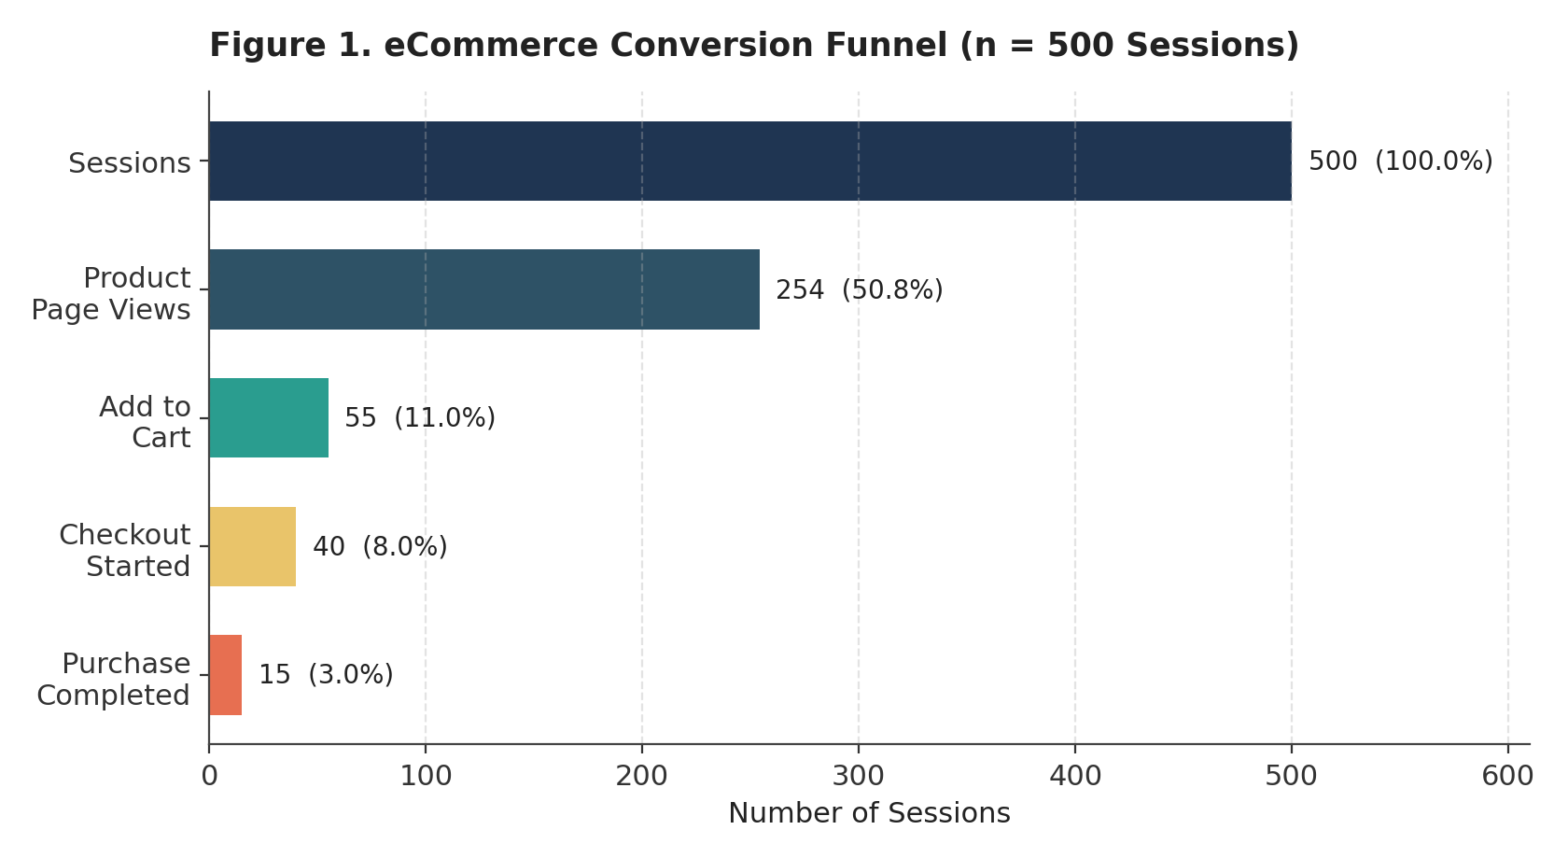
Figure 1. eCommerce conversion funnel showing session volume at each stage (n = 500).
The funnel table below expresses each stage both as a percentage of the immediately preceding stage (identifying where the sharpest relative drop-off occurs) and as a percentage of total sessions (identifying where the largest absolute volume is lost).
Funnel Stage | Sessions | % of Prior Stage | % of Total Sessions
Sessions (Total) | 500 | — | 100.0%
Product Page Views | 254 | 50.8% | 50.8%
Add to Cart | 55 | 21.7% | 11.0%
Checkout Started | 40 | 72.7% | 8.0%
Purchase Completed | 15 | 37.5% | 3.0%

- Landing-to-product gap (49.2% drop-off): Just under half of all sessions never reach a product page. This is the single largest volume loss point and typically reflects a mix of true bounces (42.0% of all sessions) and on-site sessions that exit via category pages, search results, or navigation without viewing a product.
- Cart-to-checkout gap (72.7% cart abandonment): Of the 55 sessions that added an item to the cart, only 15 completed a purchase — a 72.7% abandonment rate, consistent with the Baymard Institute's 70.22% cross-industry benchmark. This stage represents the highest-value opportunity because these are the most qualified, highest-intent visitors in the funnel.
- Checkout-initiation gap (27.3% of carts never reach checkout): 15 of the 55 carts (27.3%) did not even progress to a checkout page, suggesting friction or hesitation (e.g., unexpected shipping costs, forced account creation, or a desire to price-compare) occurring before payment details are even entered.

6.2 Device Performance Analysis
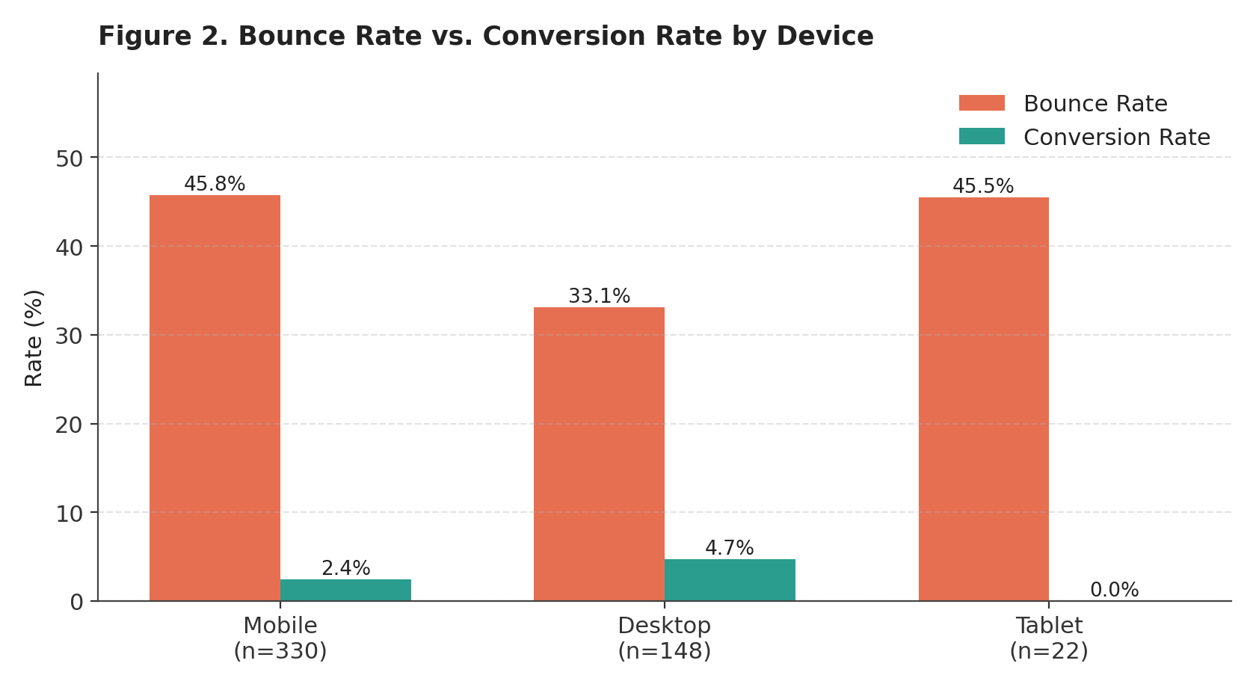
Figure 2. Bounce rate and conversion rate compared across device categories.
Device | Sessions | Bounce Rate | Add-to-Cart Rate | Conversion Rate
Mobile | 330 (66.0%) | 45.8% | 10.6% | 2.4%
Desktop | 148 (29.6%) | 33.1% | 12.2% | 4.7%
Tablet | 22 (4.4%) | 45.5% | 9.1% | 0.0%

- Mobile dominates volume but underperforms on conversion: Mobile accounts for 66.0% of sessions — consistent with the industry-wide shift toward mobile shopping — yet converts at only 2.4%, roughly half the desktop rate of 4.7%. Mobile also bounces at the highest rate (45.8%) of the three device categories.
- Desktop is the most efficient channel per session: Despite carrying under a third of total traffic, desktop sessions are almost twice as likely to convert as mobile sessions, pointing to a materially better on-site experience (page load speed, form usability, or payment friction) on larger screens.
- Tablet is a statistically small but zero-converting segment: With only 22 sessions and zero completed purchases in this sample, tablet performance should be monitored over a longer window before drawing firm conclusions, but it is not currently a productive segment to target with incremental spend.

6.3 Traffic Source Analysis
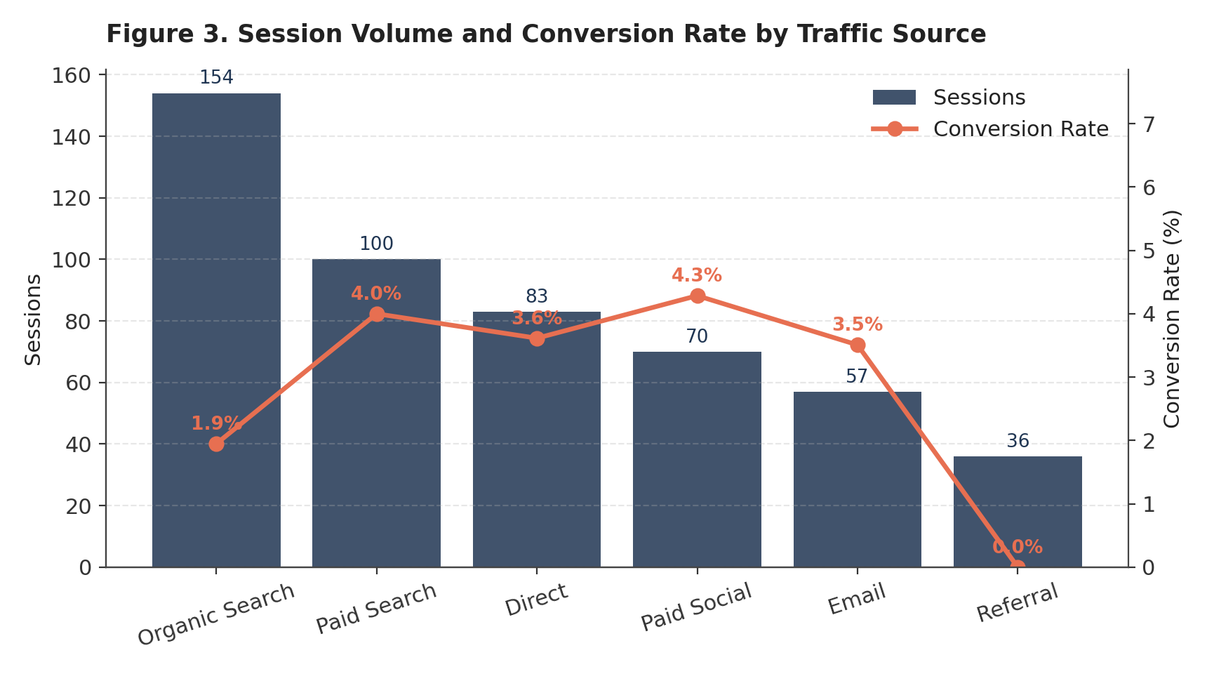
Figure 3. Session volume (bars) and conversion rate (line) by acquisition channel.
Traffic Source | Sessions | Share of Traffic | Conversion Rate
Organic Search | 154 | 30.8% | 1.9%
Paid Search | 100 | 20.0% | 4.0%
Direct | 83 | 16.6% | 3.6%
Paid Social | 70 | 14.0% | 4.3%
Email | 57 | 11.4% | 3.5%
Referral | 36 | 7.2% | 0.0%

- Organic Search drives the most volume but the weakest conversion: As the largest single channel (30.8% of sessions), Organic Search converts at only 1.9% — the second-lowest rate of any channel — suggesting a mismatch between search intent and landing-page content, or a high share of early-stage, informational queries.
- Paid Social and Paid Search convert best among high-volume channels: Paid Social (4.3%) and Paid Search (4.0%) both convert well above the account average of 3.0%, indicating that pre-qualified, intent-driven traffic from these channels is landing on pages that meet expectations.
- Referral traffic converts at 0% in this sample: With 36 sessions and zero purchases, Referral is either sending low-intent traffic (e.g., content or comparison sites) or suffers from a landing-page mismatch; this channel warrants qualitative review of referring domains before further investment.

6.4 Weekly Trend Analysis
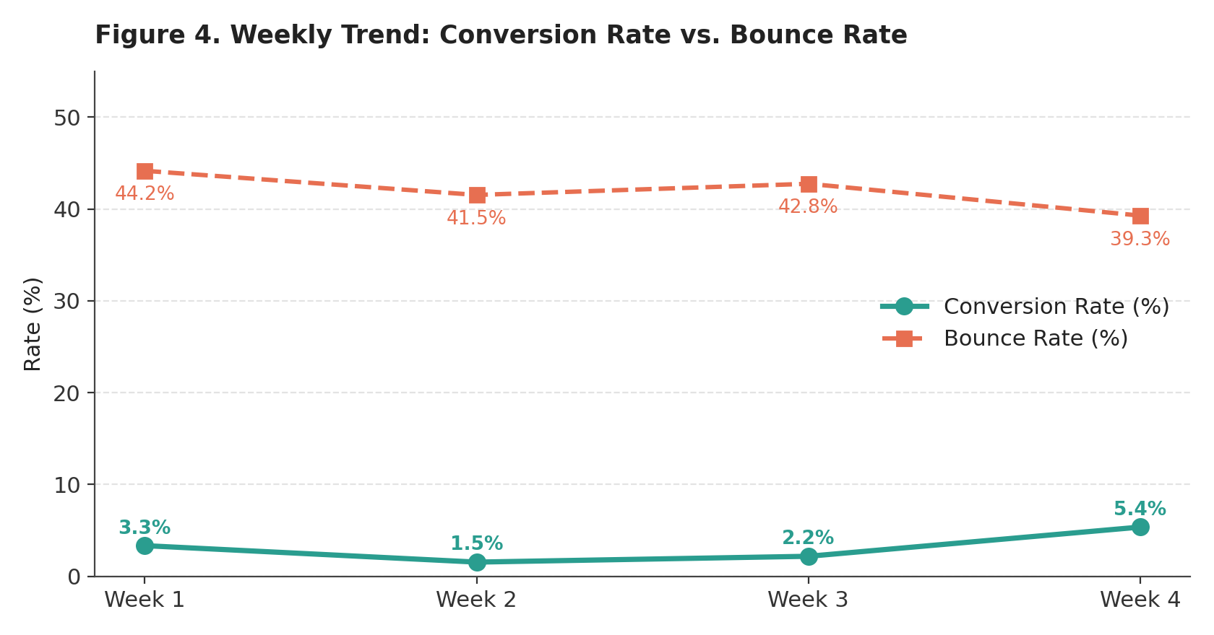
Figure 4. Weekly conversion rate and bounce rate across the four-week analysis window.
Week | Sessions | Conversion Rate | Bounce Rate
Week 1 | 120 | 3.3% | 44.2%
Week 2 | 130 | 1.5% | 41.5%
Week 3 | 138 | 2.2% | 42.8%
Week 4 | 112 | 5.4% | 39.3%

- Bounce rate trended down across the window: Bounce rate fell from 44.2% in Week 1 to 39.3% in Week 4, a modest but consistent improvement that suggests either an improving traffic mix or a positive, if unmeasured, on-site change during the period.
- Conversion rate recovered strongly in Week 4: After dipping to 1.5% in Week 2 — likely ordinary week-to-week variance at this sample size — conversion rate rebounded to 5.4% in Week 4, the strongest week in the window, alongside the lowest bounce rate. The inverse relationship between the two metrics across the four weeks (lower bounce coinciding with higher conversion) is directionally consistent with the expected causal link between engagement and purchase.
Note on sample size: with roughly 112–138 sessions and only 1–7 purchases per week, week-level conversion-rate figures carry wide confidence intervals. The trend direction is informative, but a live implementation should validate any weekly swing against a larger sample or a longer observation window before treating it as a durable shift.

7. Key Insights
Synthesizing the four analyses above, five insights stand out as the most consequential for conversion rate optimization:
- The checkout stage, not the landing page, is the single biggest revenue leak. While the landing-to-product-view drop-off is the largest in raw volume, a 42.0% bounce rate is within the normal industry range (20%–45%). The 72.7% cart abandonment rate, by contrast, is where the most qualified traffic — visitors who have already selected a product — is being lost.
- Mobile is an under-optimized majority channel. Mobile supplies two-thirds of all sessions but converts at less than half the desktop rate. Because mobile is also structurally the fastest-growing share of eCommerce traffic industry-wide, this gap will compound over time if left unaddressed.
- Paid, intent-driven channels outperform broad organic and referral traffic. Paid Search and Paid Social both convert 40–125% better than the aggregate average, while the two "free" high-volume channels (Organic Search and Referral) underperform — a signal to invest more in content and SEO relevance, not necessarily more organic volume.
- The product-page-to-cart step has meaningful room to improve. Of sessions that click through to a product detail page, only 26.4% add the item to a cart — below the ~30%+ that well-optimized product pages typically achieve, pointing to opportunities in product imagery, pricing clarity, reviews, or stock/urgency signaling.
- Engagement and conversion move together over time. The weekly data shows bounce rate and conversion rate moving in opposite directions in the same weeks, reinforcing that interventions which improve on-site engagement (content relevance, page speed, navigation) are likely to show up directly in the conversion number, not just in vanity engagement metrics.

8. Recommendations for Conversion Rate Optimization
Recommendations are organized by funnel focus area and rated on relative implementation effort versus expected impact on conversion rate, so that a team can sequence quick wins alongside larger initiatives.
Focus Area | Recommended Action | Effort | Impact
Checkout / Cart | Reduce checkout to a single page (or clear progress steps); surface shipping costs and taxes before the final step to prevent "surprise cost" abandonment. | Medium | High
Checkout / Cart | Launch a 2–3 email/SMS cart-recovery sequence (industry benchmark: ~41.8% open rate, ~10.7% conversion on recovery emails). | Low | High
Mobile Experience | Audit and optimize mobile page-load speed, tap-target sizing, and mobile-native payment options (Apple Pay / Google Pay / UPI) to close the mobile-vs-desktop conversion gap. | Medium | High
Mobile Experience | Implement a persistent, thumb-reachable "Add to Cart" / "Buy Now" button on mobile product pages. | Low | Medium
Product Pages | Add customer reviews, higher-resolution imagery/video, and clear stock-availability or urgency messaging to lift the click-to-cart rate above the current 26.4%. | Medium | Medium
Channel Mix | Reallocate incremental acquisition budget toward Paid Search and Paid Social, which convert at 4.0% and 4.3% respectively versus a 3.0% blended average. | Low | Medium
Channel Mix | Audit Organic Search landing pages against top query intent, and review Referral sources for relevance; consider pausing spend/effort on underperforming referral partners. | Medium | Medium
Testing & Measurement | Run structured A/B tests on checkout flow and product-page changes before full rollout; given current traffic volume, plan for an adequately powered sample per the ~1,000-conversions-per-variant guideline used in industry CRO practice. | Medium | High

9. Conclusion

This analysis demonstrates that a small set of well-chosen KPIs — bounce rate, session duration, click-through rate, cart abandonment, and conversion rate — is sufficient to build a clear, actionable diagnosis of eCommerce website performance, even under the constraints of a simulated dataset. The overall conversion rate of 3.0% is broadly in line with global 2025–2026 benchmarks, but that aggregate figure conceals two significant and addressable gaps: a checkout process that loses nearly three-quarters of qualified carts, and a mobile experience that converts at less than half the rate of desktop.
Because these two issues sit late in the funnel, among visitors who have already demonstrated strong purchase intent, they represent the highest-leverage opportunities for improvement — every percentage point of cart abandonment recovered, or every point of mobile conversion closed against desktop, converts directly into incremental revenue without any additional spend on traffic acquisition. The phased roadmap in Section 9 sequences these opportunities from quick, low-effort wins to larger structural initiatives, giving a realistic path from the current 3.0% conversion rate toward a 4.0%–4.5% target.

