PLC-HMI Tank Process Control System
Personal Project Report
PLC Programming HMI Integration and Process Simulation
Project period August 2026 to September 2026
Shailesh Dhakal

1. Objective
I developed a PLC-HMI tank process control system using a CompactLogix 5380 PLC, a PanelView 5510 HMI, and a PowerFlex 525 variable frequency drive. The project combined Start, Stop, and Reset controls, adjustable setpoints, tank-level monitoring, VFD-based fill-rate control, warning and fault handling, process trends, and role-based user access. The tank level was simulated mathematically while the PLC, HMI, and VFD formed the control and operator-interface setup.

2. Integrated System Description and Process Flow
The PLC performed the main control logic and tank calculations, while the HMI gave the operator a simple way to send commands and view process information. The HMI sent START, STOP, and RESET commands to controller tags. It also allowed permitted users to change the fill-speed and depletion-rate setpoints. The PLC used these values to update the simulated tank level and to create the VFD frequency command.
The VFD frequency represented the tank filling rate. The PLC also checked the tank level for warning and fault limits. The HMI showed the tank level and system status, while physical lights and LEDs were used to indicate operating conditions.
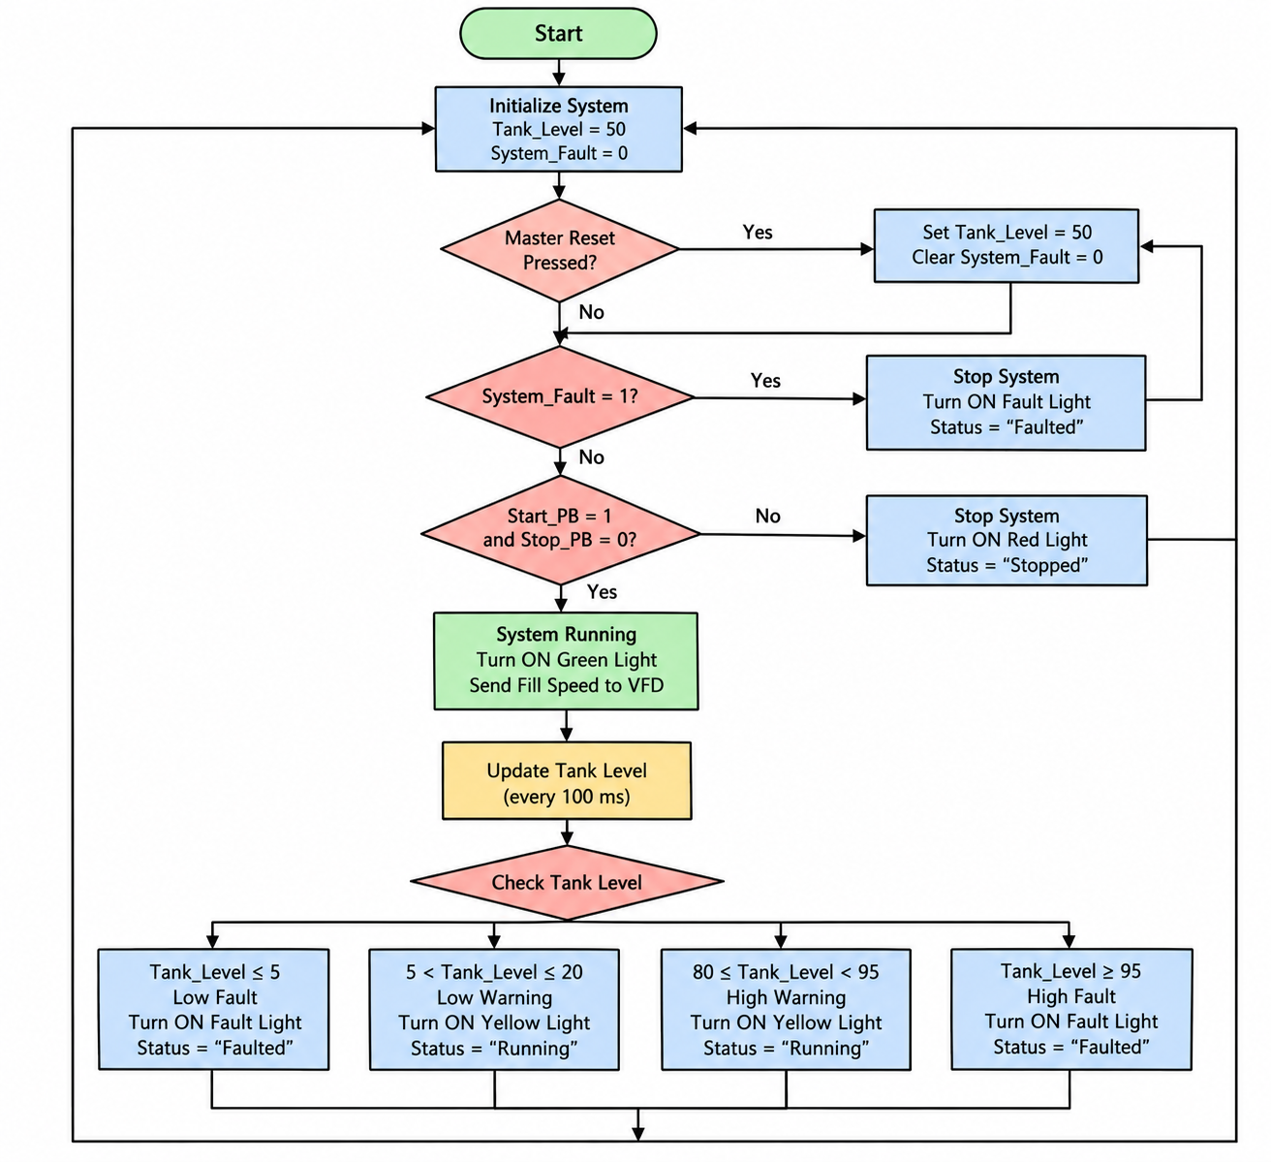
Figure 1. Overall PLC-HMI tank-control process flow.

3. MainRoutine and VFD Control
The MainRoutine called the LightsRoutine, StatusRoutine, and AlarmRoutine using JSR instructions. The Start/Stop section used a seal-in path so that System_Running stayed active after the START button was released. STOP or System_Fault removed the running condition. System_Stopped was active when the process was not running and no fault was present.
The VFD was allowed to run only when System_Running was true and System_Fault was false. The fill-speed command was limited to a maximum of 6000. When the VFD was running, the PLC converted FillSpeed_SP into the required frequency-command format. When the VFD was not running, the frequency command was moved to zero. Figure 2 shows the implemented MainRoutine while the controller was online.
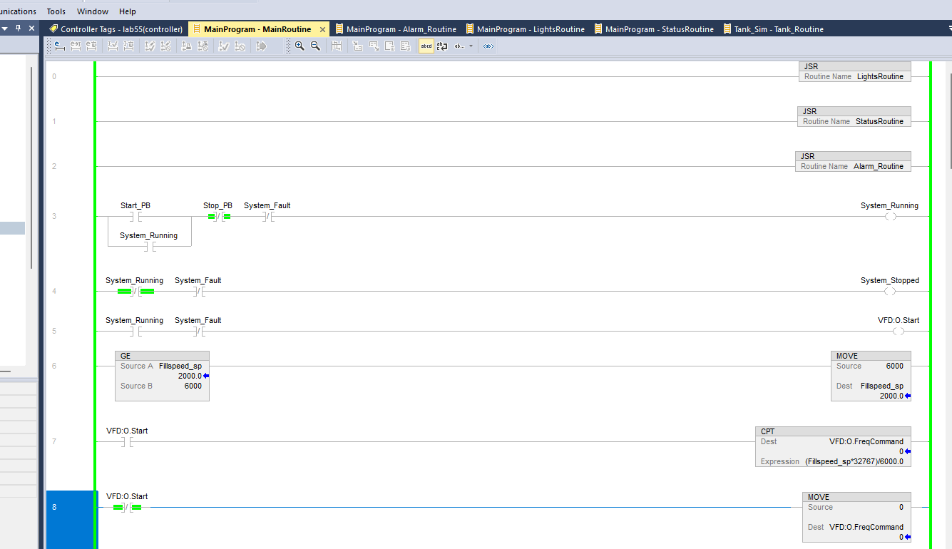
Figure 2. MainRoutine showing supporting JSR calls, Start/Stop logic, fill-speed limiting, and VFD command logic.

4. Alarm, Status, and Indication Logic
The tank used both warning and fault limits. A high warning occurred when Tank_Level was at least 80 but below 95. A high fault occurred when the level reached 95 or higher. A low warning occurred at 20 or below while remaining above 5, and a low fault occurred at 5 or below. A fault latched System_Fault so that the process would remain stopped until a reset was performed.
Condition | Tank Level
High Warning | 80 to less than 95
High Fault | 95 or greater
Low Warning | Greater than 5 to 20
Low Fault | 5 or less

I verified the high-level fault response with the controller online. Tank_Level reached approximately 95.007, Fault_High became active, and System_Fault latched. The Master Reset rung moves 50 into Tank_Level_Temp and Tank_Level and unlatches System_Fault.
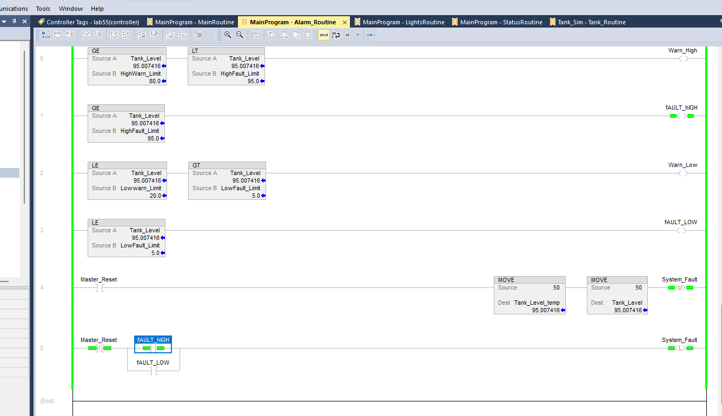
Figure 3. AlarmRoutine during a high-level fault at approximately 95.007% tank level.
I used LightsRoutine to map process conditions to the physical indicators. Running, Stopped, and Fault states controlled the tower lights, while warning and fault tags controlled the panel LEDs. During the recorded high-fault condition, the system-fault and high-fault indication logic were active, consistent with AlarmRoutine.
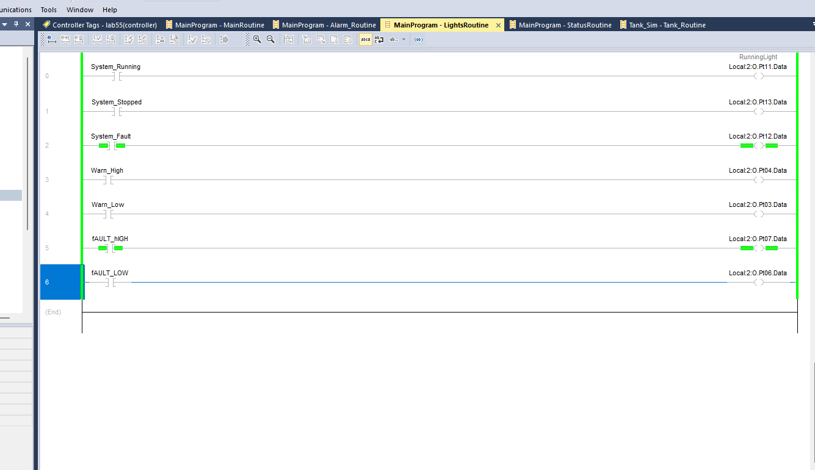
Figure 4. LightsRoutine mapping system, warning, and fault conditions to physical indicators.
The StatusRoutine wrote a text value to the Status tag. The possible states were Running, Faulted, and Stopped. Figure 5 shows the Status tag being written as Faulted while System_Fault is active.
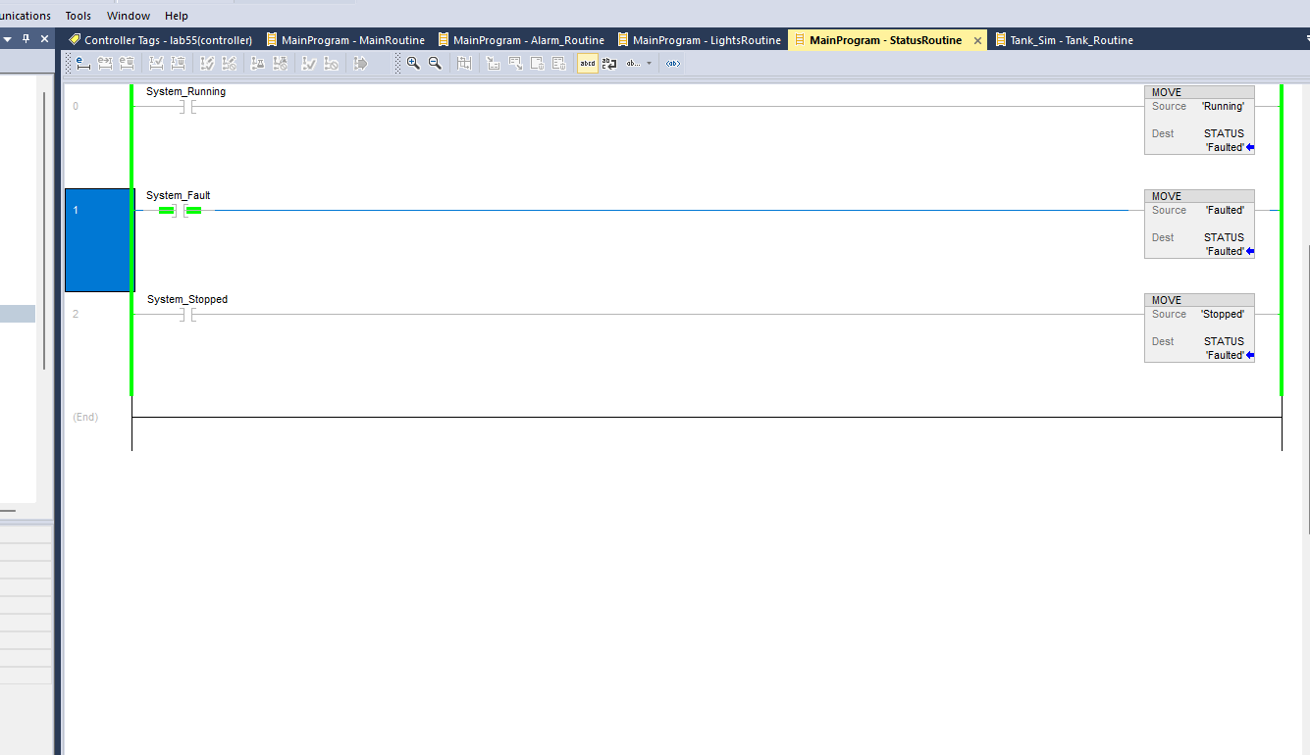
Figure 5. StatusRoutine showing the Faulted system status during the tested fault condition.

5. Tank Simulation and Periodic Execution
The tank was simulated mathematically instead of using a physical tank. The level was calculated using the fill-speed setpoint, depletion-rate setpoint, scaling constants, and a fixed time step. The equation used in TankRoutine was:
Tank_Level_Temp = Tank_Level + ((FillSpeed_SP x k_fill) - (DepletionRate_SP x k_drain)) x dt
TankRoutine was placed under a 100 ms periodic task, so dt was set to 0.1 s. The calculated temporary value was limited to the valid range of 0 to 100 before being copied to Tank_Level. This prevented impossible simulated values below an empty tank or above a full tank. Figure 6 shows TankRoutine online during the same high-level test.
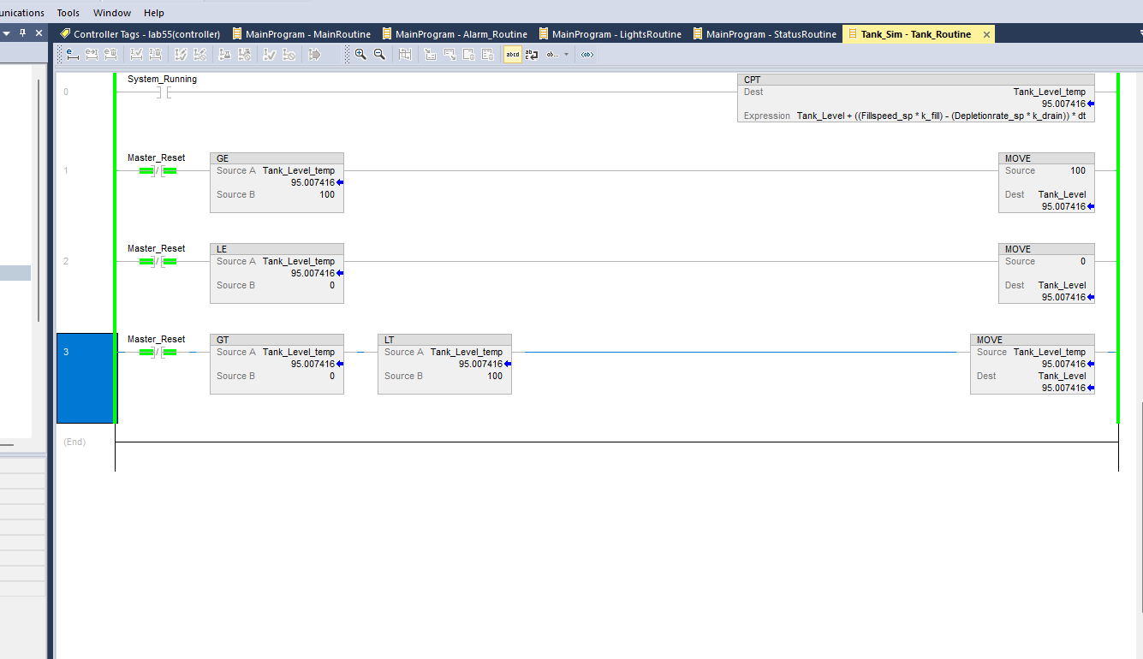
Figure 6. TankRoutine showing the tank-level calculation and 0 to 100 level limiting.

6. HMI Design, Tag Binding, Setpoints, and Trends
The HMI was developed in Studio 5000 View Designer. Two main user-defined screens were created: Home and Control. The Home screen was mainly used for monitoring and navigation. It displayed the system status, tank level, tank graphic, STOP button, Control Screen button, and logon/logoff controls.
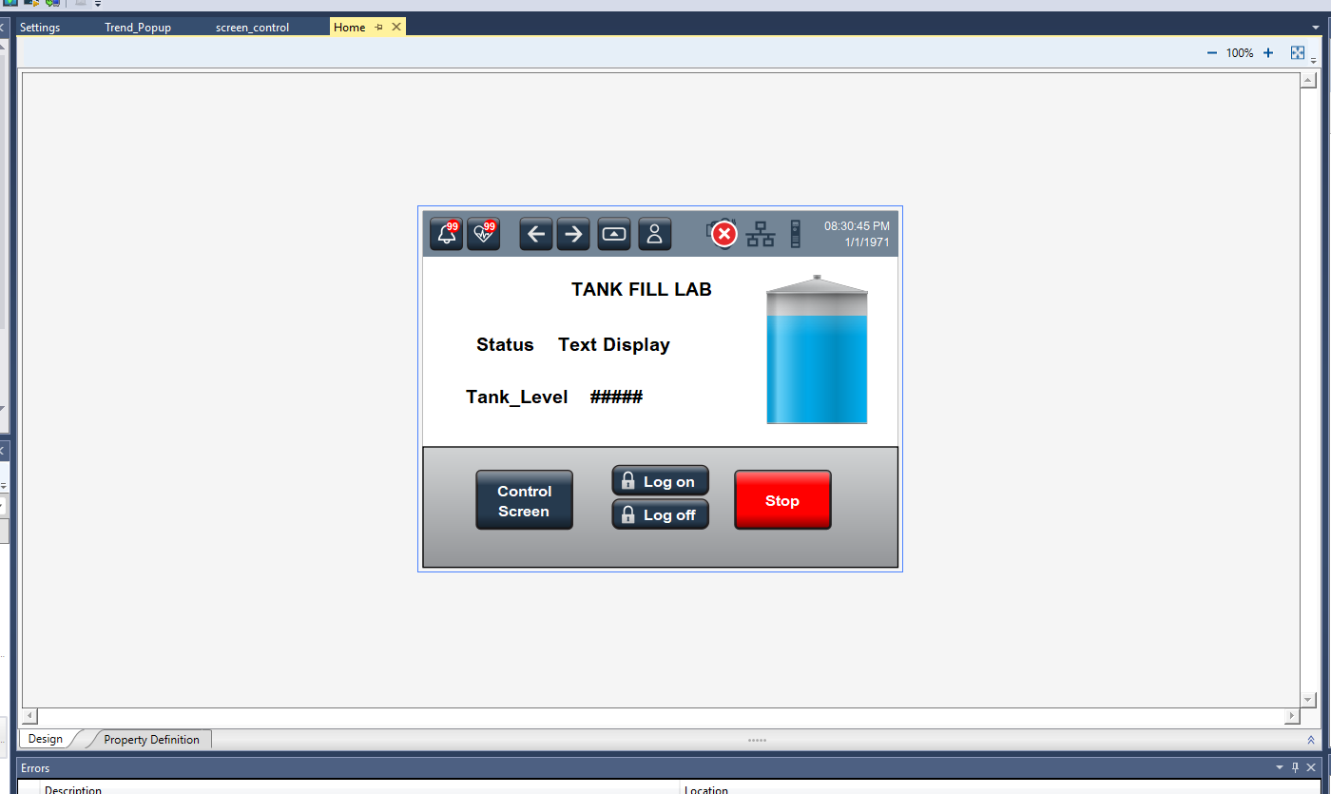
Figure 7. HMI Home screen used for process monitoring, navigation, STOP control, and user logon/logoff.
The Control screen provided the main operating commands. START and RESET were configured as momentary push buttons, and numeric inputs were connected to FillSpeed_SP and DepletionRate_SP. The screen also displayed tank level, fixed minimum and maximum references, status information, and the tank graphic.
Figure 8 also shows the security expression for the depletion-rate numeric input. The input is enabled only when CurrentUserRole is Administrator. This makes the screen useful as both an operating interface and a demonstration of role-based access control.
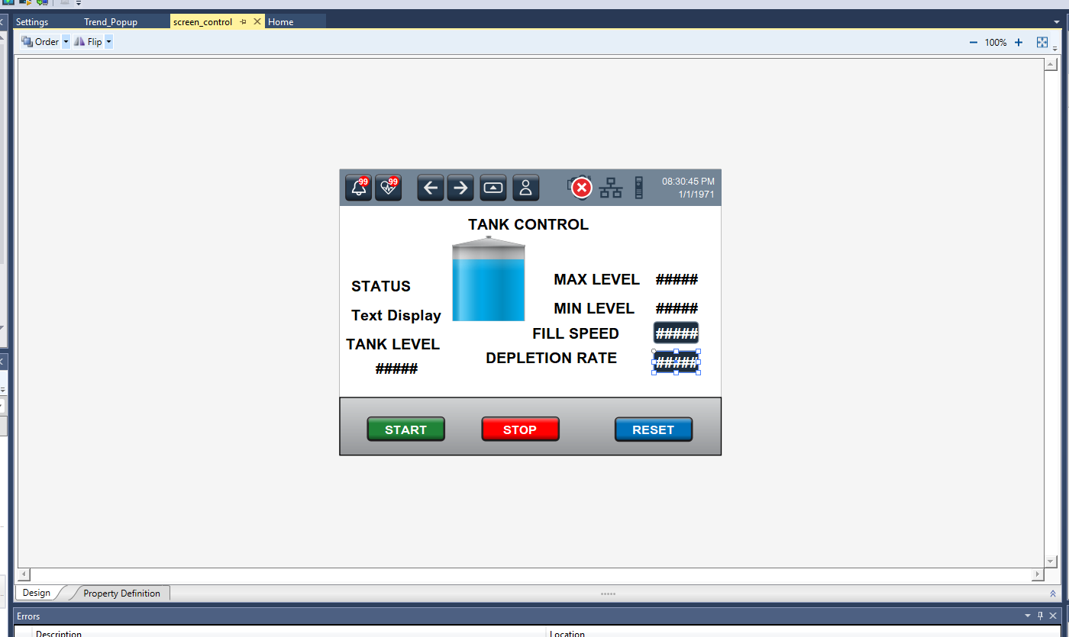
Figure 8. HMI Control screen with START, STOP, RESET, process setpoints, tank graphic, and Administrator-only depletion-rate enable expression.
A trend popup was created to display FillSpeed_SP and DepletionRate_SP over time. The trend gives the operator a graphical view of how the commanded filling and depletion rates compare. Figure 9 shows the configured trend popup in View Designer.
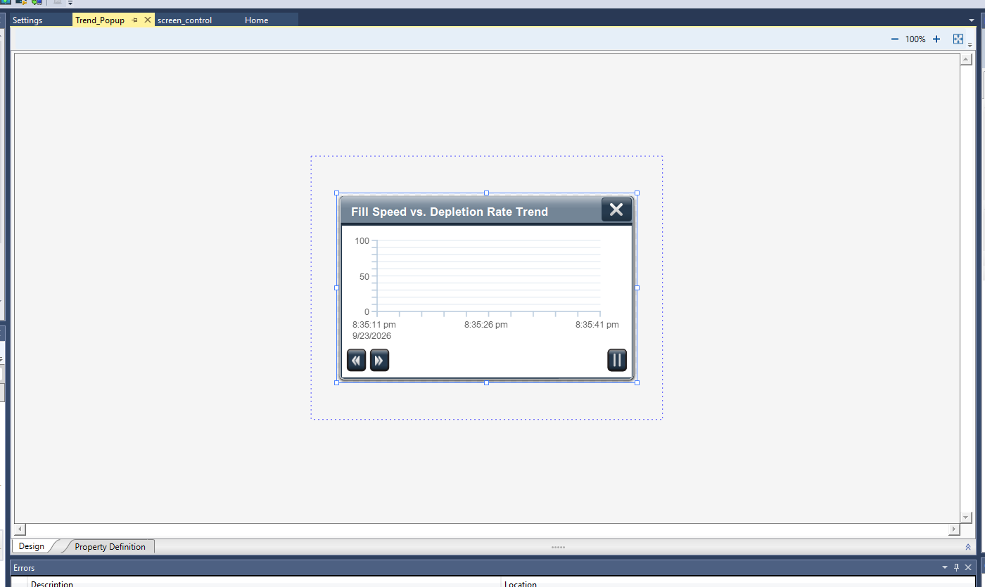
Figure 9. Trend popup configured for fill-speed and depletion-rate values.

7. Role-Based HMI Security
The HMI used three access levels. Guest users were limited to monitoring. Operators could access the Control screen and modify the fill-speed setpoint. Administrators could also modify the depletion-rate setpoint. The purpose of these permissions was to prevent every user from changing all process settings.
Role | Permitted Access
Guest | Monitoring only
Operator | Control screen and FillSpeed_SP adjustment
Administrator | Control screen, FillSpeed_SP, and DepletionRate_SP adjustment

The Administrator-only expression visible in Figure 8 is important because it directly disables the depletion-rate input for users who do not have the Administrator role. This adds an extra layer of control at the operator interface.

8. Verification, Emulation, and Testing Results
I checked the controller online in REM RUN mode and used the HMI configuration to review commands, setpoint bindings, navigation, trends, and access permissions. In the recorded high-level fault test, Tank_Level reached approximately 95.007, exceeding the 95 high-fault limit. Fault_High became active, System_Fault latched, Status changed to Faulted, and the fault indication logic became active. The observed values matched the configured high-fault response.
Verification Item | Expected Result | Recorded Result
PLC online / REM RUN | Controller executes program online | Controller online in REM RUN
High fault threshold | Fault_High at Tank_Level >= 95 | Observed at Tank_Level approximately 95.007
Fault latch | System_Fault remains active after fault | Observed active in AlarmRoutine
Status response | Status becomes Faulted | Observed in StatusRoutine
Fault indication | Fault output/indicator becomes active | Observed in LightsRoutine
Tank level limiting | Tank value limited to 0-100 | Logic shown in TankRoutine
HMI Home screen | Monitoring and navigation objects present | Configuration shown in View Designer
HMI Control screen | START/STOP/RESET and setpoints present | Configuration shown in View Designer
Role restriction | Depletion rate Administrator only | Expression shown in Control-screen properties
Trend popup | Fill/depletion trend configured | Configuration shown in View Designer
Physical integration | PLC HMI and VFD operate with the tank model | Physical setup used with simulated tank feedback; a full measurement log is not included

The verification record distinguishes observed online behavior from configuration checks. The high-fault response was recorded online, while the HMI screenshots document screen objects, trend configuration, and the Administrator-only input expression. Hardware integration used the PLC, HMI, and VFD with a simulated tank model; this report does not include a separate measurement log for every physical indicator or operating condition.

9. Engineering Analysis of Safety, Reliability, and Design Decisions
Several parts of the design improve safe and reliable operation. The VFD command depends on the running state and fault state, so the motor command is removed when the process is stopped or faulted. Tank_Level is limited between 0 and 100 so the simulation cannot create impossible level values. Warning limits give the operator notice before a fault limit is reached, and the fault is latched so the process does not automatically restart after a critical condition.
The Master Reset provides a controlled way to return the simulated tank level to 50 and clear the latched system fault. Role-based HMI security also improves reliability by allowing users to change only the settings assigned to their role. For example, an Operator cannot change the depletion rate because that input is enabled only for the Administrator role.
The main implementation boundary is the simulated tank model. A physical process would require level sensors, a tank, pumps, and consideration of measurement noise and process dynamics. The current project demonstrates controller execution, HMI integration, alarm logic, setpoint handling, and VFD command generation without modeling every physical process effect.

10. Conclusion
I integrated PLC ladder logic, a PanelView HMI, VFD control, a tank simulation, alarms, physical indication logic, trends, and user permissions in one process-control project. The CompactLogix PLC executed the control logic and tank calculations, while the HMI provided monitoring, operating commands, and permitted setpoint adjustments.
The 100 ms periodic task provided a consistent update rate for the tank model. Warning and fault limits protected the simulated process from operating outside the desired range. The high-fault test shown in the screenshots behaved as expected: the tank level exceeded the 95 limit, the fault latched, the status changed to Faulted, and the fault indication became active.
The project gave me practical experience with modular ladder logic, PLC-HMI tag integration, periodic process calculations, fault diagnostics, and operator access control. A future extension would replace the simulated tank feedback with measurements from a physical tank, level sensor, and pump.

