DAY 1 REPORT – DATASET UNDERSTANDING
Title: Brain Tumor Detection using Deep Learning
Day 1: Dataset Understanding
1.Objective - The objective of Day 1 is to explore and understand the MRI brain tumor dataset, identify the target variable, analyze class distribution, visualize sample images, and examine image characteristics such as size and format.
2.Dataset Description-
The dataset is sourced from Kaggle and consists of MRI brain scan images used for tumor detection.It is used to classify whether a tumor is present or not.
The dataset consists of two classes:
1. Brain Tumor
2. Healthy (No Tumor)
This is a binary classification problem.
3.Target Variable-
The target variable is defined as:
0 → Healthy (No Tumor)
1 → Brain Tumor
The model will be trained on labeled MRI images and will predict whether a new, unseen MRI image contains a tumor or not.
4. Dataset Structure-

The dataset is organized into two folders: Brain Tumor and Healthy, each containing corresponding MRI images.
5. CLASS DISTRIBUTION-
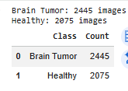
The dataset contains the following number of images:
- Brain Tumor: 2445 images
- Healthy: 2075 images
There is a slight class imbalance, but it is not significant.
6. CLASS DISTRIBUTION VISUALIZATION-
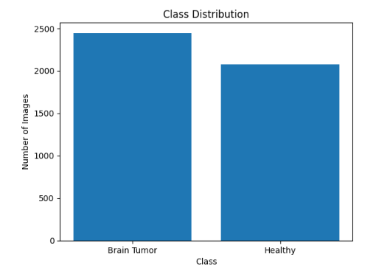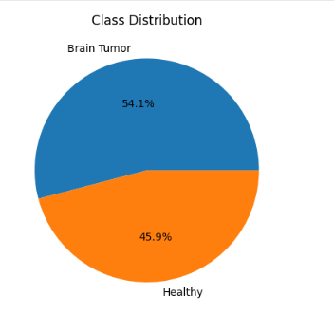

The class distribution visualization shows that the dataset is slightly imbalanced, with more tumor images than healthy images.
7. IMAGE SIZE ANALYSIS-
The dataset contains images of varying sizes such as 512×512, 630×630, and other irregular dimensions. This indicates that resizing is required before training the model.
8. Sample Image Visualization-
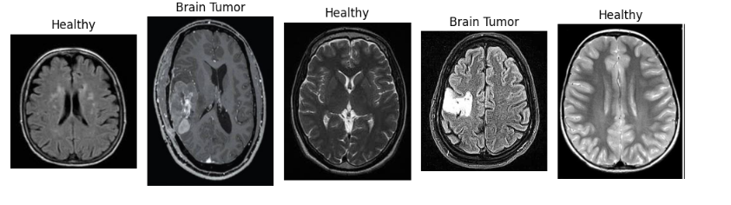
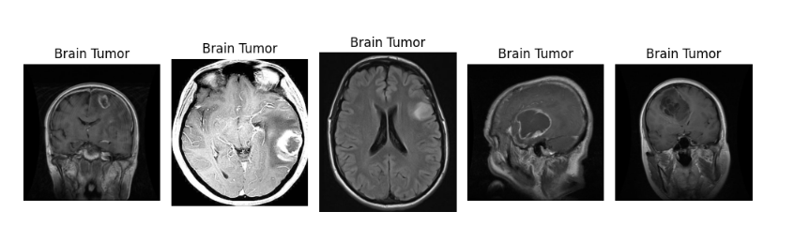
Sample MRI images were visualized from both classes. Tumor images show abnormal bright regions, while healthy images appear more uniform and symmetrical.
9. Heatmap Analysis-
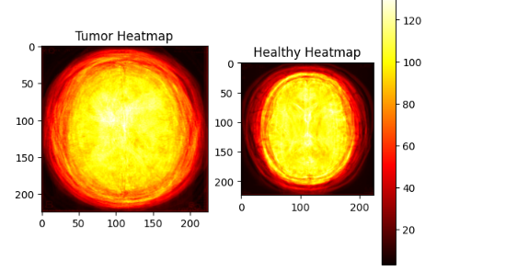
Heatmap visualization was used to compare tumor and healthy MRI images. Tumor images show irregular and concentrated high-intensity regions, while healthy images exhibit a more uniform intensity distribution. This demonstrates that tumor detection is based on intensity patterns rather than a single bright region.
10. Edge Detection Analysis-
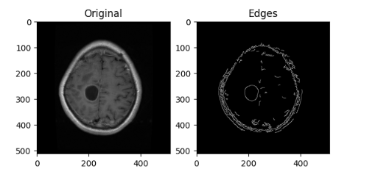
Edge detection highlights structural differences in MRI images. Tumor images show irregular boundaries, while healthy images appear smoother and more uniform.
11. Average Image Analysis-
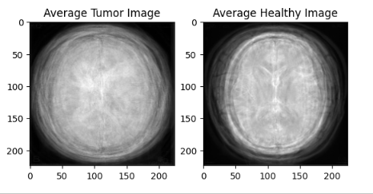
Average images were generated to observe general patterns. Tumor images show irregular intensity distribution, while healthy images appear more uniform and symmetrical.
12. IMAGE CHARACTERISTICS-
The following observations were made from the dataset:
- Images have different sizes
- Some images are grayscale while others are color-mapped
- MRI images are captured from different orientations (axial, sagittal)
- Tumor images contain irregular bright regions
13. CHALLENGES IDENTIFIED-
The following challenges were identified:
- Non-uniform image sizes
- Slight class imbalance
- Variation in image format (grayscale and color)
- Different MRI orientations
14. CONCLUSION-
The dataset is suitable for a binary classification problem (Tumor vs Healthy). However, preprocessing is required to standardize image size and format before training a deep learning model. This dataset provides a strong foundation for building a deep learning-based medical image classification system.
Tumor detection is not based on a single bright region but on intensity patterns, texture, and structural irregularities observed across the images.
15. NEXT STEP-
In the next stage (Day 2), the dataset will be preprocessed by resizing images to a fixed size (224×224), normalizing pixel values, and preparing the dataset for model training.
STORYBOARD:
1. Input: MRI Brain Images
2. Data Understanding: Analyze dataset structure and distribution
3. Preprocessing: Resize and normalize images
4. Model: Train Convolutional Neural Network (CNN) for classification
5. Output: Predict Tumor or No Tumor
6. Deployment: Build application for real-time prediction
DAILY TASK REPORT
What I did today:
- Explored dataset structure
- Identified target variable
- Checked class distribution
- Visualized sample images
- Analyzed image sizes and formats
What I will do next:
- Perform image preprocessing
- Resize images
- Normalize pixel values
- Prepare dataset for training
Issues:
- Images have different sizes
- Slight class imbalance
- Variation in image formats
16. Final Visualization Note-
The above images show sample MRI scans from both Brain Tumor and Healthy classes. Tumor images exhibit irregular and high-intensity regions, while healthy images show uniform and symmetrical patterns.
This analysis confirms that tumor detection is based on intensity patterns and structural differences rather than a single bright region.

