TASK-3

Statement: We have to create a web portal for our company with all the security as much as possible.

So, we use Wordpress software with dedicated database server.

Database should not be accessible from the outside world for security purposes.

We only need to public the WordPress to clients.

So here are the steps for proper understanding!

Steps:

1) Write a Infrastructure as code using terraform, which automatically create a VPC.

2) In that VPC we have to create 2 subnets:

a) public subnet [ Accessible for Public World! ]

b) private subnet [ Restricted for Public World! ]

3) Create a public facing internet gateway for connect our VPC/Network to the internet world and attach this gateway to our VPC.

4) Create a routing table for Internet gateway so that instance can connect to outside world, update and associate it with public subnet.

5) Launch an ec2 instance which has Wordpress setup already having the security group allowing port 80 so that our client can connect to our wordpress site.

Also attach the key to instance for further login into it.

6) Launch an ec2 instance which has MYSQL setup already with security group allowing port 3306 in private subnet so that our wordpress vm can connect with the same.

Also attach the key with the same.

REPO PATH :- <https://github.com/Shailly29/Hybrid-task3.git>

What is Amazon VPC?

Amazon Virtual Private Cloud (Amazon VPC) enables you to launch AWS resources into a virtual network that you've defined. This virtual network closely resembles a traditional network that you'd operate in your own data center, with the benefits of using the scalable infrastructure of AWS.

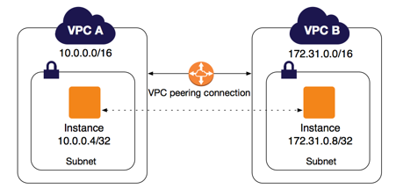

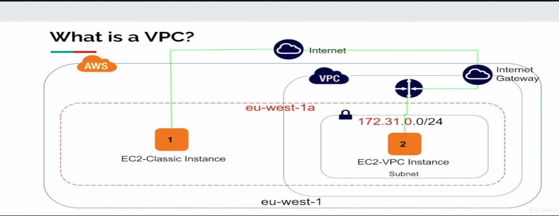

**Amazon VPC concepts**

Amazon VPC is the networking layer for Amazon EC2.

The following are the key concepts for VPCs:

* **Virtual private cloud (VPC)** — A virtual network dedicated to your AWS account.
* **Subnet** — A range of IP addresses in your VPC.
* **Route table** — A set of rules, called routes, that are used to determine where network traffic is directed.
* **Internet gateway** — A gateway that you attach to your VPC to enable communication between resources in your VPC and the internet.
* **VPC endpoint** — Enables you to privately connect your VPC to supported AWS services and VPC endpoint services powered by PrivateLink without requiring an internet gateway, NAT device, VPN connection, or AWS Direct Connect connection. Instances in your VPC do not require public IP addresses to communicate with resources in the service. Traffic between your VPC and the other service does not leave the Amazon network.

**NOTEPAD FILE:-**

1. Write a Infrastructure as code using terraform, which automatically create a VPC.

**provider "aws" {**

**region = "ap-south-1"**

**profile = "shailly"**

**}**

**resource "aws_vpc" "shaillyvpc1" {**

**cidr_block = "192.168.0.0/16"**

**instance_tenancy = "default"**

**tags = {**

**Name = "shaillyvpc1"**

**}**

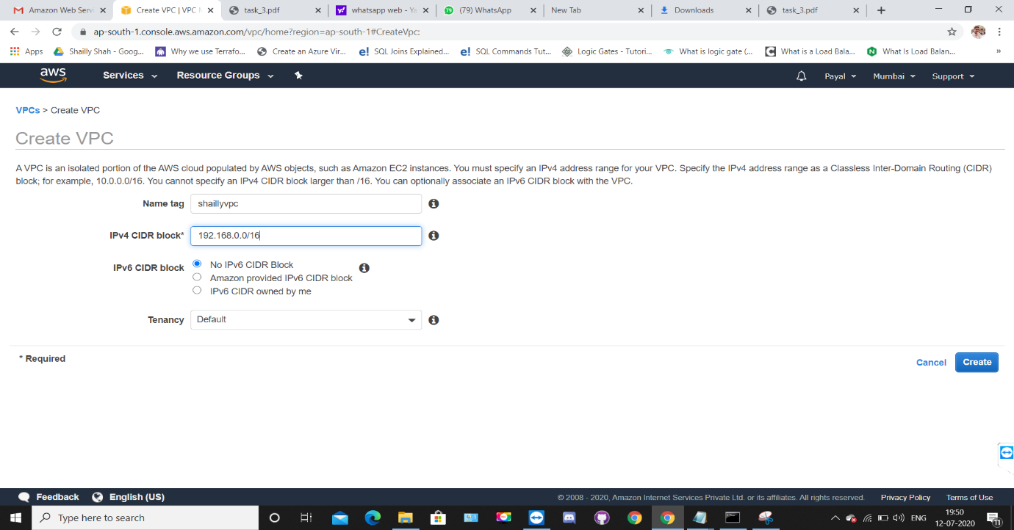**}**

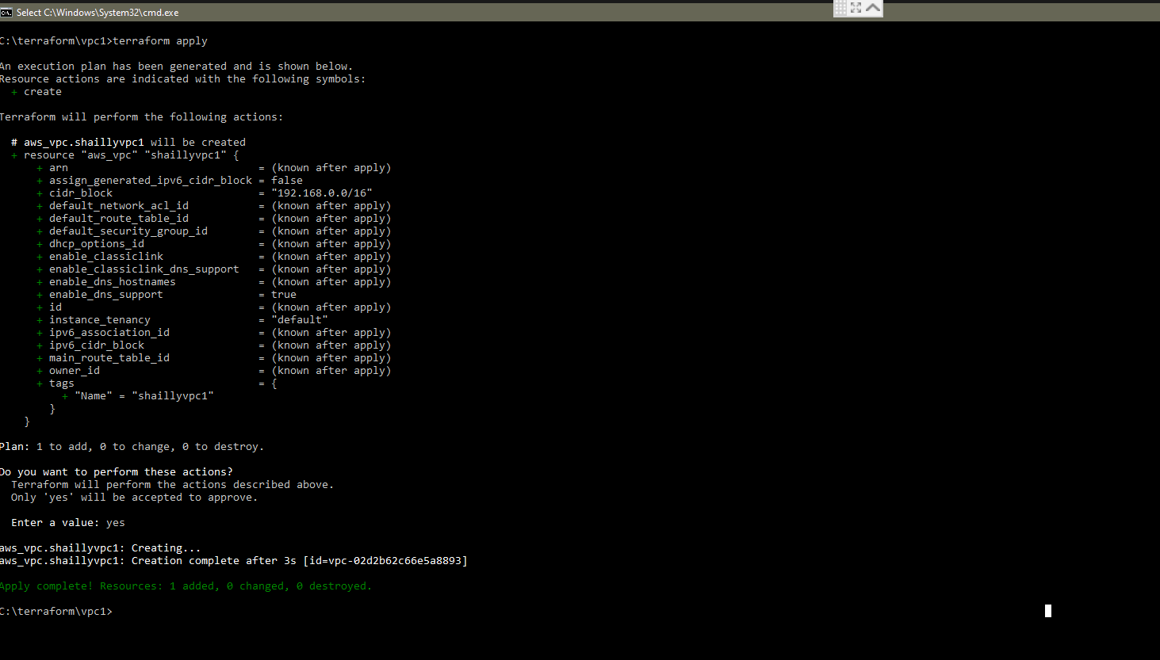

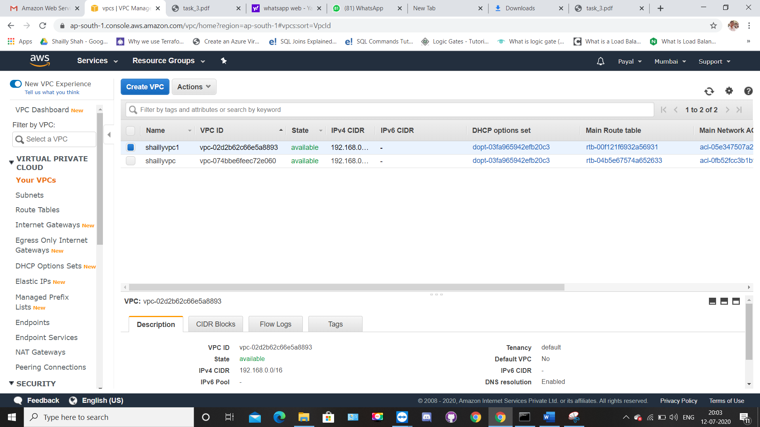

2. In that VPC we have to create 2 subnets:

a) public subnet [ Accessible for Public World! ]

b) private subnet [ Restricted for Public World! ]

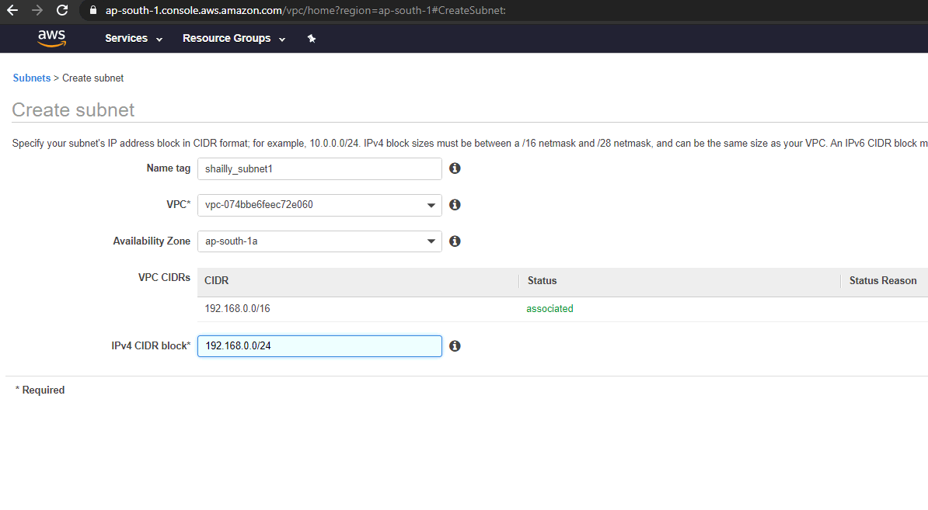

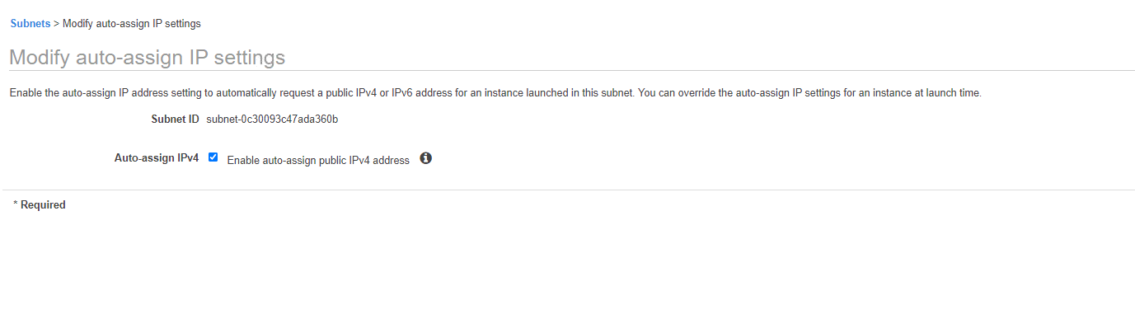

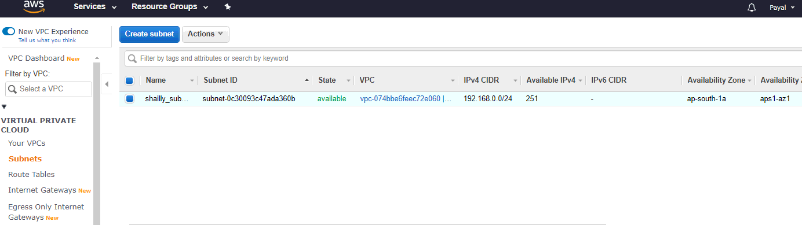

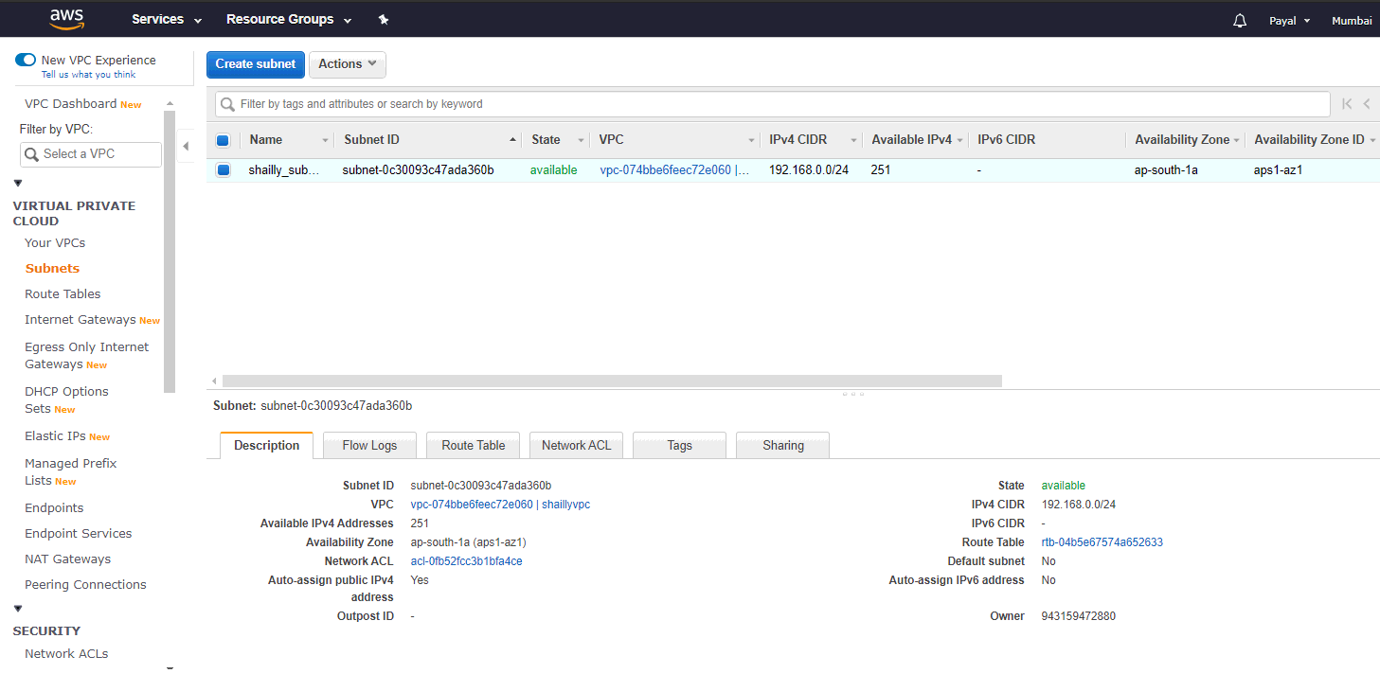

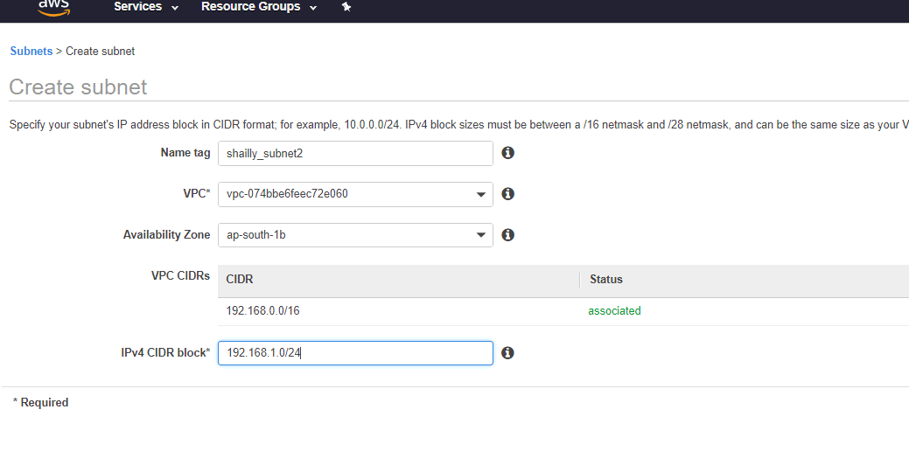

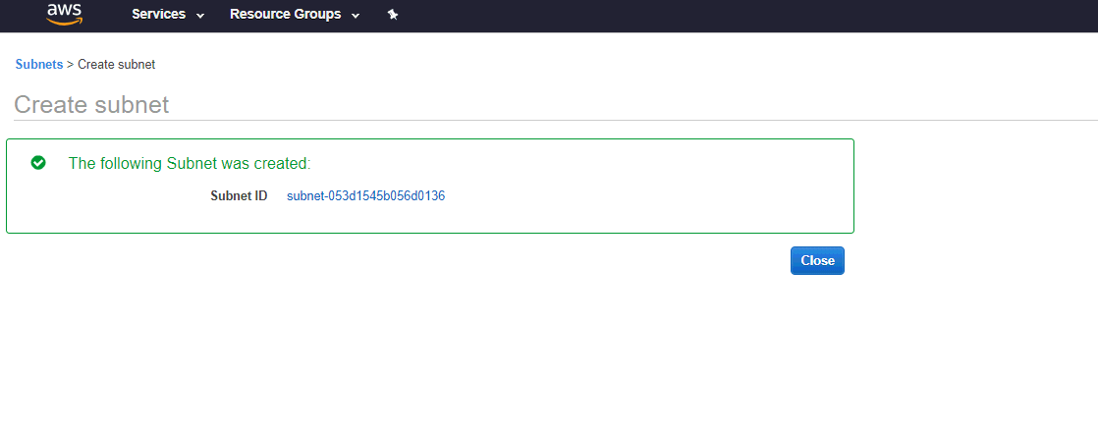

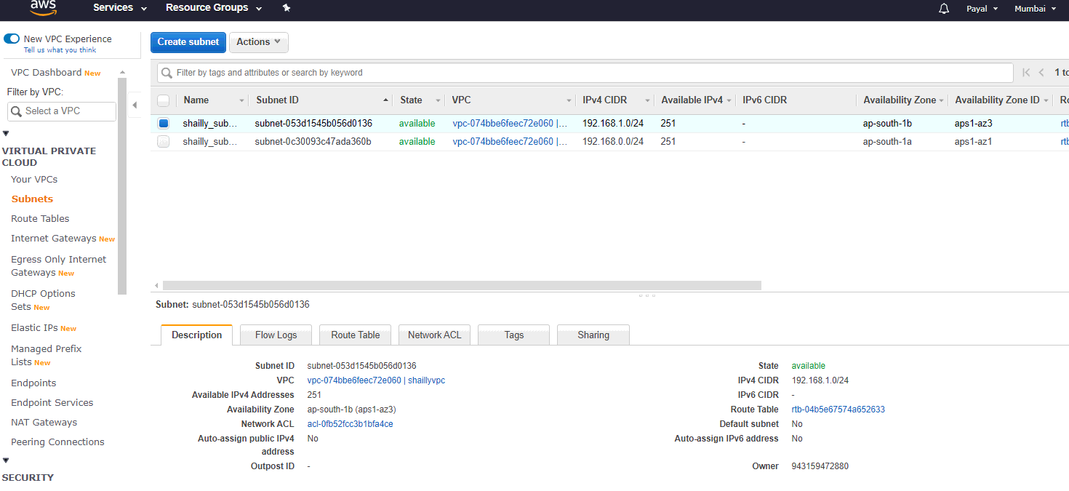

**2. Using terraform**

**resource "aws_subnet" "shaillyvpc1_subnet-1a" {**

**vpc_id = "${aws_vpc.shaillyvpc1.id}"**

**cidr_block = "192.168.0.0/24"**

**availability_zone = "ap-south-1a"**

**map_public_ip_on_launch = true**

**}**

**resource "aws_subnet" "shaillyvpc1_subnet-1b" {**

**vpc_id = "${aws_vpc.shaillyvpc1.id}"**

**cidr_block = "192.168.1.0/24"**

**availability_zone = "ap-south-1b"**

**}**

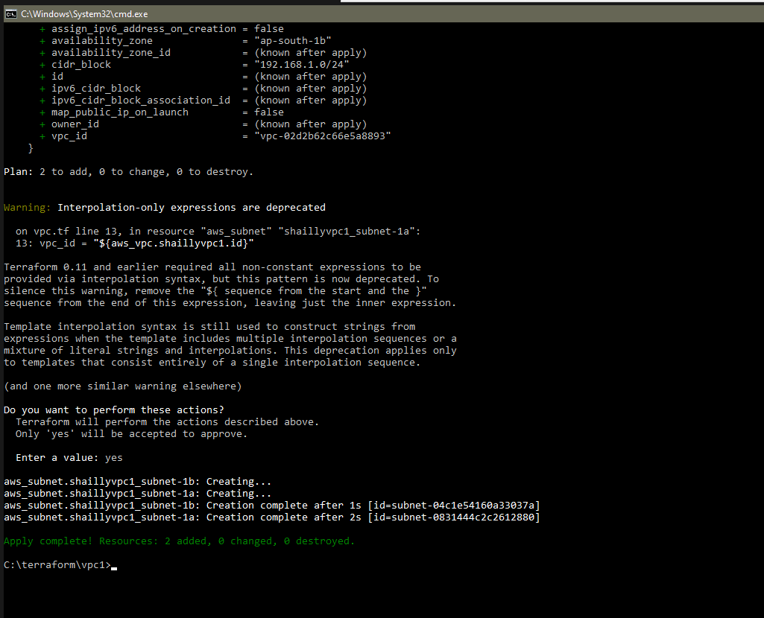

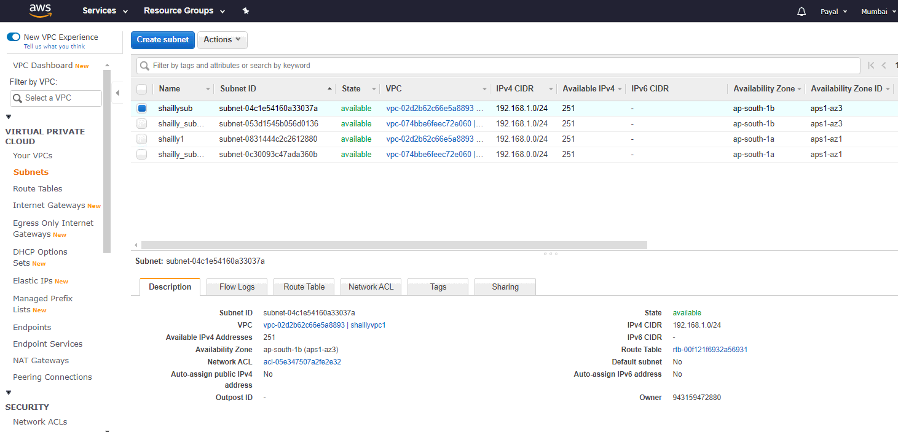

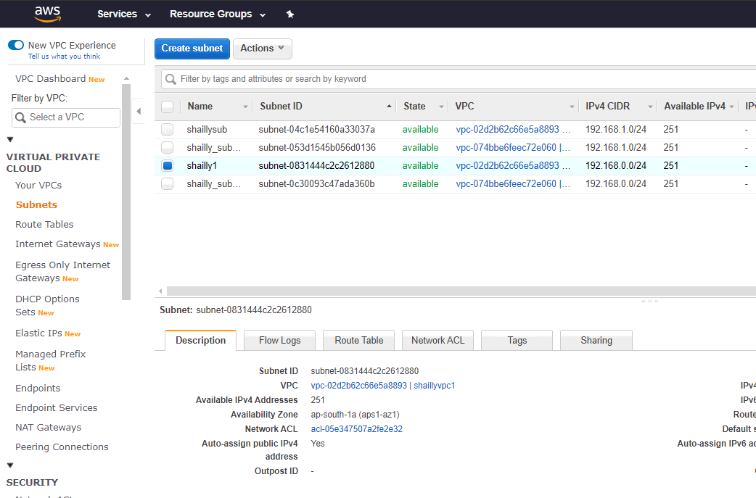

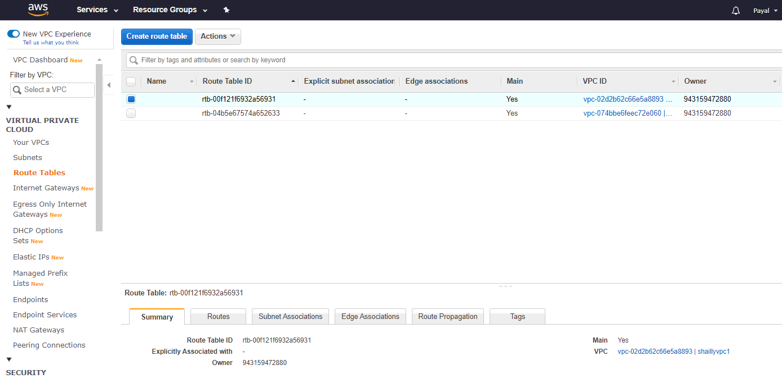

3. Create a public facing internet gateway for connect our VPC/Network to the internet world and attach this gateway to our VPC.

**resource "aws_internet_gateway" "shaillyvpc1_internet_gateway" {**

**vpc_id = "${aws_vpc.shaillyvpc1.id}"**

**tags = {**

**Name = "shaillyvpc1_internet_gateway"**

**}**

**}**

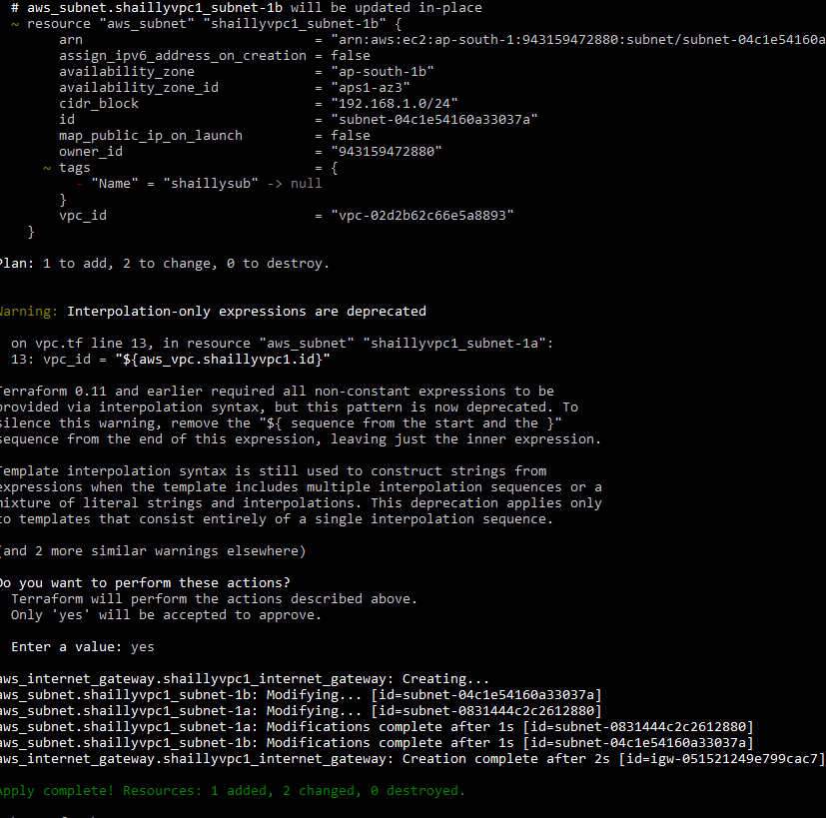

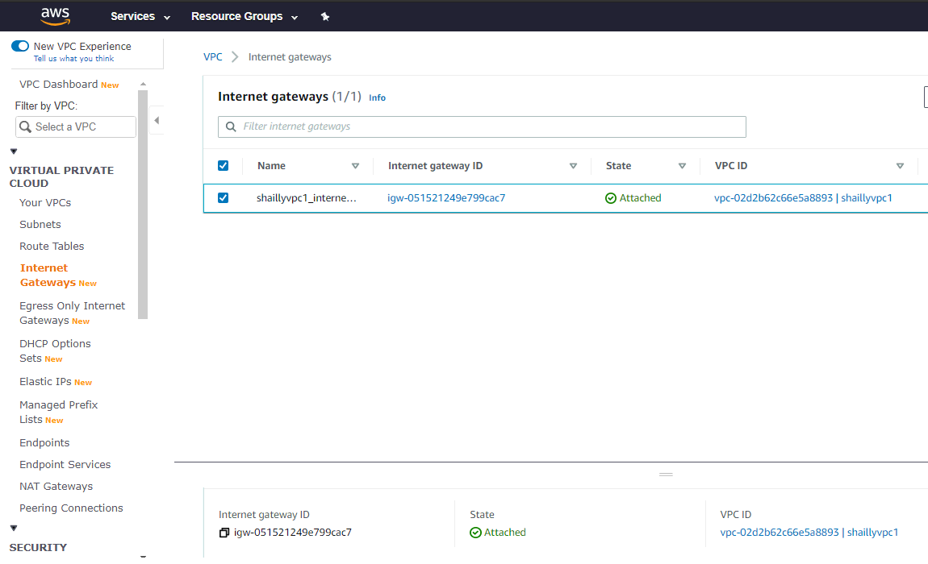

4. Create a routing table for Internet gateway so that instance can connect to outside world, update and associate it with public subnet.

# creating a route-table

# associating route-table with the internet gateway

**resource "aws_route_table" "shaillyvpc1_route_table" {**

**vpc_id = "${aws_vpc.shaillyvpc1.id}"**

**route {**

**cidr_block = "0.0.0.0/0"**

**gateway_id = "${aws_internet_gateway.shaillyvpc1_internet_gateway.id}"**

**}**

**tags = {**

**Name = "shaillyvpc1_route_table"**

**}**

**}**

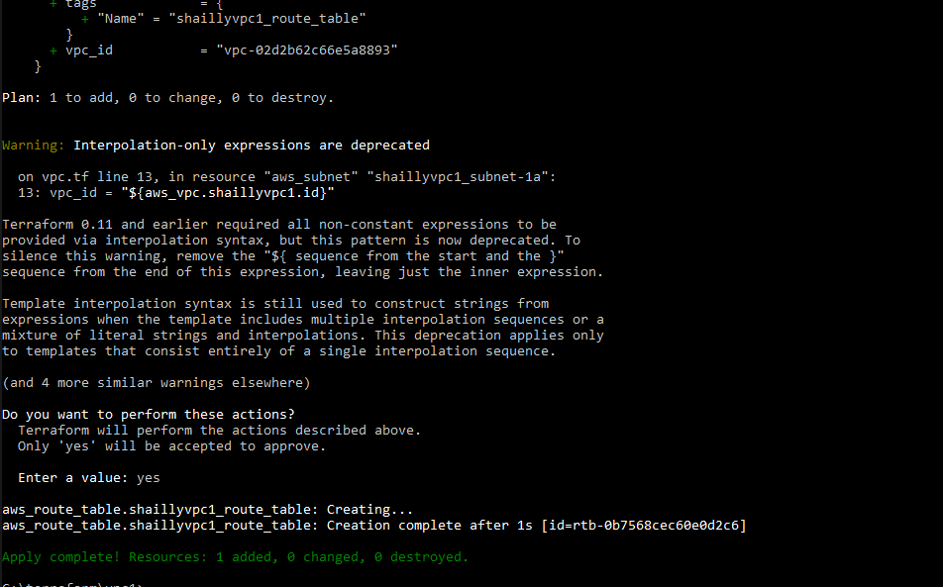

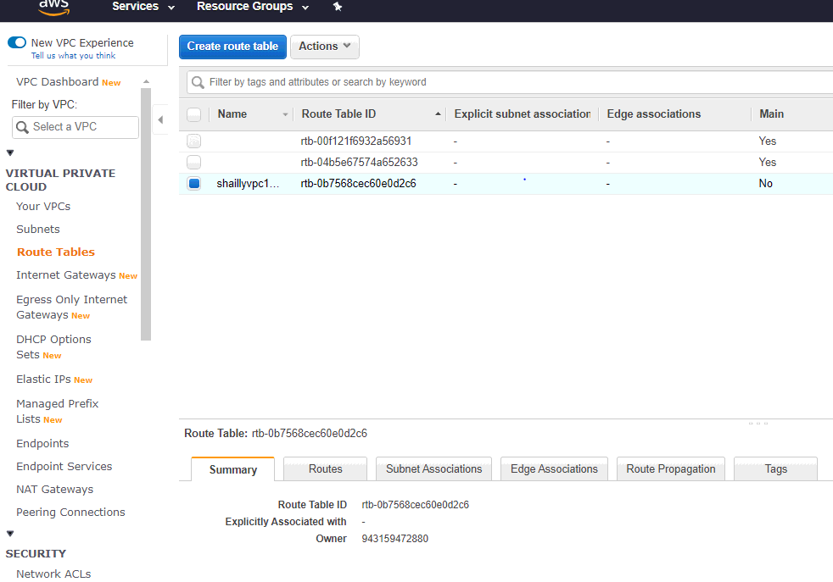

**# associating route table with subnet**

**resource "aws_route_table_association" "a" {**

**subnet_id = aws_subnet.shaillyvpc1_subnet-1a.id**

**route_table_id = "${aws_route_table.shaillyvpc1_route_table.id}"**

**}**

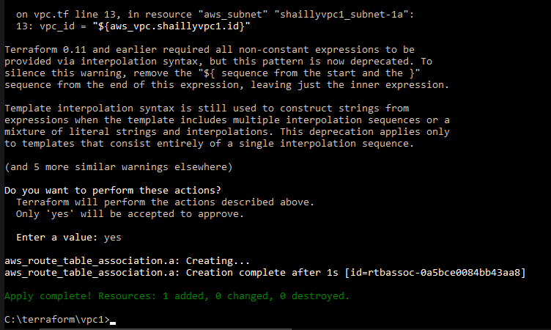

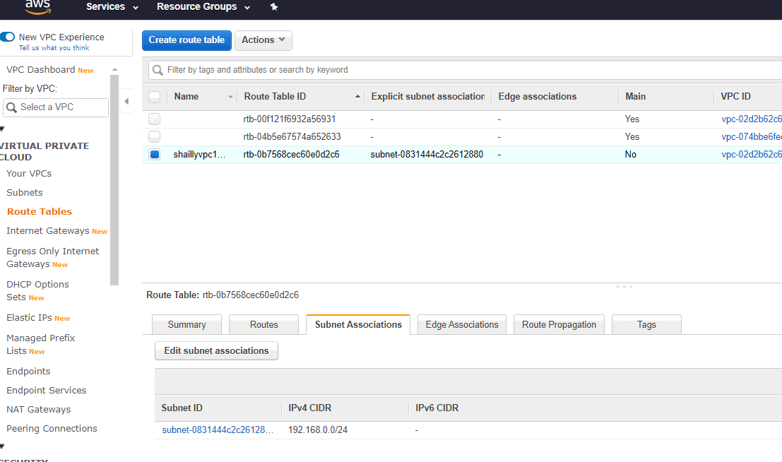

**# creating the security group**

**# shaillyweb**

**resource "aws_security_group" "shaillyweb" {**

**name = "shaillyweb"**

**description = "Allow ssh http and icmp"**

**vpc_id = "${aws_vpc.shaillyvpc1.id}"**

**ingress {**

**description = "http"**

**from_port = 80**

**to_port = 80**

**protocol = "tcp"**

**cidr_blocks = ["0.0.0.0/0"]**

**}**

**ingress {**

**description = "ssh"**

**from_port = 22**

**to_port = 22**

**protocol = "tcp"**

**cidr_blocks = ["0.0.0.0/0"]**

**}**

**ingress {**

**description = "ICMP-IPv4"**

**from_port = 0**

**to_port = 0**

**protocol = "-1"**

**cidr_blocks = ["0.0.0.0/0"]**

**}**

**egress {**

**from_port = 0**

**to_port = 0**

**protocol = "-1"**

**cidr_blocks = ["0.0.0.0/0"]**

**}**

**tags = {**

**Name = "shaillyweb"**

**}}**

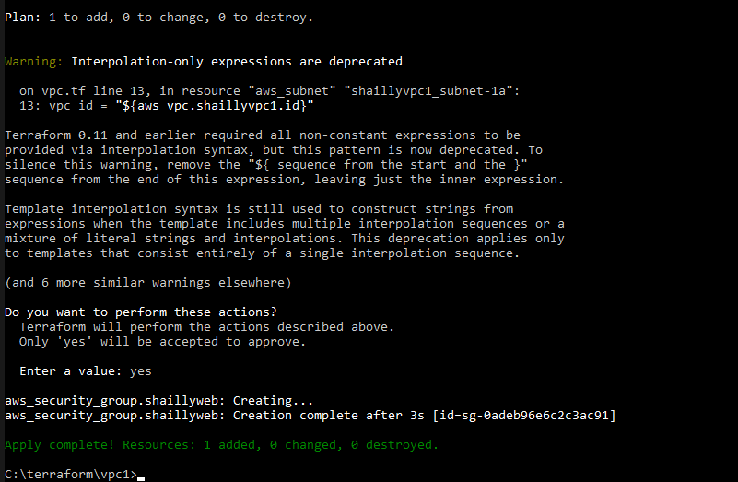

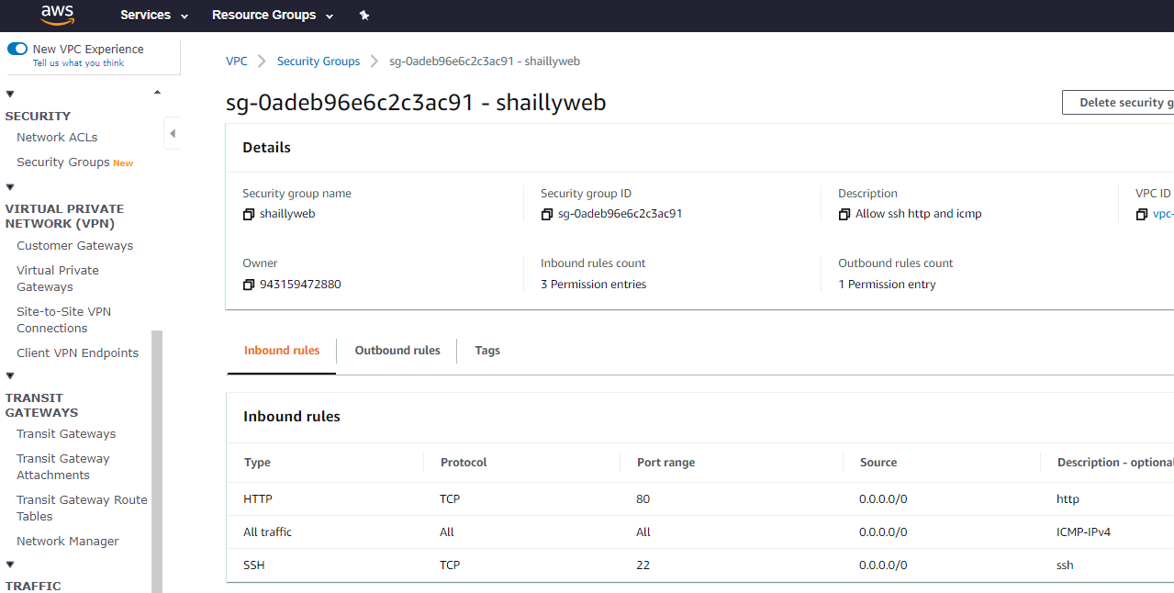

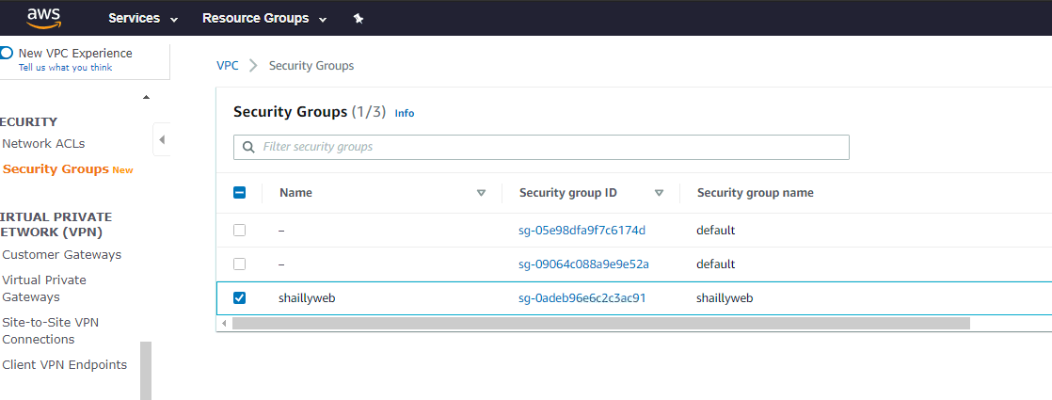

**# creating a subnet group with MYSQL protocol and give the value of security id (shaillyweb)**

**# shaillysql**

**resource "aws_security_group" "mysql" {**

**name = "shaillysql"**

**description = "Allow sql"**

**vpc_id = "${aws_vpc.shaillyvpc1.id}"**

**ingress {**

**description = "MYSQL"**

**security_groups=[ "${aws_security_group.shaillyweb.id}" ]**

**from_port = 3306**

**to_port = 3306**

**protocol = "tcp"**

**}**

**egress {**

**from_port = 0**

**to_port = 0**

**protocol = "-1"**

**cidr_blocks = ["0.0.0.0/0"]**

**}**

**tags = {**

**Name = "shaillysql"**

**}**

**}**

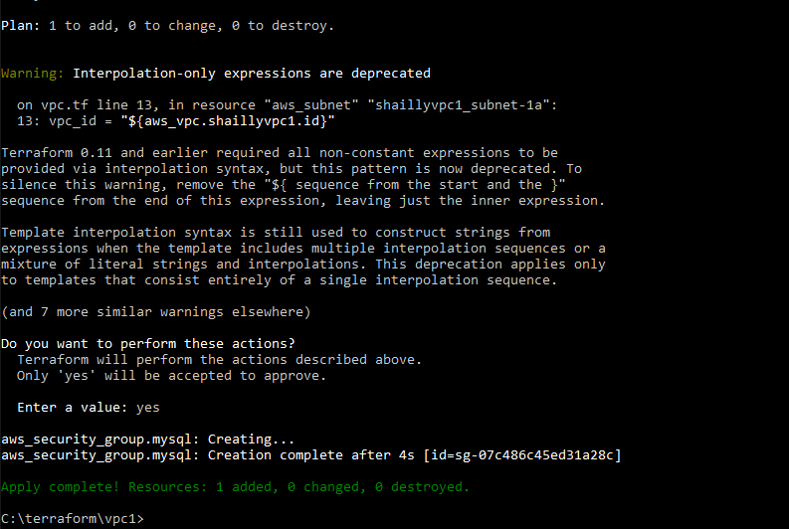

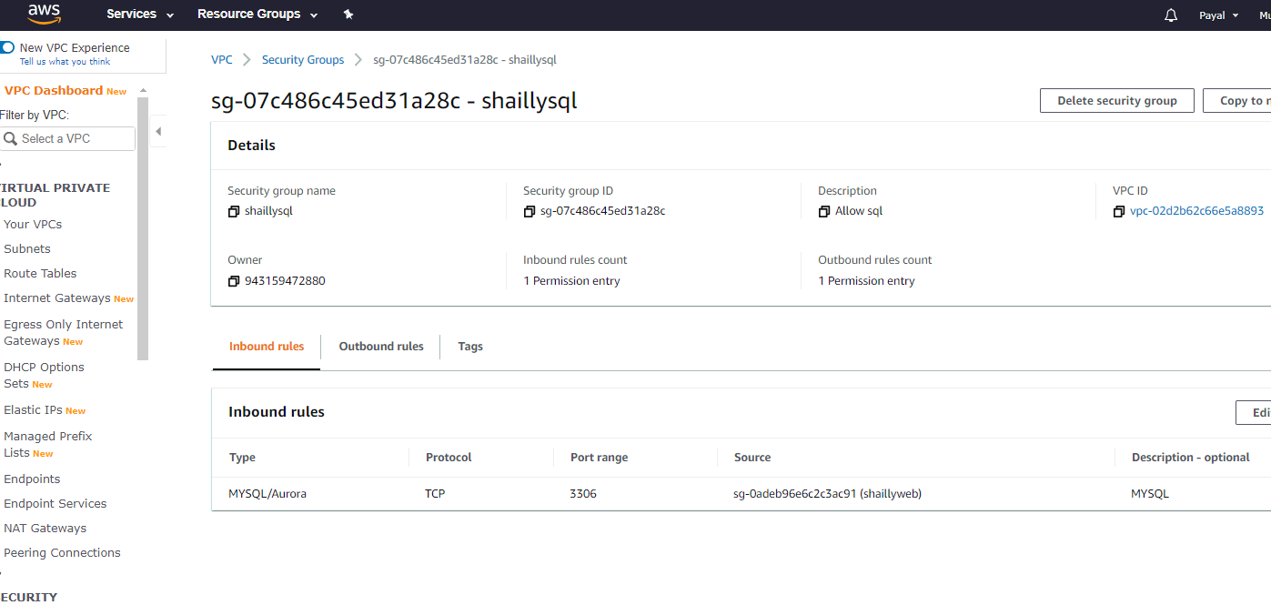

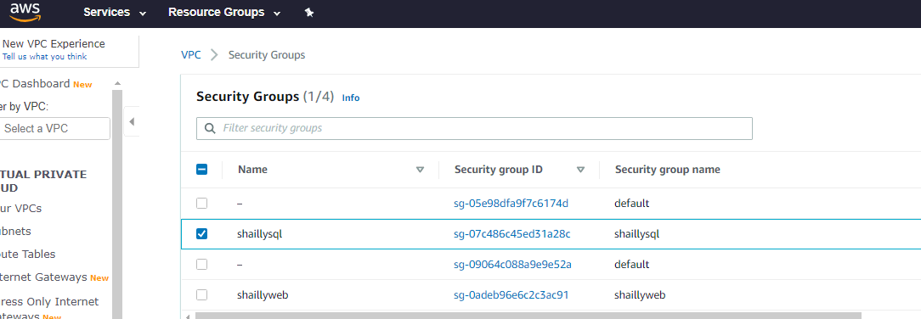

**# creating a security group with ssh protocol**

**# bastionhost**

**resource "aws_security_group" "shahbastion" {**

**name = "shahbastion"**

**description = "Allow ssh for bastion"**

**vpc_id = "${aws_vpc.shaillyvpc1.id}"**

**ingress {**

**description = "ssh"**

**from_port = 22**

**to_port = 22**

**protocol = "tcp"**

**cidr_blocks = ["0.0.0.0/0"]**

**}**

**egress {**

**from_port = 0**

**to_port = 0**

**protocol = "-1"**

**cidr_blocks = ["0.0.0.0/0"]**

**}**

**tags = {**

**Name = "shahbastion"**

**}**

**}**

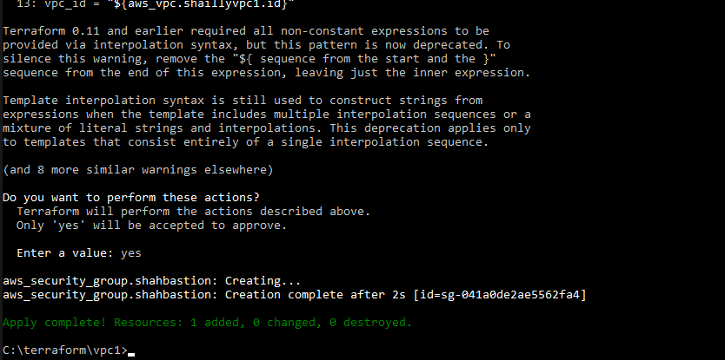

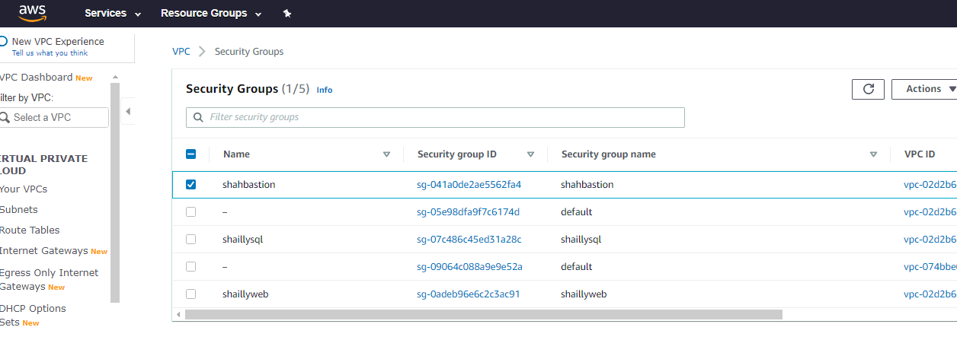

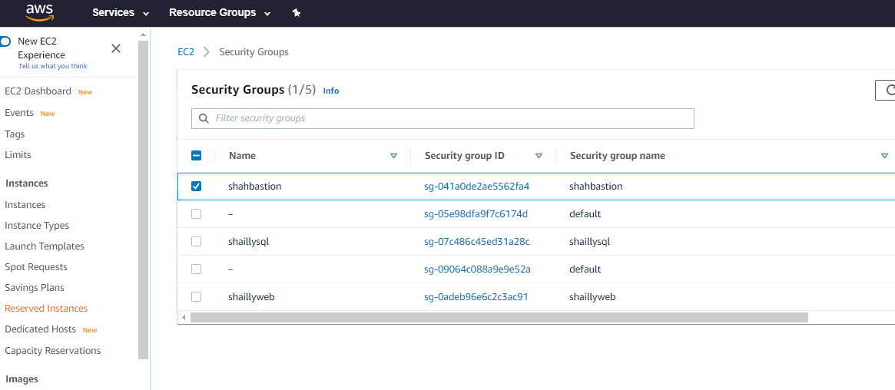

**# creating a subnet group with ssh protocol**

**# shahsqlallow**

**resource "aws_security_group" "shahsqlallow" {**

**name = "shahsqlallow"**

**description = "ssh allow to the mysql"**

**vpc_id = "${aws_vpc.shaillyvpc1.id}"**

**ingress {**

**description = "ssh"**

**security_groups=[ "${aws_security_group.shahbastion.id}" ]**

**from_port = 22**

**to_port = 22**

**protocol = "tcp"**

**}**

**egress {**

**from_port = 0**

**to_port = 0**

**protocol = "-1"**

**cidr_blocks = ["0.0.0.0/0"]**

**}**

**tags = {**

**Name = "shahsqlallow"**

**}**

**}**

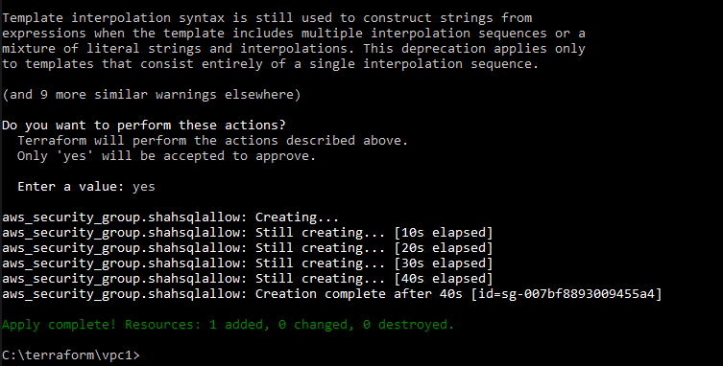

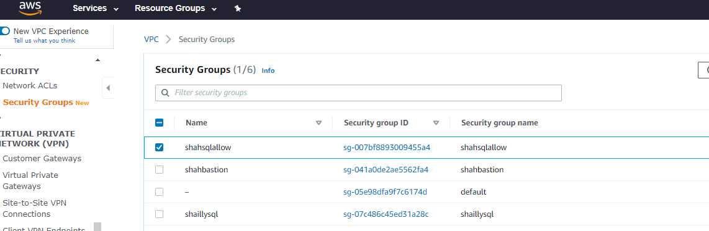

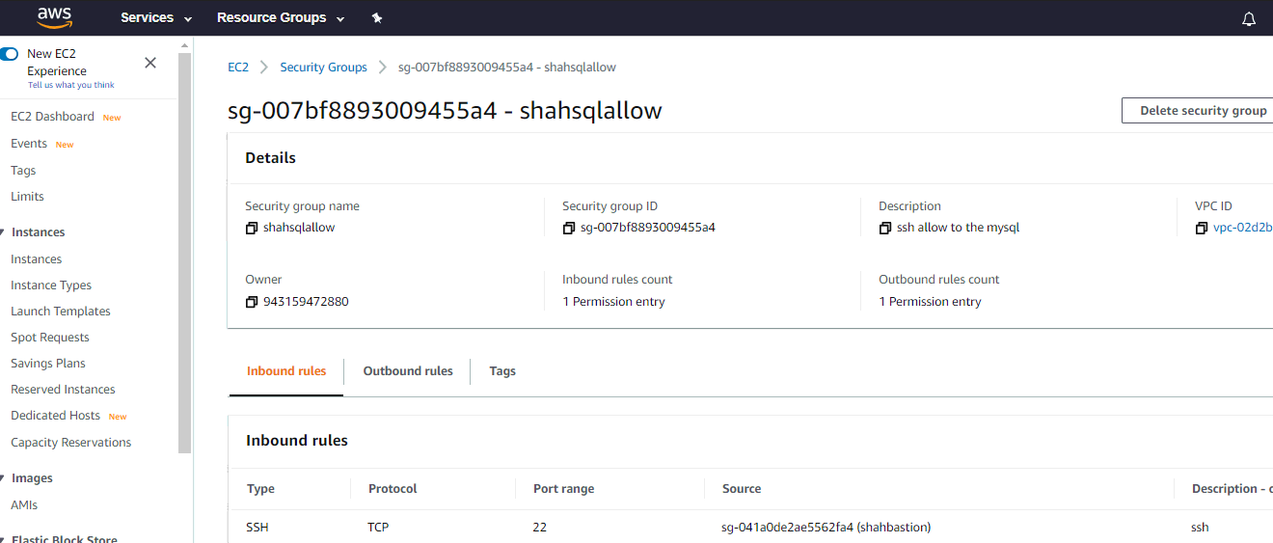

5. Launch an ec2 instance which has Wordpress setup already having the security group allowing port 80 so that our client can connect to our wordpress site.

Also attach the key to instance for further login into it.

**resource "aws_instance" "shahwordpress" {**

**ami = "ami-0cb39c5da8e2fa515"**

**instance_type = "t2.micro"**

**key_name = "shailly.pem"**

**availability_zone = "ap-south-1a"**

**subnet_id = "${aws_subnet.shaillyvpc1_subnet-1a.id}"**

**security_groups = [ "${aws_security_group.shaillyweb.id}" ]**

**user_data = <<-EOF**

**#! /bin/bash**

**sudo yum install dnf install php-mysqlnd php-fpm httpd tar curl php-json -y**

**systemctl start httpd**

**systemctl enable httpd**

**curl https://wordpress.org/latest.tar.gz --output wordpress.tar.gz**

**tar xf wordpress.tar.gz**

**cp -r wordpress /var/www/html**

**chown -R apache:apache /var/www/html/wordpress**

**chcon -t httpd_sys_rw_content_t /var/www/html/wordpress -R**

**EOF**

**tags = {**

**Name = "shahwordpress"**

**}**

**}**

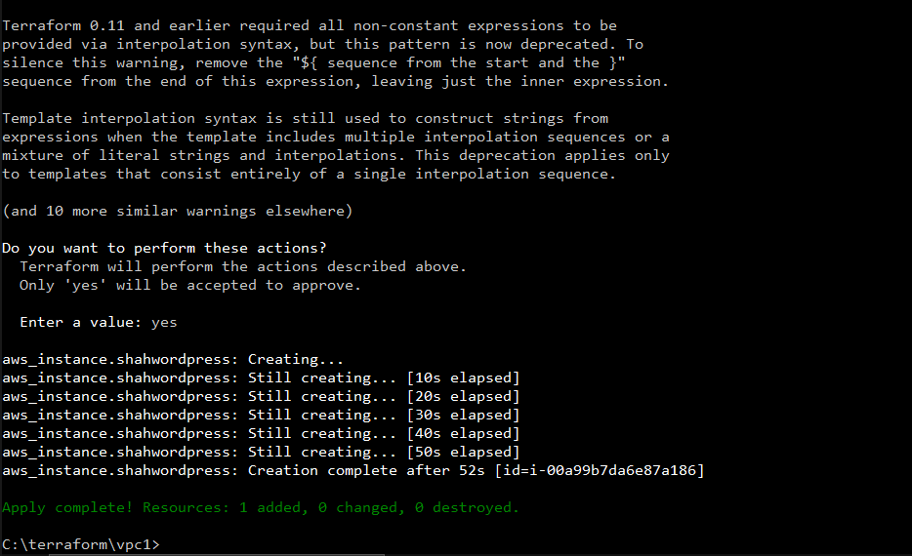

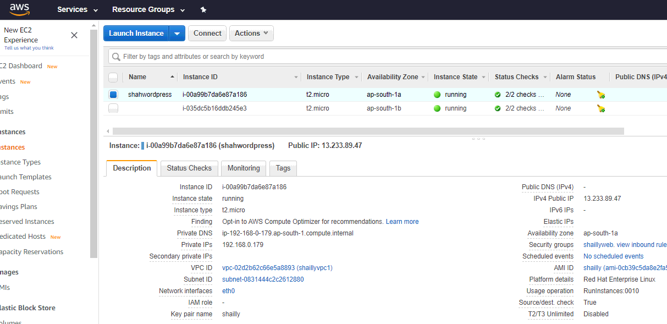

6. Launch an ec2 instance which has MYSQL setup already with security group allowing port 3306 in private subnet so that our wordpress vm can connect with the same.

Also attach the key with the same.

**# launching the instance with the rhel image in the region 1b and attaching the security group shaillysql and shaillysqlallow**

**# not enabling the public-ip**

**resource "aws_instance" "shahsqlsecure" {**

**ami = "ami-02c9b9770f41dc7de"**

**instance_type = "t2.micro"**

**key_name = "shailly"**

**availability_zone = "ap-south-1b"**

**subnet_id = "${aws_subnet.shaillyvpc1_subnet-1b.id}"**

**security_groups = [ "${aws_security_group.mysql.id}" ,**

**"${aws_security_group.shahsqlallow.id}"]**

**user_data = <<-EOF**

**#! /bin/bash**

**sudo yum install @shaillysql -y**

**systemctl start shaillysqld**

**systemctl enable shaillysqld**

**EOF**

**tags = {**

**Name = "shahsqlsecure"**

**}**

**}**

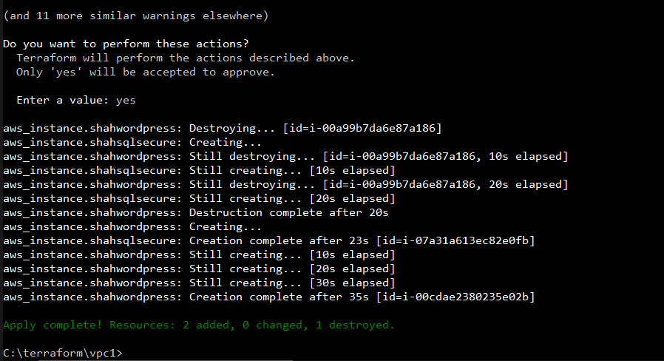

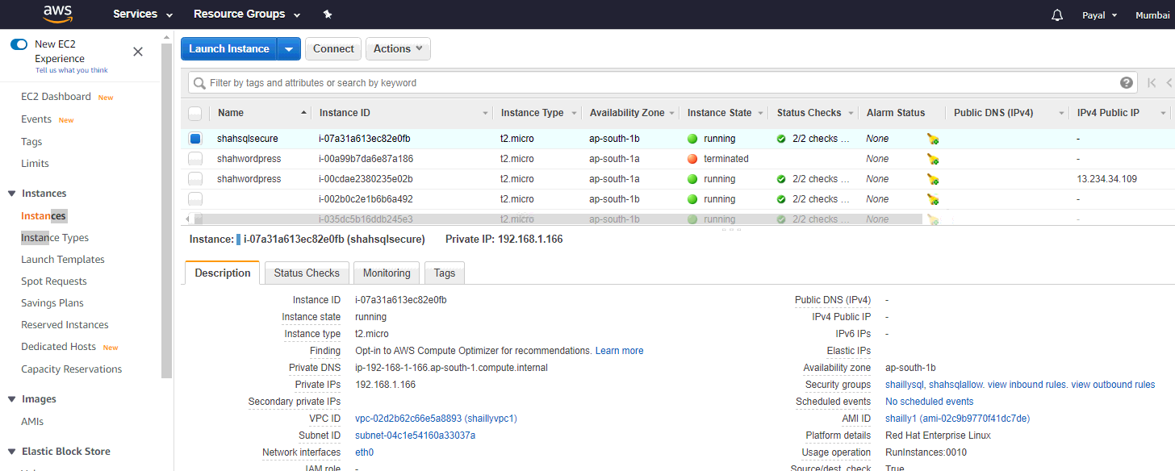

**# launching the instance with the rhel image in the region 1a and attaching the security group shahbastion**

**# enabling the public-ip**

**resource "aws_instance" "shahbastion" {**

**ami = "ami-073a8ab1b15e272e5"**

**instance_type = "t2.micro"**

**key_name = "shailly"**

**availability_zone = "ap-south-1a"**

**subnet_id = "${aws_subnet.shaillyvpc1_subnet-1a.id}"**

**security_groups = [ "${aws_security_group.shahbastion.id}" ]**

**tags = {**

**Name = "shahbastion"**

**}**

**}**

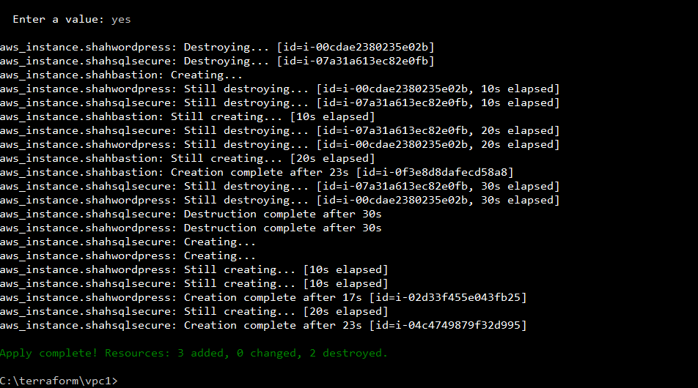

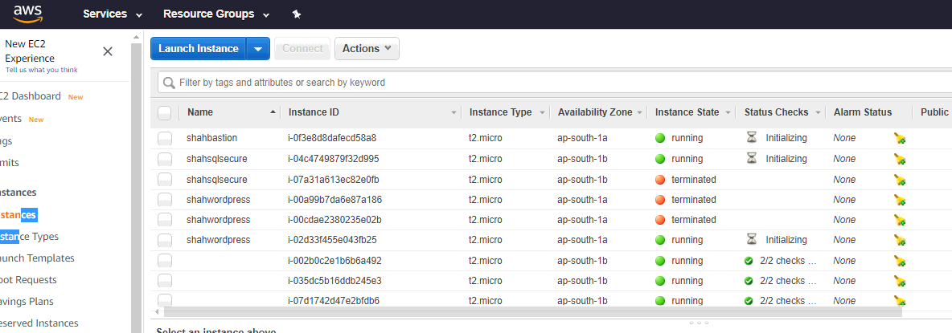

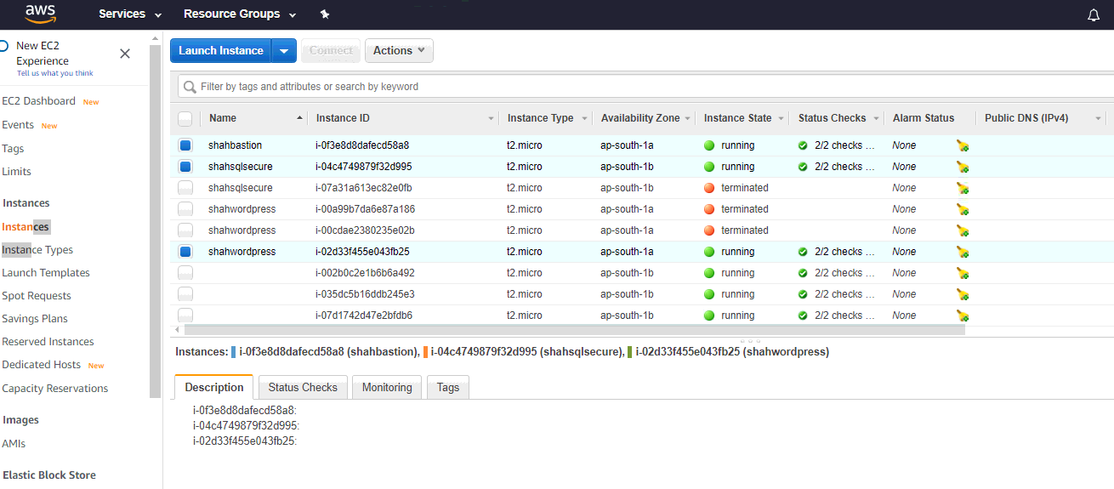

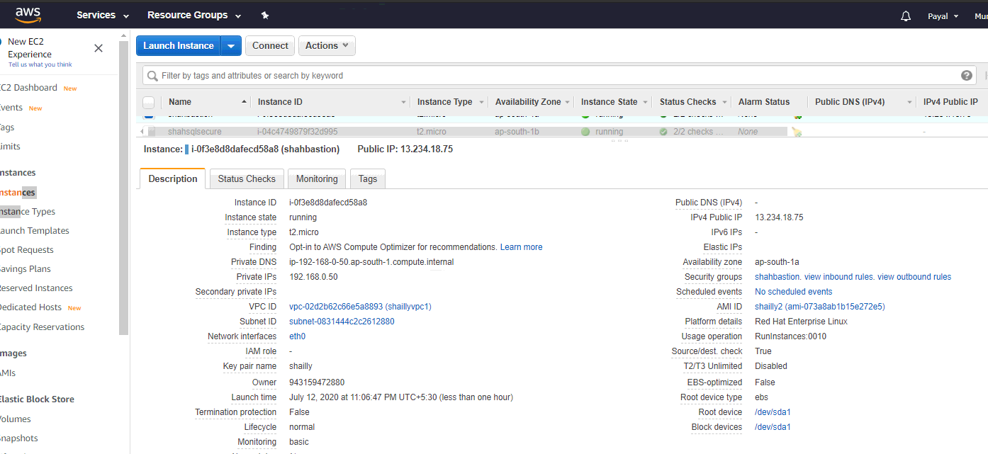

Now, login to the bastion host which will be used to the access MysqlOS. First do ssh to login into bastion host, then copy .pem key into bastionhost using winscp software. After this do ssh from bastion host to mysqlos using private key. After all the setup you can do any update in mysqlOS.

