Tutor LMS Portal Launch Checklist

Platform Features, Integrations, and User Roles
- Feature Setup: Verify every Tutor LMS module (courses, lessons, quizzes, certificates, forums, etc.) and related plugins are activated and functioning (e.g. build a test course, preview it, verify quizzes grade correctly).
- Integrations: Test all third-party connections. For example, if using WooCommerce/Easy Digital Downloads for payments (Tutor LMS supports both)[1], perform a test purchase to ensure payments, tax, and email receipts work. Check email notification (SMTP), video conferencing (Zoom/BigBlueButton), analytics (Google Analytics), and any CRM/SSO integrations.
- User Roles & Permissions: Create test accounts for each role (Student/Learner, Instructor, Admin, etc.) and confirm each has only appropriate access. For example, students should only see their enrolled courses, instructors can create/edit their own courses, and admins can manage all content[2][3]. Misconfigured roles can block users (e.g. a student seeing no courses assumes the LMS is broken[3]). Ensure role-based access control (RBAC) is correctly enforced – only admins can change site settings[4][2].
- Data Integrity Audit: If migrating existing data, run an audit of imported users, courses, and enrollments. Check that usernames/emails are correct and each user has the right courses/permissions[5]. Ensure no duplicate or outdated records. Test that any group or cohort assignments imported properly. Even one data error (wrong email, missing enrollment) can create confusion.
- System Configuration: Confirm DNS and hosting are set up correctly (domain pointing to server) and that an SSL/TLS certificate is installed (so the portal uses HTTPS)[6]. This encryption is a fundamental security measure[6]. Also verify server requirements (PHP version, memory limits) match Tutor LMS recommendations. Finally, clear any caching plugins or maintenance mode settings so the live site is visible to users.

Content Quality, Course Structure, and Assessments
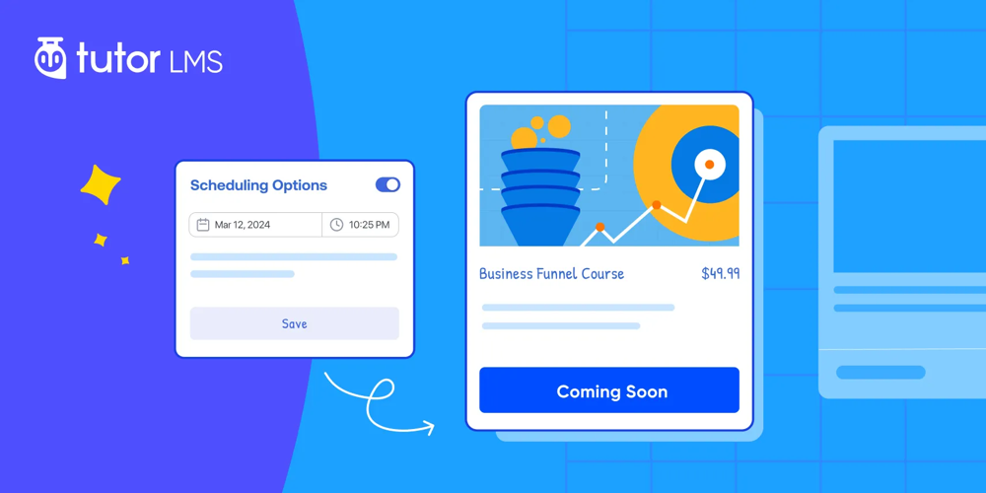
Before going live, thoroughly audit all course content and structure. Ensure accuracy and clarity: every lesson and quiz should have correct information and no typos or broken links[7]. Instructors (or admins) should “test-drive” each course as a student – navigate every lesson, play videos, take the quizzes – to catch confusing wording or mistakes[8]. Engage a small pilot group if possible: real learners can verify that instructions make sense, modules are of reasonable length, and content feels up-to-date[9].
- Learning Objectives: Check that each course has clear objectives/outcomes listed, and that the curriculum (lesson order) logically flows toward those goals. Remove any outdated or irrelevant material.
- Content Review: Ensure all media (videos, PDFs, images) load correctly and are high quality. Confirm any interactive content (H5P, SCORM) plays as intended. Provide alt-text for images and captions for videos where needed to improve accessibility.
- Assessment Workflows: Verify quiz and assignment settings. Ensure every quiz question has the correct answer keyed and scoring rules (passing grade, attempts) work. Confirm that prerequisites or drip schedules release modules in the right sequence. Test that completion criteria award certificates or badges properly.
- Engagement & Interactivity: Include interactive elements (questions, polls, discussions) as needed to keep learners engaged. Check that forums or comments work. If content uses third-party embeds (e.g. YouTube/Vimeo), make sure they display.

Security, Backups, Performance, and Scalability
- Encryption & Access Control: Ensure the site uses HTTPS with a valid SSL/TLS certificate (TLS encryption is a key security measure[6][10]). Require strong passwords (length and complexity) for all accounts and enable measures like reCAPTCHA or login limits to prevent brute-force attacks[11]. If available, enable two-factor authentication for admin users. Verify that role permissions (RBAC) are tight: no student account has admin-level access[4].
- Data Backup: Configure automated backups of the LMS (database and uploaded course files) at least daily, stored offsite or on a separate server. Test the restore process on a development site to ensure backups can recover the portal if needed[12]. Frequent backups are recommended to minimize downtime in case of data loss.
- Software Updates: Update WordPress core, theme, Tutor LMS plugin, and all extensions to the latest versions. Apply any security patches. Disable or delete unused plugins/themes. Keeping software current closes known security vulnerabilities.
- Performance Testing: Load-test the portal under expected and high traffic (e.g. simultaneous logins or quiz submissions)[13]. Tutor LMS should handle hundreds of concurrent users without errors. Use tools or scripts to simulate many users and monitor response times. Optimize caching (object and page cache) and consider a CDN if serving large media. Confirm the server can scale (increase resources) if traffic spikes.
- Monitoring & Logging: Set up monitoring to alert for downtime or errors. Enable server error logging and consider an application monitoring tool (New Relic, Sentry, etc.) to catch uncaught exceptions. Plan to review logs in the first days after launch.

Payment, Enrollment, and Legal Compliance
- Payment Gateways: If selling courses, test every payment path: perform test transactions through PayPal, Stripe, or other gateways integrated via WooCommerce/EDD[1]. Verify taxes, coupons/discounts, and refunds work. Ensure learners receive order confirmations and that the LMS enrolls them automatically after payment. Test subscription/recurring payments and expiration rules if using memberships. For example, Tutor LMS can connect to WooCommerce or Easy Digital Downloads to support multiple gateways[1].
- Enrollment Process: Test free vs. paid enrollment workflows. For free courses, sign up as a learner and confirm automatic enrollment email. For paid courses, confirm enrollment only after successful payment. If courses require instructor approval, test the approval emails and student notifications. Ensure any enrollment expiration settings or seat limits (Tutor LMS supports enrollment limits) are respected.
- Financial Setup: Confirm merchant accounts (Stripe/PayPal) are live and funds flow to the correct business account. Ensure any necessary tax settings (VAT/GST for digital goods in various countries) are configured. If applicable, set up accounting reports (via WooCommerce reports or export tools).
- Privacy and Terms: Publish a clear Privacy Policy and Terms of Service on the site. Because Tutor LMS sites collect user data (names, emails, IPs), you are legally obliged to disclose data practices[14]. Ensure GDPR/CCPA compliance: add cookie consent banner if needed, provide data deletion process, and only collect necessary personal data. If you have an affiliate or refund policy, make it visible.
- Intellectual Property: Verify you have rights to all content (images, videos, text). Use only licensed or original materials. Provide attribution if required by licenses. Include a DMCA notice or copyright policy if hosting user-generated content or third-party videos.
- Accessibility & Compliance: Check the portal for basic accessibility (WCAG) compliance: e.g., all pages are navigable by keyboard, forms have labels, images have alt-text. While not a strict legal checklist, an accessible site avoids legal risks and improves UX.

Monitoring, Support, and Launch Communication
- Admin/Instructor Training: Before launch, train all administrators and instructors on using Tutor LMS features (creating courses, managing students, running reports). Prepare internal documentation or quick-start guides. Udutu recommends live or recorded training sessions and FAQs for each role[15].
- Support Channels: Set up a support framework for learners (and instructors). This might include a helpdesk email, chat, or ticket system. Create a FAQ or knowledge base addressing common questions (how to enroll, reset password, contact an instructor). Ensure support staff know how to troubleshoot basic issues.
- Analytics & Monitoring: Enable site analytics (e.g. Google Analytics) and the built-in Tutor LMS analytics (course progress, completions). After launch, track metrics like active users, login rates, course completions, and support tickets[16]. Plan to review these regularly (30/60/90 days) and survey users for feedback.
- Launch Communication: Execute a launch communication plan. Send countdown and launch announcement emails or newsletters to your user list. Use social media or on-site banners to build excitement. Udutu recommends countdown emails and even virtual launch events to create buzz[17]. In all communications, clearly point users to help resources (support contact, FAQ) and highlight what’s new.
- Post-Launch Feedback: In the weeks after launch, actively solicit feedback. Send short surveys to early users to uncover pain points. Monitor forum posts or social media mentions. Use this feedback and analytics (login/drop-off data) to fix any urgent issues and plan future improvements[16].
Sources: Best practices were synthesized from LMS implementation guides and e-learning sources[2][7][8][13][4][11][12][9][14][18] (above citations). Each item is grounded in expert recommendations for LMS rollouts and Tutor LMS-specific documentation.

[1] [8] How You Can Launch Your eLearning Course the Right Way | Tutor LMS
https://tutorlms.com/blog/launch-elearning-course-the-right-way/
[2] The Ultimate LMS Implementation Checklist - LearnUpon
https://www.learnupon.com/blog/lms-implementation-checklist/
[3] [5] [9] Soft Launching an LMS: Test Before Full Rollout — LMS for Retail
https://www.thelearning-lab.com/blog-elearning-platform/1nxmf3btr6n4wl5gcklu0kx8hfepir
[4] [6] LMS Security & Data Privacy in 2026: Risks & Compliance Checklist
https://lmspedia.org/lms-security-data-privacy-2026-guide/
[7] Evaluating E-Learning Platforms: A Comprehensive Checklist Approach
https://elqn.org/key-criteria-in-evaluating-the-effectiveness-of-e-learning-platforms-a-checklist-approach/
[10] [11] [12] LMS Security: 7 Key Features for Secure Online Learning
https://www.docebo.com/learning-network/blog/lms-security-features/
[13] Education and E-learning Performance Testing | Load Test with LoadView
https://www.loadview-testing.com/industry/e-learning/
[14] Selling With Trust: Privacy Policy Requirements for Course Creators | LearnDash
https://www.learndash.com/blog/selling-with-trust-privacy-regulated-data-for-course-creators/
[15] [16] [17] [18] Mastering LMS Implementation: Your 2025 Readiness Checklist - Udutu
https://www.udutu.com/mastering-lms-implementation-your-2025-readiness-checklist/

