**Oracle Integration Cloud**

**Case Study**

You are an Oracle Integration (OIC) integration developer tasked with automating a data exchange process between two systems: **System A** and **System B**.

**System A** generates daily CSV files containing transaction records, and these files need to be processed by **System B** for further analysis and reporting. You need to design and implement an integration that will handle these CSV files efficiently and ensure they are correctly processed by **System B**.

Here are the requirements:

1. The integration should pick up CSV files from a specific directory on a secure FTP server.
2. After processing, the files should be archived in a different directory for auditing purposes.
3. If a file fails to process, it should be moved to an error directory for troubleshooting.
4. The integration should send a notification email to the Operations team upon successful or failed processing of the files.

Design and implement an integration that will handle these CSV files efficiently and ensure they are correctly processed.

**Note: System A: Oracle CX Sales Cloud, System B: Oracle RightNow.**

**Hint:** Follow the any one approach as given approach given below and analyze the merits and demerits of your selected approach other approaches. Which set of steps should you follow to implement the file handling options to meet the requirements.

**Approach-1:** Configure a Scheduled Integration in OIC to periodically check the secure FTP server directory using the FTP Adapter, process the files by invoking System B, and move them to the archive or error directory based on the processing outcome. Use the Notification action to send emails to the Operations team.

**Approach-2:** Use the FTP Adapter to read the files from the secure FTP server directory to trigger the integration, process the files by invoking System B, and move them to the archive or error directory based on the processing outcome.

**Approach-3:** Configure the Notification action to send emails to the Operations team. Use the File Adapter to read the files from the secure FTP server directory to trigger the integration, process the files by using Stage File Action operations to System B, and use the FTP Adapter to move them to the archive or error directory based on the processing outcome. Use the Notification action to send emails to the Operations team.

**Approach-4:** Use the FTP Adapter to read the files from the secure FTP server directory to trigger the integration, process them by using Stage File Action operations to System B, and use the FTP Adapter to move the processed file to the archive directory. Configure error handling to move failed files to the error directory. Use the Notification action to send emails to the Operations

***Solution :***

I am choosing approach-2:Use the FTP Adapter to read the files from the secure FTP server directory to trigger the integration, process the files by invoking System B, and move them to the archive or error directory based on the processing outcome.

**Step 1 – Create Project in which we create our Integration.**



**Step 2 – Create FTP and Oracle RightNow (System B) Connections –**

**FTP Adapter** : Retrieves the CSV files from the FTP server.

FTP Adapter is used to connect the secure FTP server and pick up the CSV files. So, we will configured the FTP adapter by giving the credentials for the FTP server and the directory where the files are located.

Oracle RightNow Adapter: The transformed data will be sent to Oracle RightNow for processing.

**Step 2 – Open the WinSCP File server where (System A) Oracle CX Sales Cloud generates the file in the specific directory.**

Create below three folders under main directory: Submain, Archive, Error

**Step 3 – Create Schedule Driven Integrations**

We create a Scheduled Integration that will periodically trigger the integration flow to pick up new CSV files from the FTP server.

Steps to create a Scheduled Integration:

* Navigate to OIC: Go to the Integrations section in OIC.
* Create Integration: Select Scheduled Orchestration Integration.
* Set the Schedule: Configure the integration to run at a specific time interval (e.g., daily) to check for new files.

**Step 4 – Add a scope**

Drag a **Scope** component from the palette into the integration canvas.

A **Scope** is a container for a set of activities that will be executed together.

Inside the **Scope**, we put the activities related to file processing, including:

* FTP Adapter to fetch the file.
* **Invoke the Oracle RightNow (System B)**

**Success Path (After Scope)**:

* After processing the file within the scope, if everything goes successfully, move the file to the **archive directory** using the FTP Adapter’s **Move** operation.
* Add a **Success Notification** to email the Operations team about the successful processing of the file.

**Step 5 -** **Configure Fault Handler**:

* Inside the **Scope**, add a **Fault Handler**.
* The **Fault Handler** will handle errors that occur within the **Scope**.
* Use the Fault Handler to:
  + **Move to Error Directory**: If an error occurs, move the problematic file to an **error directory** on the FTP server using the **FTP Adapter** with the **Move** operation.
  + **Send Failure Notification**: Send an email notification to the Operations team to inform them that the file processing failed. Include details like the file name, the error message, and any other relevant information.

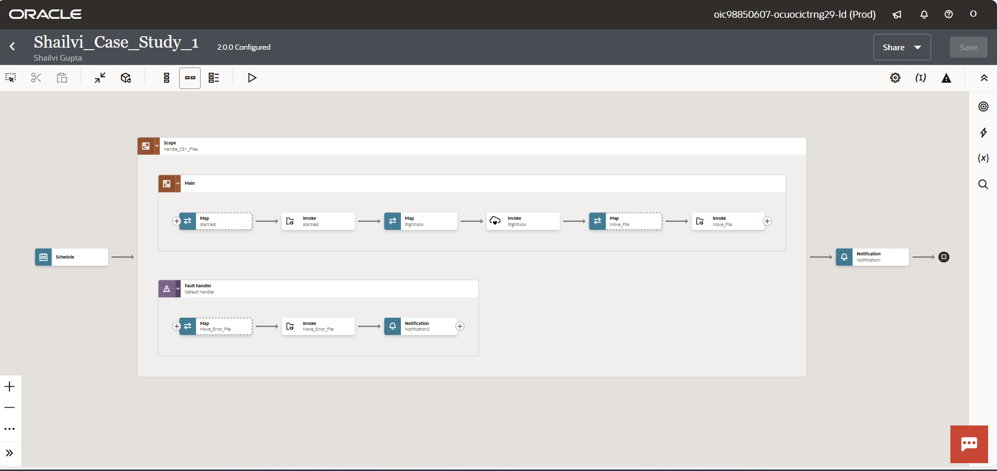

**Step 6 - Activate and Run it**

We will get mail according to status of file received like below and check the file server file will be moved to Target Directory.

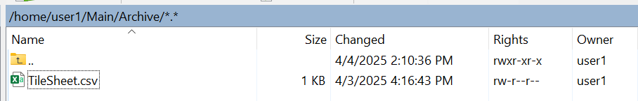

PFA, Project

