Tables of content

1. **Entity Relationship Diagram**………….…………………………pg2
2. **Legend**…………...…………………………………………………..……..pg2
3. **Fact Tables**
   1. Rental…………………...…………………………………………………...pg3
   2. Payment……………………………………………………………………..pg3
4. **Dimensions Tables**
   1. Store…………………………………………………………………………pg4
   2. Staff………………………………………………………………………….pg4
   3. Inventory…………………………………………………………………….pg4
   4. Film…………………………………………………………………………..pg5
   5. Category…………………………………………………………………….pg6
   6. Film Category……………………………………………………………....pg6
   7. Language……………………………………………………………………pg7
   8. Actor…………………………………………………………………………pg7
   9. Film Actor……………………………………………………………………pg7
   10. Customer…………………………………………………………………….pg8
   11. Address………………………………………………………………………pg8
   12. City…………………………………………………………………………...pg9
   13. Country……………………………………………………………………....pg9

Entity Relationship Diagram

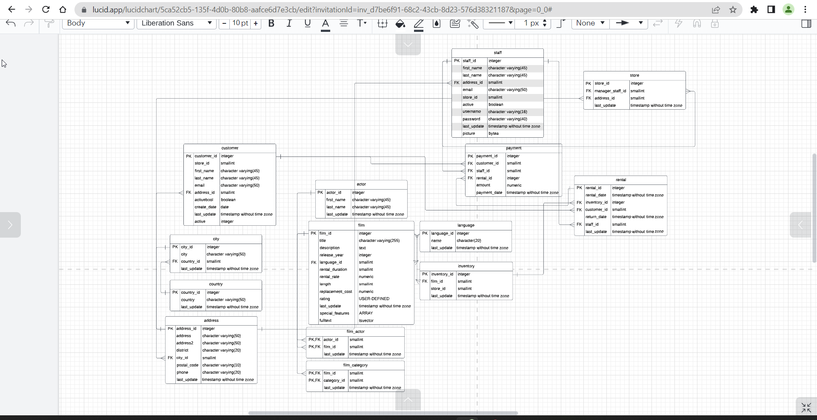

It is a snowflake schema as the facts table have other sub division tables linked to them.

2. Legend

Primary Key

Foreign Key

**3. Facts Table**

3.1 **Rental**: This table contains information about the rental records of the films.

|  |  |  |  |
| --- | --- | --- | --- |
| **Column** | **Datatype** | **Description** | **Links to** |
|  |  |  |  |
| **Rental_id** | Integer | Primary key of the rental table | payment |
| Rental _date | Timestamp without time zone | Time stamp of the date includes (yyyy-mm-dd), plus hours, minutes and seconds of the rental. Does not include the time zone. |  |
| **Inventory_id** | Integer | Foreign key to the inventory table. It is also the unique identifier (primarykey) in the inventory table. | Inventory |
| **Customer_id** | Smallint | Foreign key to customer table. It is also the unique identifier (primary key) in the customer table | customer |
| Return_date | Timestamp without time zone | Time stamp of the date includes (yyyy-mm-dd), plus hours, minutes and seconds of the rental. Does not include the time zone. |  |
| **Staff_id** | Smallint | Foreign to the staff table. Data type is small integer. It is also the unique identifier of staff in the staff table. | staff |
| Last_update | Timestamp without time zone | Time stamp of the date includes (yyyy-mm-dd), plus hours, minutes and seconds of the rental. Does not include the time zone. |  |

3.2 **Payment**: This table contains information about the payment made for the rentals.

|  |  |  |  |
| --- | --- | --- | --- |
| **Payment_id** | Integer | Primary key of this, payment table | Link To |
| **Customer_id** | Small int | Foreign key to customer table | Customer |
| **Staff_id** | Small int | Foreign key to staff table | Staff |
| **Rental_id** | Integer | Foreign key to rental table, numbers are whole | Rental |
| Amount | Numeric (5,2) | This is the actual amount paid for the rental in the currency. The numeric data type means it is decimal and the column can include any value with five digits and two decimals. |  |
| Payment date | Timestamp without time zone | Time stamp of the date includes (yyyy-mm-dd), plus hours, minutes and seconds of the rental. Does not include the time zone. |  |

**Store Table**: This table has information on the store records where films are stocked to be rented.

|  |  |  |  |
| --- | --- | --- | --- |
| **Column** | **Data Type** | **Data Description** | **Links To** |
| **Store_id** | Integer | Primary Key, unique identifier for Store table | Customer, Inventory, Staff |
| **Manager_staff_id** | Small Integer | Foreign key to staff record |  |
| **Address_id** | Small Integer | Foreign Key to staff record | Address |
| **Last_update** | Timestamp without time zone | Foreign key to staff record |  |

**Staff Table**: This Table has information of the staff record who work at the rental store.

|  |  |  |  |
| --- | --- | --- | --- |
| **Column** | **Data Type** | **Data Description** | **Links To** |
| **Staff_id** | Integer | Primary key, unique identifier for Staff Table |  |
| **First_name** | **Character Varying (45)** | **First Name in character not exceeding length of 45** |  |
| Last_name | Character Varying (45) | Last name in character not exceeding length of 45 |  |
| **Address_id** | **Small int** | **Foreign Key to address table** | **Address** |
| **Email** | **Character varying (50)** | **Email address of customer, character length 50** |  |
| **Store_id** | Small int | Foreign key to store | Store |
| **Active** | **Boolean** | **True or false value (is the staff active or not)** |  |
| Username | Character varying (16) | Username for entering in the company’s internal system, sung words, numbers, or special characters with length of 16 |  |
| **Last_update** | **Timestamp (6) without time zone** | **Timestamp of the last update include data (yy-mm-dd), plus hours, minutes and seconds of the rental. Does not include the time zone** |  |
| Picture | Bytea | Picture of the staff member in binary data |  |

**Inventory Table**: This table has information of the inventory of film records for renting.

|  |  |  |  |
| --- | --- | --- | --- |
| **Column** | **Data** | **Description** | **Links To** |
| **Inventory_id** | Integer | Primary key of the inventory table | Rental |
| **Film_id** | Small int | Foreign key to film table | Film |
| **Store_id** | small int | Foreign key to store table | Store |
| Last_update | Timestamp without time zone | Time stamp of the date includes (yyyy-mm-dd), plus hours, minutes and seconds of the rental. Does not include the time zone. |  |

**Film Table**: This table has information about the films available for rent including details on the language, release year, title, rental rate and duration, length, replacement cost all the extra credits related information.

|  |  |  |  |
| --- | --- | --- | --- |
| **Column** | **Data Type** | **Description** | **Links To** |
| **Film_id** | Integer | Primary key to the film table | film actor, Film, Category, Inventory |
| Title | Character varying (255) | Title of the movie can contain numbers, text or special characters with a length of up to 255 |  |
| Description | Text | Description of the film, which is a short synopsis of the film |  |
| Release_year | Year | Year the film was released |  |
| **Language_id** | Smallint | Language in which the movie is. This is also a foreign key to the language table | Language |
| Rental_duration | Smallint | Duration (in days) of the rental of the film. |  |
| Rental_rate | Numeric (5,2) | Cost of renting the film in numeric values |  |
| Length | Small int | Duration of the film in minutes, in whole numbers. |  |
| Replacement_cost | Numeric (5,2) | Cost in numeric values including decimal values. |  |
| Rating | User-defined | Ratings given to the film by viewers or users |  |
| Last_update | Timestamp without time zone | Time stamp of the last update includes (yyyy-mm-dd), plus hours, minutes and seconds of the rental. Does not include the time zone. |  |
| Special feature | Array [] | Refers to special feature included in the rental movie can be pertaining to bloopers or behind the scene. To create an array, define the data type (like int ) and specify the name of the array followed by square brackets []. |  |
| Full text | Tsvector | Text is organised in an optimised form for the text search |  |

**Category Table**: This table has information on the film category

|  |  |  |  |
| --- | --- | --- | --- |
| **Column** | **Data** | **Description** | **Links To** |
| Category_id | Serial | Auto generated ID number for unique film category | Film_category |
| name | Character varying (25) | Film Category name |  |
| Last_update | Timestamp without time zone | Time stamp of the last update includes (yyyy-mm-dd), plus hours, minutes and seconds of the rental. Does not include the time zone. |  |

**Film Category Table**:

|  |  |  |  |
| --- | --- | --- | --- |
| **Column** | **Data** | **Description** | **Links To** |
| Film_id | Smallint | Foreign to the film_category, and it is also the primary key to film table | Film |
| Category_id | Smallint | Foreign key to the film_category table as it is also the primary key to | Film_category |
| Last_update | Timestamp without time zone | Time stamp of the last update includes (yyyy-mm-dd), plus hours, minutes and seconds of the rental. Does not include the time zone. |  |

**Language Table**: This table has information of the language the film is available in for rent.

|  |  |  |  |
| --- | --- | --- | --- |
| **Column** | **Data** | **Description** | **Links To** |
| Language_id | Integer |  | Film |
| Name | Character (20) | Name of the language ex Hindi, English etc, where character length does not exceed 20. |  |
| Last_update | Timestamp without time zone | Time stamp of the date includes (yyyy-mm-dd), plus hours, minutes and seconds of the rental. Does not include the time zone. |  |

**Actor Table**: This table has Actor details.

|  |  |  |  |
| --- | --- | --- | --- |
| **Column** | **Datatype** | **Description** | **Links To** |
| **Actor_id** | Smallint | Primary key for the Actor table. | Film_actor |
| First_name | Character varying (45) | first name of the actor in the movie where the character length does not exceed (45) |  |
| Last_name | Character varying (45) | Last name of the actor in the film where the character length does not exceed (45) |  |
| Last_update | Timestamp without time zone | Time stamp of the date includes (yyyy-mm-dd), plus hours, minutes and seconds of the rental. Does not include the time zone. |  |

**Film Actor Table**: This table has information on the ID of actors in the films available for rent

|  |  |  |  |
| --- | --- | --- | --- |
| **Column** | **Datatype** | **Description** | **Links To** |
| **Actor_id** | Smallint | Primary key in the actor table as well as foreign key in the film_actor table. | Actor |
| **Film_id** | Smallint | Primary key to the film table as well as foreign key to the film_actor table | Fil |
| Last_update | Timestamp without time zone | Time stamp of the last update includes (yyyy-mm-dd), plus hours, minutes and seconds of the rental. Does not include the time zone. |  |

**Customer Table**: This table has information about the customers who rent films.

|  |  |  |  |
| --- | --- | --- | --- |
| **Column** | **Data type** | **Description** | **Links To** |
| **Customer_id** | Integer | Primary key of the customer table | Payment, Rental |
| **Store_id** | Small int | Foreign key to store table | Store |
| First_name | Character Varying (45) | First Name in character not exceeding length of 45 |  |
| Last_name | Character Varying (45) | Last name in character not exceeding length of 45 |  |
| Email | Character varying (50) | Email address of customer, character length 50 |  |
| **Address_id** | Small int | Foreign Key to address table | Address |
| Activebol | Boolean | True or false value- is the customer active or not |  |
| Create_date | Date | Date the customer file was created |  |
| Last_update | Timestamp (6) without time zone | Timestamp of the last update include data (yyyy-mm-dd), plus hours, minutes and seconds of the rental. Does not include the time zone |  |
| Active | Integer | Number (seems like a true or false value) |  |

**Address Table**: This table has information about the stores where films are rented.

|  |  |  |  |
| --- | --- | --- | --- |
| **Column** | **Data** | **Description** | **Links To** |
| **Address_id** | Integer | Primary key, unique identifier for address id in the address table. | Customer, Staff, Store |
| Address | Character varying (50) | Address details such as building name, door number etc using words, special characters or number within limit of 50 characters |  |
| Address2 | Character varying (50) | Additional address details such as landmark or zip code using words, special characters or number within the character limit of 50. |  |
| District | Character varying (20) | Additional address detail within 20-character limit using words, special characters or numbers. |  |
| **City_id** | Smallint | Foreign key to the address table as it is a primary key in the city table which is part of the address | City |
| Postal_Code | Character varying (10) | Providing zip code details within character limit of 10 using words, special numbers or characters. |  |
| Phone | Character varying (10) |  |  |
| Last_udpate | Timestamp without time zone | Time stamp of the last update includes (yyyy-mm-dd), plus hours, minutes and seconds of the rental. Does not include the time zone. |  |

**City Table**: This table has information on the city id where stores are located, as well as a sub division of the address table.

|  |  |  |  |
| --- | --- | --- | --- |
| **Column** | **Data** | **Description** | **Links To** |
| **City_id** | Integer | Primary key of the city table. | Address |
| City | Character varying (50) | Name of the city within character limit of 50 using words, special characters or numbers |  |
| **Country_id** | Smallint | Foreign key to the city table. | Country |
| Last_update | Timestamp without time zone | Time stamp of the last update includes (yyyy-mm-dd), plus hours, minutes and seconds of the rental. Does not include the time zone. |  |

**Country Table**: This table has information on the country id where stores are located, as well as a sub division of the address table.

|  |  |  |  |
| --- | --- | --- | --- |
| **Column** | **Data** | **Description** | **Links To** |
| **Country_id** | Integer | Primary key to the country table. | City |
| Country | Character varying (50) | Country length within 50 characters using words, special characters or numbers |  |
| Last_update | Timestamp without time zone | Time stamp of the last update includes (yyyy-mm-dd), plus hours, minutes and seconds of the rental. Does not include the time zone. |  |