**Name**: Shaimaa Ahmed Rabee

**B.N**: 422

**Topic**: Artificial Intelligence

**GitHub Link:** https://github.com/ShaimaaAhmed35/ECE001

**GitHub Pages:** https://shaimaaahmed35.github.io/ECE001/

*Artificial Intelligence and its Applications:*

Artificial Intelligence Artificial intelligence is one of the branches of computer science, and it is defined as the characteristics that make computer programs that make it simulate the mental capabilities of humans and their work patterns, and the most prominent of these characteristics is the ability to infer, learn, and react to situations not programmed inside the machine, as it is known to design and study Smart clients

Artificial intelligence applications are used in a wide range of areas such as: expert systems, medical diagnostics, Internet search engines, natural language processing, video games, stock trading, law, image discrimination and analysis, toys, scientific discoveries, automatic control, and voice recognition

**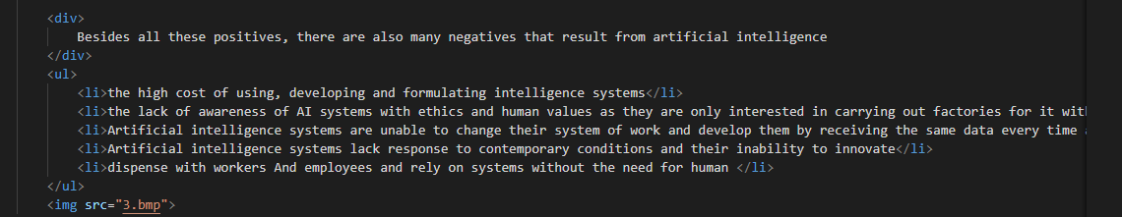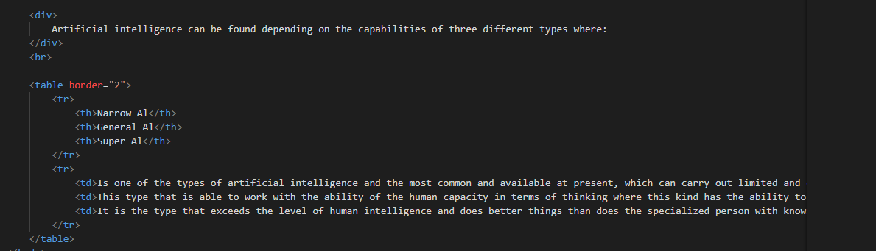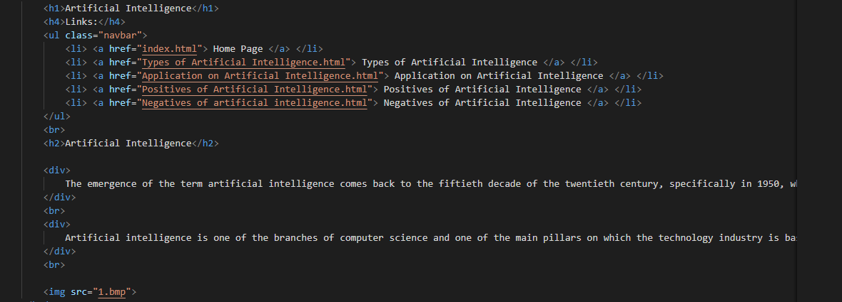***Source Code:*

*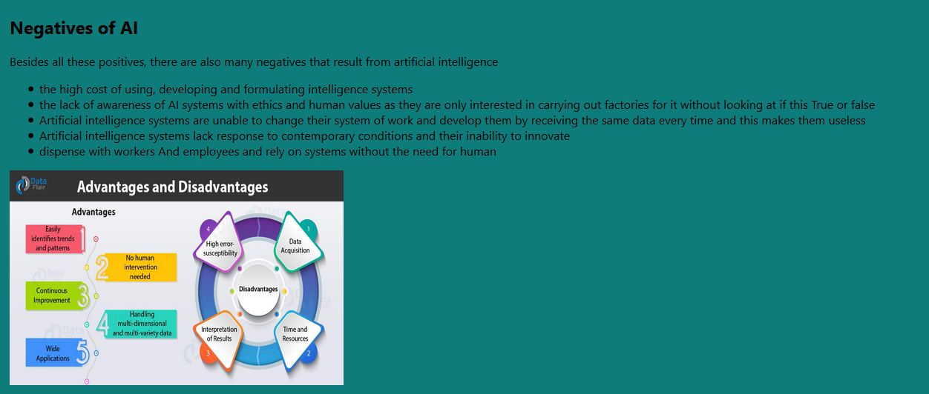Screenshots:*

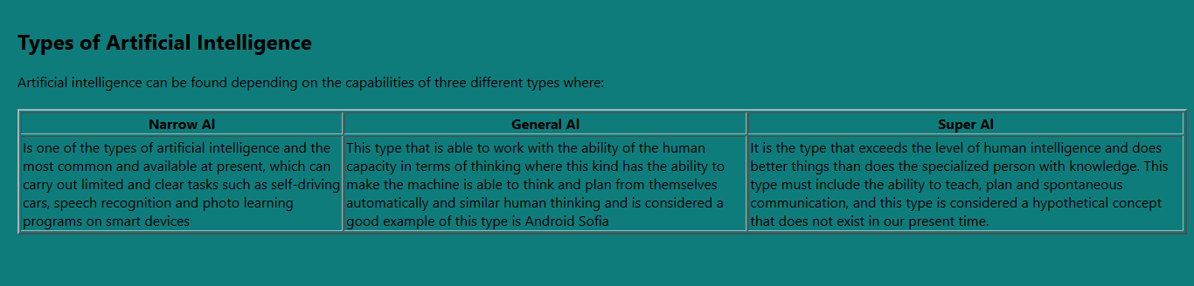

*References*

<https://www.sas.com/en_us/insights/analytics/what-is-artificial-intelligence.html>

<https://www.iqvis.com/blog/9-powerful-examples-of-artificial-intelligence-in-use-today/>

<https://www.govtech.com/computing/Understanding-the-Four-Types-of-Artificial-Intelligence.html>

<https://books.google.com.eg/books?id=v6OTDwAAQBAJ&printsec=frontcover&dq=Artificial+intelligence&hl=en&sa=X&ved=0ahUKEwi88oL04-HpAhUNtRoKHfZfCBQQuwUIDTAA#v=onepage&q=Artificial%20intelligence&f=false>

<https://books.google.com.eg/books?id=UbaIDwAAQBAJ&printsec=frontcover&dq=Artificial+intelligence&hl=en&sa=X&ved=0ahUKEwi88oL04-HpAhUNtRoKHfZfCBQQ6AEIGDAC#v=onepage&q=Artificial%20intelligence&f=false>