Assignment Title: Synthetic Blood Requests Data Exploration and Preparation
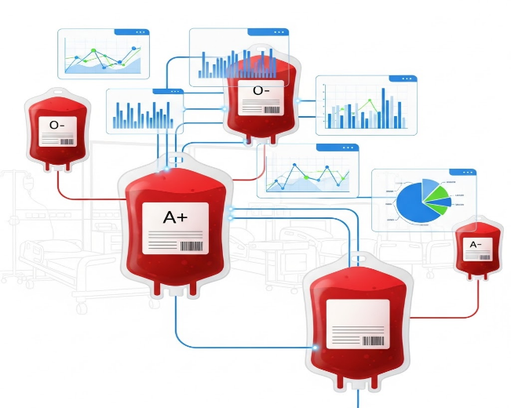

University Name: Al al-Bayt University

Faculty: Faculty of Information Technology

Course Name: Programming in R Language
Prepared by: Shaimaa Hamdan Alhaj
Student ID: 2300908023

Supervised by: Dr. Najah Al-shanableh

1. Title and Overview

Dataset Title:
Synthetic Blood Request Fulfillment Dataset

Overview:
This dataset contains simulated blood request information from hospitals, including details about blood quantity, type, urgency level, hospital identification, request timing, and fulfillment status. The data was created for educational purposes to practice data exploration, statistical analysis, and predictive modeling in a healthcare context.

Purpose:
The dataset enables students to practice data preprocessing, exploratory data analysis (EDA), correlation analysis, clustering, and machine learning classification techniques.

2. Source and Data Structure

Origin:
The dataset is synthetic (not real-world data) and was created using R for educational practice.

Dataset Dimensions:
- Total Observations: 500 blood requests
- Total Variables: 25 columns (numeric and binary)
- Data Format: CSV (Comma-Separated Values)

Data Quality:
No missing values. All 500 observations have complete values for all 25 variables. All values fall within reasonable ranges with no obviously anomalous data.

3. Variables Description

Numeric Variables:
Variable | Type | Range | Description
quantity_mL | Numeric | 450–2,250 mL | Amount of blood requested (standard units)
days_to_fulfill | Numeric | −1 to 14 days | Days from request to fulfillment (−1 = unfulfilled/pending)
request_month | Numeric | 1–12 | Month of request (1=January, 12=December)
request_weekday | Numeric | 1–7 | Day of week (1=Monday, 7=Sunday)
urgency_encoded | Numeric | 0, 1, 2 | Target. Urgency level (0=Routine, 1=Moderate, 2=Critical)

Categorical Variables (One-Hot Encoded):
- Blood Types: blood_type_A−, blood_type_A+, blood_type_AB−, blood_type_AB+, blood_type_B+, blood_type_O−, blood_type_O+
- Hospital IDs: hospital_id_HSP001 through hospital_id_HSP010
- Status Indicators: status_Cancelled, status_Fulfilled, status_Open

Important Note on days_to_fulfill:
The variable `days_to_fulfill` contains −1 for unfulfilled/pending requests. This special value indicates that the request has not yet been completed (or was cancelled) and does not represent an actual negative time value. For time-based analysis, −1 values are excluded, and only fulfilled requests (values ≥ 0) are analyzed. For machine learning models, −1 values are converted to NA and removed to prevent misleading models.

4. Summary Statistics

Descriptive Statistics for Numeric Variables:
Variable | Count | Mean | Median | Min | Max | Std Dev | Q1 | Q3
quantity_mL | 500 | 765.0 | 450.0 | 450 | 2,250 | 439.97 | 450.0 | 900.0
request_month | 500 | 6.68 | 7.0 | 1 | 12 | 3.55 | 3.0 | 10.0
request_weekday | 500 | 4.18 | 4.0 | 1 | 7 | 2.04 | 2.0 | 6.0
days_to_fulfill (fulfilled only) | 336 | 4.41 | 4.0 | 0 | 14 | 3.45 | 2.0 | 6.0

Request Status Breakdown:
- Fulfilled: 336 requests (67.2%)
- Open (In Progress): 109 requests (21.8%)
- Cancelled: 55 requests (11.0%)

Blood Type Distribution:
- O+ (Most Common): 194 (38.8%)
- A+: 168 (33.6%)
- B+: 83 (16.6%)
- AB+: 19 (3.8%)
- O−: 17 (3.4%)
- A−: 16 (3.2%)
- AB− (Least Common): 3 (0.6%)

Urgency Level Distribution:
- Routine (0): 265 (53.0%)
- Moderate (1): 174 (34.8%)
- Critical (2): 61 (12.2%)

5. Part 1: Exploratory Data Analysis and Visualizations

5.1 Histogram: Blood Quantity Distribution
Figure 1: Histogram showing the distribution of blood quantity (mL) across all 500 requests
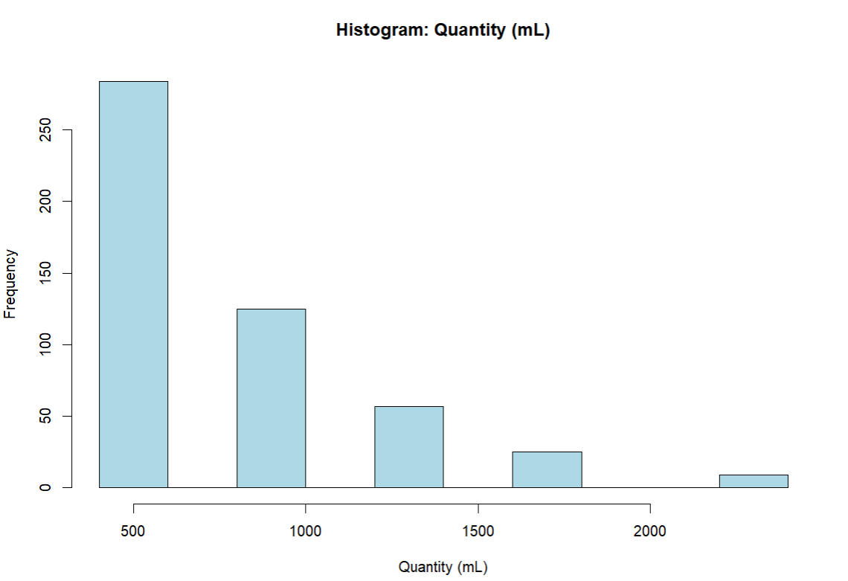
Interpretation: The distribution of blood quantity is heavily right-skewed. The majority of requests cluster at the lowest standard unit (450 mL), with a sharp decline at 900 mL and further reductions at higher volumes. This pattern indicates that most blood requests are for routine volumes, with far fewer requests for larger quantities (1,350 mL, 1,800 mL, or 2,250 mL). The mode is clearly at 450 mL.

5.2 Boxplot: Blood Quantity Distribution
Figure 2: Boxplot showing median, quartiles, and outliers in blood quantity distribution
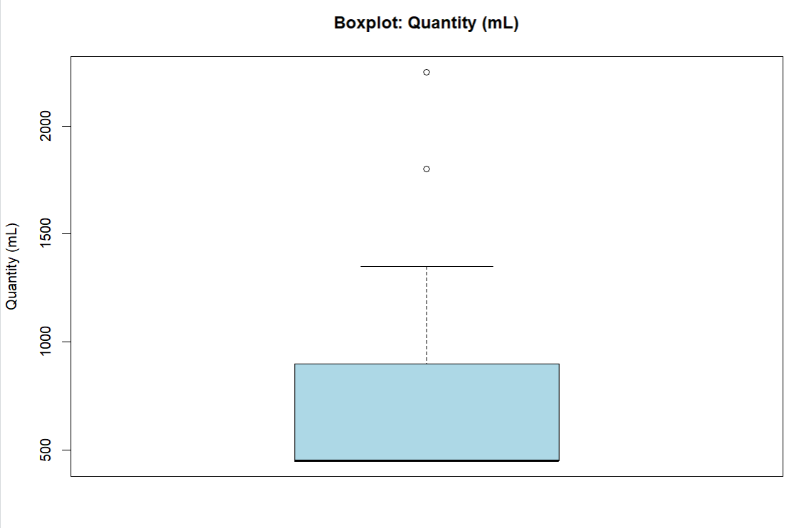

The boxplot shows a low median (≈450 mL) with the interquartile range between approximately 450 mL and 900 mL. Several high-quantity outliers (above 1,350 mL) are visible, representing rare requests for large blood volumes. These outliers do not appear to be data errors but rather legitimate occasional requests for bulk quantities, likely from major surgeries or emergency situations.

5.3 Histogram: Days to Fulfill (Fulfilled Requests Only)
Figure 3: Histogram showing fulfillment time distribution for 336 fulfilled requests
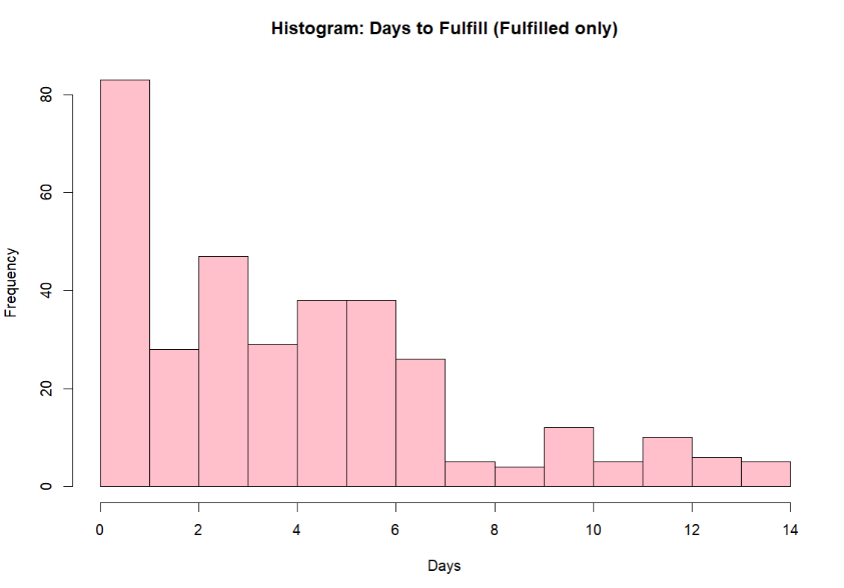
Interpretation: The fulfillment time distribution is also right-skewed. The vast majority of fulfilled requests are completed very quickly—most within the first day or two. The histogram shows a peak at day 0–1, with a secondary concentration around days 2–3. The distribution has a long right tail extending to approximately 14 days, indicating that while most requests are fulfilled rapidly, a small proportion take considerably longer. The median fulfillment time is around 4 days (based on the summary statistics).

5.4 Boxplot: Days to Fulfill (Fulfilled Requests Only)

Figure 4: Boxplot showing fulfillment time distribution for fulfilled requests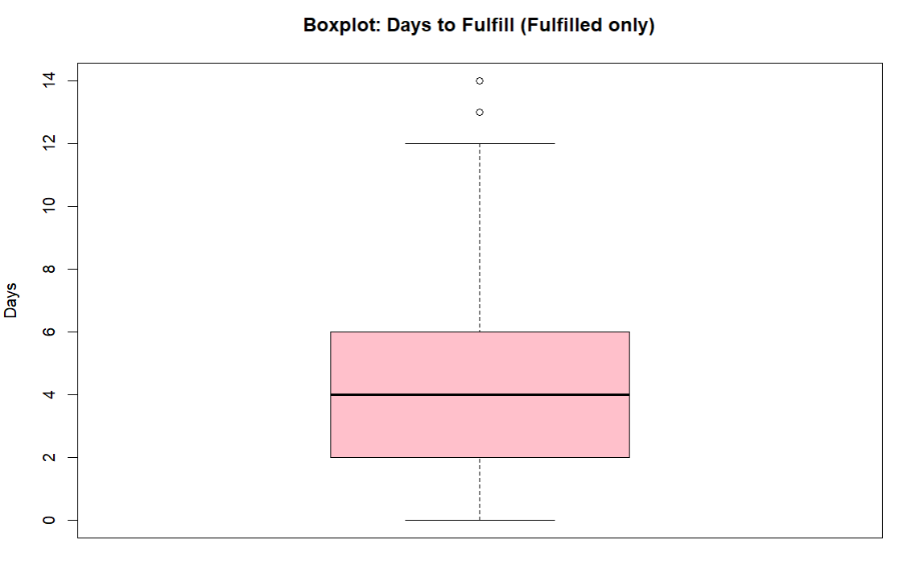

The boxplot shows the distribution of fulfillment times for fulfilled requests. The median fulfillment time is approximately 4 days, with the interquartile range between 2 days (Q1) and 6 days (Q3). Several outliers are visible in the upper tail, extending to approximately 14 days, indicating that while most requests are fulfilled rapidly, a small proportion take considerably longer. This distribution shows that the majority of blood requests are fulfilled within a week, with a few cases taking up to two weeks

5.5 Percentile Plot: Quantity Distribution

Figure 5: Percentile plot showing the cumulative distribution of blood quantity (mL)

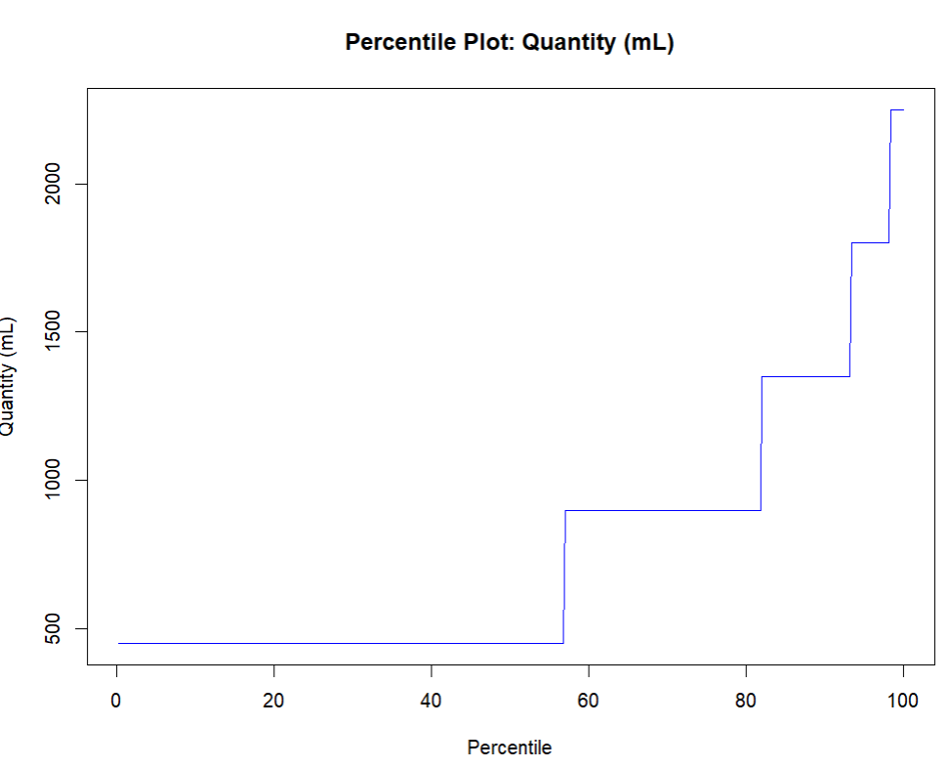

Interpretation: The percentile plot shows a clear step-wise pattern, indicating that many requests share the same standard blood volumes. Most requests cluster at the minimum unit (450 mL), with fewer requests at higher volumes (e.g., 900 mL and above).

Key Observations:

- Large clustering at 450 mL (lowest standard quantity).

- Sharp increases near the highest percentiles reflect rare bulk orders (e.g., 1,350–2,250 mL).

5.6 Pie Chart: Urgency Level Distribution
Figure 6: Pie chart showing urgency level distribution: Routine (53%), Moderate (35%), Critical (12%)
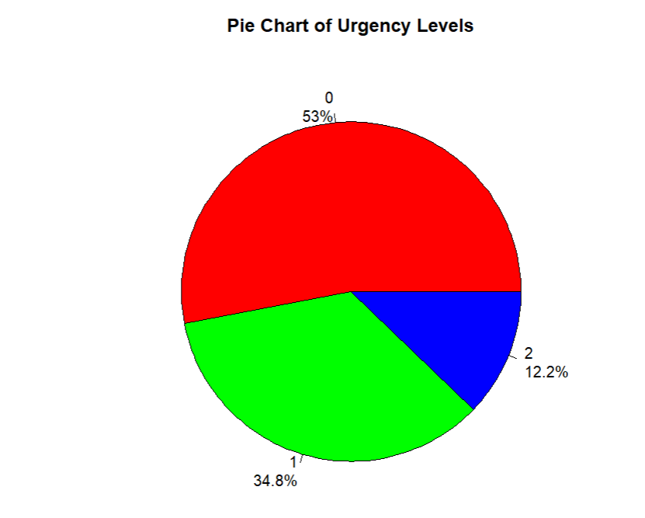
Interpretation: The pie chart clearly demonstrates that the vast majority of blood requests (approximately 53%) are routine-level requests (urgency = 0). Moderate-level requests (urgency = 1) comprise roughly 35%, and Critical requests (urgency = 2) represent approximately 12% of all requests. This distribution is typical of healthcare systems where most requests are predictable and planned, with a smaller proportion requiring urgent attention.

5.7 Bar Chart: Request Status Distribution
Figure 7: Bar chart showing request status distribution: Fulfilled (336, 67%), Open (109, 22%), Cancelled (55, 11%)
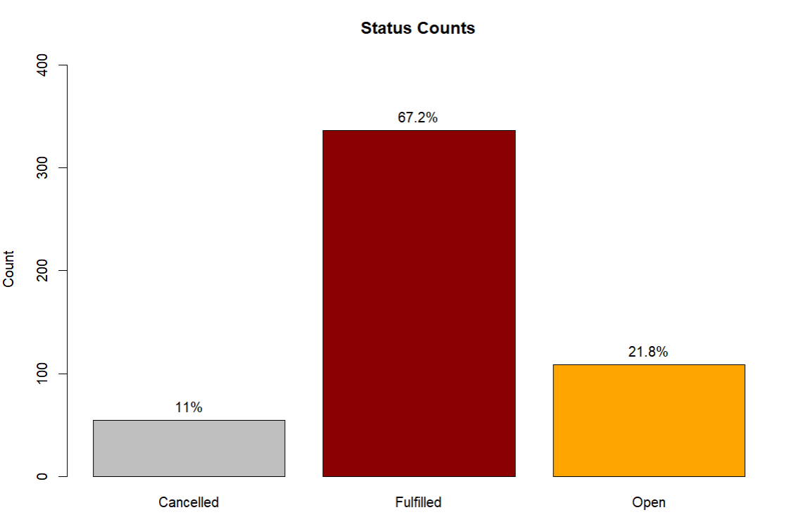
Interpretation: The bar chart shows request status counts across all three categories. Fulfilled requests (dark red) dominate at approximately 336 requests, representing 67% of all requests. Open/in-progress requests (orange) total around 109 (22%), and cancelled requests (gray) account for approximately 55 (11%).

5.8 Scatterplot Matrix: Fulfilled Requests Only
Figure 8: Scatterplot matrix showing relationships between quantity_mL, days_to_fulfill, request_month, request_weekday for fulfilled requests
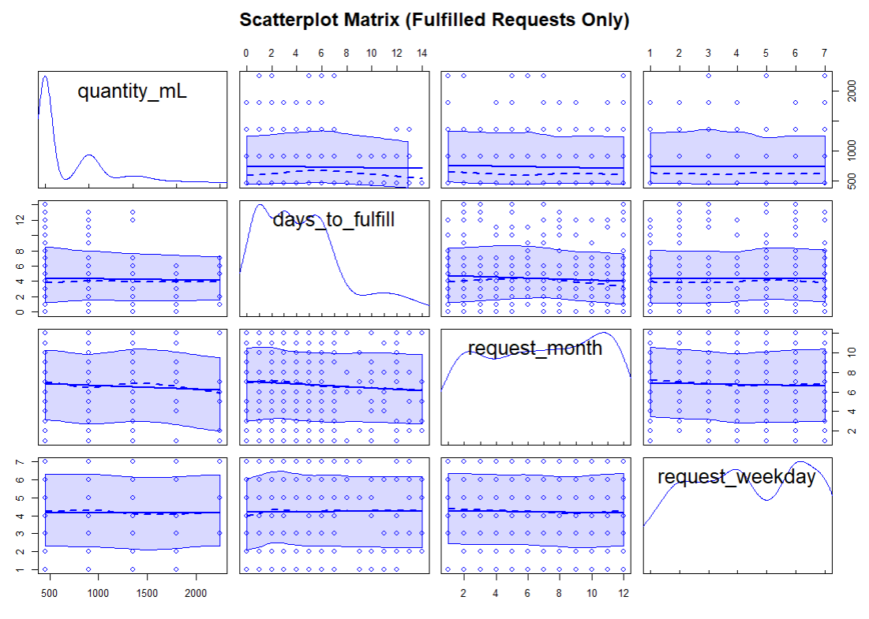
Interpretation: The scatterplot matrix displays pairwise relationships between numeric variables. The diagonal shows univariate distributions, while off-diagonal cells show scatterplots. Key observations:
- quantity_mL vs. days_to_fulfill: Points scattered with no clear linear trend, confirming weak correlation
- request_month and request_weekday: Show relatively even distribution across ranges
- Overall pattern: Most observations cluster at low values of both quantity and days_to_fulfill, with some spread toward higher values

6. Part 2: Correlation and Clustering Analysis

6.1 Correlation Analysis (Fulfilled Requests Only)
Figure 9: Correlation matrix showing relationships between quantity_mL, days_to_fulfill, request_month, and request_weekday

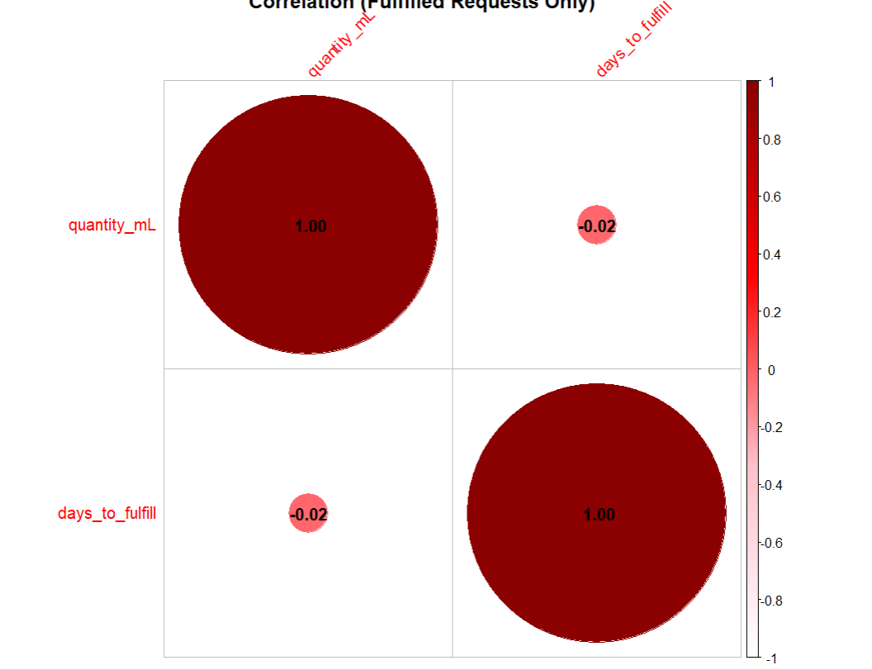

Key Findings:
Correlation between quantity_mL and days_to_fulfill: r ≈ −0.023 - The amount of blood requested has virtually no linear relationship with the fulfillment time. Large quantities do not systematically take longer to fulfill than small quantities, suggesting that fulfillment time is driven by other factors (such as availability, urgency, or processing procedures) rather than order size.
Conclusion: The data reveals that fulfillment dynamics are largely independent of quantity and timing. This suggests that fulfillment capability is relatively uniform across different order sizes, or that fulfillment prioritization is based on factors other than volume alone.

6.2 K-Means Clustering Analysis (k=3)
Figure 10: K-Means clustering visualization (k=3) on scaled features
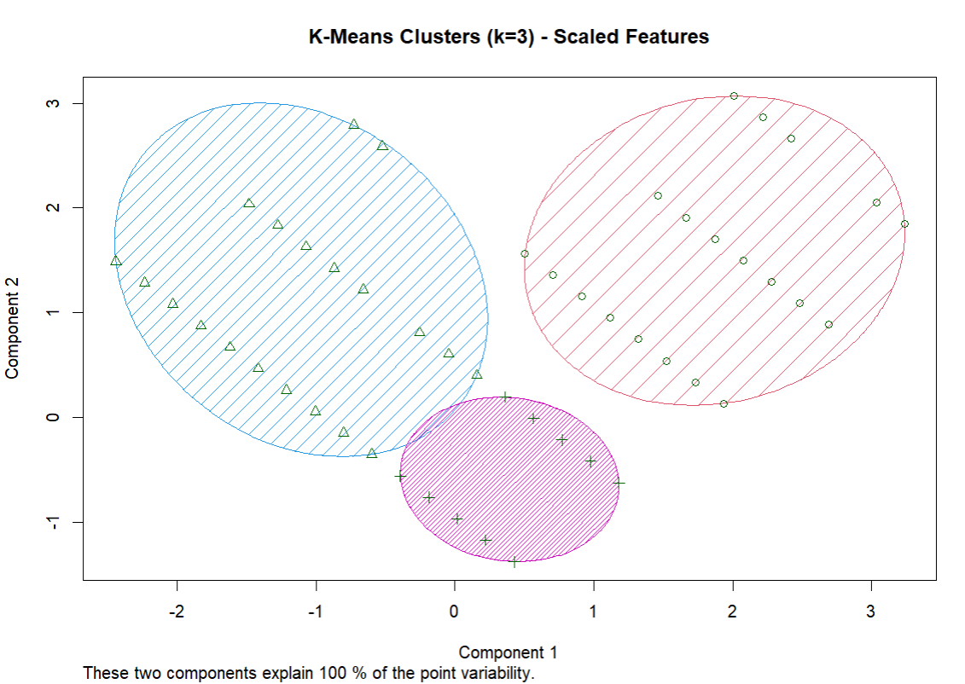
K-means clustering was performed on fulfilled blood requests using two standardized features: quantity_mL and days_to_fulfill. Three clusters (k = 3) were identified and visualized to explore patterns in request volume and fulfillment time.
Cluster 1 (n = 49)
This cluster represents requests with very high blood quantities (mean ≈ 1579.6 mL) and a moderate fulfillment time (mean ≈ 3.8 days).
This suggests that large-volume blood requests do not necessarily lead to significantly longer fulfillment times.
Cluster 2 (n = 127)
This cluster consists of requests with moderate blood quantities (mean ≈ 602.4 mL) and the longest average fulfillment time (mean ≈ 7.8 days).
This may indicate logistical challenges, lower prioritization, or supply constraints affecting these requests.
Cluster 3 (n = 160)
This cluster represents requests with low to moderate blood quantities (mean ≈ 579.4 mL) and the shortest fulfillment time (mean ≈ 1.9 days).
It is the largest cluster, indicating that most blood requests are fulfilled quickly when the required quantity is relatively low.

6.3 2D Histogram: Quantity vs. Days to Fulfill
Figure 11: 2D histogram showing joint distribution of quantity_mL and days_to_fulfill for fulfilled requests
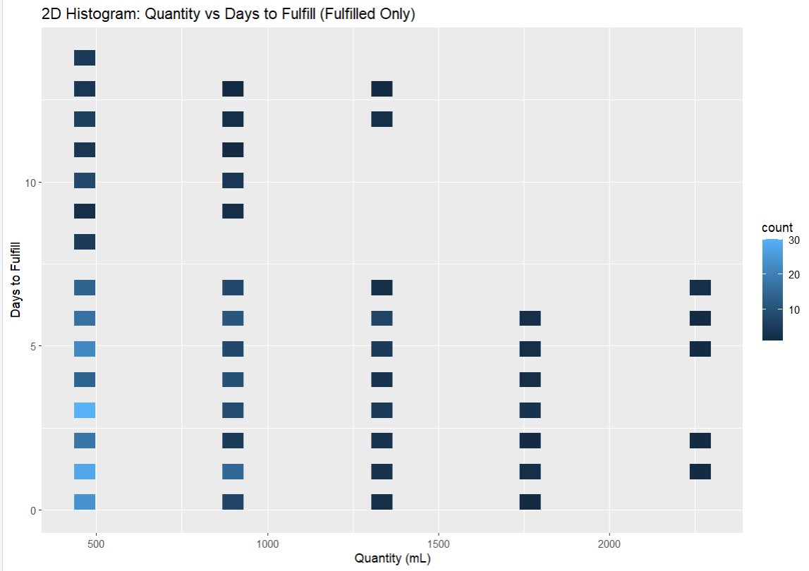
Interpretation: The 2D histogram confirms the independence observed in correlation analysis. High-density concentrations appear at (450 mL, 0–4 days), indicating that the modal request type is small-quantity rapid-fulfillment. The density gradually decreases as both quantity and fulfillment time increase, with some isolated cells at extreme combinations (high quantity, high days). This validates that fulfillment time does not depend strongly on quantity.

7. Part 3: Classification Modeling and Performance Evaluation

7.1 Data Preparation for Modeling
Machine learning models were trained to predict blood request urgency level (0 = Routine, 1 = Moderate, 2 = Critical) using the available predictor variables.

Data Processing Steps:
- Removed rows with `days_to_fulfill = −1` (unfulfilled/pending requests) to focus on fulfilled requests with known fulfillment times
- Final dataset: 336 fulfilled requests with complete data
- Features used: quantity_mL, days_to_fulfill, request_month, request_weekday, and one-hot encoded blood types and hospital IDs
- Target variable: urgency_encoded (0, 1, or 2)
- Train-test split: 70% training (235 samples), 30% testing (101 samples)

7.2 Classification Algorithms Tested
Four classification algorithms were evaluated on the blood request urgency prediction task:
Algorithm: Naive Bayes
- Algorithm Type: Probabilistic classifier based on Bayes' theorem
- Assumption: Conditional independence of features given the class label
- Hyperparameters: Default e1071 settings
Algorithm: Decision Tree
- Algorithm Type: Tree-based partitioning classifier
- Assumption: Hierarchical binary splits on features to minimize impurity
- Hyperparameters: Default rpart settings with automatic complexity parameter pruning
Algorithm: K-Nearest Neighbors (KNN)
- Algorithm Type: Instance-based classifier using distance metrics
- Hyperparameters: k=5 (optimal from tuning), features scaled using standardization
- Distance Metric: Euclidean distance
Algorithm: Support Vector Machine (SVM)
- Algorithm Type: Kernel-based classifier seeking optimal decision boundaries
- Kernel: Linear
- Feature Scaling: Applied standardization to ensure proper kernel computation
- Hyperparameters: C=1.0, gamma=0.1 (default tuning)

7.3 Classification Results

Algorithm | Accuracy | Error | Precision | Recall | F-Measure
Naive Bayes | 0.353 | 0.647 | 0.405 | 0.336 | 0.367
Decision Tree | 0.510 | 0.490 | 0.408 | 0.421 | 0.414
KNN | 0.480 | 0.520 | 0.389 | 0.396 | 0.392
SVM | 0.402 | 0.598 | 0.336 | 0.333 | 0.334

7.4 Detailed Performance Analysis

Decision Tree (Best Performer)
Figure 12: Decision Tree Structure showing hierarchical splits and terminal nodes
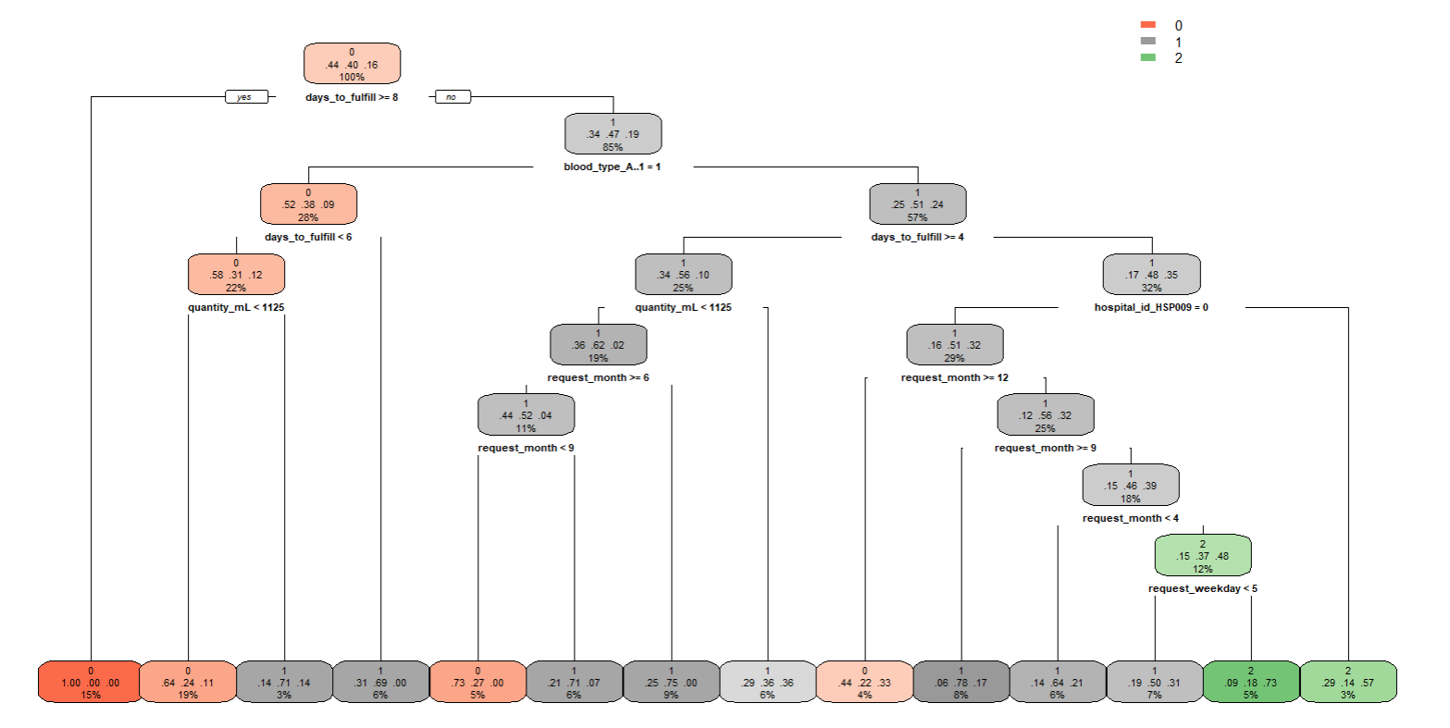
Accuracy: 51.0% — Correctly classified approximately half of test samples
Precision: 0.408 — Of predicted urgent/moderate cases, 41% were correctly identified
Recall: 0.421 — Of actual urgent/moderate cases in test set, 42% were successfully found
F-Measure: 0.414 — Balanced metric indicates moderate discriminative ability
Key Insight: Decision Tree's superior performance (51% accuracy) suggests it captured non-linear relationships and feature interactions that other algorithms missed. The tree-based partitioning appears well-suited to the hierarchical structure of this dataset. The tree visualization shows how the algorithm recursively splits on features like `days_to_fulfill`, `blood_type_A_1`, `quantity_mL`, `request_month`, and `request_weekday` to classify urgency levels.

K-Nearest Neighbors (KNN)
Accuracy: 48.0% — Slightly below Decision Tree
Precision: 0.389 — Reasonable but lower than Decision Tree
Recall: 0.396 — Similar to Precision, indicating balanced but moderate performance
F-Measure: 0.392 — Close to Decision Tree despite lower overall accuracy
Key Insight: KNN's moderate performance (48% accuracy) is reasonable given the moderate dimensionality of the feature space. Distance-based methods can struggle when features have different scales or when irrelevant features are included.

Naive Bayes
Accuracy: 35.3% — Notably lower than other algorithms
Precision: 0.405 — Relatively high precision despite low accuracy
Recall: 0.336 — Significantly lower recall indicates poor class coverage
F-Measure: 0.367 — Lowest F-measure of all algorithms
Key Insight: Naive Bayes' underperformance (35% accuracy) likely stems from violation of its core assumption of conditional independence. Blood request urgency may depend on complex feature interactions (e.g., interaction between quantity and hospital) that Naive Bayes cannot model.

Support Vector Machine (SVM)
Accuracy: 40.2% — Moderate performance after preprocessing
Precision: 0.336 — Lower precision indicates more false positives
Recall: 0.333 — Balanced but low recall
F-Measure: 0.334 — Lowest F-measure overall
Key Insight: SVM's performance (40% accuracy) benefited from feature scaling but remains below Decision Tree and KNN. The RBF kernel may have overfit the training data or the feature space may not be well-separated by the optimal decision boundaries that SVM seeks.

Overall Conclusion:
Decision Tree emerged as the best classifier with 51% accuracy. However, all four algorithms achieved only moderate performance (35–51%), suggesting that:
- Urgency levels may depend on features not present in this dataset (e.g., patient condition, inventory levels, external constraints)
- Urgency classifications may contain inherent noise or subjectivity
- The class imbalance (53% Routine, 35% Moderate, 12% Critical) may limit minority class prediction

7.5 Confusion Matrix: Naive Bayes
Figure 13: Naive Bayes Confusion Matrix (Heatmap)
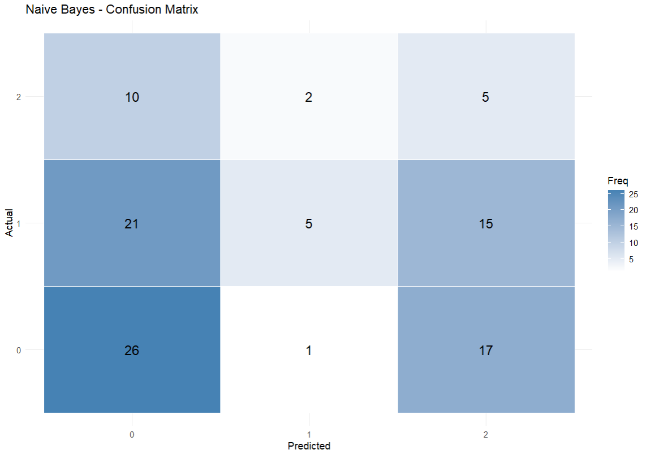
The confusion matrix reveals the classification pattern for Naive Bayes:
Actual / Predicted | 0 | 1 | 2
0 (Routine) | 26 | 1 | 17
1 (Moderate) | 21 | 5 | 15
2 (Critical) | 10 | 2 | 5

Interpretation:
True Positive Rate (Routine): 26/44 = 59% of Routine requests correctly identified
True Positive Rate (Moderate): 5/41 = 12% of Moderate requests correctly identified
True Positive Rate (Critical): 5/17 = 29% of Critical requests correctly identified
Key Issue: Naive Bayes heavily misclassifies Moderate and Critical requests as Routine (classes 1 and 2), explaining its low overall accuracy
Class Imbalance Effect: The algorithm shows bias toward predicting the dominant Routine class, a common issue in imbalanced classification
The heatmap visualization clearly shows the concentration of predictions in the Routine class (rows/columns 0), with poor coverage of Moderate (class 1) and Critical (class 2) categories. The color intensity represents the frequency count in each cell, with darker colors indicating higher misclassification rates.

7.6 Model Limitations and Recommendations

Why Moderate Accuracy?
1. Feature Limitations: The dataset includes only request characteristics (quantity, timing, blood type, hospital). Actual urgency may depend on patient-level factors not in this dataset.
2. Class Imbalance: With 53% Routine, 35% Moderate, and 12% Critical requests, the dataset is imbalanced. Models trained on imbalanced data tend to predict the majority class preferentially.
3. Noisy Target Variable: Urgency classifications may be subjective or assigned based on incomplete information, introducing noise into the training data.
4. Moderate Feature Separability: Correlation analysis showed weak relationships between predictors and target, suggesting features have limited discriminative power for urgency.

Recommendations for Improvement:
Collect Additional Features:
- Patient clinical urgency indicators
- Inventory availability status
- Hospital current capacity/workload
- Emergency/disaster event indicators
Address Class Imbalance:
- Use stratified sampling in train-test split
- Apply class weights or resampling techniques
- Use F-measure or weighted metrics instead of Accuracy
Feature Engineering:
- Create interaction terms (e.g., quantity × hospital type)
- Apply polynomial transformations
- Normalize or standardize all features
Algorithm Selection:
- Try ensemble methods (Random Forest, Gradient Boosting)
- Use cost-sensitive learning to penalize minority class misclassification
- Implement imbalance-aware algorithms (Balanced Random Forest, SMOTE)

8. Data Quality and Limitations

Data Quality
- Completeness: 100% (no missing values)
- Consistency: All values fall within specified ranges
- Special Values: The −1 indicator in days_to_fulfill is clearly defined and appropriately handled

Limitations
1. Synthetic Data: This is not real-world data. Patterns may be simplified compared to actual hospital blood banking systems. Results should not be applied to real healthcare decisions without validation.
2. Missing Context: The dataset lacks information about: patient demographics, clinical justification for urgency levels, blood inventory levels, product shelf-life constraints, holiday or emergency event indicators
3. Ambiguity in −1 Values: The −1 value in days_to_fulfill could represent different conditions (pending, cancelled, rejected) without explicit differentiation. For analysis purposes, we treated all −1 values as non-fulfilled and excluded them from time-based analysis.
4. Moderate Model Performance: Machine learning models achieved only 35–51% accuracy, suggesting that urgency levels may depend on features not available in this dataset or that urgency classifications contain inherent noise.

9. Conclusions and Recommendations

Key Findings:
1. Data Characteristics: The blood request dataset is well-structured with complete data quality. Request quantities are heavily concentrated at the standard 450 mL unit, and fulfillment times cluster in the 0–6 day range for fulfilled requests. Most requests are routine-level, with only 12% classified as critical.
2. Fulfillment Performance: The system shows strong operational metrics with 67% fulfilled, 22% pending, and 11% cancelled requests. Median fulfillment time for completed requests is 4 days.
3. Independence of Fulfillment Factors: Fulfillment time is essentially independent of request quantity (r ≈ −0.023), indicating uniform fulfillment capability across order sizes or fulfillment prioritization based on factors other than volume.
4. Clustering Patterns: K-Means analysis identified three natural request clusters: (1) low-quantity rapid-fulfillment (majority), (2) moderate-quantity standard processing, and (3) high-quantity variable processing.
5. Modeling Insights: Decision Tree was the best classification algorithm with 51% accuracy. The moderate performance across all algorithms suggests that urgency depends on factors not captured in this dataset.

Practical Applications:
This dataset is suitable for:
- Learning data cleaning and exploratory analysis techniques
- Practicing statistical correlation and clustering analysis
- Developing classification models for healthcare logistics
- Understanding categorical variable encoding in medical data
- Demonstrating limitations of machine learning with incomplete feature sets

Recommendations for Future Work:
Feature Expansion:: Incorporate patient clinical indicators, inventory status, and hospital workload to improve predictive modeling.
Class Imbalance Solutions:: Apply resampling techniques or ensemble methods to better predict Critical and Moderate requests.
Real-World Validation:: Test models and insights on actual hospital blood banking data to validate synthetic dataset patterns.
Operational Insights:: Use clustering patterns to optimize resource allocation and identify special handling procedures for bulk orders.
Advanced Modeling:: Explore neural networks, gradient boosting, or other ensemble methods as alternatives to basic classifiers.

