Introduction

The Grocery Tracking Program is designed to help the Corner Grocer analyze sales data by tracking the frequency of purchased items. The program reads from a text file containing a list of purchased items, processes this data, and provides various functionalities to display item frequencies and a histogram representation. This tool will assist the store in optimizing the layout of their produce section based on the frequency of purchases.

Class Design

The ItemTracker class is the core component of the program, designed to encapsulate the functionality needed to track and analyze item frequencies. The class uses a map<string, int> to store item names and their corresponding purchase frequencies, ensuring efficient retrieval and storage.

Private Member:

map<string, int> itemFrequency: Stores items and their purchase frequencies.

Public Methods:

void LoadData(const string& filename): Reads item data from a file and populates the itemFrequency map.

int GetItemFrequency(const string& item): Returns the frequency of a specified item.

void PrintAllFrequencies(): Outputs the frequency of all items.

void PrintHistogram(): Displays a histogram based on item frequencies.

void SaveDataToFile(const string& filename): Writes the item frequencies to a backup file.

Program Flow

The main function provides a user menu with four options. The user can navigate through the menu to perform various actions related to item frequency analysis:

Look up item frequency:

Prompts the user to input an item name.

Displays the frequency of the specified item using the GetItemFrequency method.

Display all item frequencies:

Calls the PrintAllFrequencies method to display the frequency of all items in the input file.

Display histogram of item frequencies:

Calls the PrintHistogram method to display a histogram where each asterisk (\*) represents a unit of frequency.

Exit the program:

Exits the program.

Screenshots

Main Menu:

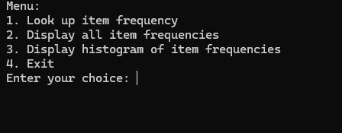

Item Frequency:

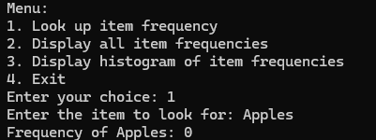

All Frequencies:

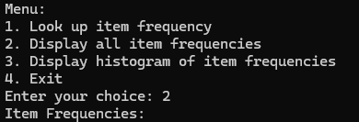

Histogram:

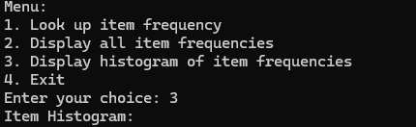

Conclusion

This program provides the Corner Grocer with an efficient tool to analyze item sales data. It meets all specified requirements, including displaying item frequencies and a histogram. The program is designed with user input validation and error handling to ensure robustness and reliability. By utilizing C++ features such as classes and maps, the program is both efficient and easy to understand.