# Profile

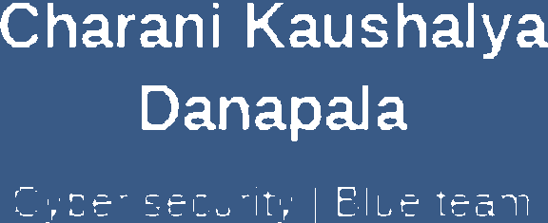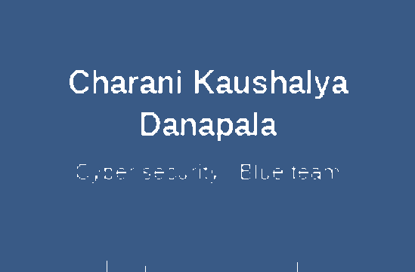

Personal details

 Chcrani Kaushalyn DanapaJc KaushaIyadcnapcIa01@gmaiI.

Motivated and detaikoriented aspiring cybersecurizy analyst with a solid foundation in cybersecurity. arid information security knowledge. Experienced in idenoty arid access management and conducting security awareness training on phishing.

Proficient in using Python . HTML. CSS. and JavaScript to creata security tools. Strong communication skills demonstrated through affective security awareness campaigns. Eager to leverage zechniCcl skills and project experience in c professionaJ sezong to conpibuze to innovative cybersecurfty solutions.

Education

## COIN

**Ordinary nnd Advanced Level Examinations**

Poramadulla Central Collage. R iki lagascada , S•i Lan<a

Apr 2011 - Dec 2019

0771689637 \ 0750248904

Advanced Level Examination in Technology Stream ( Engineering Technology )

Nuwara Mya Hangurazikzrha

Ilkedin.com/m/charani- kaushaIya-57b857287

# Skills

Cybersecuri\y Fundamentals



## Bachelors of Information Communication Technology {B.I.C.T Hons)

Un ersity of Jaffria „ Vavunrya Campus. Vavur iya „ Sri Lan<a

Internships

Security Awarez›ess Team Ana /•st M astercard, Foray• I Rem ate

e Phishing awareness , Management of phishing m ails



Taza Group, Fa rage I Remcne

Sep 2021 - Present

1un 2024

1un 2024



Cybersocuri\y Principles

e Miro internship on Forage as ari IAM developer ri:de, wirhin the team at Tata Consultancy Services. Python and IAM.

Ne\work Secu ri\y



CodeAJph a, Indi• I Rem ate

Apr 2024 - Ju 1 2024



Comm unica\ion Cri\ical Thinking Activa Listening Security assessments

Security comrols

* I gain sMIs about Netuzork sniffing tool and other tools to auom ale nevñvs , Uses pythm as language.

# Courses & Celifications

Certified in Cybersecurity’ Jun 2024

* Cerofied in Cybersecurity certification provide by ISC2 with self placed raining.

**Introduction to cryptography** May 2024

e Hushing algorithms, cryptography algorithms . ASE and DSE algorithms

Network Sniffung Tools G G6 0



HTML/CSS/JS



# Languages

Cybarsacurity Professional Certification [



e learn in-demand skills at fundamental to advanced of cybsrsacurity.

## Network Technician career pnth

* Cerofication prepares me for the entry-level Cisco Cerofied Support Technician (CCST) Network certification arid entry-level roles.

Run 202d

Jul 2024

May 2024

Eng lish Tamil

* + Cerñficatiori prepares me for the eMry-level Cisco Ceréfied 3upgiort Technlian (CCST) Cybersecurity certification arid entry-level cybersecurity

 

References