Project Details Tab
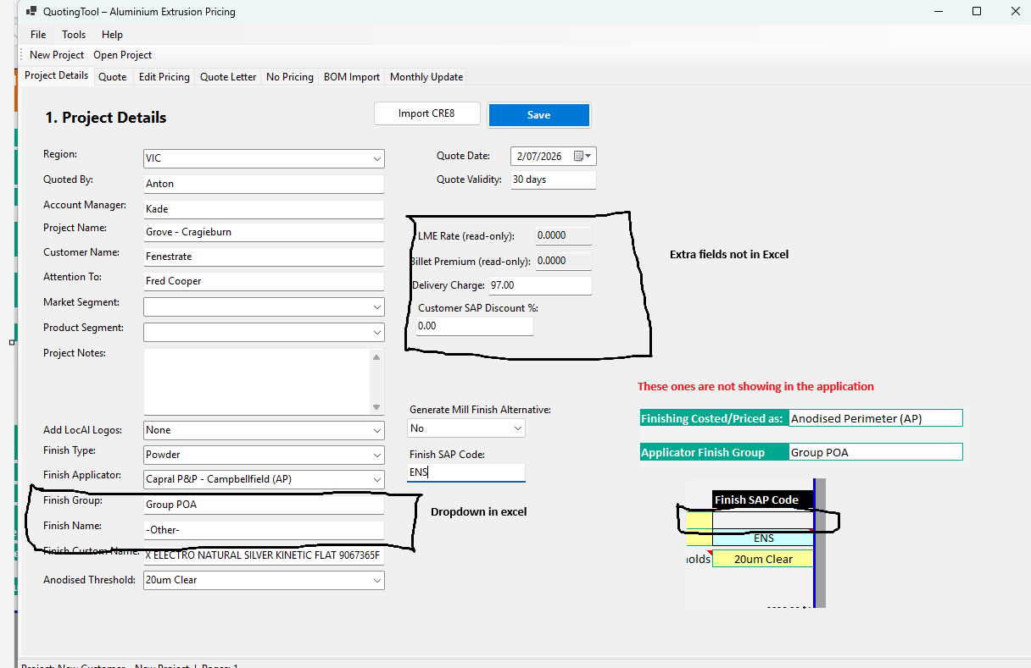
Issues-
Highlighted in above screenshot

Quote Tab
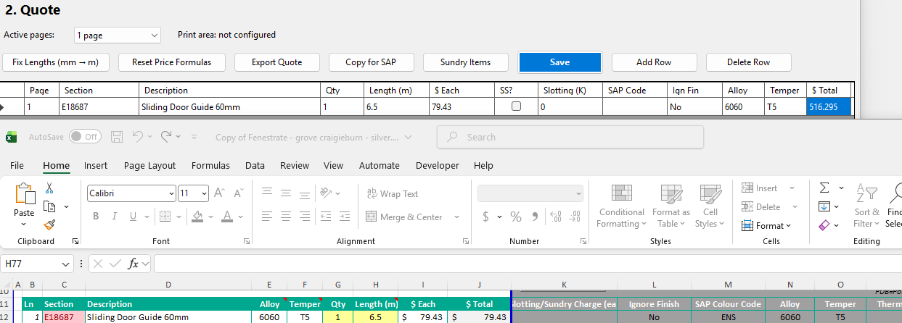
Issues
Section- Should be dropdown
Description, Alloy, Temper – Automatically load based on the section selection
Qty,Length -Manual input
$each-based on Length
Total calculation is wrong.

Edit Pricing Tab
Issues :-
Excel and application doesn’t look same
Excel
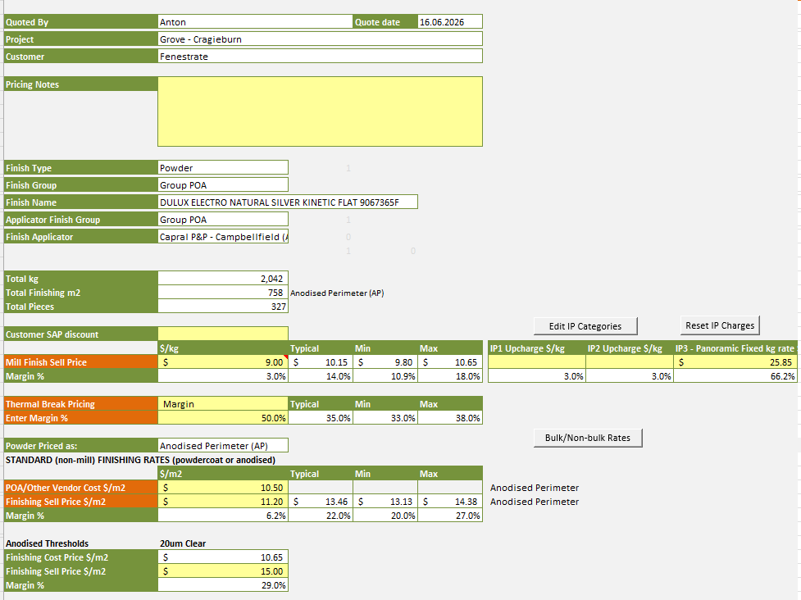

Application
