

BANGLADESH UNIVERSITY OF PROFESSIONALS (BUP)
Project Proposal
Tentative Title: Obstacle Avoiding Robot Car

1. | Student Name | Student ID
 | Shruti Khisa | 2252421003
 | Shaira Akhter Diba | 2252421105
 | Fazli Rabbi Noor | 225242113
 | Md. Farhan Tanvir | 225242115
2. | Name of the Department/Office/Faculty: | Faculty of Science and Technology (FST)
3. | Name of the University: | Bangladesh University of Professional
4. | Title of the Project: | Obstacle avoiding Robot Car
5. | Place where the work will be performed:
 | - Name of the University | Bangladesh University of Professional
 | - Name of Department/Institute | Department of Computer Science and Engineering (CSE)

- Introduction

Obstacles Avoiding Robots are intelligent machines that can autonomously detect obstacles in their path and steer clear of them by changing direction. The necessity for any autonomous mobile robot is the ability to avoid collisions, which is made possible by this design. The application of the obstacle-avoiding robot is not restricted and occurs in many different fields. We have presented an improved version of the robot in this project using basic algorithms and design, and we will talk about how to use it effectively in different fields.

1.1 Problem Statement

All mobile robots have some form of collision avoidance, from simple algorithms that detect an impediment and cause the robot to stop short of it in order to avoid a collision to complex algorithms that allow the robot to avoid collisions altogether. Some fairly well-known techniques for robot navigation include wall-following and edge-following. One recently released commercial device uses a floor cleaning robot for lengthy halls that follow walls. One of the main challenges to effective applications of mobile robot systems is real-time obstacle avoidance. The requirement for the robot to stop in front of an obstruction in order to allow for a more precise measurement is a drawback of obstacle avoidance based on edge detection.The dynamic steering algorithm used in this project makes sure that the robot doesn't have to stop in front of an obstacle while navigating. Hence the robot will find an alternative path for navigation after detecting the location and dimension of the object and it can navigate smoothly during its operation avoiding the collisions. Where conventional mobile robots stop after detecting obstacles, our robot will continue to detect obstacles as well as determine new paths without stopping, which will reduce both time and human effort. So this robot will give more benefits than conventional obstacle detecting robots. If we only go with the conventional obstacle detecting robots then various problems will be observed in its output. Mobile robotics are becoming more and more crucial in military operations, from patrol to handling potential bombs. Mobile robots are controlled remotely for reconnaissance patrol and provide video images to an operator when equipped with the proper sensors and cameras to carry out various tasks. Politecnico di Torino presented an innovative solution for a small hybrid mobile robot. Its operating mode adapts to the ground conditions and changes accordingly, and it is easy to control with only a few actuators. The mechanism makes it difficult for the robots to navigate and turn in tight spaces. We addressed this issue using a unique selection and design. features of the robot car we will be building, none of these innovations would be possible.
Through the algorithm we are going to use in our obstacle avoiding robot car, will give more efficiency than other robots as it will find different convenient routes without stopping and will move accordingly.

1.2 Rational studies

According to the concept, a robotic vehicle can be autonomous and have remote-free motion control. It uses sensors to identify obstacles in its path, avoids them, and then decides, depending on the internal code we have programmed into it.
Many areas in scientific research and emergency rescue are dangerous or unthinkable for humans to enter instantaneously. In this case, we will need these robots to assist us. The robots can gather enough knowledge of their environment under challenging conditions to avoid obstacles and find an alternate rescue route. This feature is much more critical for robots exploring outer space because there may be a delay of a few seconds or even minutes between the command center on earth and the robot. People today require a robot that can recognize and avoid obstacles in everyday surroundings. In conclusion, obstacle avoidance is a topic of extensive research and application. Life without this robot will be unfathomable in the future.
In order to reduce the risk of traffic accidents, road vehicles can also use the obstacle-avoiding robot feature.

Uses for robocars that can identify and avoid obstacles include:

(i) Almost all portable robot navigation systems can use obstacle-avoiding robots.

(ii) They may be applied to domestic tasks like automated vacuuming.

(iii) They can also be utilized in dangerous areas where human entry might be fatal.

(iv) It also plays an important role in construction and industrial management.

Therefore, the necessity for an obstacle-detecting and avoiding robot is urgent. Moreover, because its result is very accurate, it will have a massive impact on our lives.

1.3 Objectives

- To find obstacles in its path by using a set distance as a threshold.
- To find a different route without any help from outside.
- To get better at figuring out how far away things are from it all the time.

- Literature Review

The obstacle detection system is among the highly researched sectors in the current world. Different vehicles and hardware projects include this technology for different purposes.
Hearing of obstacle avoidance, one of the significant applications must be in autonomous cars and vehicles. As we know that AI is going to take over almost all sectors, and doing most jobs instead of human interaction is our main focus. Moreover, distance measuring and analysis are crucial if we want to replace cars or vehicle drivers with software. AI for transportation can save many lives. AI-powered self-driving cars are widely anticipated to prevent at least 90 percent of road fatalities^{[1]}. That level of complex object analysis is far beyond our project, but the basic idea is the same.
Another great use of object-detecting technology is in flying vehicles. Aeroplanes use this system to navigate throughout the sky as the vision in air transportation is of almost no use. In the future, flying cars and jet packs can use this system for path detection^{[2]} .
This obstacle avoidance technique is also applicable for Night Based robot rescue missions. When it is dark, the only way to move forward will be to detect the path by sound reflection. Like bats, the SONAR device sends and receives a sound wave and analyses the distance. Dr.Sandeep Bhat and Dr.M. Meenakshi has done some research on this matter^{[3]}.
Landmark recognition is identified as one important research area in robot navigation systems. It is a crucial feature for building robots capable of performing tasks in the human environment. We send rovers to mars which use SONAR sensors primarily for landmarking. Jianwei Zhang and Mohammed Elmogy have conducted some study regarding this matter^{[4]}.
Besides all these very impactful devices, object avoiding system plays an integral part in many valuable and clever robots, like smart vacuum robots and many others.

- Methodology To Be Adopted in The Investigation

As we have already known, our robot detects an obstacle and avoids them, turning another way to find a clear path. To make this system work, we have connected some essential electronic devices. They are Arduino Uno R3, Motor Shield L294D, Micro Servo, Sonar Sensor, 4x 3-6v Geared DC Motors, Rechargeable Battery 2X, Male and Female Jumper Wire 20X, Wheels 4X, DC Power Switch, Battery Holder, Acrylic Sheet for robot chassis. Let us first introduce these parts.

Arduino Uno R3: A microcontroller board called the Arduino Uno is based on the ATmega328. It contains 20 digital input/output pins, a 16 MHz resonator, a USB port, a power jack, an in-circuit system programming (ICSP) header, and a reset button, of which six can be used as PWM outputs and six as analog inputs. It has everything required to support the microcontroller; to get going, power it using an AC-DC converter or battery or a USB connection to a computer. ^{[6]}

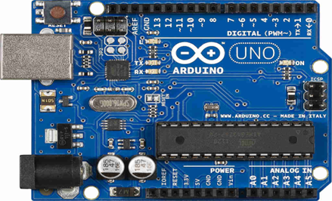
Image: Arduino Uno R3

Motor Shield L298N: To build our robot, we will need to manage DC motors. We need to connect the Arduino Uno R3 to the Motor Shield L298N in order to accomplish that.

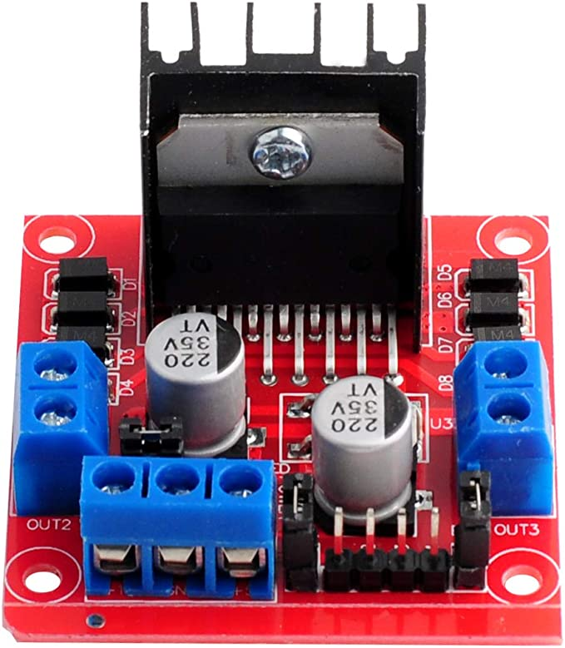
Image: Motor Shield L298N

Micro Servo: A small, light server motor with a high power output is called a micro servo motor, or SG90. The servo works exactly like the standard types and has a rotational range of about 180 degrees (90 in each direction). These servos can be managed by any servo code, hardware, or library. Source
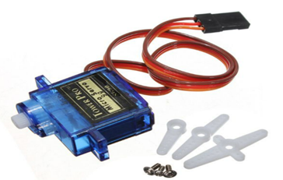
Image: Micro Servo

Sonar Sensor: An ultrasonic sensor is a technological device that uses ultrasonic sound waves to detect the separation between a target object and itself before turning the sound's reflection into an electrical signal. The speed of audible sound is greater than the speed of ultrasonic waves (i.e., the sound that humans can hear).Source
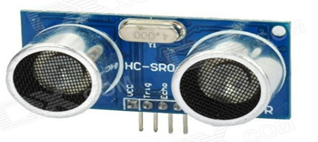
Image: Sonar Sensor hc-sr04

DC Motor: A type of electric machine known as a direct current (DC) motor transforms electrical energy into mechanical energy. DC motors use direct current to transform electrical energy into mechanical rotation.Source

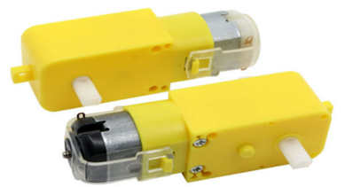
Image: DC Motors

Male and Female Jumper Wire: This cable has two ends. Male ends feature a protruding pin and can be plugged into objects, but female ends do not and are used to plug objects into them.

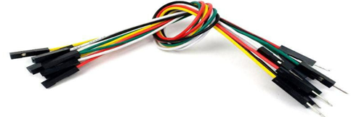
Image: Male and Female Jumper Wire

Wheels: Will be needed for running the device.
DC Power Switch: Switch will be needed for turning on and off the Robot.
Rechargeable Battery: Battery will power the system.
Battery Holder: The battery holder will keep the batteries together in place.
Acrylic Sheet: This will hold the whole system on wheels.
Hot Glue Gun: To attach all parts with an acrylic sheet.

Setting the Robot: Initially, we will take the acrylic sheet and attach 4 DC motors at four corners with hot glue. Then we will place our Arduino Uno R3 on the sheet and screw it. Motor shield L298n will be on top of the Arduino as interfaced with it. Wires connected to the motors will go into the stepper of the motor shield. Then we will glue the micro servo in front of the rover and fix the SONAR sensor on top of it. Then we will have to connect our SONAR sensor with the motor shield via male and female jumper wires. We will place the batteries in the holder and glue them to the back of the sheet. Battery wires will connect to the 9V adapter of the motor shield. We will finally attach wheels with the motors.

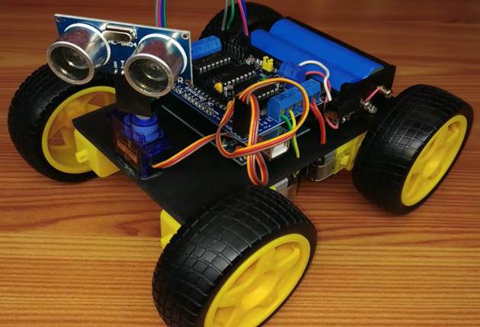
Image: Final robot after adding all hardwires.

System Diagram:

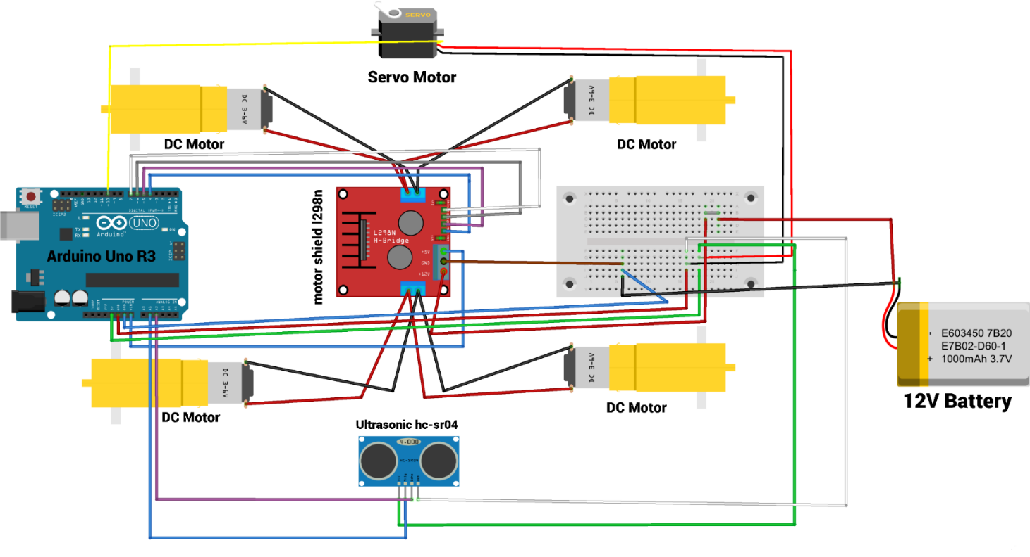

Image: System Diagram

Description: To initiate DC motors, we used the L298n motor shield. First and second motors are pinned out to "DC motor A output." Wires, both positive and negative, are pinned out individually. The third and fourth motors are connected to "DC motor B output." Connections are the same as others. The other three pinouts are +12V power (External motor power supply DC 5-35V), Common ground (GND), and +5V DC output or logic input. The Arduino board is used to command the whole operation. The 5V pin is connected to the Arduino's VIN pin,+12V is connected to the positive wire of the external battery, and the ground wire is grounded to the breadboard. To control the direction of the robot car, there are 4 control ports: IN1,IN2, IN3, and IN4 are periodically connected to Arduino's 4, 5, 6, and 7 pins. Motor outputs ENA and ENB are enabled by using jumpers. Ultrasonic sonar is used to detect the object by using its ultrasonic wave. Ultrasonic sonar has 4 pins which are VCC, Trig, Echo and GND. Trig is connected to Arduino's analog pin 1, and echo is connected to analog pin 2.VCC is parallelly connected to 5V via a breadboard, and GND is commonly grounded. The servo motor is used for rotating the sonar sensor. Servo's pluse is connected to Arduino's pin 10, positive wire is connected to the battery in parallel using the breadboard, and GND is commonly grounded. The breadboard is used to make wire connections easier and to prevent short circuits.

Algorithm: 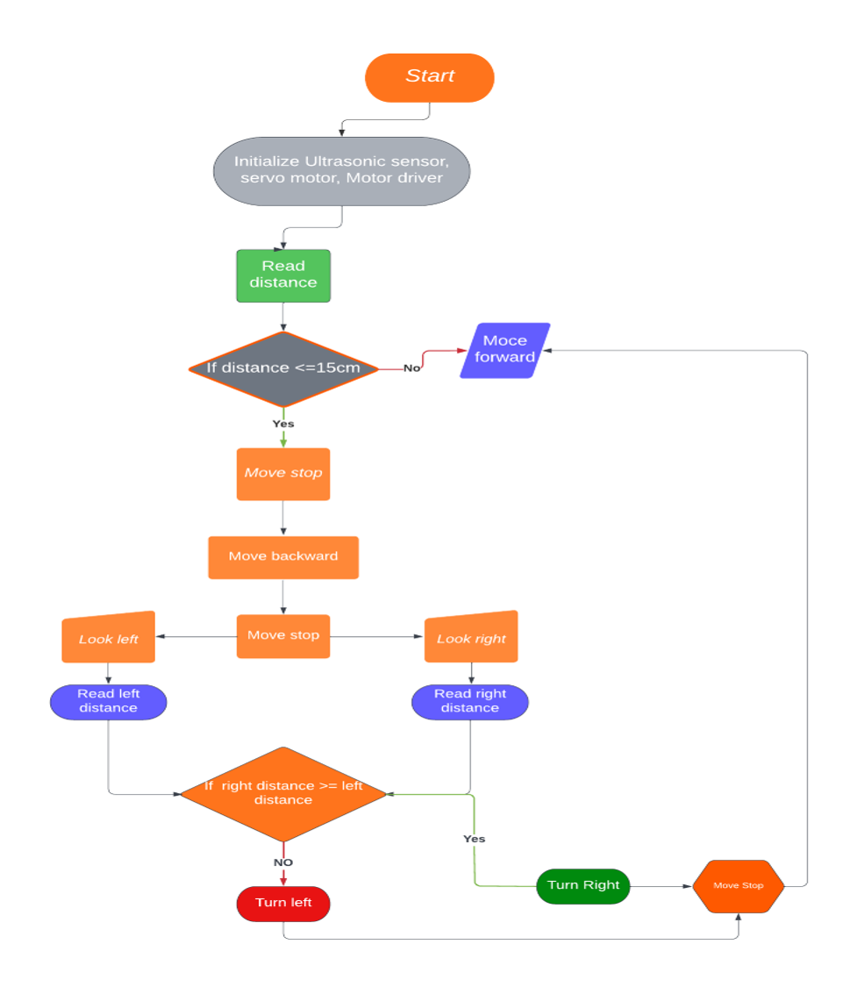

Image: System Algorithm

How it actually work: Our creation of an obstacle-avoiding robot was primarily based on the

a sensor for ultrasound. Up until it encounters an obstacle of any type, our robot initially advances. It continuously sends and receives distance-related information while driving, checking for obstacles every time. The signal will be sent using the Trig pin, and it will be received using the Echo pin.

So, we notice something that is more than 15 centimeters away from our robot. The answer to the check is either yes or no. Yes, indicating that there is an object that is 15 cm or closer. No, which means that no objects have been found within 15 cm. The Robot can simply move forward if there is nothing within 30 cm of it because the way is clear. The Robot must make obstacle avoidance maneuvers if something is more than 30 cm away.

Another check is made to determine the appropriate course of action. If going left is the best course of action, then it must turn around and move forward. The Robot simply advances because it is already facing in the appropriate direction if going right is the best course of action.

The only thing we actually did was translate the diagram into Arduino code. The obstacle avoidance code was finished shortly.

4. Description of Weekly Work Plan

Using a top-down methodology, this project is broken up into a number of stages that are connected to one another. In the first two weeks, we plan to gather information on the task, the components needed, and the cost involved in creating this obstacle-avoiding robot car. We then will take an additional week to annotate the data in both text and images. The pre-processing of the data for use took an additional week. Following that, we will begin turning our project into reality, and we aim to do it in three weeks. The findings will be presented after the model has been developed. It will take a week to complete the report's final preparations.

Table-1: Weekly work plan for the project:

Work plan and Data Collection | Weeks
Data Annotation
Data pre-processing
Model development & reporting result
Final report submission

References

- Max Tegmark. 2017. Life 3.0: Being Human in the Age of Artificial Intelligence. Alfred A. Knopf.
- Moore, M.M. and Lu, B., 2011. Autonomous vehicles for personal transport: A technology assessment. Available at SSRN 1865047.
- Bhat, D. and Meenakshi, D.M., 2019, May. Night Vision Based Optimum Robot Path Planning in Rescue Operations. In Proceedings of the Second International Conference on Emerging Trends in Science & Technologies For Engineering Systems (ICETSE-2019).

- Elmogy, M. and Zhang, J., 2009, February. Robust real-time landmark recognition for humanoid robot navigation. In 2008 IEEE International Conference on Robotics and Biomimetics (pp. 572-577). IEEE.

- Quaglia, G., Maffiodo, D., Franco, W., Appendino, S. and Oderio, R., 2010. The Epi. q-1 hybrid mobile robot. The International Journal of Robotics Research, 29(1), pp.81-91.

