

**Department of Computer Science and Engineering**

**Course Title:** Internet Of Things

**Code:** CSE406

**Section:** 2

**LAB-02**

**Submitted To:**

Dr. Raihan Ul Islam

Associate Professor

Department of Computer Science & Engineering

**Submitted by**

**Name:** Shairin Akter Hashi

**ID:** 2022-2-60-102

**TASK:** How Water Level Sensor Works and Interface it with Arduino

**Arduino UNO Code:**

*// Sensor pins*

#define sensorPower 7

#define sensorPin A0

*// Value for storing water level*

int val = 0;

int lowerThreshold = 200;

int upperThreshold = 400;

*// Declaring pins to which LEDs are connected*

int redLED = 2;

int yellowLED = 3;

int greenLED = 4;

void setup() {

Serial.begin(9600);

pinMode(sensorPower, OUTPUT);

digitalWrite(sensorPower, LOW);

*// Set LED pins as an OUTPUT*

pinMode(redLED, OUTPUT);

pinMode(yellowLED, OUTPUT);

pinMode(greenLED, OUTPUT);

*// Initially turn off all LEDs*

digitalWrite(redLED, LOW);

digitalWrite(yellowLED, LOW);

digitalWrite(greenLED, LOW);

}

void loop() {

int level = readSensor();

**if** (level == 0) {

Serial.println("Water Level: Empty");

digitalWrite(redLED, LOW);

digitalWrite(yellowLED, LOW);

digitalWrite(greenLED, LOW);

} **else** **if** (level > 0 && level <= lowerThreshold) {

Serial.println("Water Level: Low");

digitalWrite(redLED, HIGH);

digitalWrite(yellowLED, LOW);

digitalWrite(greenLED, LOW);

} **else** **if** (level > lowerThreshold && level <= upperThreshold) {

Serial.println("Water Level: Medium");

digitalWrite(redLED, LOW);

digitalWrite(yellowLED, HIGH);

digitalWrite(greenLED, LOW);

} **else** **if** (level > upperThreshold) {

Serial.println("Water Level: High");

digitalWrite(redLED, LOW);

digitalWrite(yellowLED, LOW);

digitalWrite(greenLED, HIGH);

}

delay(1000);

}

*//This is a function used to get the reading*

int readSensor() {

digitalWrite(sensorPower, HIGH);

delay(10);

val = analogRead(sensorPin);

digitalWrite(sensorPower, LOW);

**return** val;

}

**Github Link :** <https://github.com/Shairin207/IoT-Lab-Assignments>

**Output Image:**

Image:1

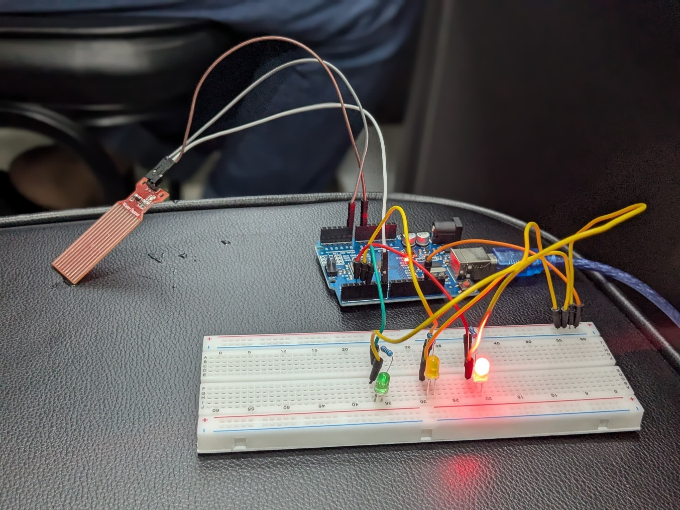

Image:2

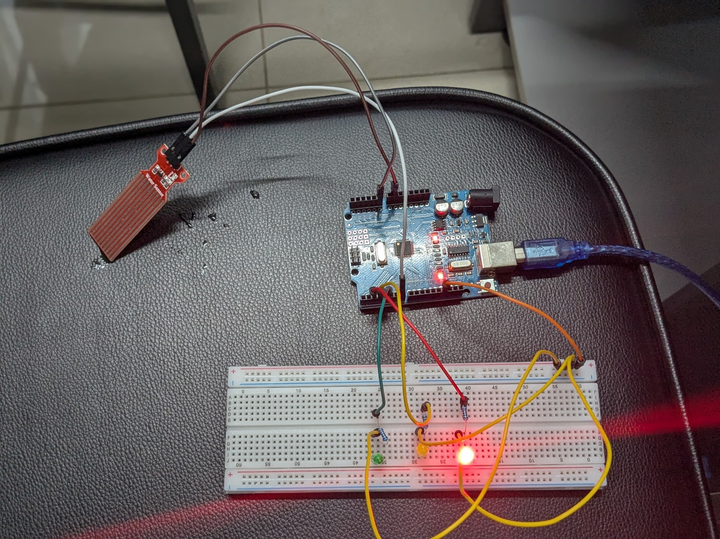

Image:3

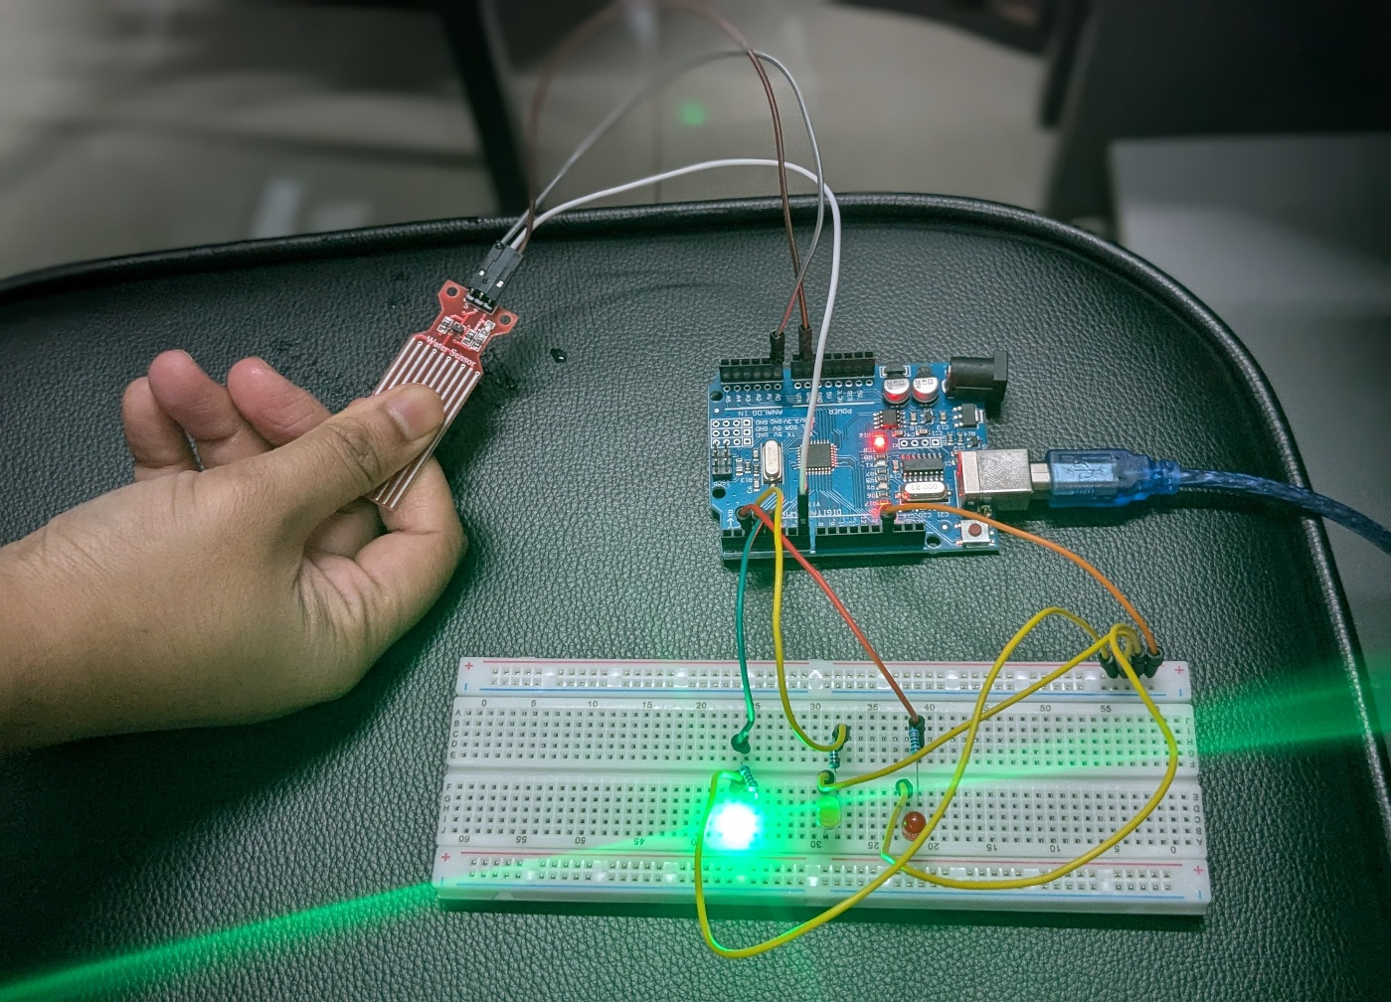

Image:4

**Conclusion:**

In this experiment, we successfully developed and tested an Arduino-based water level monitoring system using an analog sensor and a simple LED-based visual feedback mechanism. The system effectively measured water levels and triggered corresponding LED indicators based on predefined thresholds, providing real-time status updates via serial communication.