1. **Suppose, a=10 and b=20. Now swap the value without a temp variable. Output: a=20, b=10**

Ans:

public class SwapWithoutTemp {  
 //1  
 public static void main(String[] args) {  
 int a = 10;  
 int b = 20;  
  
 System.*out*.println("Before Swap: ");  
  
 System.*out*.println("a: " + a);  
 System.*out*.println("b: " + b);  
  
  
 a = a + b;  
 b = a - b;  
 a = a - b;  
  
 System.*out*.println("After Swap: ");  
  
 System.*out*.println("a: " + a);  
 System.*out*.println("b: " + b);  
  
 }  
}

output:

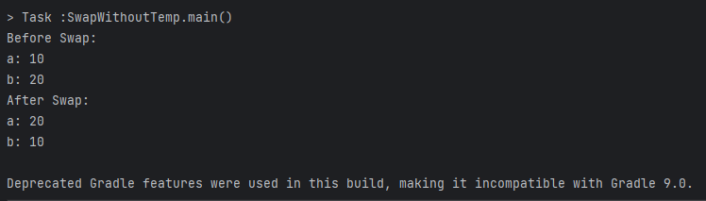

**2. Here is the 10 students CGPA [3.50, 3.52, 3.43, 3.63, 3.48, 3.32, 3.30, 3.60, 3.86, 3.75]**

**Find out who achieved the 2nd highest score. (without sorting, use linear searching algorithm)**

**Ans:**

public class SecondHighestCGPA {  
 public static void main(String[] args) {  
 //2  
 double[] cgpa = {3.50, 3.52, 3.43, 3.63, 3.48, 3.32, 3.30, 3.60, 3.86, 3.75};  
  
 double max = 0;  
 double max2 = 0;  
  
 for (int i = 0; i < cgpa.length; i++) {  
 if (max <= cgpa[i]) {  
 max = cgpa[i];  
 }  
 }  
  
 for (int i = 0; i < cgpa.length; i++) {  
 if (max2 <= cgpa[i] && cgpa[i] != max) {  
 max2 = cgpa[i];  
 }  
 }  
 System.*out*.println("Second Highest CGPA: " + max2);  
 }  
}

**output:**

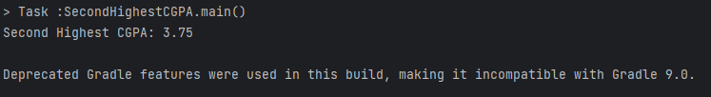

**3. Sort the above scores from according to the order of highest CGPA (don’t use Arrays.sort() method, do it programmatically)**

import java.util.Arrays;  
  
public class SortArray {  
 //3  
 public static void main(String[] args) {  
 double[] cgpa = {3.50, 3.52, 3.43, 3.63, 3.48, 3.32, 3.30, 3.60, 3.86, 3.75};  
 double temp;  
 boolean status;  
 do {  
 status = false;  
 for (int i = 0; i < cgpa.length - 1; i++) {  
 if (cgpa[i] < cgpa[i + 1]) {  
 temp = cgpa[i + 1];  
 cgpa[i + 1] = cgpa[i];  
 cgpa[i] = temp;  
 status = true;  
 }  
 }  
 }  
 while (status);  
  
 System.*out*.println("Sorted CGPA: " +Arrays.*toString*(cgpa));  
 }  
}

**Output:**

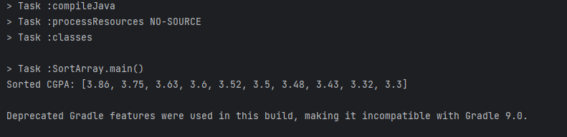

**4. From the given array find if your input CGPA is present using binary search algorithm**

import java.util.Arrays;  
import java.util.Scanner;  
  
public class FindCGPA {  
 public static void main(String[] args) {  
 //4  
 double[] cgpa = {3.50, 3.52, 3.43, 3.63, 3.48, 3.32, 3.30, 3.60, 3.86, 3.75};  
 Arrays.*sort*(cgpa);  
  
 Scanner scanner = new Scanner(System.*in*);  
 System.*out*.println("Enter the CGPA: ");  
 double num = scanner.nextDouble();  
  
 boolean status=false;  
 int startingIndex = 0;  
 int endingIndex = cgpa.length - 1;  
  
 while (startingIndex <= endingIndex) {  
  
 int mid = (startingIndex + endingIndex) / 2;  
  
 if (cgpa[mid] == num) {  
 status = true;  
 break;  
  
 } else if (cgpa[mid] > num) {  
 endingIndex = mid - 1;  
 } else {  
 startingIndex = mid + 1;  
 }  
 }  
 if(!status){  
 System.*out*.println("Not Found");  
 }  
 else {  
 System.*out*.println("Cgpa: "+ num+" Found");  
 }  
  
 }  
}

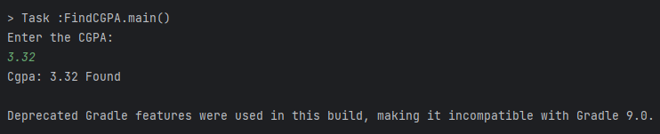

**5. Calculate and Print the MEDIAN of the CGPA**

import java.util.Arrays;  
  
public class Median {  
 public static void main(String[] args) {  
 //5  
 double[] cgpa = {3.50, 3.52, 3.43, 3.63, 3.48, 3.32, 3.30, 3.60, 3.86, 3.75};  
 Arrays.*sort*(cgpa);  
 int index = cgpa.length;  
 System.*out*.println(Arrays.*toString*(cgpa));  
 double median;  
  
 if (index % 2 == 0) {  
 median = (cgpa[(index - 1) / 2] + cgpa[index / 2]) / 2;  
 } else {  
 median = cgpa[(index - 1) / 2];  
 }  
 System.*out*.println("Median: " + median);  
  
 }  
}

output:

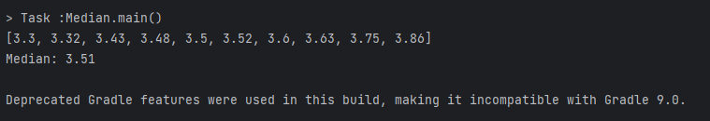

**6. Generate random 10 integer numbers in an array and print out all the numbers from the array and also print the max and min number from the array.**

import java.util.Arrays;  
import java.util.Random;  
  
public class RandomNum {  
 //6  
 public static void main(String[] args) {  
 int[] rand = new int[10];  
  
 for (int i = 0; i < rand.length; i++) {  
 Random random =new Random();  
 rand[i] = random.nextInt(100);  
 }  
  
 System.*out*.println("Random Number Array: "+ Arrays.*toString*(rand));  
  
 int max = rand[0];  
 int min = rand[0];  
  
 for (int i = 0; i < rand.length; i++) {  
 if (rand[i] > max) {  
 max = rand[i];  
 }  
 if (rand[i] < min) {  
 min = rand[i];  
 }  
 }  
 System.*out*.println("Max Number: " + max);  
 System.*out*.println("Min Number: " + min);  
 }  
}

output:

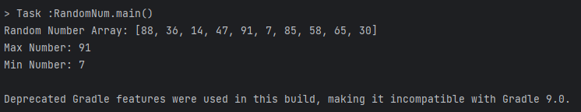

**7. Write a program that will break down the amount and count notes for any given amount. Here is the notes in the given array:**

**notes=[1000,500,200,100,50,20,10,5,2,1]**

**Input: 546**

**Output:**

**500 1**

**20 2**

**5 1**

**1 1**

import java.util.Scanner;  
  
public class CountNotes {  
 public static void main(String[] args) {  
 //7  
 int[] notes = {1000, 500, 200, 100, 50, 20, 10, 5, 2, 1};  
 System.*out*.println("Enter Input: ");  
 Scanner scanner =new Scanner(System.*in*);  
 int input = scanner.nextInt();  
  
 System.*out*.println("Input: " + input);  
 for (int i = 0; i < notes.length; i++) {  
 if (input >= notes[i]) {  
 int count = input / notes[i];  
 input = input % notes[i];  
 System.*out*.println(notes[i] + " " + count);  
 }  
 }  
 }  
}

output:

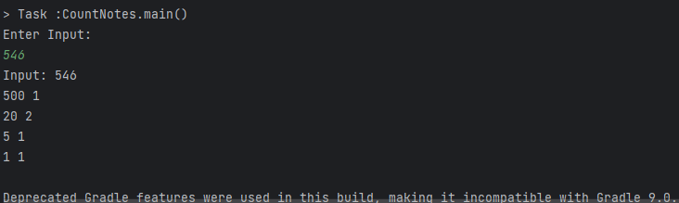

**8. Write a program that will give following output:**

**1**

**12**

**123**

**1234**

**12345**

public class Output {  
 public static void main(String[] args) {  
 //8  
 for (int i = 1; i <= 5; i++) {  
 for (int j = 1; j <= i; j++) {  
 System.*out*.print(j);  
 }  
 System.*out*.println();  
 }  
 }  
}

output:

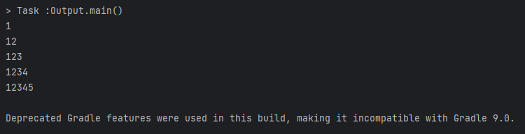

**9. Write a program that will shuffle (values will randomly change their position) from the given array**

**numbers=[1,2,3,4,5,6,7,8,9,0]**

import java.util.Arrays;  
import java.util.Random;  
  
public class RandomSwap {//9  
 public static void main(String[] args) {  
 int[] numbers ={1,2,3,4,5,6,7,8,9,0};  
 System.*out*.println("Before Random Swap: "+Arrays.*toString*(numbers));  
  
 for (int i=0;i<numbers.length;i++){  
 Random random =new Random();  
 int j = random.nextInt(numbers.length-1);  
  
 int temp = numbers[i];  
 numbers[i]=numbers[j];  
 numbers[j]=temp;  
 }  
  
 System.*out*.println("After Random Swap: "+Arrays.*toString*(numbers));  
  
 }  
}

output:

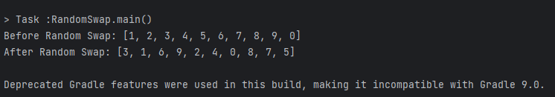

**10. Take input as height of 10 babies in cm. Now find out the 2 lowest height of babies. (Don’t use Arrays.sort() method)**

import java.util.Arrays;  
import java.util.Scanner;  
  
public class Height {  
 //10  
 public static void main(String[] args) {  
  
 int[] heights= new int[10];  
 Scanner scanner =new Scanner(System.*in*);  
 System.*out*.println("Input Height(in cm): ");  
  
 for(int i=0;i< heights.length;i++){  
 heights[i]=scanner.nextInt();  
 }  
 System.*out*.println("Heights: "+ Arrays.*toString*(heights));  
  
  
 int min = heights[0];  
 int min2 = heights[1];  
  
 for (int i = 0; i < heights.length; i++) {  
 if (min > heights[i]) {  
 min = heights[i];  
 }  
 }  
  
 for (int i = 0; i < heights.length; i++) {  
 if (min2 > heights[i] && heights[i] != min) {  
 min2 = heights[i];  
 }  
 }  
 System.*out*.println("Lowest Height: "+min);  
 System.*out*.println("2nd Lowest Height: "+min2);  
 }  
}

output:

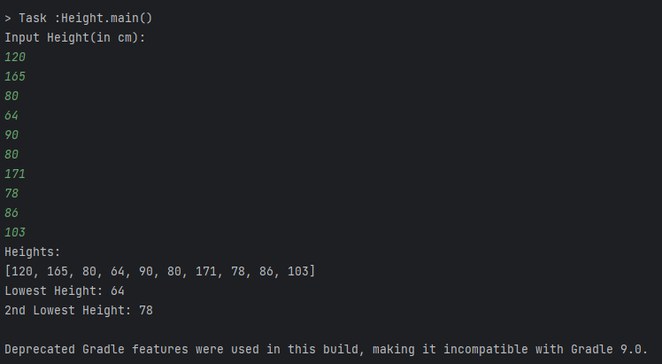

**11. Count number of words, number of characters without spaces, number of vowels and consonant from the given string:**

**Input: I am a SQA Engineer**

**Output:**

**Words: 5**

**Chars: 15**

**Vowel: 8**

**Consonant: 7**

public class CountFromString {  
 public static void main(String[] args) {//11  
 String word = "I am a SQA Engineer";  
 System.*out*.println(word);  
 String[] words = word.split(" ");  
 int wordLength = words.length;  
 System.*out*.println("Words: " + wordLength);  
  
 int chars = 0;  
 int vowels = 0;  
 int cons = 0;  
  
 for (int i = 0; i < word.length(); i++) {  
 if (word.charAt(i) != ' ') {  
 chars++;  
 if (word.charAt(i) == 'a' || word.charAt(i) == 'e' || word.charAt(i) == 'i' || word.charAt(i) == 'o' || word.charAt(i) == 'u' ||  
 word.charAt(i) == 'A' || word.charAt(i) == 'E' || word.charAt(i) == 'I' || word.charAt(i) == 'O' || word.charAt(i) == 'U') {  
 vowels++;  
 } else {  
 cons++;  
 }  
 }  
 }  
 System.*out*.println("Chars : " + chars);  
 System.*out*.println("Vowel: " + vowels);  
 System.*out*.println("Consonant: " + cons);  
 }  
}

output:

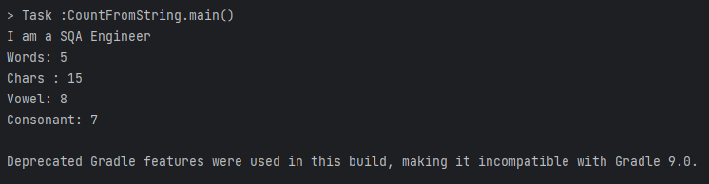

**12. Print the duplicate numbers in the given array.**

**numbers=[1, 2, 3,1, 2, 4, 5, 6, 4]**

**Output:**

**1 2 4**

import java.util.ArrayList;  
  
public class DuplicateNUmber {  
 //12  
 public static void main(String[] args) {  
 int[] numbers= {1, 2, 3, 1, 2, 4, 5, 6, 4};  
 ArrayList<Integer> duplicates = new ArrayList<Integer>();  
  
 for(int i=0;i<numbers.length;i++){  
 for(int j= i+1; j<numbers.length;j++){  
 if((numbers[i]==numbers[j]) && !duplicates.contains(numbers[j])){  
 duplicates.add(numbers[j]);  
 }  
 }  
 }  
 System.*out*.println("Duplicates numbers: " + duplicates);  
 }  
}

output:

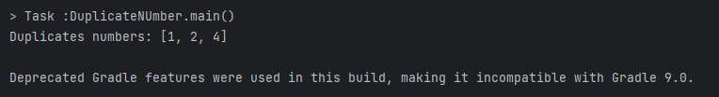

**13. Here is the array of lucky draw numbers:**

**[100,150,140,180,170,200,250,230,220,300]**

**Now, input any number from this array. The program will randomly generate any one number of this array. If your input number and generated number matches, it will print you are lucky! Continue it max 3 times until you are lucky. If at the 1st or 2nd time you are lucky, then the program will quit instead of giving you a chance 3 times.**

import java.util.Arrays;  
import java.util.Random;  
import java.util.Scanner;  
  
public class LuckyDraw {//13  
 public static void main(String[] args) {  
 int[] numbers ={100,150,140,180,170,200,250,230,220,300};  
 System.*out*.println(Arrays.*toString*(numbers));  
 Scanner scanner =new Scanner(System.*in*);  
 System.*out*.println("Please Enter a Number from the given array: ");  
 int input = scanner.nextInt();  
 System.*out*.println("Input Number: "+input );  
  
 boolean status = false;  
 Random random =new Random();  
  
 for(int i=0;i<3;i++){  
 int j=random.nextInt(numbers.length-1);  
 System.*out*.println("Random Number: "+ numbers[j]);  
 if(input==numbers[j]){  
 status =true;  
 break;  
 }  
 }  
 if(status){  
 System.*out*.println("You are Lucky");  
 }  
 else {  
 System.*out*.println("You are not Lucky");  
 }  
 }  
}

output:

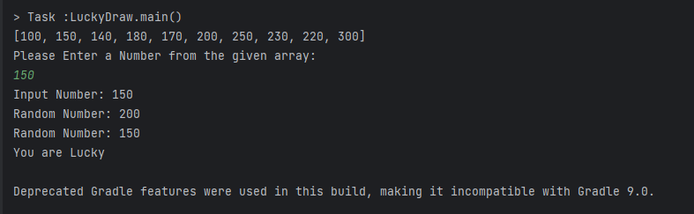

**14. Write a program that will take integer numbers as user input continuously and print the sum of numbers until user input q from the keyboard. When user input q, the program will be quit. If the user inputs another character, then the program will ask to input the number again.**

import java.util.Scanner;  
  
public class Sum {  
 public static void main(String[] args) {//14  
 int sum=0;  
 String ch;  
  
 do {  
 System.*out*.println("Input number:");  
 Scanner input=new Scanner(System.*in*);  
 ch=input.next();  
  
 if(Character.*isDigit*(ch.charAt(0))){  
 int num= Integer.*parseInt*(ch);  
 sum+=num;  
 System.*out*.println("Sum: " +sum);  
 }  
 else if((!ch.equals("q"))){  
 System.*out*.println("Input the number again");  
 }  
 else{  
 break;  
 }  
 }  
 while (true);  
 System.*out*.println("Total sum: " + sum);  
 }  
}

**output:**

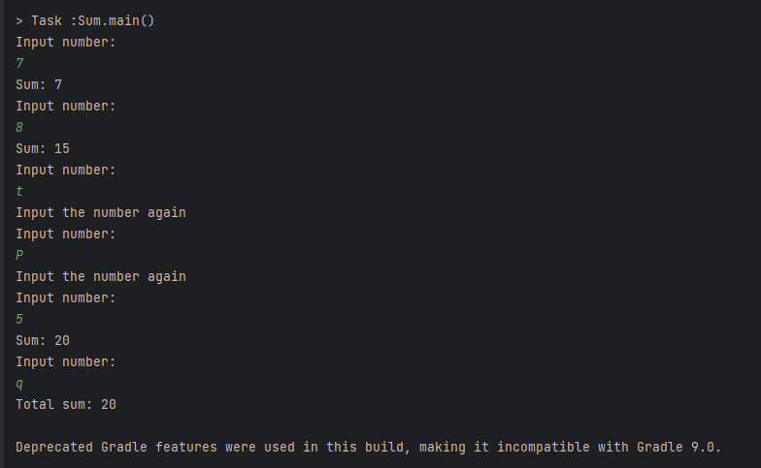

**15. A core i 7 laptop price is 85000 tk and a gaming mouse price is 2500 tk. If I buy the laptop and 1 piece mouse, what will be my total cost after giving 15% discount? [Extract the digits from the paragraph and calculate the price]**

public class DigitExtract {  
 public static void main(String[] args) {//15  
 String str="A core i 7 laptop price is 85000 tk and a gaming mouse price is 2500 tk. If I buy the laptop and 1 piece mouse, what will be my total cost after giving 15% discount?";  
 str = str.replaceAll("[^\\d]", " ");  
 str = str.trim();  
 str = str.replaceAll(" +", " ");  
 System.*out*.println(str);  
 String[] word=(str.split(" "));  
 int laptop_price = Integer.*parseInt*(word[1]);  
 int mouse_price = Integer.*parseInt*(word[2]);  
 int vat= Integer.*parseInt*(word[4]);  
  
 System.*out*.println("Laptop Price: "+laptop_price);  
 System.*out*.println("Gaming Mouse Price: "+mouse_price);  
 System.*out*.println("Vat: "+vat);  
  
 double total_cost = ((laptop_price+mouse_price)-((laptop_price+mouse_price)*((double) vat /100)));  
  
 System.*out*.println("Total Cost: "+total_cost );  
 }  
}

**output:**

