This document should have 3 sections:

a)Meeting the specifications: Describe how your site meets the assignment specifications, particularly what interactive functionality (i.e. jQuery-UI, plugins, source of Ajax requests) you have implemented. Also, list the accessibility principles and guidelines you implemented on your website. This can be a series of bullet points, or one paragraph.

a)

Entry or Home Page:

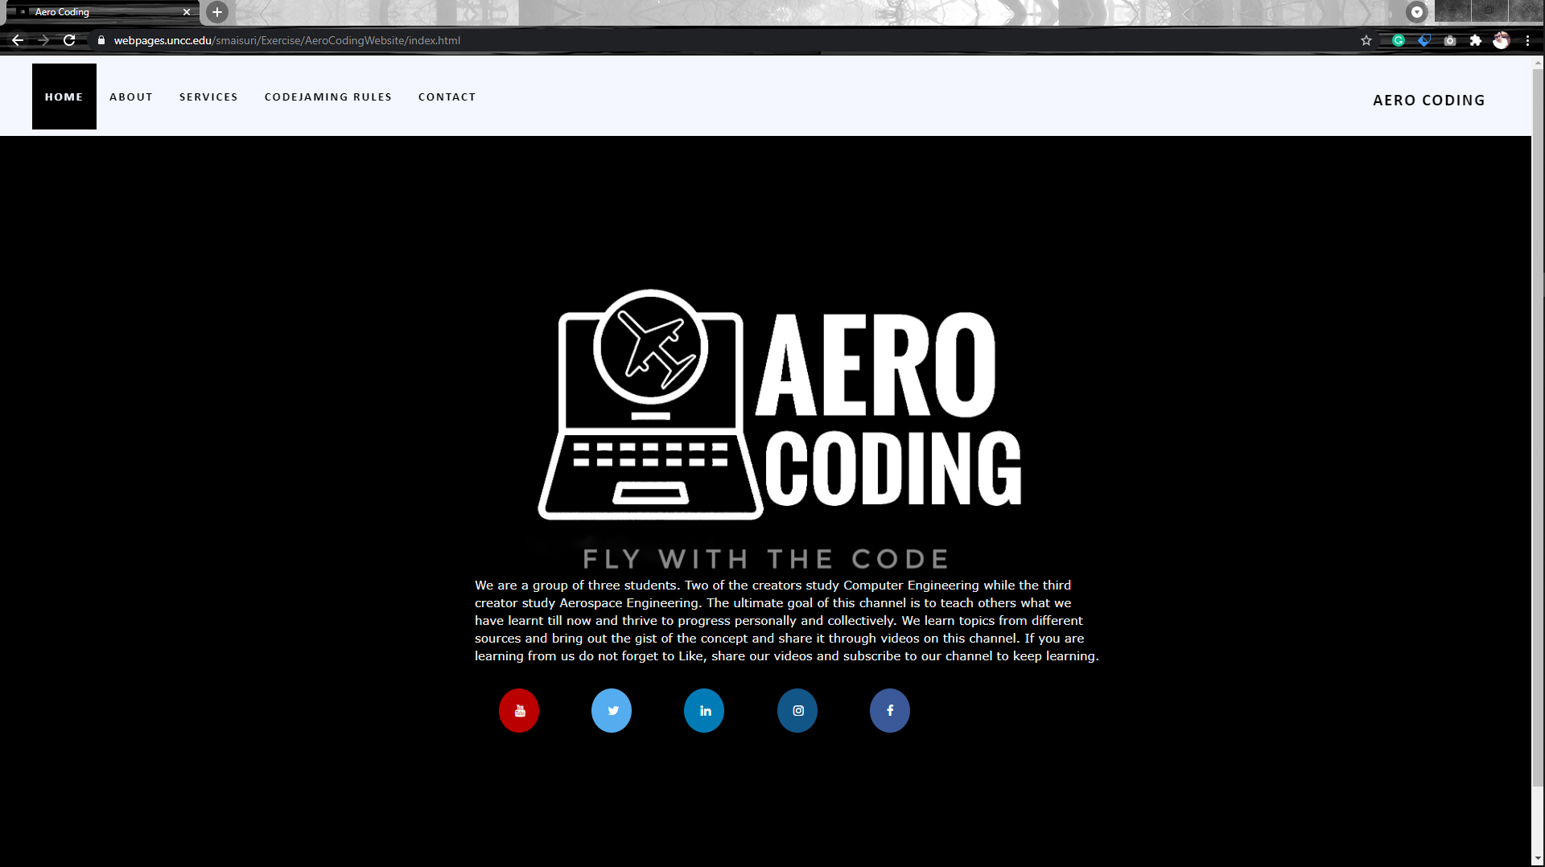

Home page or also know as entry page, will have picture of customers company (as per customers request). In addition, I tired to show their mission and purpose of their website on home page. As the clients main focus was to have a website that shows their logo and helps their users to connect with them on social media. Therefore,I have kept all the requested social media logos on the home page.

Navigation Bar:



The navigation Bar consists of Home, About, Services, Codejaming Rules and contact links. Customer did not wanted any buttons, Therefore, I thought to use link and customize it based on the need. In addition, Navigation bar also helps to know the user that on which they are. As we can see that based on screenshot I am in home page. In addition, The customers main focus was to help user get used to their unique names and Therefore, I was asked to use AeroCoding logo Link with words only. As customer wants their users to know their name as much as possible rather than their symbol. I used “Aero Coding” for their logo. This logo is a direct link to home page. When clicked user will be taken to the home page and the Home page link will also become active.

3 Other Pages:

Page-2.1

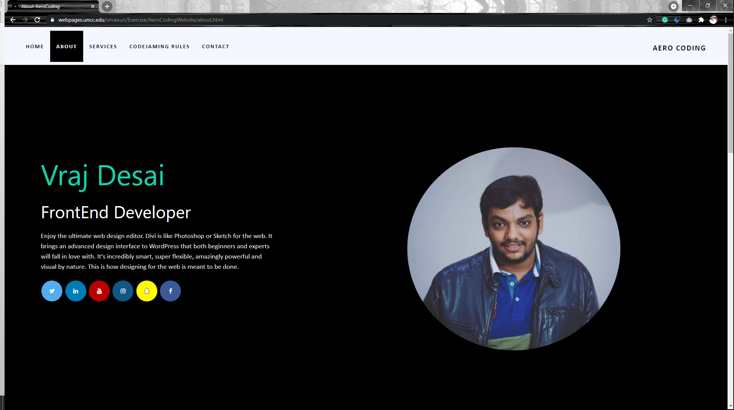

Page-2.2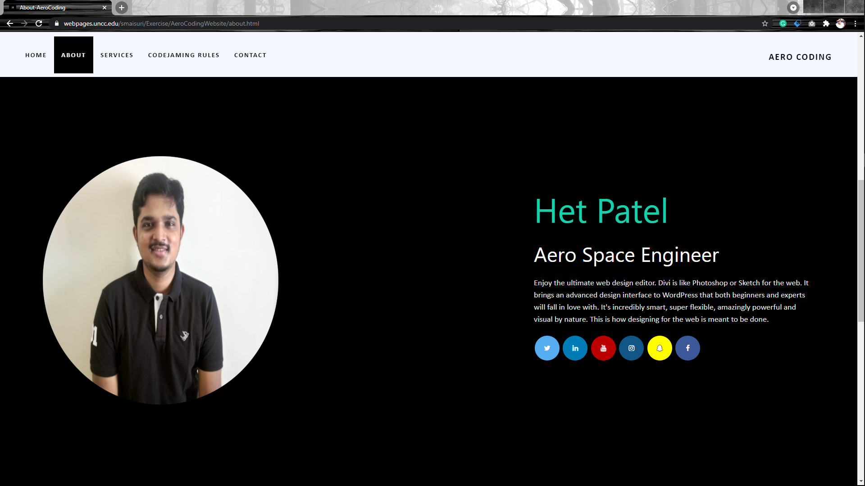

Page-2.3

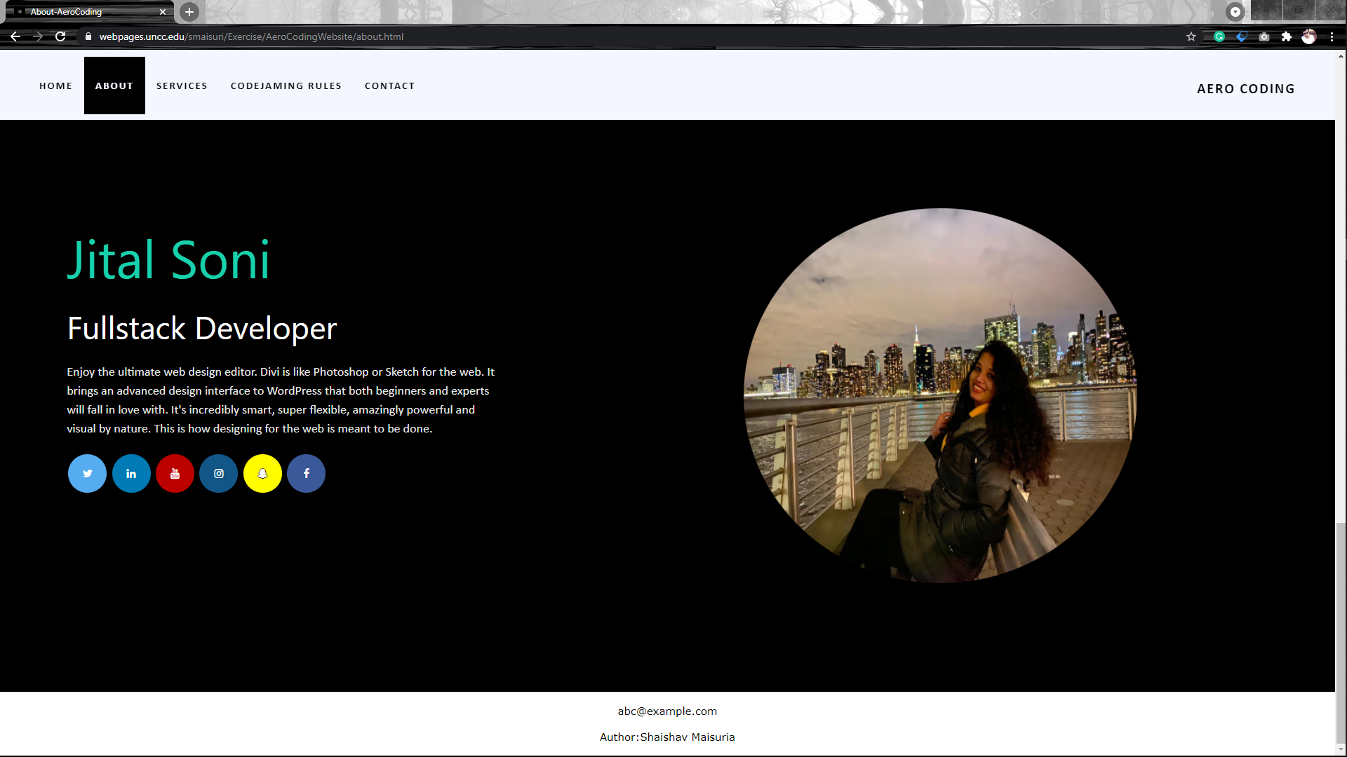

Page 2 Description:

This is page is for helping client users to know client better. This page is helps to users to obtain and know the background of the clients. This page works as About page where users can see the experience and number of members as well as know the team members little more in depth. In addition, the user can also connect to the team members over social media. Therefore, as per request I have added the possible symbols and path of their social medias. As this moments the link to the social media has not be provided by the client and is kept for future update.

In addition, the text and color contrast consistency is maintained through-out the web page.

Page-3

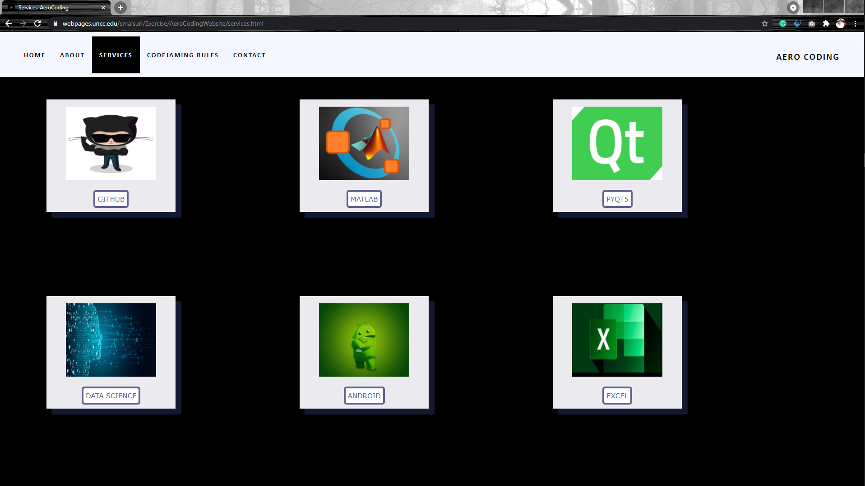

Page -3 description:

This page is of services. Mainly to display all possible courses my client want to display. Customer wanted to keep it simple but with little decorative. Therefore, keeping it as card view and hover able button. Each card will have the playlist logo and the button consisting the name of the playlist that user have on YouTube. The changing/adding/sorting the playlist is kept for future upgrades.

Page 4

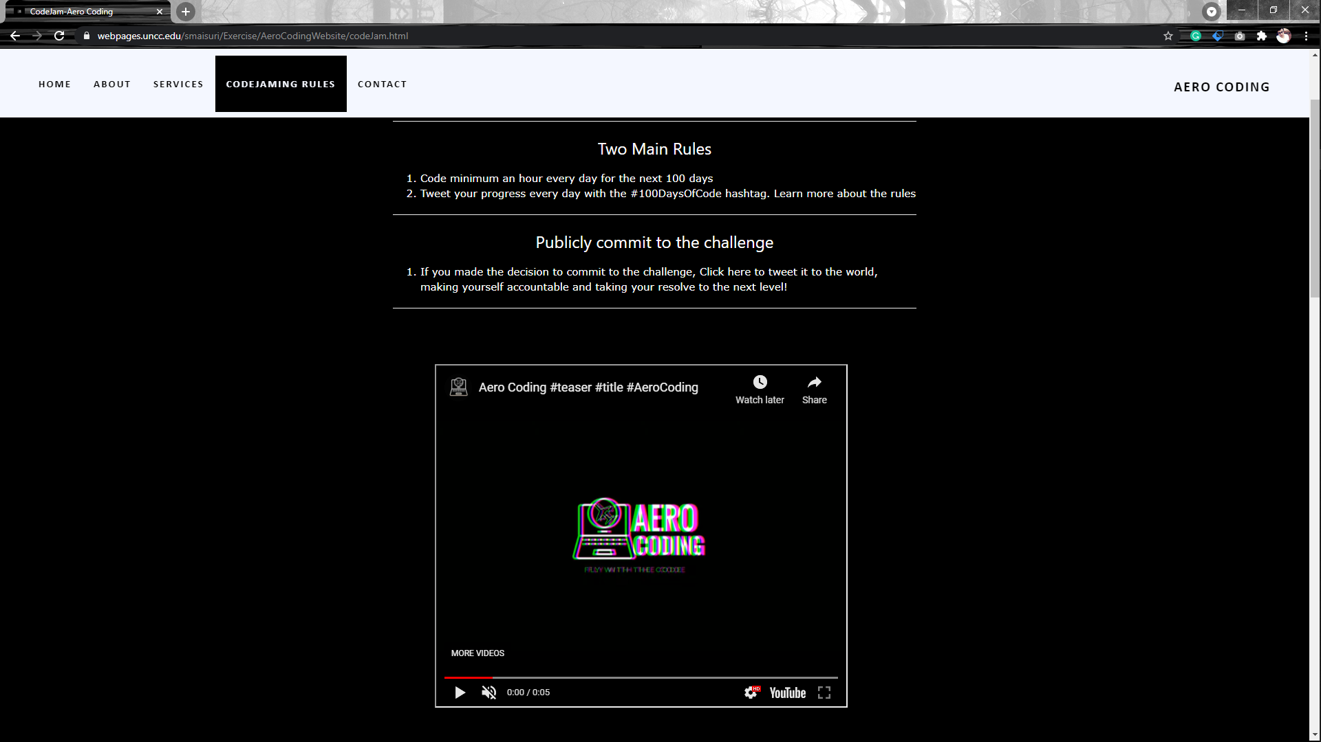

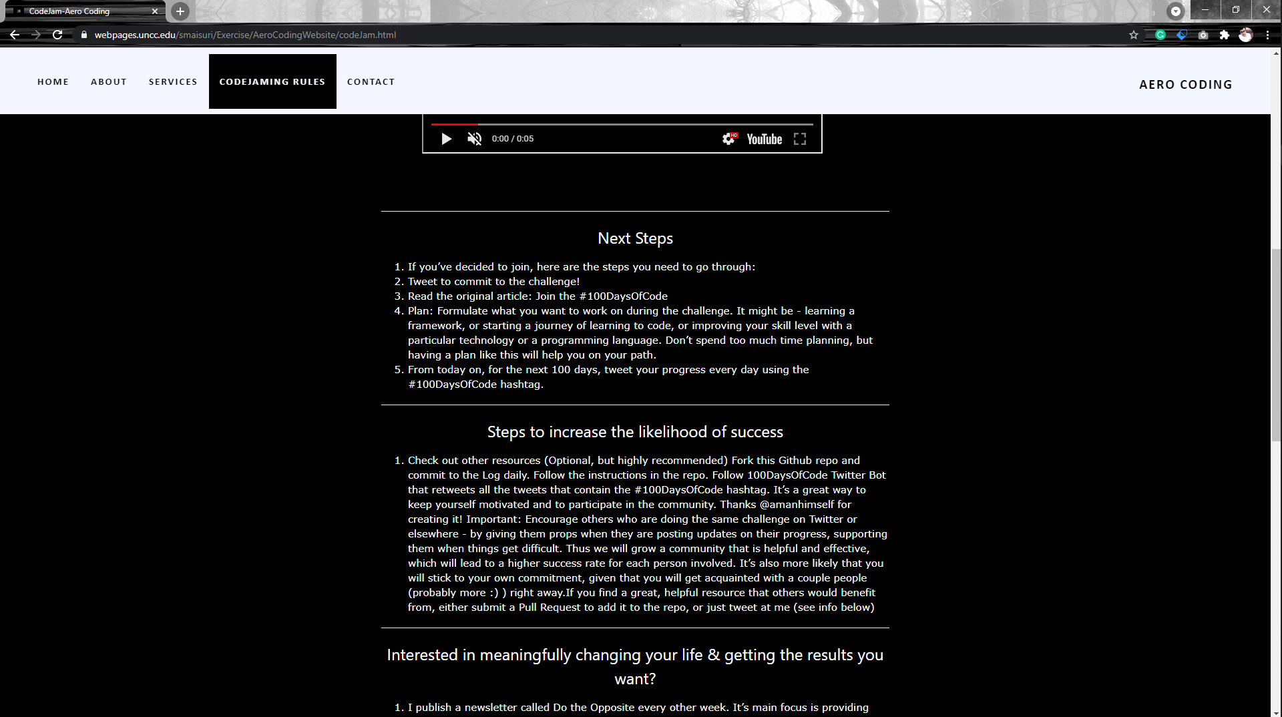

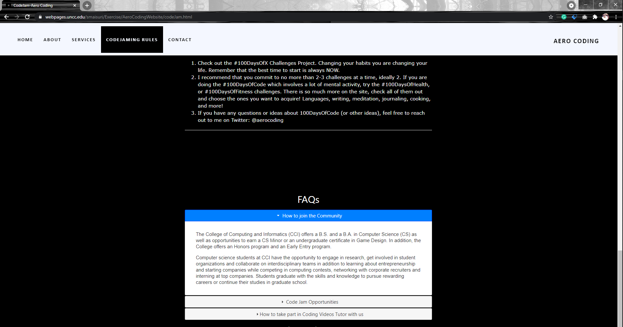

Page 4 Description

This page is CodeJaming Rules. This page will help client to provide any rules and regulation that want to display for event, streaming, or competition they held every month. Also, user wanted to provide some motivation to their user so first part is text helping their user to motivate and later discussing the rules and possible way to take the advantage of client’s events. The user also request to post the possible FAQs user will need. The addition of more faqs and changes in faqs is kept for future upgrades.

Page 5

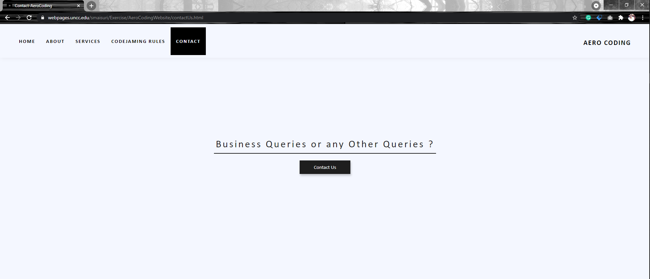

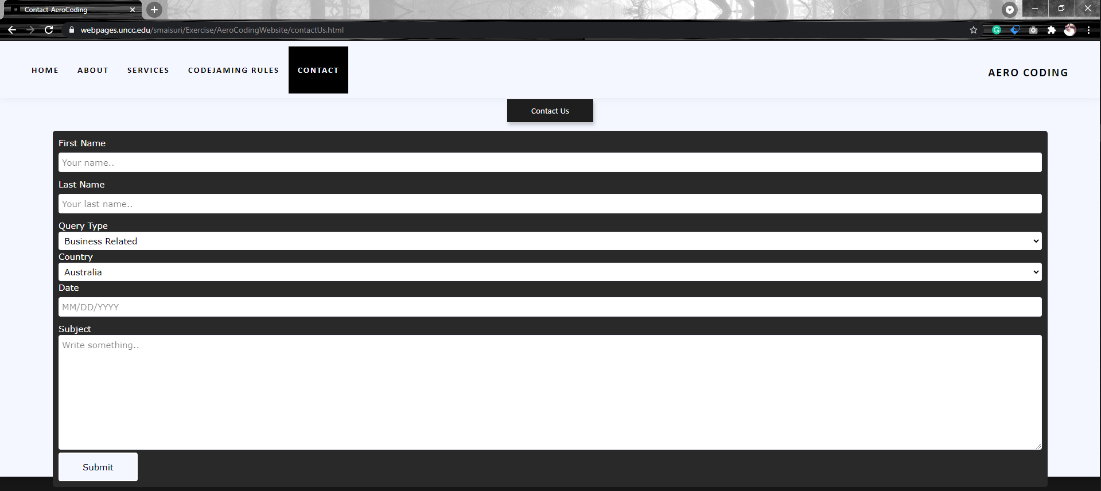

Page 5-Description:

This page is contact page. This page is used for clients user to contact them for any possible business collaboration or queries or any request. The client wanted to keep the contact page to some business profile view and have some essence of white but different than the actual theme of the website.

**Interactivity:**

2 Jquery Plugins:

1. Toggle Jquery plugin

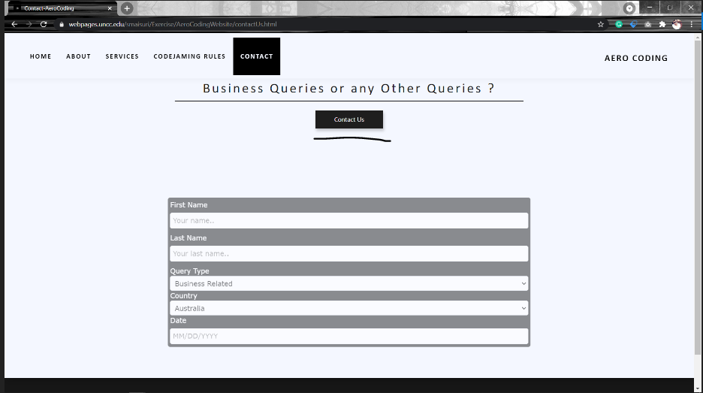

1. DatePicker, Jquery plugin

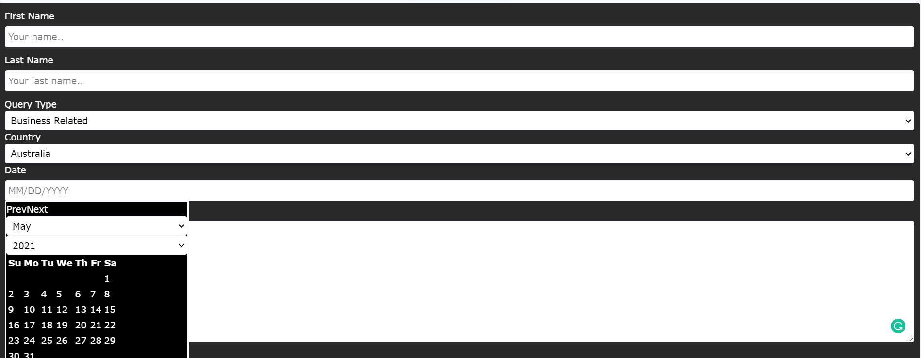

1 Jquery-UI widgets: Accordion

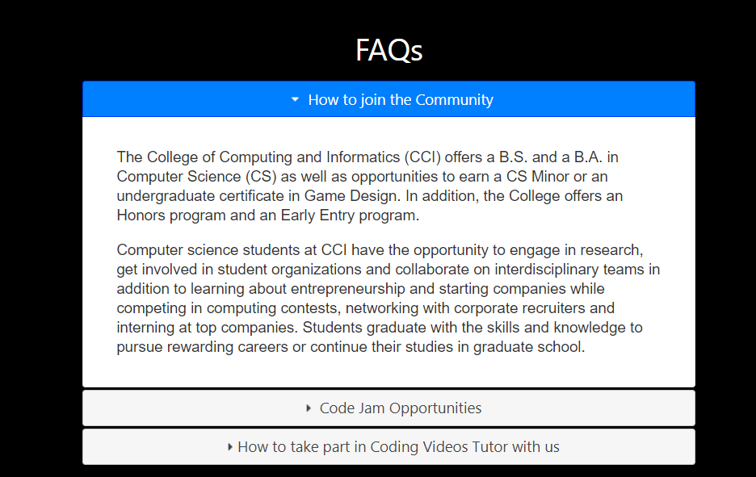

I have used 2 jquery plugins in contactUs. html page 1) is toggle ( when contact us button is pressed) and 2) date picker (Inside the form that helps to pick the date).I have also used 1 j query ui-widget in the CODEJAMING Rules page the Accordion one. This is Jqeury-UI-Wideget inside the Code Jaming Rules page, it will help the user to provide information of FAQs.

Quality of the layout:

2 AJAX requests:

1. Request one Data one (inside the codeJamGuidelines.json inside for codeJam.html and codeJam.js(ajax))

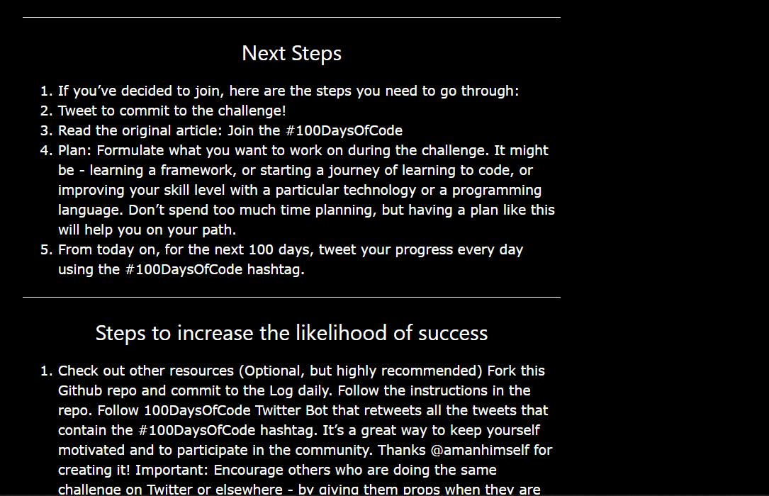

1. Request Two Data Two (inside the codeJam.json inside for codeJam.html and codeJam.js (ajax))

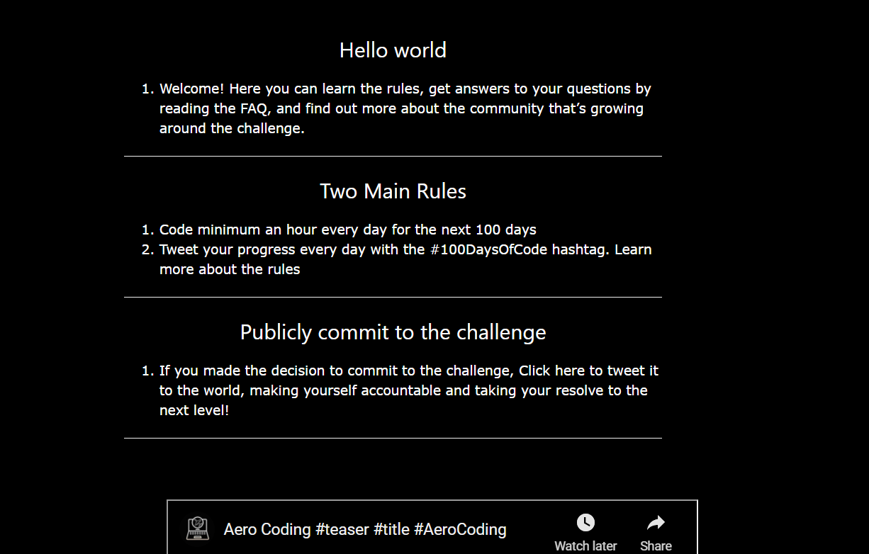

1. Request 3 ( google apis ajax)

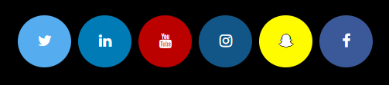

1 and 2 shown above for interactivity is uses data that is stored in json file. The data obtained and displayed on the page using ajax method inside codeJam.js

3 shown above is button obtained from google api to display the standard symbols used for social media. In addition, it eliminates the use of storing the photos on the main sever.

Code Design:

b)

c)

**Accessibility:**

1)

Consistent Navigation

Level AA

<https://www.w3.org/WAI/WCAG21/Techniques/general/G61.html> (done)

I have kept Navigation bar consistent throughout the websites in all the webpages.

2)

4.1.1

Parsing

Level A

Validating Web pages (done)

<https://www.w3.org/WAI/WCAG21/Techniques/general/G134.html>

There is no errors while validating html,css and js

3)

Using the language attribute on the HTML element (done)

<https://www.w3.org/WAI/WCAG21/Techniques/html/H57.html>

Each webpages indicates the language of the content as “en” at beginning of all webpages inside the code.

4)

Using aria-label for link purpose

<https://www.w3.org/WAI/WCAG21/Techniques/aria/ARIA8.html> (done)

I have used the aria-label for links describing the purpose purpose of link

5)

Providing descriptive titles for Web pages (done)

<https://www.w3.org/WAI/WCAG21/Techniques/general/G88.html>

I have provided the descriptive titles for each webpages so that user know which page they are on as well as active button in navigation bar providing on which page user is on.

**b)Summarize the feedback you received in your critiques and how you updated your website in response. This can be a set of bullet points or a paragraph or two. If you did not update your website, include your justifications.**

In my critics suggested to provide the working functionality of one link which was not kept accessible in last version in the navigation bar.

To which I added the page codejam.html for the link CodeJaming Rules in navigation bar. I kept the theme same as critics did mention that my website looks good for color contrast that I have at this moment. Therefore, kept the same color contrast for added page.

**c)A paragraph on how well you think your website will meet the needs of your stakeholders/clients, and your future plans with the website.**

Based on the clients request I think I was able to meet most of the clients needs such as contrasts which my client loved it, proper and customized navigation bar, business contact page. As I was able to meet the key requirement of my client my client was happy to use my website. There were some part my client request but was not able to fulfill as it it out of this course scope example. Live AI assistant like siri, streaming platform such as twitch, and server based account creation and manging huge database.

My client was happy with the layout, and has agreed to work with me to provide more details over the time in which I would learn each specification and slowly add to the website.

For future, clients main aim is to provide automatic playlist sorting, working social media links provide by client, Live AI assistant for FAQs and some form of connecting with database.

Github link for code

<https://github.com/ShaishavMaisuria/AeroCodingWebsite>

Live hosted page:

<https://webpages.uncc.edu/smaisuri/Exercise/AeroCodingWebsite/index.html>

Create a video for final presentation:

<https://drive.google.com/file/d/1jyj2Z43BhUIvSduvDoq5or7pRf0BpOH8/view?usp=sharing>

AeroCoding Entire Folder (code+video+Final Report link):

<https://drive.google.com/drive/folders/10-SJD9ZiMRIXzx-vRIKl7UqJPBB2GIZY?usp=sharing>