Assignment #1

**Visualization 1: Analyzing the Dynamics of the COVID-19 Pandemic: A Line Graph Overview**

A sharp surge in confirmed cases together with an increase in active cases and fatalities might point to an epidemic that is spreading quickly. On the other hand, a flattening or fall in these lines can indicate that the virus is spreading less as a result of the management efforts.

The line graph is a valuable tool for tracking the evolution of the COVID-19 pandemic and for making informed decisions related to public health and healthcare resource allocation.

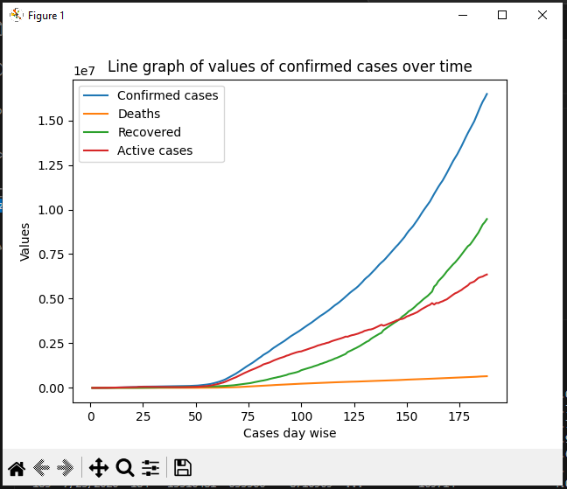

**Conclusion:**

There is a sharp incline in the rate of Confirmed cases, recovered and active cases 50 days after the outbreak, the deaths are rather slow in comparison to the other 3 attributes which indicates a smaller loss.

The confirmed cases are increasing rapidly followed by the recovered cases.

**Visualization 1: Analyzing the Dynamics of the COVID-19 Pandemic: A Line Graph Overview**

The percentage of confirmed cases, fatalities, and recoveries is graphically represented by a pie chart showing COVID-19 cases on a given day. A greater orange section denotes recoveries, a smaller blue segment shows deaths, and a larger green segment indicates Active cases.

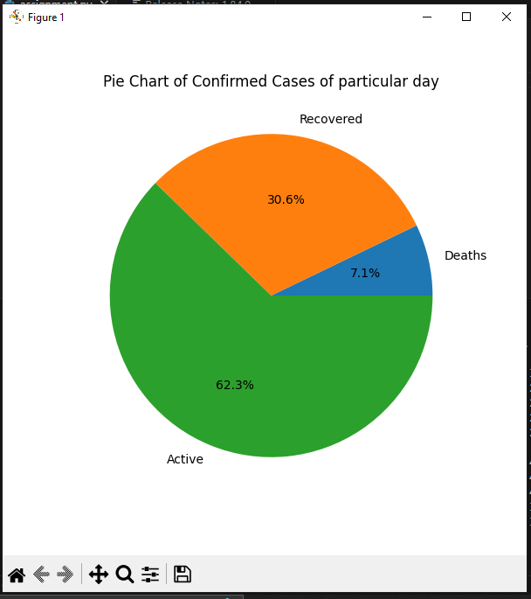

**Why chose Pie chart:**

In addition to offering a simple way to track the pandemic's status and its effects on various case categories, a pie chart of COVID-19 cases on a given day may help with effective communication, decision-making, and public participation. For the purpose of making informed decisions and allocating resources, this graphic facilitates knowledge of the pandemic's daily condition.

**Visualization 1: Analyzing the Dynamics of the COVID-19 Pandemic: A Line Graph Overview**

By examining the daily variations and patterns in these categories, this bar chart analysis may be used to pinpoint possible hotspots, evaluate the success of initiatives, and manage resource allocation. It offers a concise, data-driven summary of the pandemic's historical progression.

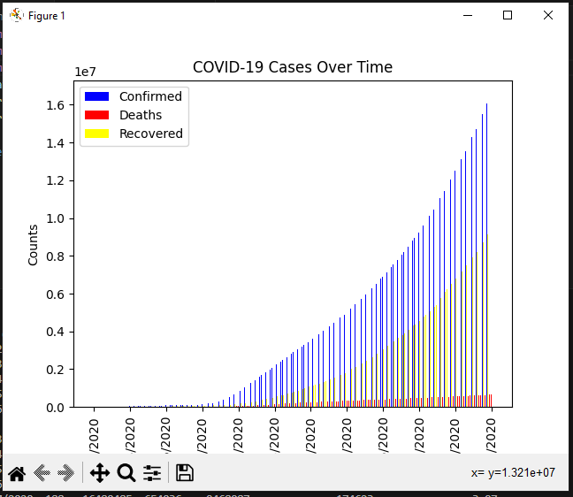

**Why chose Bar chart:**

The COVID-19 case bar chart provides a thorough and data-rich overview of the historical development of the epidemic. It is an essential tool for resource allocation, hotspot discovery, and assessing the effects of different treatments.

**Repository link:**