**Title:** Exploratory Data Analysis (EDA) and Business Insights  
**Your Name:**Shaista Afreen  
**Internship Company:** Zeotap  
**Date:** 27/01/2025  
 **1. Introduction**

In this report, we present an **Exploratory Data Analysis (EDA)** of customer, product, and transaction data with the objective of deriving business insights. The analysis covers data cleaning, merging, and visualization to uncover trends and patterns. The insights derived aim to provide actionable recommendations to improve business strategies, optimize marketing campaigns, and enhance customer engagement.

**2. Exploratory Data Analysis (EDA)**

The process of exploratory data analysis involved the following steps:

1. **Data Cleaning:** We identified and handled missing values by filling them with appropriate default values, such as "Unknown" for customer data and "0" for transaction data. Duplicates were also removed to ensure data accuracy.
2. **Data Merging:** The customer, product, and transaction datasets were merged using the common identifiers "CustomerID" and "ProductID" to create a unified dataset for analysis.
3. **Visualizations:** We created several visualizations to better understand customer distribution, product sales trends, and spending patterns. These included:
   * **Customer Distribution by Region**
   * **Top Product Categories by Sales**
   * **Daily Sales Trend**
   * **Top 10 High-Spending Customers**
   * **Top 10 Best-Selling Products**

**3. Business Insights**

1. **Customer Distribution by Region:** *Insight:*  
   The majority of customers are located in the 'North' region, with significantly fewer customers in the 'East' and 'West' regions. This insight suggests that marketing efforts should focus on attracting more customers from these underrepresented regions to balance customer distribution.
2. **Top Product Categories by Sales:** *Insight:*  
   Electronics is the highest-performing product category, contributing significantly to overall sales. This finding indicates that a focused marketing campaign centered on electronic products could drive higher revenue, especially during peak shopping periods such as holidays or special promotions.
3. **Daily Sales Trend:** *Insight:*  
   Daily sales data reveals a significant spike in sales on **2024-12-15**, possibly due to a special promotion or event. Identifying such patterns helps in forecasting sales for future campaigns, and businesses can replicate successful promotional strategies to optimize sales.
4. **Top 10 High-Spending Customers:** *Insight:*  
   The top 10 customers contribute a large share of the total sales revenue. Offering loyalty programs, personalized discounts, and exclusive offers to these high-spending customers could increase their retention and boost lifetime value, helping to sustain revenue growth.
5. **Best-Selling Products:** *Insight:*  
   Products like 'Wireless Headphones' and 'Smartphone Cases' are among the best-selling items, indicating their strong market demand. Ensuring that these products are always in stock and promoting them further could help maintain consistent sales and customer satisfaction.

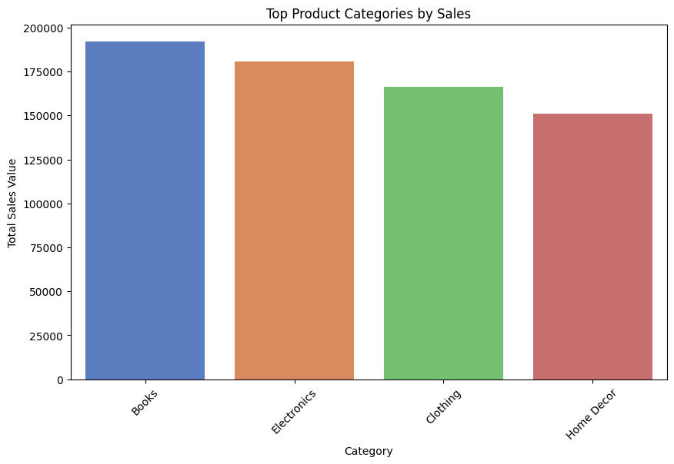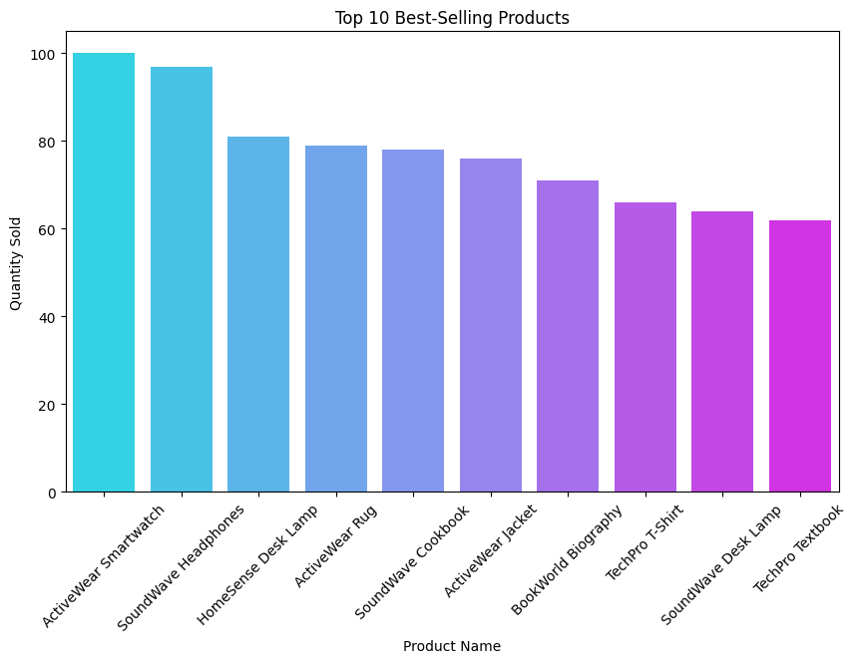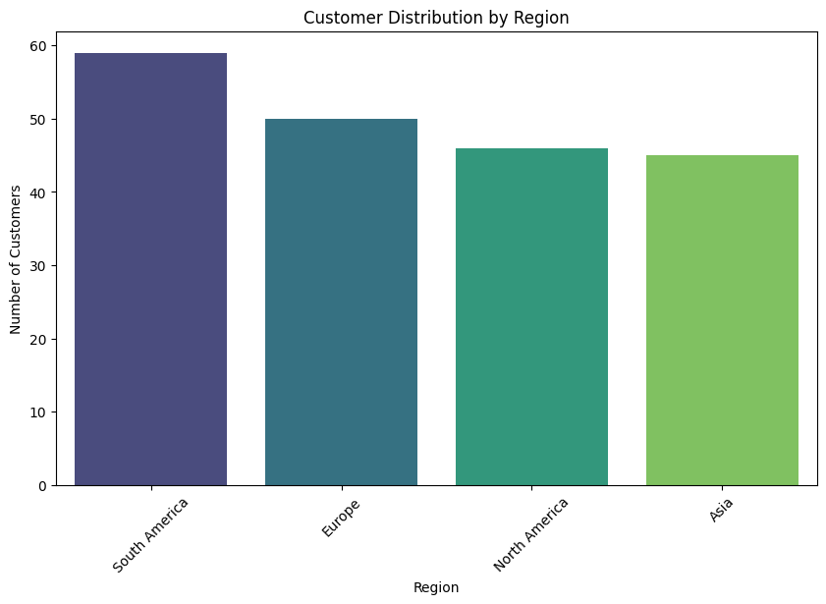

**4. Conclusion**

The exploratory data analysis has provided valuable insights into customer behavior, product sales, and overall business performance. By focusing on targeted marketing strategies, promotions for high-demand products, and personalized offers for high-spending customers, businesses can optimize revenue, enhance customer retention, and drive growth. Future efforts should focus on utilizing these insights to fine-tune business strategies and operational decisions.