Software Requirements Specification
AI-Powered Multi-Agent Project Management System
Built on Microsoft Azure AI Foundry, Python, and Microsoft 365
Atlas · Sentinel · Workflow Orchestrator · Human Approval Agent
Version 1.0 | Hackathon MVP + Production Architecture
2026-07-24

Table of Contents
1. Executive Summary
2. Problem Statement & System Goals
3. System Architecture
4. Multi-Agent Design
5. Sequence & Multi-Agent Interaction Diagrams
6. Knowledge Base & Retrieval-Augmented Generation
7. Tool Definitions (Function Calling)
8. Data Models
9. Database Schema
10. API Specification
11. Azure Resources Required
12. Frontend Implementation
13. Repository / Folder Structure
14. Deployment Guide
15. Non-Functional Requirements
16. 24-Hour Hackathon MVP Plan
17. Known Limitations & Roadmap

1. Executive Summary
This document specifies and describes the implementation of an AI-Powered Multi-Agent Project Management System: an autonomous platform where independent AI agents observe project state, reason about methodology and risk, invoke enterprise tools (Microsoft Planner, Teams, SharePoint, Outlook), monitor execution continuously, and collaborate with each other to manage a project end-to-end with minimal human intervention. Human involvement is limited to a deliberate approval gate for high-impact actions (deadline changes, resource reassignment, task deletion, escalations, and budget changes).
The system is delivered as a working codebase (not just a design on paper): a Python/FastAPI backend implementing four collaborating agents, a React/TypeScript dashboard, an event-driven orchestration layer, a rule-based risk engine, and a full adapter layer that runs entirely on mock enterprise integrations today and swaps to real Microsoft Graph, Azure AI Foundry, and Azure AI Search clients by changing one environment variable, following the accompanying integration guide.

1.1 What makes this agentic, not a chatbot
Three properties distinguish this system from a prompt-response assistant:
- Continuous operation: Sentinel runs a background monitoring loop (independent of any user request) that re-evaluates every active project on a fixed interval, exactly as specified.
- Tool execution, not text generation: Atlas does not return a WBS as JSON for a human to act on - it calls create_bucket(), create_task(), send_teams_message(), and create_project_folder() itself, against real (or mock) Microsoft 365 endpoints.
- Multi-agent collaboration via events: Atlas, Sentinel, the Workflow Orchestrator, and the Human Approval Agent communicate through a publish/subscribe event bus, not direct function calls, so each agent can be reasoned about, tested, and replaced independently.

1.2 Document scope
This SRS covers: system architecture and component/sequence/multi-agent diagrams, the multi-agent design and each agent's responsibilities, the knowledge base and RAG design, the tool-calling contract, data models, the database schema (both the hackathon in-memory store and the production PostgreSQL/Cosmos DB schema), the REST API specification, the frontend, the deployment approach, the GitHub repository layout, and a 24-hour hackathon MVP plan that separates must-have from deferred scope. Detailed, numbered, step-by-step instructions for provisioning and wiring the real Azure AI Foundry and Microsoft 365 services are kept in a companion document, docs/architecture/azure-foundry-m365-integration-guide.md, and referenced throughout.

2. Problem Statement & System Goals

2.1 Problem statement
Project managers spend a disproportionate amount of time on repetitive administrative work: reading requirements documents, selecting a methodology, building a Work Breakdown Structure, sequencing dependencies, assigning priorities and owners, keeping Planner and Teams up to date, tracking progress against deadlines, spotting risk and blockers, and producing status reports. Existing AI tools largely generate text describing what should happen; they do not execute the workflow.

2.2 Goal
Deliver an AI Project Coordinator that can: understand project requirements from an uploaded brief; choose an appropriate methodology (Agile Scrum, Kanban, Waterfall, PRINCE2, or Hybrid); plan the project (WBS, phases, epics, stories, tasks, milestones, dependencies, timeline, sprint plan, critical path, risk register); execute enterprise actions (Planner, Teams, SharePoint, Outlook); monitor execution continuously; detect and predict risk; collaborate across agents; and request human approval only where the action's blast radius warrants it.

2.3 Success criteria for the hackathon MVP
- A project brief submitted through the API results in a fully populated Planner plan, a Teams notification, and a SharePoint folder, with zero manual PM steps in between.
- Sentinel autonomously detects at least one class of risk (overdue task, dependency violation, or resource conflict) without being asked, and proposes a mitigation.
- A critical risk automatically produces a Teams-deliverable approval request, and approving it executes the underlying Planner change.
- The whole flow runs with zero external credentials (mock mode), and the exact steps to connect real Azure AI Foundry + Microsoft 365 are documented and file-referenced.

3. System Architecture
The system is organized into six layers: a client dashboard, a FastAPI API layer, a multi-agent layer, a tool layer, an integration adapter layer, and the underlying Azure AI Foundry / Microsoft 365 services. A persistence layer sits alongside the agent layer - an in-memory repository for the hackathon MVP, with a documented migration path to PostgreSQL/Cosmos DB.
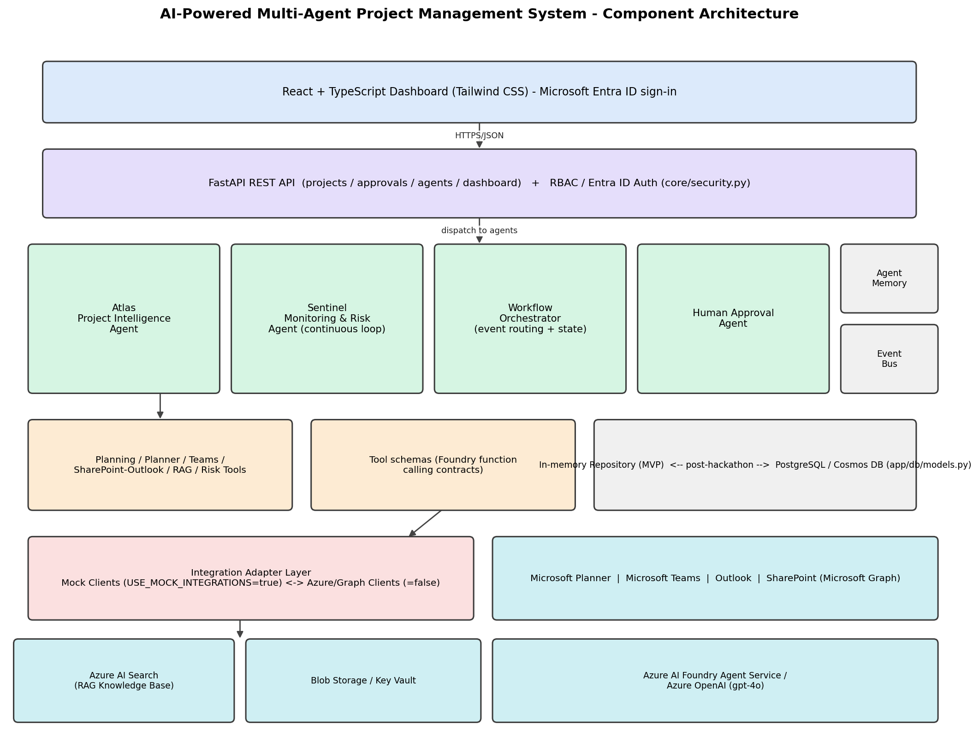
Figure 1. Component architecture.

3.1 Layer responsibilities
- Client layer: React + TypeScript dashboard (Tailwind CSS) - project ingestion form, WBS/task table, risk register, approval queue, Teams activity feed, health indicators.
- API layer: FastAPI, stateless REST endpoints, Entra ID-ready RBAC middleware (core/security.py), CORS configured for the dashboard origin.
- Multi-agent layer: Atlas, Sentinel, Workflow Orchestrator, Human Approval Agent, communicating over an in-process async event bus; per-agent, per-project memory.
- Tool layer: typed Python functions (planner_tools, teams_tools, sharepoint_outlook_tools, rag_tools, planning_tools, risk_tools, status_tools) that agents call; a matching JSON schema module (tool_schemas.py) for Azure AI Foundry Agent Service function-calling.
- Integration adapter layer: an interface (port) per external system (Planner, Teams, Outlook, SharePoint, Search, LLM, Blob, Key Vault) with a mock implementation and a real Azure/Graph implementation, switched by one setting.
- Azure AI Foundry + Microsoft 365: Azure AI Foundry Agent Service/Azure OpenAI for reasoning, Azure AI Search for RAG, Microsoft Graph for Planner/Teams/Outlook/SharePoint, Blob Storage for brief ingestion, Key Vault for secrets.

3.2 Design pattern: adapter / hexagonal architecture
Every enterprise integration is defined as an abstract interface in backend/app/integrations/interfaces.py. Agents and tools depend only on these interfaces, resolved at runtime by backend/app/core/config.py based on the USE_MOCK_INTEGRATIONS flag. This lets the entire agent/tool/API layer be developed, tested, and demonstrated with zero external credentials, while keeping the real Azure/Graph implementation in the same codebase, one flag away from production. See docs/architecture/azure-foundry-m365-integration-guide.md for the exact steps to complete each real implementation.

3.3 Event-driven communication
Agents do not call each other's methods directly. Each agent publishes typed events (e.g. atlas.plan.created, sentinel.risk.detected, approval.decided) onto a shared async EventBus (backend/app/orchestration/event_bus.py). The Workflow Orchestrator Agent is the only component that subscribes broadly across event types and decides which agent to invoke next, keeping every individual agent small, independently testable, and unaware of the others' internals.

4. Multi-Agent Design

4.1 Atlas - Project Intelligence Agent
File: backend/app/agents/atlas.py. Owns understanding the brief and turning it into an executed plan.

Observe
- Reads the uploaded project brief (backend/app/models/project.py: ProjectBrief).
- Retrieves contextual knowledge via retrieve_rag_documents() against the PM knowledge base (Azure AI Search / mock equivalent).

Reason
- Classifies project type and complexity (0-1 score) via an LLM call (Azure AI Foundry Agent / mock heuristic).
- Selects a methodology - Agile Scrum, Kanban, Waterfall, PRINCE2, or Hybrid - with a recorded rationale and confidence score.

Plan
- generate_wbs(): phases, epics, tasks, milestones from brief-derived feature lines and methodology-aware templates.
- detect_dependencies(): sequential finish-to-start chains per phase (extensible to LLM/graph-based inference).
- calculate_critical_path(): longest-path CPM walk over the dependency DAG; critical-path tasks are tagged.
- generate_sprint_plan(): buckets execution-phase tasks into capacity-bounded sprints for Agile/Hybrid projects.

Act (enterprise tool calls - not JSON output)
- create_sharepoint_project_folder() - creates the project's SharePoint folder.
- create_channel() + send_teams_message() - creates a Teams channel and posts a kickoff notification.
- create_plan() + create_bucket() (one per phase) + create_planner_task() (one per task, with assignee and due date) - populates Microsoft Planner.
- Emits atlas.plan.created so the Orchestrator can trigger Sentinel's first monitoring pass.

4.2 Sentinel - Monitoring & Risk Agent
File: backend/app/agents/sentinel.py. Runs continuously via an asyncio background task started at API startup (run_forever()), polling every SENTINEL_POLL_INTERVAL_SECONDS - not waiting for a user request.

Observe / Reason (detect)
- detect_late_tasks() - tasks past their due date, severity scaled by days late.
- detect_dependency_violations() - a successor task started before its predecessor completed.
- detect_resource_conflicts() - a resource over-allocated or marked unavailable.

Predict
- calculate_project_risk() - aggregates open/critical risk counts and overdue tasks into a ProjectHealth: status, schedule variance, delay probability, budget risk score, resource bottleneck score.

Mitigate
- suggest_mitigation() - rule-based recommendation (e.g. reassignment candidate with lowest utilization, fast-track suggestion, escalation guidance).
- High/critical risks are emitted as sentinel.risk.detected; critical ones are automatically routed to the Human Approval Agent by the Orchestrator.
- Every pass posts a Teams summary notification, whether or not new risk was found to be critical.

4.3 Workflow Orchestrator Agent
File: backend/app/agents/orchestrator.py. Holds no domain logic - only event routing and per-project workflow state. Subscriptions wired at startup:
- atlas.plan.created -> triggers Sentinel's first monitor_project() pass.
- planner.task.updated -> triggers a Sentinel re-check.
- sentinel.risk.detected (severity=critical) -> requests approval via the Human Approval Agent.
- approval.decided (approved) -> triggers a Sentinel re-check to confirm the mitigation took effect.

4.4 Human Approval Agent
File: backend/app/agents/human_approval.py. The single gate for six action types the specification marks as requiring a human: change_deadline, reassign_resource, delete_task, escalation, budget_change, and large_schedule_modification.
- request_approval() - persists an ApprovalRequest and pushes a Teams Adaptive Card with Approve/Reject actions (backend/app/tools/teams_tools.py: build_approval_card()).
- decide() - on approval, executes the actual enterprise action (Planner update, reassignment, deletion) that was withheld pending sign-off; on rejection, only the audit trail is updated.

4.5 Agent memory
File: backend/app/memory/memory_store.py. Each agent has a per-project AgentMemory record: current_state, completed_task_ids, known_risk_ids, methodology, dependency_ids, approval_ids, a decision log (MemoryEntry list), and a conversation log. The hackathon MVP keeps this in-process; the production schema (agent_memory table, Section 8) persists it.

5. Sequence & Multi-Agent Interaction Diagrams

5.1 Atlas: brief ingestion to executed plan
This is the primary end-to-end flow: a project brief becomes a fully populated Planner plan and a Teams-notified project team, with Sentinel monitoring beginning automatically - no separate 'now start monitoring' step required.
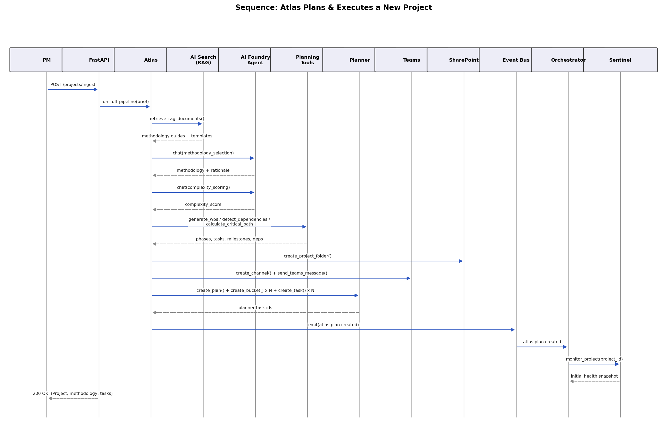
Figure 2. Atlas plans and executes a new project.

5.2 Sentinel: risk detection through approval to mitigation
This flow shows the human-in-the-loop gate in context: Sentinel detects and predicts risk autonomously and continuously; only the actual corrective action (a Planner update / reassignment) waits on a human decision, delivered and collected through a Teams Adaptive Card.
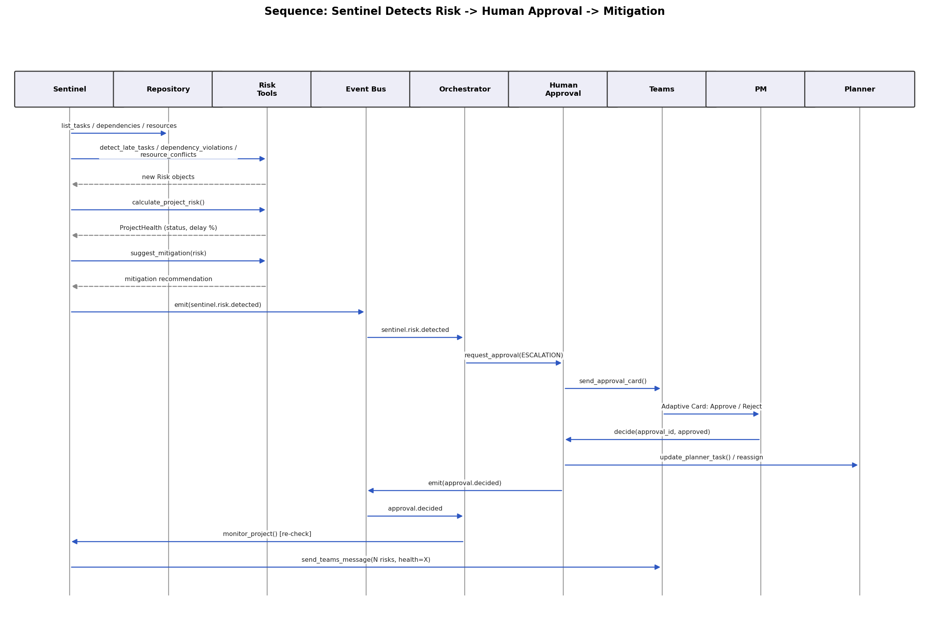
Figure 3. Sentinel detects risk, escalates for approval, and executes the approved mitigation.

5.3 Multi-agent interaction overview
A condensed view of the same event-driven relationships, emphasizing that every agent reads/writes the shared Agent Memory store and that the Orchestrator is the sole cross-agent router.
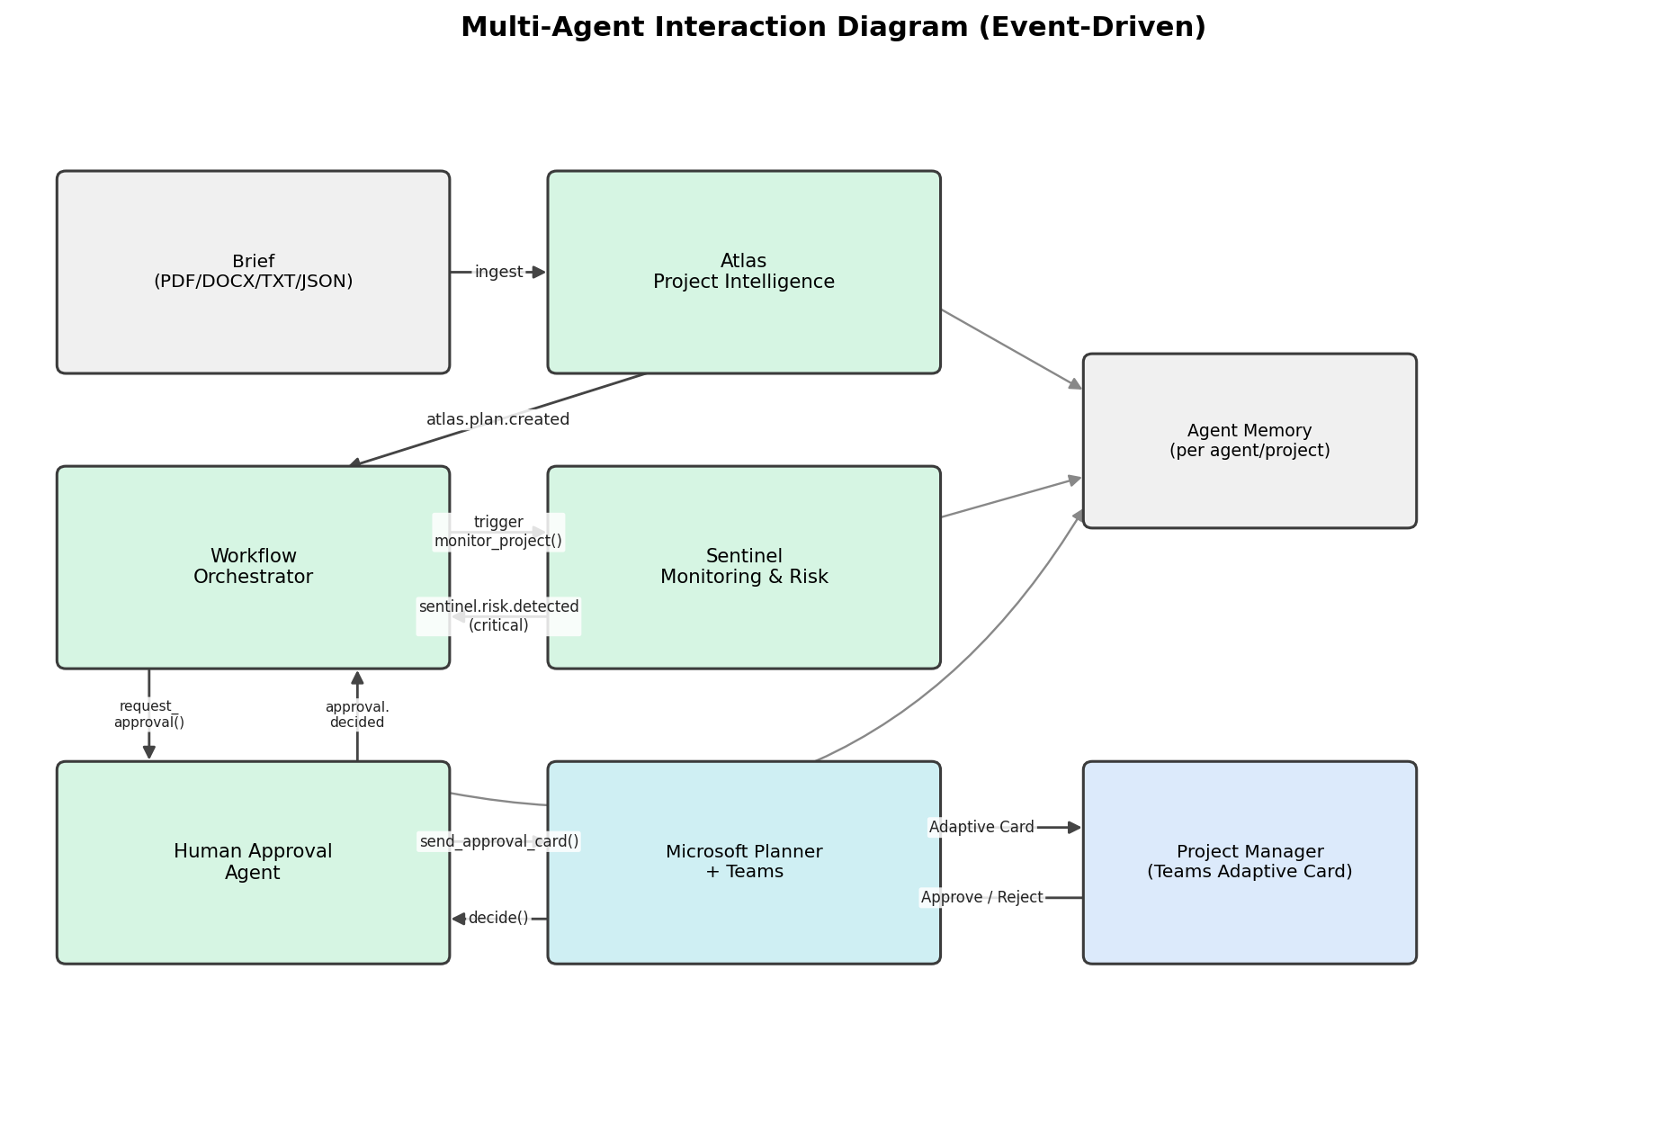
Figure 4. Multi-agent interaction diagram (event-driven).

6. Knowledge Base & Retrieval-Augmented Generation
Atlas grounds its methodology selection and planning decisions in a knowledge base retrieved via Azure AI Search (RAG), rather than relying purely on parametric model knowledge. The hackathon MVP ships ten seed documents (backend/app/knowledge_base/seed_docs/*.md) covering:
- Methodology guides: Agile Scrum, Kanban, Waterfall, PRINCE2, Hybrid - each with the brief-language signals that suggest it.
- Enterprise templates: Definition-of-Done checklist, milestone readiness checklist.
- Company SOPs: risk escalation policy, methodology selection policy.
- Historical projects: a worked 'lessons learned' example (effort under-estimation pattern, resourcing lesson) that Atlas's planning heuristics already encode (e.g. a duration multiplier for third-party integration tasks).
In mock mode, backend/app/integrations/mock/mock_search_client.py loads these files into memory and scores them with a lightweight TF-IDF-style keyword match - enough signal for deterministic demo behavior. In production mode, backend/app/integrations/azure/azure_search_client.py performs real hybrid (vector + keyword) semantic search against an Azure AI Search index; see the integration guide, Section 4, for index schema and ingestion steps.

7. Tool Definitions (Function Calling)
Every tool the specification calls out is implemented as a typed Python function in backend/app/tools/*.py, and mirrored as a JSON Schema in backend/app/tools/tool_schemas.py (TOOL_SCHEMAS) in the exact format Azure AI Foundry Agent Service / Azure OpenAI function calling expects. This lets the same tool be invoked two ways: directly by agent code (today), or by a Foundry Agent's model deciding to call it (once wired per the integration guide, Section 3.4-3.5).
Tool | File | Purpose
create_planner_task | planner_tools.py | Create a Microsoft Planner task in a plan/bucket
update_planner_task | planner_tools.py | Update status/due date/percent complete on a Planner task
create_bucket | planner_tools.py | Create a Planner bucket (one per project phase)
create_plan / assign_task | planner_tools.py | Create a Planner plan; bind a resource to a task
send_teams_message | teams_tools.py | Post a plain-text notification to a Teams channel
send_approval_card | teams_tools.py | Post an Adaptive Card approval request
create_channel / schedule_meeting | teams_tools.py | Create a Teams channel; schedule a meeting
upload_document / create_sharepoint_project_folder | sharepoint_outlook_tools.py | SharePoint document/folder actions
send_email_notification / schedule_kickoff_meeting | sharepoint_outlook_tools.py | Outlook mail/calendar actions
retrieve_rag_documents | rag_tools.py | Query the PM knowledge base (Azure AI Search)
generate_wbs | planning_tools.py | Generate phases/epics/tasks/milestones from a brief
detect_dependencies / calculate_critical_path | planning_tools.py | Infer task dependencies; compute critical path
estimate_duration / generate_sprint_plan | planning_tools.py | Heuristic effort estimate; sprint bucketing
calculate_project_risk / suggest_mitigation | risk_tools.py | Compute ProjectHealth; recommend a mitigation
detect_late_tasks / detect_dependency_violations / detect_resource_conflicts | risk_tools.py | Risk detection primitives
update_project_status / generate_status_report | status_tools.py | Persist health status; produce an executive summary

8. Data Models
All domain objects are strongly typed Pydantic v2 models (backend/app/models/*.py), used across the agents, tools, repository, and API response bodies - the API layer returns these models directly, so the OpenAPI schema (available at /docs) is always in sync with the code.
Model | Key fields | Notes
Project | methodology, methodology_rationale, complexity_score, phases, health, planner_plan_id, teams_channel_id, sharepoint_folder_url | Root aggregate
ProjectBrief | source_filename, source_type, raw_text, blob_url | Raw ingested input
Task | status, priority, assignee, estimated_hours, due_date, wbs_code, dependency_ids, planner_task_id, sprint_id, tags | Leaf WBS node
Epic / UserStory | phase_id / epic_id, acceptance_criteria, story_points | Agile grouping
Milestone | due_date, is_deliverable, dependent_task_ids, on_critical_path
Sprint | sprint_number, start_date, end_date, task_ids, committed_points, completion_probability | Agile/Hybrid only
Dependency | predecessor_task_id, successor_task_id, dependency_type, is_violated | FS/SS/FF/SF
Risk | category, severity, probability, impact_score, mitigation_plan, requires_approval, resolved | risk_score = probability x impact
Resource | role, skills, weekly_capacity_hours, allocated_hours, is_available | utilization computed property
ApprovalRequest | action_type, payload, status, teams_card_id, reviewer, decision_reason | Human-in-the-loop gate
PlannerTask / PlannerPlan / PlannerBucket | plan_id, bucket_id, assignee_ids, percent_complete | Mirrors Graph plannerTask shape
Notification | channel, is_adaptive_card, card_payload, sent_by_agent | Teams/email/in-app
AgentMemory / MemoryEntry | current_state, decisions, conversation_log, methodology | Per agent, per project
ProjectHealth | status, delay_probability, budget_risk_score, resource_bottleneck_score, summary | Sentinel's output

9. Database Schema

9.1 Hackathon MVP: in-memory repository
backend/app/db/repository.py implements a single in-process Repository class holding every entity in a dict keyed by id, with project_id-scoped list accessors (list_tasks, list_risks, etc.), plus five seeded demo Resource records. This lets the entire demo run with zero infrastructure and near-zero latency, at the cost of state not surviving a process restart - acceptable for a hackathon MVP and explicitly called out as the first post-hackathon migration target.

9.2 Production schema (PostgreSQL / Cosmos DB)
backend/app/db/models.py defines the SQLAlchemy 2.0 declarative schema that a production deployment migrates to, with app/db/session.py providing the async engine/session factory. The table set mirrors the Pydantic models 1:1:
Table | Primary purpose | Key foreign keys
projects | Root project record, methodology, health | -
project_phases | WBS phase grouping | project_id
epics | Agile epic grouping | project_id, phase_id
tasks | WBS leaf nodes | project_id, epic_id
dependencies | Task predecessor/successor edges | project_id, predecessor/successor task_id
milestones | Deliverable checkpoints | project_id
sprints | Agile/Hybrid sprint buckets | project_id
risks | Risk register entries | project_id
resources | Team members / capacity | -
approval_requests | Human-in-the-loop gate | project_id
notifications | Teams/email delivery log | project_id
agent_memory | Serialized AgentMemory per agent/project | project_id
Migration path: implement a SqlRepository(Repository) backed by these tables (or a Cosmos DB SDK-backed equivalent) and swap it in via the same factory-function pattern used for the integration adapters in app/core/config.py - no agent, tool, or API route code needs to change.

10. API Specification
FastAPI serves interactive OpenAPI documentation at /docs and /redoc directly from the route/model definitions. Endpoints, grouped by router:

10.1 Projects (backend/app/api/routes_projects.py)
Method & Path | Purpose
POST /projects/ingest | Upload a brief; Atlas plans and executes the full pipeline synchronously
GET /projects/ | List all projects
GET /projects/{id} | Get a project
GET /projects/{id}/tasks | /milestones | /sprints | /dependencies | /risks | /notifications | Scoped entity lists

10.2 Dashboard (routes_dashboard.py)
Method & Path | Purpose
GET /dashboard/{project_id} | Aggregated view: project, health, tasks, risks, sprints, approvals, notifications, task_summary
GET /dashboard/{project_id}/status-report | LLM-generated (or templated, in mock mode) executive status report

10.3 Approvals (routes_approvals.py)
Method & Path | Purpose
GET /approvals/{project_id} | List approval requests (optional pending_only filter)
POST /approvals/{approval_id}/decide | Approve or reject; executes the underlying action on approval
POST /approvals/{project_id}/propose-reassignment | Agent- or PM-initiated reassignment proposal

10.4 Agents (routes_agents.py)
Method & Path | Purpose
POST /agents/sentinel/monitor/{project_id} | Manually trigger one Sentinel pass (also runs automatically)
GET /agents/memory/{agent_id}/{project_id} | Inspect an agent's memory for a project
GET /agents/orchestrator/state/{project_id} | Workflow Orchestrator's per-project routing state
GET /agents/events/{project_id} | Full event-bus audit trail for a project
All routes accept x-user-id and x-user-role headers (local/demo auth) and enforce RBAC via core/security.py's require_permission(); see the integration guide, Section 6, for upgrading this to real Entra ID JWT validation.

11. Azure Resources Required
The following Azure resources are required for a full production deployment (not required for the hackathon MVP, which runs entirely on mocks). Full step-by-step provisioning instructions - what to click/run and which file each resource wires into - are in docs/architecture/azure-foundry-m365-integration-guide.md, organized by the same section numbers below.
# | Azure resource | Used for | Guide section
1 | Storage account (Blob) | Project brief ingestion, generated report archival | Section 1
2 | Microsoft Entra ID app registration | Graph API auth for Planner/Teams/Outlook/SharePoint | Section 2
3 | Azure AI Foundry project + model deployment (gpt-4o) | Atlas/Sentinel reasoning, tool-calling agent | Section 3
4 | Azure AI Search | RAG knowledge base retrieval | Section 4
5 | Azure Key Vault | Centralized secrets | Section 5
6 | Entra ID app (frontend sign-in) | User authentication / RBAC | Section 6
7 | Azure Container Registry + App Service (or Container Apps) | Hosting backend + frontend | Section 7
- | Azure Monitor / Application Insights | Structured logging, tracing (post-hackathon) | -
- | Azure DevOps or GitHub (optional) | Work-item sync for engineering-heavy projects | -

12. Frontend Implementation
frontend/ is a Vite + React 18 + TypeScript + Tailwind CSS single-page dashboard.
- IngestForm - submits a project name + brief text to POST /projects/ingest.
- Dashboard - polls GET /dashboard/{id} every 15s; renders health badge, stat cards, the WBS/task table, the risk register, the approval queue, and the Teams activity feed.
- ApprovalQueue - Approve/Reject buttons call POST /approvals/{id}/decide directly, so the human-in-the-loop flow is fully operable from the dashboard without a Teams bot.
- api/client.ts - a thin fetch wrapper; VITE_API_BASE_URL points at the FastAPI backend.
Authentication is currently a demo header (x-user-role); Section 6 of the integration guide covers upgrading to MSAL/Entra ID sign-in.

13. Repository / Folder Structure
ai-pm-multiagent/
├── backend/
│ ├── app/
│ │ ├── main.py FastAPI app, lifespan starts Sentinel loop
│ │ ├── agents/ Atlas, Sentinel, Orchestrator, Human Approval
│ │ ├── tools/ planner/teams/sharepoint/rag/planning/risk/status tools
│ │ ├── integrations/
│ │ │ ├── interfaces.py Abstract ports (Planner, Teams, Search, LLM, ...)
│ │ │ ├── mock/ In-memory clients (default, no credentials)
│ │ │ └── azure/ Real Graph/Azure SDK clients (production)
│ │ ├── models/ Pydantic domain models
│ │ ├── db/ In-memory Repository + production SQLAlchemy schema
│ │ ├── memory/ Agent memory store
│ │ ├── orchestration/ Async event bus
│ │ ├── knowledge_base/ Seed RAG documents
│ │ ├── core/ config.py, security.py, logging.py
│ │ └── api/ FastAPI routers + DTOs
│ ├── tests/ pytest end-to-end pipeline test
│ ├── requirements.txt
│ └── Dockerfile
├── frontend/
│ ├── src/
│ │ ├── api/, components/, pages/, types/
│ │ ├── App.tsx, main.tsx
│ ├── package.json
│ └── Dockerfile
├── docs/
│ ├── architecture/
│ │ └── azure-foundry-m365-integration-guide.md
│ └── diagrams/ Component, sequence, and interaction diagrams
├── infra/ (reserved for Bicep/Terraform)
├── .github/workflows/ci-cd.yml Build, test, and deploy pipeline
├── docker-compose.yml
└── .env.example

14. Deployment Guide

14.1 Local development
# Backend
cd backend
python -m venv .venv && source .venv/bin/activate
pip install -r requirements.txt
cp ../.env.example .env # defaults to USE_MOCK_INTEGRATIONS=true
uvicorn app.main:app --reload --port 8000
# Frontend
cd frontend
npm install
npm run dev # http://localhost:5173

14.2 Docker Compose (local, mock mode)
docker compose up --build # backend:8000, frontend:5173

14.3 Production (Azure App Service via GitHub Actions)
The .github/workflows/ci-cd.yml pipeline runs backend pytest, builds and type-checks the frontend, builds both Docker images, and - on pushes to main - deploys to Azure App Service using a service principal stored in repository secrets. See docs/architecture/azure-foundry-m365-integration-guide.md Section 7 for one-time setup: resource group, App Service plan, Container Registry, and the az ad sp create-for-rbac command that produces the AZURE_CREDENTIALS secret.

14.4 Flipping from mock to real integrations
Set USE_MOCK_INTEGRATIONS=false once every relevant section of the integration guide (1 through 6, as needed) is complete, and supply the corresponding environment variables. No application code changes are required - app/core/config.py's factory functions resolve to the real Azure/Graph client classes automatically.

15. Non-Functional Requirements
Requirement | How it is met
Modular architecture | Layered structure (Section 3); agents/tools/integrations are independently swappable
Event-driven communication | Async pub/sub EventBus; no direct agent-to-agent calls
Asynchronous processing | FastAPI + asyncio throughout; Sentinel runs as a non-blocking background task
Fault tolerance | Sentinel's monitoring loop catches and logs per-project exceptions without killing the loop
Retry mechanisms | Documented as a post-hackathon addition at the integration adapter layer (Section 16.2)
Structured logging | Centralized logger factory (core/logging.py); every tool call and agent decision is logged
RBAC | Role enum + permission table in core/security.py; enforced per-route via require_permission()
Responsible AI | Deterministic, explainable rule-based risk engine (not an opaque LLM score); human approval gate for high-impact actions
Human-in-the-loop approval | Human Approval Agent; six gated action types; Teams Adaptive Card delivery
Scalable, microservice-ready | Adapter pattern + event bus mean each agent can be extracted into its own service without interface changes
Clean architecture | Domain models, tools, integrations, and API are separated; dependencies point inward toward models

16. 24-Hour Hackathon MVP Plan
This plan assumes the codebase in this repository as the starting point (it already implements the items marked 'Done'). It is organized as a build order for a team recreating or extending this system live, with a clear essential-vs-deferred line.

16.1 Build order (hours elapsed)
Hours | Milestone | Status
0-2 | Repo scaffold, Pydantic models, .env / config factory | Done
2-5 | Mock integration adapters (Planner, Teams, SharePoint, Outlook, Search, LLM) | Done
5-8 | Tool layer + tool_schemas.py; seed knowledge base | Done
8-12 | Atlas (observe/reason/plan/act) + Planning tools (WBS, dependencies, critical path) | Done
12-15 | Sentinel (continuous loop) + risk engine + Human Approval Agent | Done
15-17 | Event bus + Workflow Orchestrator wiring | Done
17-19 | FastAPI routes + end-to-end pytest | Done
19-22 | React dashboard (ingestion form, WBS table, risk register, approvals, activity feed) | Done
22-24 | Docker/Compose/CI, demo script, README polish | Done

16.2 Essential vs. deferred feature matrix
Feature | Priority
Brief ingestion -> Atlas plan -> Planner/Teams/SharePoint tool execution | Essential (in MVP)
Methodology selection with rationale | Essential (in MVP)
WBS, dependencies, critical path, sprint plan | Essential (in MVP)
Continuous Sentinel monitoring + rule-based risk detection | Essential (in MVP)
Human Approval Agent + Teams Adaptive Card + dashboard decisioning | Essential (in MVP)
Event-driven Orchestrator routing | Essential (in MVP)
React dashboard | Essential (in MVP)
Real Azure AI Foundry Agent tool-calling (vs. mock LLM heuristics) | Deferred - Section 3 of integration guide
Real Microsoft Graph (Planner/Teams/Outlook/SharePoint) calls | Deferred - Section 2 of integration guide
Real Azure AI Search hybrid/vector RAG | Deferred - Section 4 of integration guide
Entra ID authentication (frontend + API) | Deferred - Section 6 of integration guide
PostgreSQL/Cosmos DB persistence (vs. in-memory repository) | Deferred - Section 9.2
Teams Bot for interactive Adaptive Card callbacks | Deferred - Section 2.5 of integration guide
Retry/backoff policies on external tool calls | Deferred - post-hackathon hardening
Azure Monitor / Application Insights tracing | Deferred - post-hackathon hardening
Azure DevOps / GitHub work-item sync | Deferred - optional integration
Gantt-style visual schedule in the dashboard | Deferred - nice-to-have UI

17. Known Limitations & Roadmap
- Reasoning is heuristic in mock mode: MockLLMClient uses keyword scoring, not a real language model. This is by design for a zero-credential demo; Section 3 of the integration guide is the highest-value upgrade.
- Dependency inference is sequential-by-phase, not derived from explicit brief language ('X must finish before Y'); a real LLM pass (or a lightweight NLP rule set) is the natural next step.
- Resource utilization is engagement-scoped, not week-scoped: allocated_hours accumulates across a resource's whole set of assigned tasks and is compared to a capacity figure meant to represent the full engagement window, not a literal single week. Post-hackathon: track allocation per ISO week for precise weekly over-allocation detection.
- State does not persist across a process restart in the hackathon MVP (in-memory repository). Section 9.2 documents the production schema this migrates to.
- Teams Adaptive Card buttons are demonstrated end-to-end via the dashboard's own Approve/Reject controls; wiring the card's native buttons requires a Teams Bot Framework registration (integration guide, Section 2.5).
- Single-process deployment: agents run in one FastAPI process for simplicity. The event-bus/adapter architecture is written so any agent can be extracted into its own deployable service without changing its public interface.

