Datathon Report

Tech-Triathlon 2026 - Waypoint Group delivery planning

By:
Team Ctrl+5
Table of Contents
1. Overview 3
2. Solution architecture 4
2.1 Preprocessing pipeline 4
2.2 Model architecture 5
2.3 Proposed deployment 6
3. Data and preprocessing 7
3.1 Data used 7
3.2 Data quality and cleaning 7
3.3 What the data showed (exploratory analysis) 8
4. Label construction (Task 1) 9
5. Feature engineering (Task 1) 10
6. Task 1 models: service time and late probability 11
6.1 Validation design 11
6.2 Model comparison 11
6.3 Results in detail 11
7. Task 2A: weekly demand forecast 13
7.1 Approach 13
7.2 Backtests 13
7.3 Forecast 14
8. Task 2B: peak-day allocation and prioritization policy 15
8.1 What limited service: refrigerated capacity in the pre-dawn window 15
8.2 How we chose: the optimization model and priority rules 15
8.3 Deferred orders and why 16
9. Challenges and what we learned 17
10. AI tool disclosure 18
Appendix: Submission contents and how to run 19

1. Overview
Waypoint Group delivers to 120 outlets from two depots (Peliyagoda and Kandy) with a fleet of 60 vehicles. The organizers gave us about two years of operating records: every order, every route leg, and the planned and actual times of each delivery. The Datathon asks for three things:
Task | Question | What we built
Task 1 | For each planned delivery: how long will unloading take, and how likely is it to arrive late? | Two gradient-boosted decision tree models (LightGBM)
Task 2A | How much volume (total and chilled) will each depot and brand need in each of the next 10 weeks? | Daily demand models (Ridge regression + LightGBM), added up to weeks
Task 2B | On a peak day with too few vehicles, which orders go on which vehicle and trip, and which are deferred? | An optimisation model (mixed-integer programming) and a written policy

Results at a glance (measured on data the models had not seen)
Task | Simple baseline | Our solution
Task 1, service time error (MAE) | 7.05 min | 3.73 min
Task 1, late prediction | 0.880 | 0.974
Task 2A, weekly volume error | 11.7% | 6.2%
Task 2B, peak-day allocation | - | 77 of 85 orders served, all rules passed
A baseline is a simple guess that any useful model must beat. Comparing against it shows how much value the model adds.

2. Solution architecture
We present the architecture in three diagrams: the preprocessing, the model, and the proposed deployment

2.1 Preprocessing pipeline
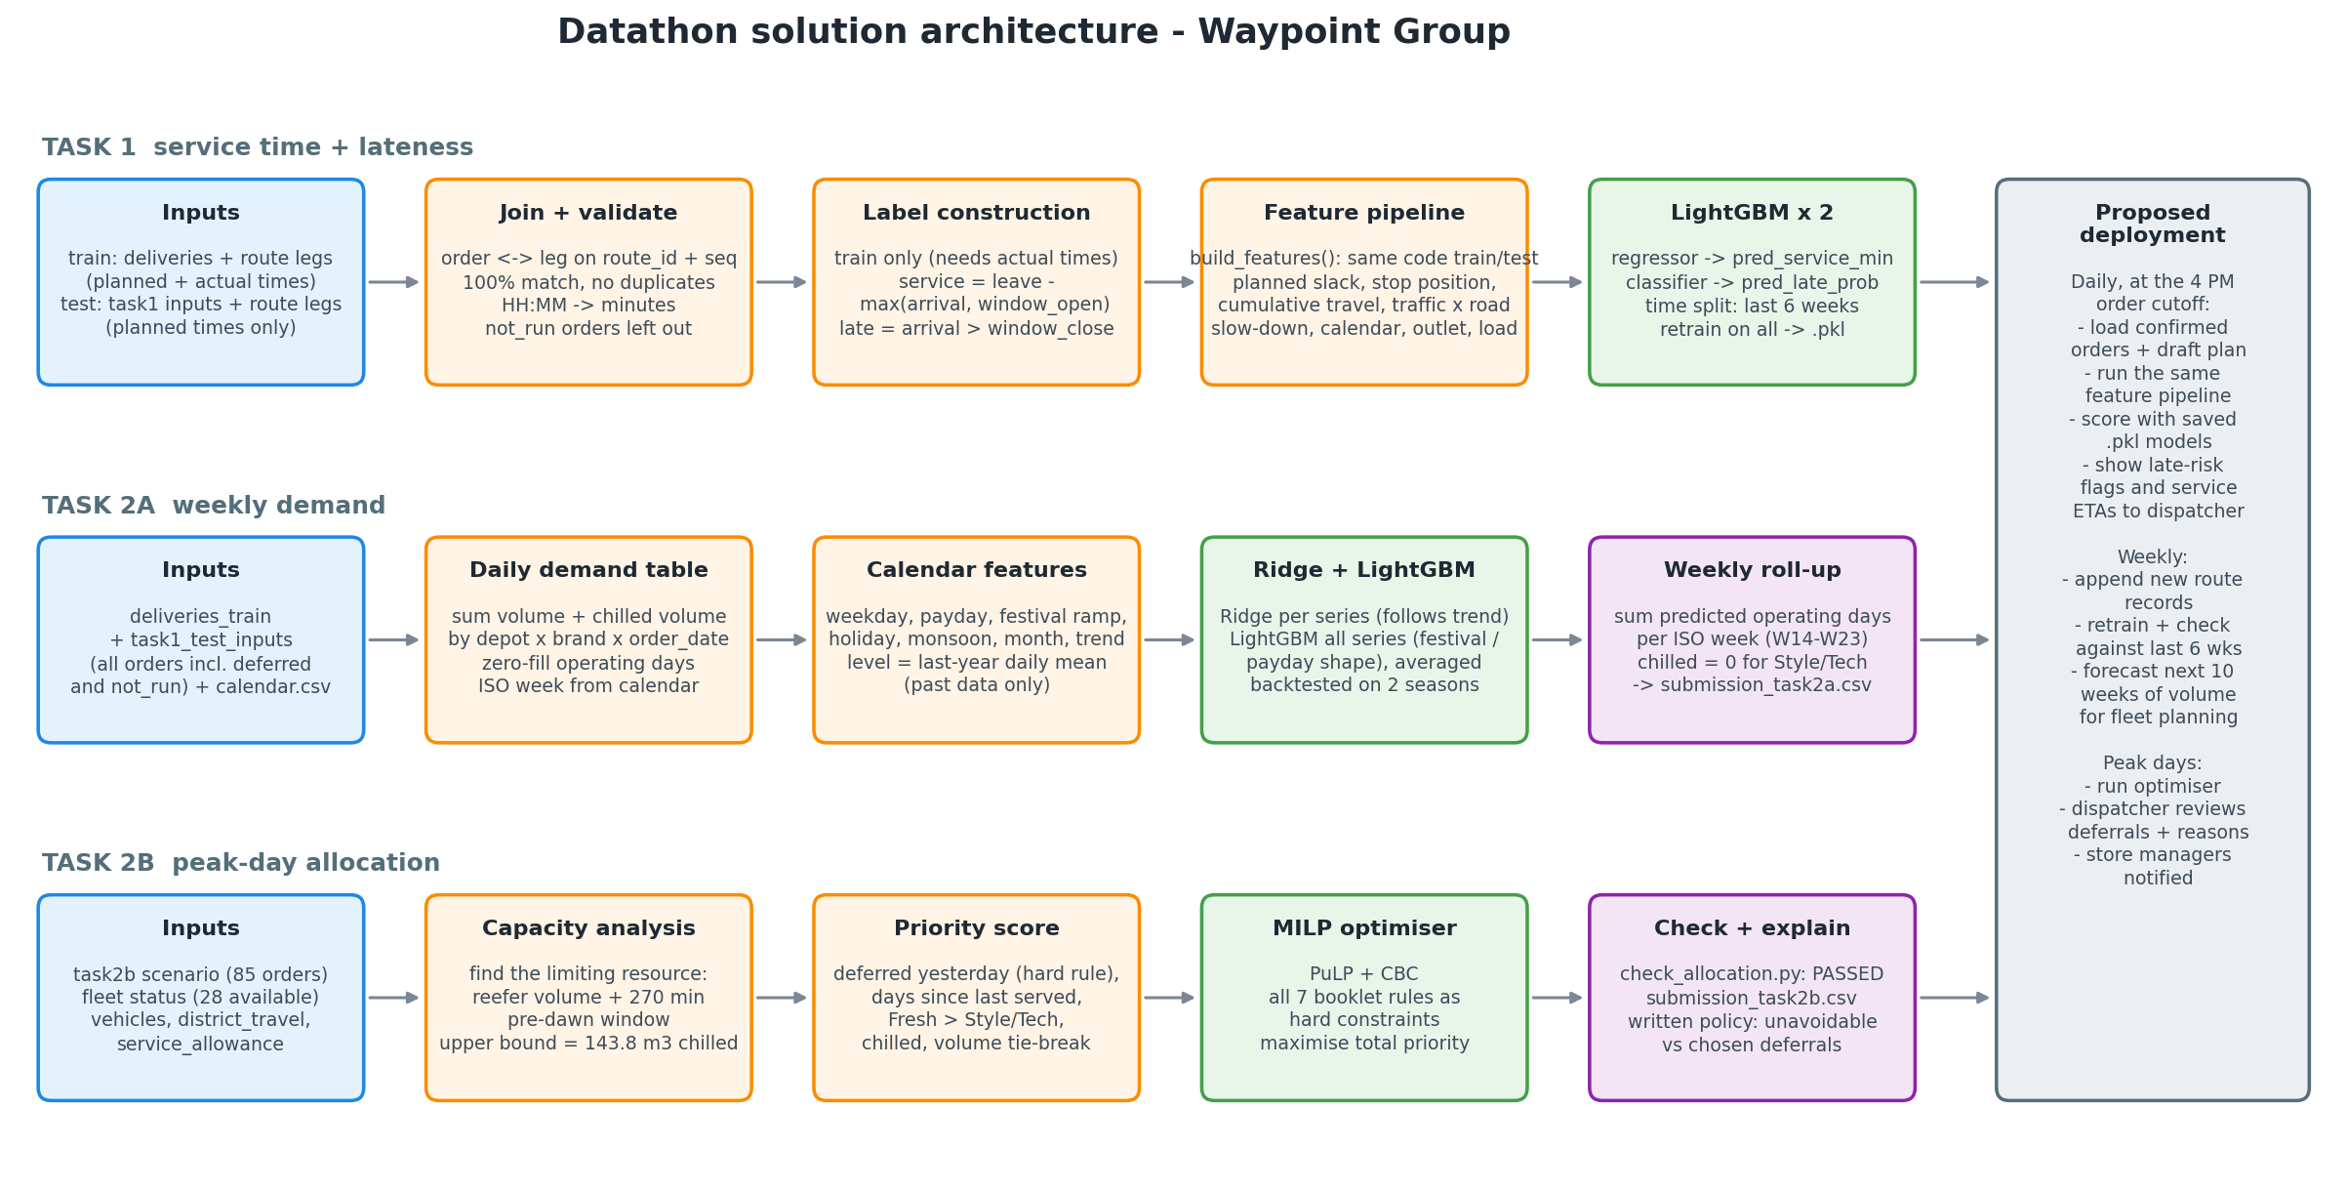
Pipeline: one flow per task, from raw data to the submission files

How the pieces fit together. All three tasks start from the same organiser files. Task 1 joins orders to their route legs, builds labels from the actual times, creates features, and trains two LightGBM models. Task 2A turns the same order history into a daily demand table, learns calendar effects, and adds the daily forecasts up into weeks. Task 2B reads the peak-day scenario and fleet, finds the limiting resource, and solves the allocation with an optimizer and the trained models are saved as .pkl files.

2.2 Model architecture
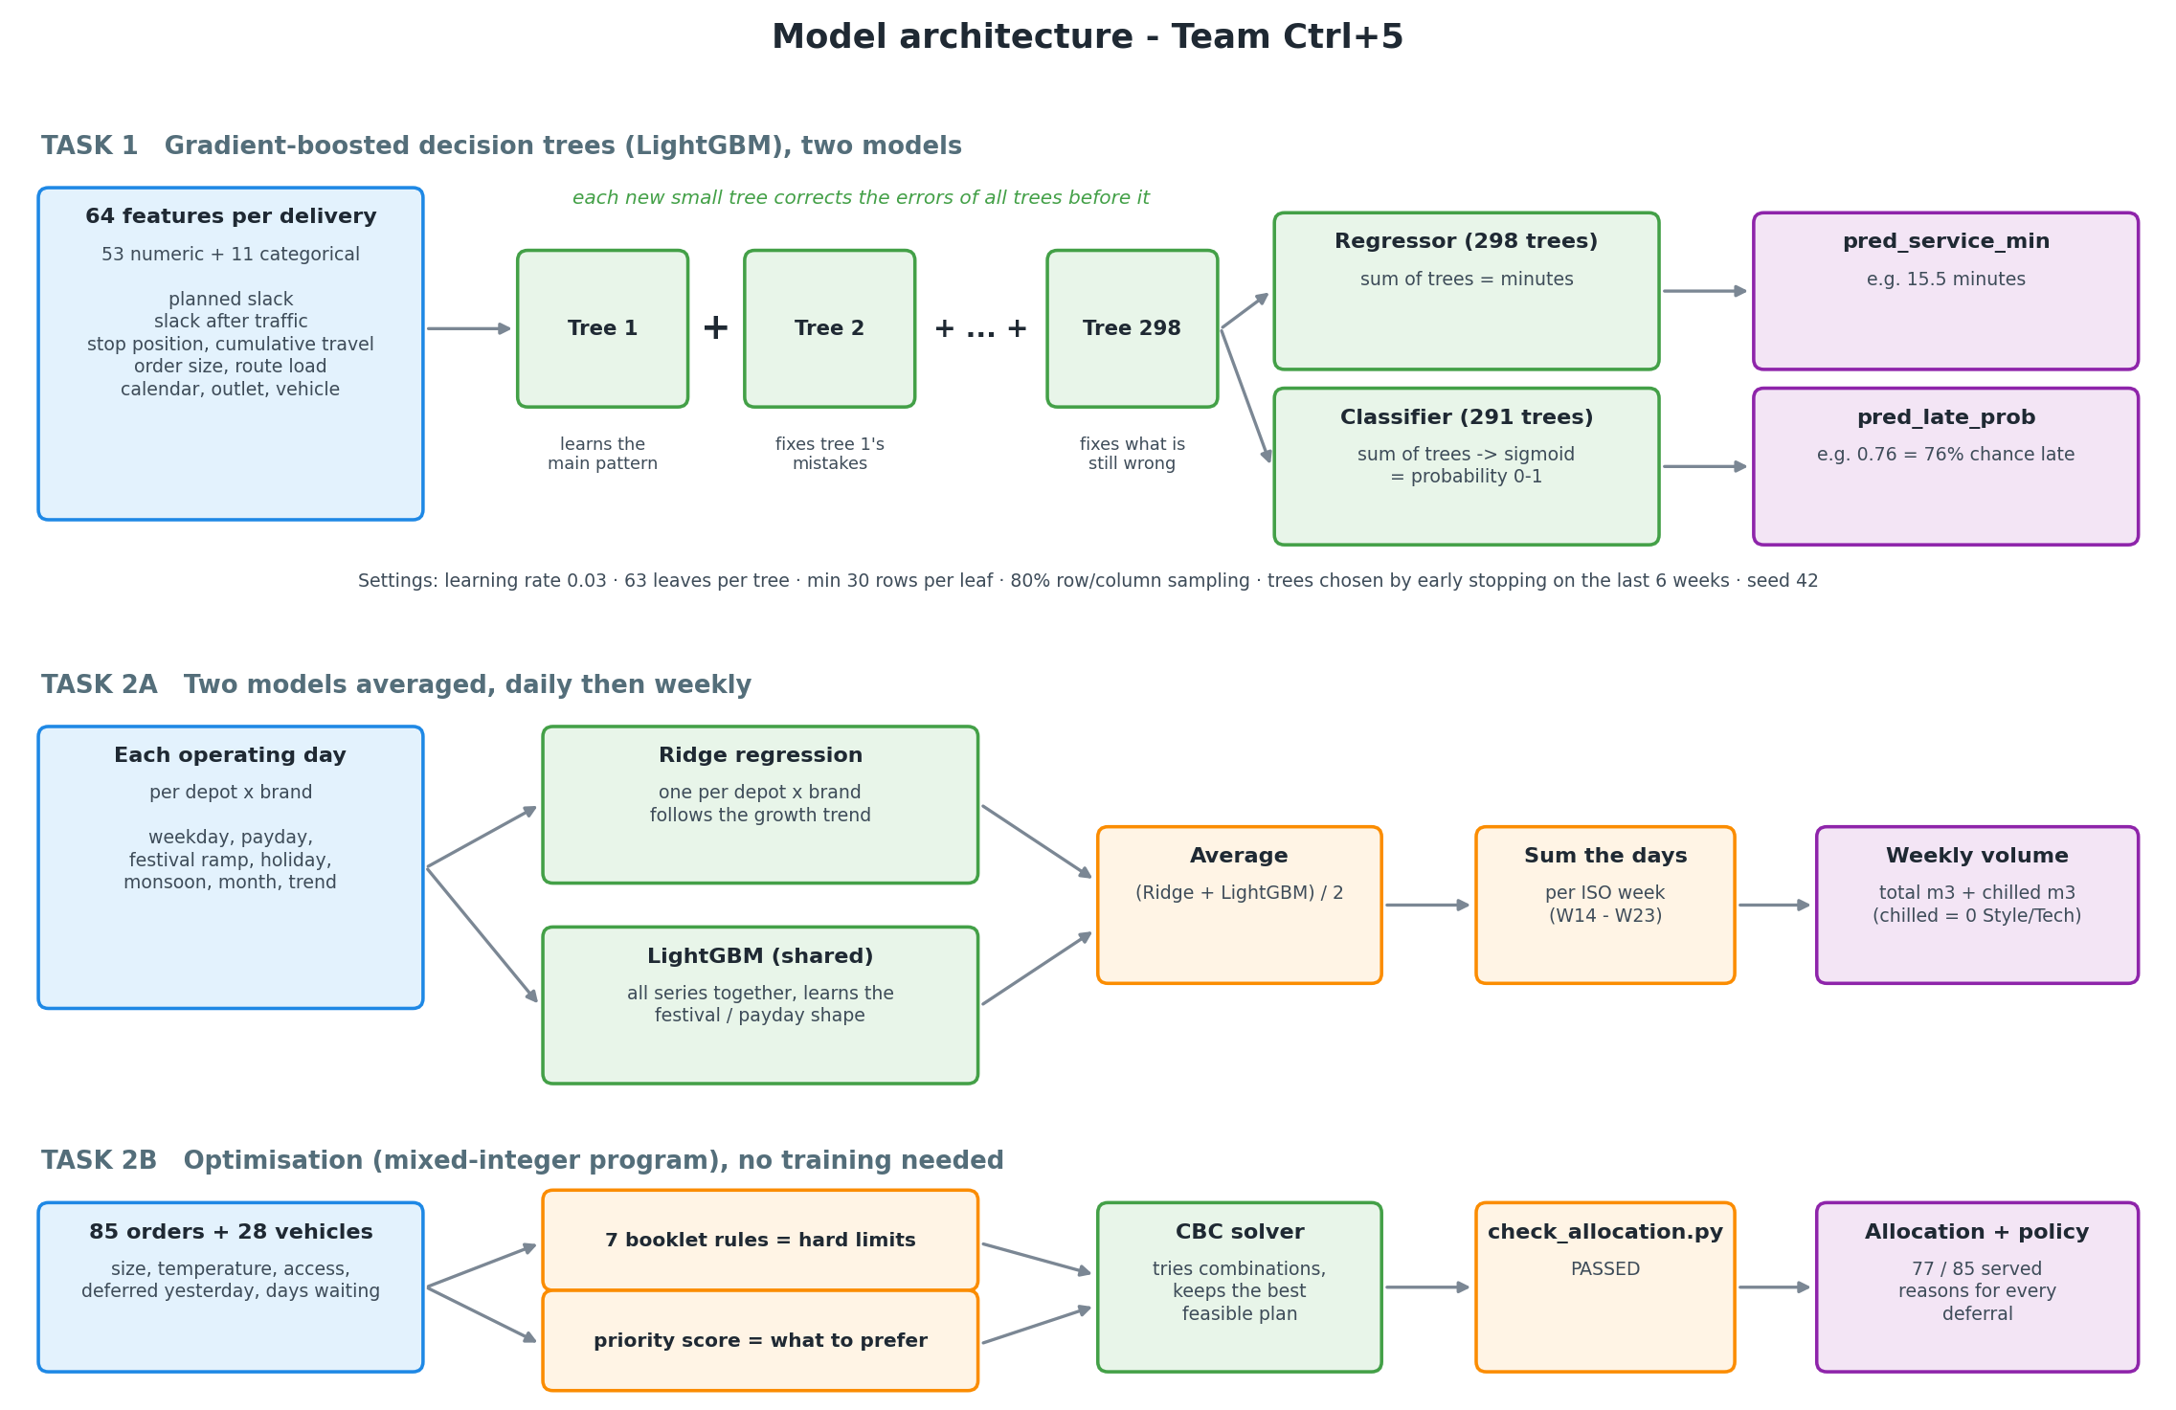
Model architecture for each task

- Task 1 uses gradient-boosted decision trees (LightGBM). The first small tree learns the main pattern, and each following tree learns to correct what the trees before it still get wrong. The answers of all trees are added up: in minutes for the service-time regressor (298 trees), or turned into a 0-1 probability for the lateness classifier (291 trees).
- Task 2A averages two models for each operating day: a Ridge regression per depot and brand, which follows the growth trend, and one LightGBM shared by all series, which learns the festival and payday shape. The daily forecasts are added up into ISO weeks.
- Task 2B isn't trained. The booklet rules become hard limits, the priority score says what to prefer, and the CBC solver searches for the best plan that respects every limit. The organisers' checker then confirms the plan.

2.3 Proposed deployment
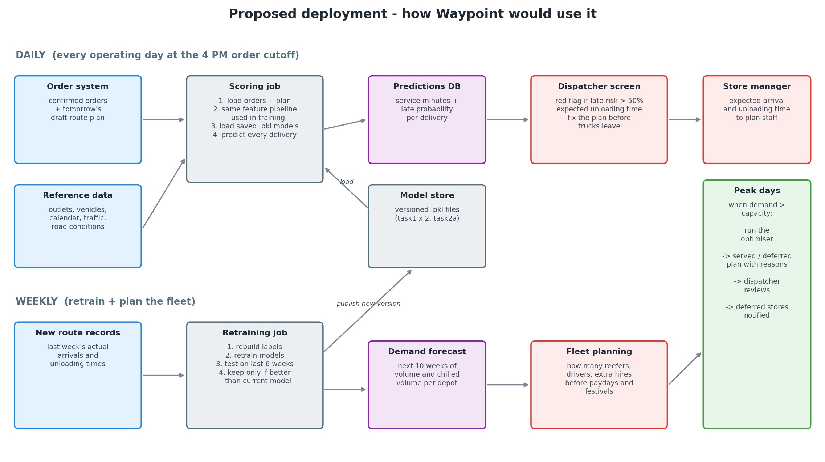
How Waypoint would run the solution day to day
When | What runs | Who uses it
Daily, at the 4 PM order cutoff | Load confirmed orders and the draft plan, run the same feature pipeline, score them with the saved models | Dispatcher sees late-risk flags and expected unloading times before trucks leave
Weekly | Add the new route records, retrain, check against the last 6 weeks, forecast the next 10 weeks | Fleet planning
Peak days | Run the optimiser on the confirmed orders and the available fleet | Dispatcher reviews deferrals and reasons; store managers are notified

3. Data and preprocessing

3.1 Data used
File | Rows | Role
deliveries_train.csv | 92,307 orders (2024-01-01 to 2026-02-14) | order history: Task 1 training, Task 2A demand
route_legs_train.csv | 91,894 route legs | planned and actual times, used to build the Task 1 labels
task1_test_inputs.csv + route_legs_test.csv | 5,014 orders (2026-02-16 to 2026-03-28) | Task 1 prediction set (planned times only)
task2a_test_inputs.csv | 60 rows | 2 depots x 3 brands x weeks 2026-W14 to W23
task2b_peak_day_scenarios.csv + task2b_peak_day_fleet.csv | 85 orders, 38 vehicles (28 available) | Task 2B peak day
outlets, vehicles, calendar, district_travel, traffic_speed, road_conditions, service_allowance | reference tables | features and constraints
A full list of the columns we used, with examples, is in Appendix A.

3.2 Data quality and cleaning
- Joining. Each dispatched order matches exactly one route leg on route_id + seq_in_route = route_id + seq. All 91,894 dispatched orders matched, and there are no duplicate delivery_ids. As an extra check, a stop’s leave_outlet_time equals the next leg’s actual_depart_time in 100% of cases.
- Missing values. The only blanks belong to the 413 not_run orders, which never left the depot. That’s expected, not an error. They are left out of Task 1 and kept in Task 2A.
- Deferred orders (1,543) are counted on the date the store requested them for Task 2A, as the booklet says.
- Times. All HH:MM clock times are converted to minutes after midnight. No route crosses midnight, and there are no negative durations.
- Outliers. A few Style/Tech mall-bay stops take 4-7 hours. They are rare but plausible, so we kept them. Removing them would make the model over-confident on exactly the stops the dispatcher most needs to know about.

3.3 What the data showed (exploratory analysis)
Full charts are in 01_EDA_and_Labels.ipynb. The main findings that shaped our features:
- Planned slack drives lateness. Slack is how many minutes the plan leaves before the outlet’s window closes. With 0-15 min of slack, over 90% of deliveries are late. With 120+ min, only 4% are.
- Plans are too optimistic. Trucks leave a median of 21 min later than planned, and actual travel takes about 1.5x the planned time.
- Calendar effects. Paydays, festival build-up and holidays raise both lateness and order size.
- Service time depends on brand, dock type and order size. Fresh takes about 15 min, while Style and Tech take 45-75 min. The standard allowance badly underestimates Tech at mall bays and street docks.

4. Label construction (Task 1)
Neither target is given in the data, so we built both from the actual times in the training route records.
Service time. The booklet says a vehicle that arrives early waits until the window opens. Waiting isn’t handling, so:
service_min = leave_outlet_time - max(arrival_time, window_open_time)
Late. Lateness means arriving after the window closes (the delivery still happens):
late = 1 if arrival_time > window_close_time, otherwise 0
Evidence that the waiting rule is right. 4.4% of stops arrive early. With the naive formula (leave - arrival), their median unloading time is 30 min. With our formula, it’s 13 min, the same as stops that didn’t arrive early (15 min). The naive label would wrongly teach the model that arriving early makes unloading slow.
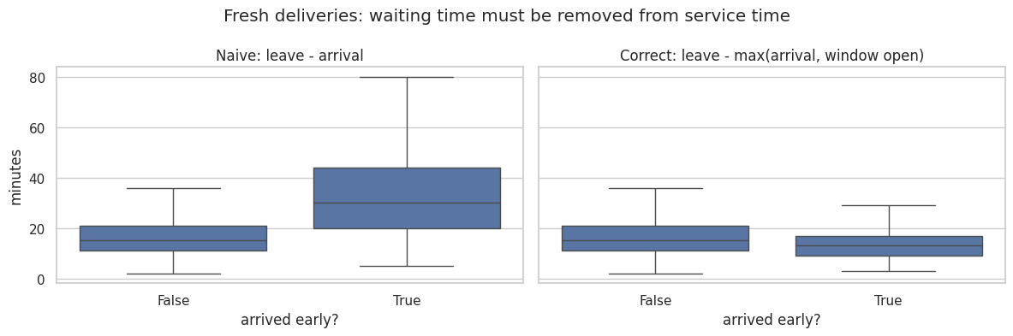
Fresh deliveries: waiting time must be removed from service time
Result: 19.6% of deliveries are late (Fresh 20.4%, Style 5.5%, Tech 2.5%). Median unloading time is 15 min for Fresh, 46 for Style and 52 for Tech.
Worked example. A truck arrives at 04:48 and leaves at 05:12. If the window opened at 04:30, unloading = 24 min. If the window only opened at 05:00, the truck waited, so unloading = 05:12 - 05:00 = 12 min.

5. Feature engineering (Task 1)
Rule: no leakage. At prediction time only planned times are known, so every feature comes from planned columns, the order, the outlet, the vehicle, the calendar, the hourly traffic profile and the day’s road conditions. Actual times are used only to build the labels. One function (build_features) runs the same six steps on training and test data, so the two can’t drift apart.
Step | Features | Why
1. Outlet and vehicle | dock type, parking constraint, mall flag, standard allowance, road class, vehicle capacity | access and unloading conditions
2. Time window | window open/close and length, planned slack, planned wait, arrival hour | the strongest lateness signal
3. Route position | stop number, stops left, cumulative planned travel and distance, earlier stops’ handling time | delays build up along a route
4. Load | units, kg, m3, kg per unit, route load vs vehicle capacity | bigger orders take longer
5. Calendar | weekday, month, payday, days since payday, festival ramp, holiday | demand and congestion peaks
6. Traffic | speed index, disruption index, slow factor, expected travel, slack after traffic | plans assume clear roads
Our key feature: slack_after_traffic. This is the planned slack minus the extra travel time expected from that hour’s traffic and that day’s road disruption. It combines the dispatcher’s plan with the congestion the plan ignores, and it turned out to be the most important feature in the lateness model.

6. Task 1 models: service time and late probability

6.1 Validation design
We hid the last 6 weeks of history (2026-01-03 to 2026-02-14) and tested every model on them. That’s the same length as the test period. We used a time-based split rather than a random one, so no model could learn from the future.

6.2 Model comparison
Model | Service time MAE (min, lower is better) | Late AUC (higher is better) | Late log-loss (lower is better)
Baseline (standard allowance / slack rule) | 7.05 | 0.880 | 0.405
Linear (Ridge / Logistic Regression) | 4.40 | 0.964 | 0.156
Single decision tree | 5.07 | 0.958 | 0.174
Random forest (100 trees) | 4.03 | 0.971 | 0.146
LightGBM (our final model) | 3.73 | 0.974 | 0.134
Why LightGBM? LightGBM is a library that trains gradient-boosted decision trees. Instead of one big tree, it builds hundreds of small trees one after another, and each new tree corrects the mistakes of the trees before it. A single tree is easy to read but less accurate. A random forest is close, but LightGBM was better on all three measures. LightGBM also handles numeric and categorical data together, learns interactions like little slack x heavy traffic x festival, trains in seconds, and saves as a .pkl file. No pre-trained models were used: everything was trained from scratch on the competition data.
Settings. Learning rate 0.03, 63 leaves, at least 30 rows per leaf, 80% row and column sampling, seed 42. The number of trees was chosen by early stopping on the validation weeks . The final models were then retrained on all history with 10% more trees.

6.3 Results in detail
Brand | Deliveries | Allowance MAE | Model MAE | Actual late rate | Predicted late rate
Fresh | 4,926 | 6.31 | 3.35 | 13.6% | 13.3%
Style | 151 | 16.64 | 9.48 | 4.0% | 3.3%
Tech | 96 | 30.32 | 14.40 | 3.1% | 1.5%
The late probabilities are well calibrated: when the model says 30%, about 30% of those deliveries really are late. The most important features are slack after traffic, the outlet and planned slack. For service time, the most important are brand, dock type, order size and the outlet.
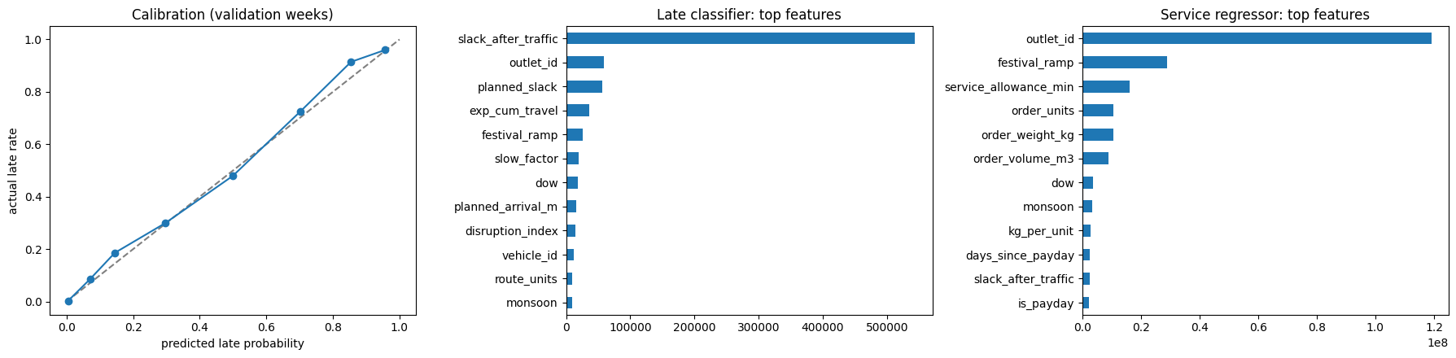
Calibration and feature importance on the validation weeks
Output: submissions/submission_task1.csv

7. Task 2A: weekly demand forecast

7.1 Approach
- Training data. deliveries_train.csv + task1_test_inputs.csv. Every order is counted once, including deferred and not_run ones, on its order_date, and grouped into ISO weeks using calendar.csv.
- Daily, then weekly. Weeks have different numbers of operating days, paydays and festival days. So we predict volume for each operating day and add the days up into weeks.
- Two models, averaged:
  - Ridge regression per depot x brand, on weekday, payday, festival ramp, holiday, monsoon and a time trend. It follows the slow growth in demand.
  - One LightGBM for all series, predicting each day’s volume relative to that series’ average over the past year. It learns the shared festival and payday pattern.
- Chilled volume only exists for Fresh. It’s set to 0 for Style and Tech.

7.2 Backtests
Test | Baseline WAPE total | Our WAPE total | Baseline WAPE chilled | Our WAPE chilled
A: same season last year (train to 2025-W13, predict W14-W23) | 11.7% | 6.2% | 11.3% | 5.5%
B: most recent 10 weeks (train to 2026-W3, predict W4-W13) | 4.8% | 4.2% | 3.8% | 3.3%
Backtest A is the most honest test, because it covers the same New Year, Vesak and Poson weeks we have to forecast. The baseline is “same week last year x recent growth”. Fresh, the largest brand, is forecast within about 5%. Tech is the noisiest series because its weekly volumes are small.

7.3 Forecast
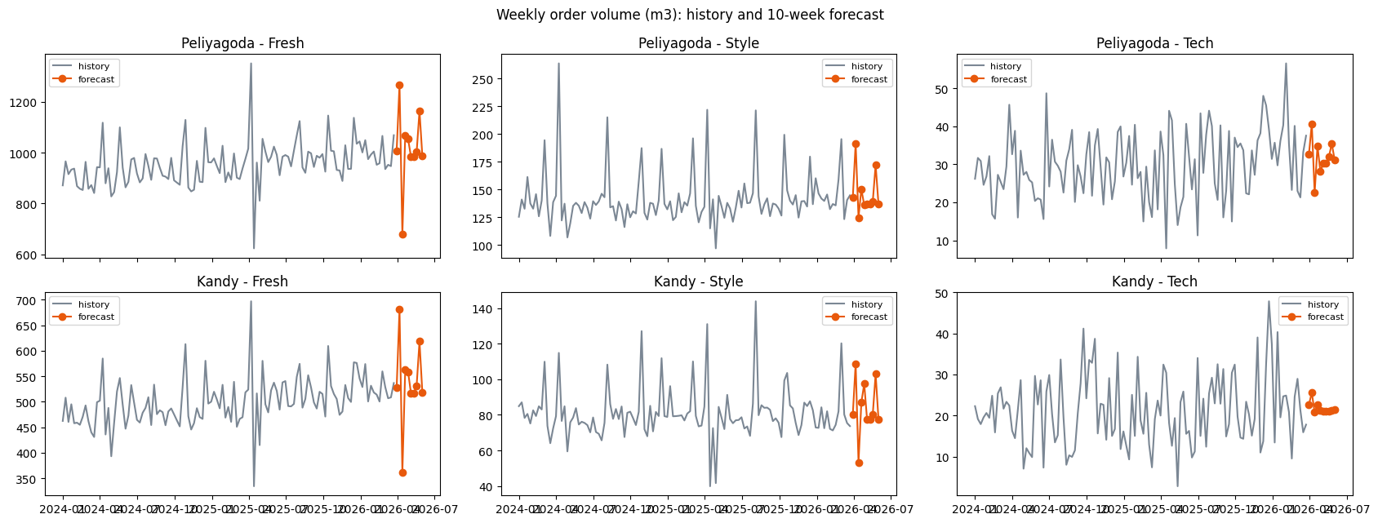
Weekly order volume: history and the 10-week forecast
Week (2026) | Peliyagoda Fresh | Kandy Fresh | Note
W14 | 1,008 | 528
W15 | 1,268 | 681 | build-up to Sinhala and Tamil New Year: peak
W16 | 678 | 361 | New Year holidays: only 4 operating days
W17-W21 | 985-1,067 | 517-562 | back to normal, Vesak in W18
W22 | 1,164 | 618 | Poson and two paydays: second peak
W23 | 987 | 518
Output: submissions/submission_task2a.csv.

8. Task 2B: peak-day allocation and prioritization policy
Result: 77 of 85 orders served (313.8 of 409.9 m3). check_allocation.py: PASSED. All 10 outlets that were skipped yesterday are served today.

8.1 What limited service: refrigerated capacity in the pre-dawn window
Resource | Available | Needed | Verdict
Ambient trucks and vans | 24 vehicles, 673 m3 per trip | 228.2 m3 ambient | plenty of room
Reefers (the only vehicles that can carry chilled goods) | 3 trucks + 1 van = 86.2 m3 per trip (5 reefers in the workshop) | 181.6 m3 chilled | bottleneck
Fresh time window | 270 min per vehicle (03:30-08:00) | far districts: Puttalam 173 min outbound, Matara 137, Kurunegala 127, Galle 103 | one far trip uses most of a reefer’s morning
Even with two full trips per reefer (172.4 m3), the chilled load doesn’t fit, and the time window makes it worse. One Puttalam stop takes 173 + 15 = 188 min, which leaves room for only a short second trip. We solved a separate optimization that maximizes chilled volume alone across the 4 reefers. The best possible is 143.8 m3, so at least 37.9 m3 of chilled orders must be deferred, whatever policy is used.

8.2 How we chose: the optimization model and priority rules
We modelled the allocation as a mixed-integer program (PuLP with the CBC solver). Every booklet rule is a hard constraint: one brand and one district per trip, chilled orders only in reefers, van-only outlets only by van, home depot, whole orders, weight and volume caps, at most two trips per vehicle, and the 270 / 480 minute time budgets. The objective maximizes the total priority of the orders served:
priority = 100 + 60 x deferred_yesterday + 15 x min(days_since_last_served, 5) + 40 if Fresh + 20 if chilled Fresh + 2 x m3
- Never skip the same outlet two runs in a row. This is a hard rule. It fixes the booklet’s problem of outlets left unserved on consecutive runs.
- Fresh before Style and Tech. Fresh must reach shelves before 8 AM, and dairy, meat and produce demand is rising a week before the festival. Style and Tech can move to a later daytime run without spoiling.
- Longer without a delivery means more urgent.
- Then move as much volume as possible. This decides close calls.

8.3 Deferred orders and why
Order(s) | Why deferred | Avoidable?
S1-078 (Style, Kurunegala, 40.66 m3) | larger than the biggest vehicle in the fleet (38 m3), and orders can’t be split | unavoidable. The dispatcher should ask the store to split it
S1-058 (Galle), S1-064 and S1-067 (Matara), chilled, 28.5 m3 | far districts use most of a reefer’s 270 minutes | part of the unavoidable 37.9 m3
S1-071, S1-073, S1-075 (Kurunegala, chilled, 25.0 m3) | a reefer’s long trip goes to Puttalam instead | our choice (see below)
S1-003 (Colombo, chilled, van-only, 1.8 m3) | the only reefer van (1,040 kg) can’t take all three van-only chilled orders (1,096 kg) in one trip; its second trip serves Galle (an outlet without delivery for 2 days) | our choice, small
The key trade-off. S1-083 (Puttalam) was deferred yesterday and hasn’t had a delivery in 5 days. Without our “never twice” rule, the optimizer would skip it again and carry 140.7 m3 of chilled goods instead of 126.3. We chose fairness: one outlet without dairy for six days before a festival is worse than three outlets waiting one extra day. Cost of that choice: 14.4 m3 of chilled goods and two more deferred orders today. Tomorrow, the Kurunegala orders become “deferred yesterday” and are guaranteed a slot.
In short: 37.9 m3 of chilled goods and one Style order were unavoidable. Another 17.4 m3 of chilled goods was deferred by our choice, to protect the outlet skipped yesterday and to use the pre-dawn window on closer stops. Getting even one workshop reefer back on the road would remove most deferrals, and the Task 2A forecast shows Fresh demand peaking again in W15 and W22.
Output: submissions/submission_task2b.csv.

9. Challenges and what we learned
- Getting the labels right. The early-arrival waiting time looked like slow unloading until we checked it against the window opening time.
- Avoiding leakage. It’s tempting to use actual departure or travel times. We only used what’s known before a trip starts, and validated on a time-based split.
- Holiday weeks. Weekly totals jump when operating days drop (for example, New Year week). Modelling daily and then adding up fixed this.
- Imbalanced brands. Fresh is 95% of the deliveries, so Style and Tech errors are larger. We reported results per brand so this stays visible.
- Optimizer run time. The Task 2B model has about 4,000 yes/no decisions. We gave the solver a time limit and checked every plan with the organizers’ checker.

10. AI tool disclosure
AI tools used: Claude (Anthropic)
AI-Assisted Work
AI tools were used to support activities such as:
- writing the Python code for engineering, model training, demand forecasting and the peak-day optimization;
- running experiments and producing comparison tables and charts;
- suggesting analysis ideas
- Drafting and formatting documentation.
All models were trained from scratch on the competition data only. No pre-trained models, paid modelling APIs or AutoML/no-code tools were used.
Work Directed and Controlled by the Team
- interpreting the competition requirements and deciding what the Datathon submission should contain;
- summarizing the challenge brief, datasets and submission requirements;
- studying and understanding the exploratory analysis: data quality, the label rules, and the drivers of lateness and demand;
- directing how the work was structured: all code inside the final notebook in small, explained steps, a separate EDA notebook, and one combined report;
- questioning and validating the approach: baselines, label definitions, and why LightGBM was chosen over a single decision tree, a random forest and linear models (the comparison was added at our request);
- checking that the work followed the booklet rules, such as no use of actual times as features and the Task 2B feasibility rules;
- running the notebooks on our own machines and checking the submission files;
- reviewing and approving the Task 2B prioritisation policy and its fairness rule;
- editing and finalising this report, and preparing and presenting the demo video;
- all final submission decisions.
AI was used to speed up coding and analysis. The team directed the work, reviewed every output, made the final decisions, and is responsible for the submitted solution.

Appendix: Submission contents and how to run
Item | File
Final notebook (labels, preprocessing, training, evaluation, inference demo) | Ctrl+5_FinalNotebook.ipynb
Exploratory notebook | 01_EDA_and_Labels.ipynb
Saved models | models/task1_service_regressor.pkl, models/task1_late_classifier.pkl, models/task2a_demand_models.pkl
Predictions | submissions/submission_task1.csv, submission_task2a.csv, submission_task2b.csv
This report (architecture, preprocessing, Task 2B policy, AI disclosure) | docs/Ctrl+5_Datathon_Report.docx
To run: pip install -r requirements.txt, then open Ctrl+5_FinalNotebook.ipynb from the folder that contains data/

