ShopNest Store Power BI Capstone
(Dashboard Report)

- Question statement:
Top Categories by Total price: Identify and visually represent the top 10 product categories by total sales.

Visualization:

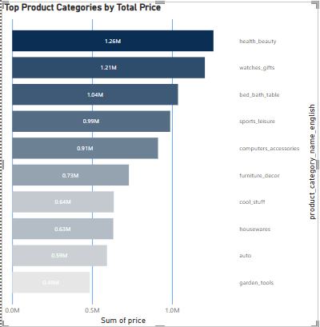

Explanation:
- At 1,258,681.34, health beauty had the highest sales and was 159.38% higher than garden tools, which had the lowest sales at 485,256.46 in top 10 sales.﻿
- ﻿Health beauty accounted for 14.85% of sales in top 10 products.
- ﻿Across all 10 products, sales ranged from 485,256.46 to 1,258,681.34.

- Question statement:
Delayed Orders Analysis: Determine the number of delayed orders in each category. An order is considered delayed if the actual delivery date is later than the estimated delivery date.

Visualization:

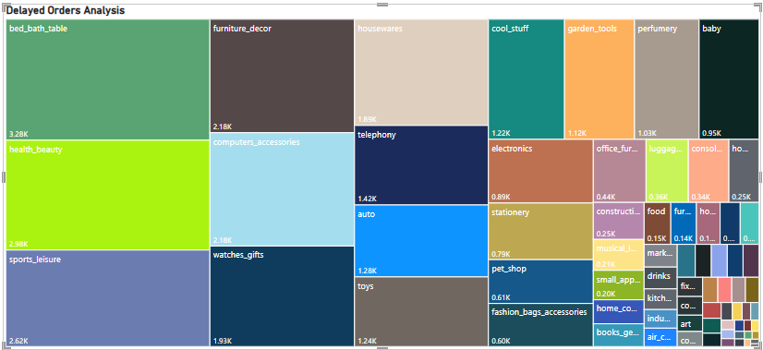

Explanation:
- An order is considered delayed if actual delivery date is later than the estimated delivery date. Also order status should be delivered. There were few entries with missing delivery date implying they haven’t been delivered yet and they are counted as delayed orders.
- Bed bath table accounts for maximum delay (3279 orders) followed by health beauty and sports leisure.
- Fashion children clothes accounts for the least delay (only 3 orders) followed by cds-dvds musical (5 orders).
- Only 13 out of the total of 71 product categories had more than 1000 order delays.

- Question statement: Monthly Comparison of Delayed and On-Time Orders: Create a dynamic visual that compares the number of delayed orders to the number of orders received earlier for each month. Utilize the drill-through cross-report feature to provide a detailed analysis of late and on-time deliveries.

Visualization:
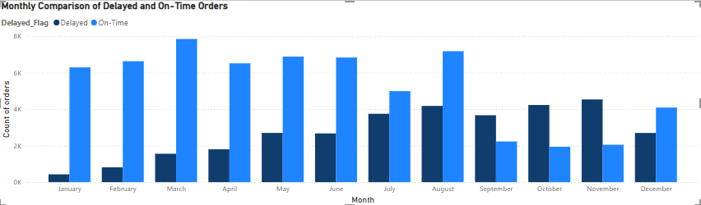
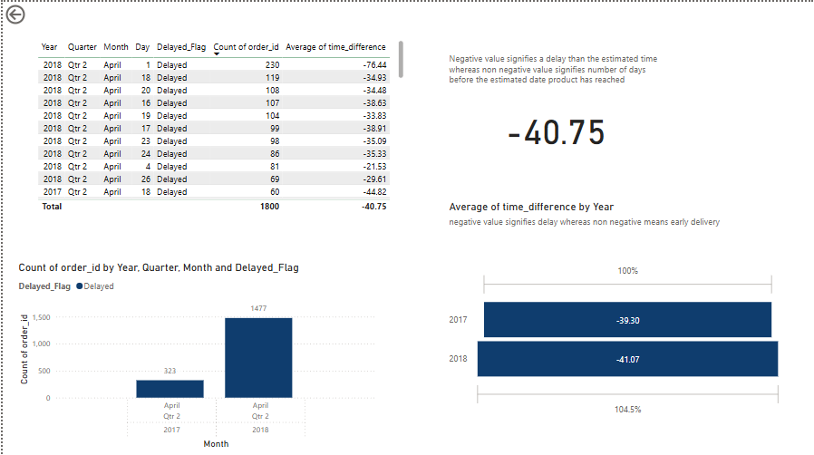
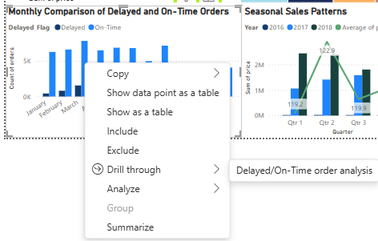

Explanation:
  - The total number of on-time orders is more than the delayed orders from the month of January to August.
  - During the months of September, October and November, delayed orders are higher than the orders delivered on-time.
  - In the month of March, order delivery performance exhibits maximum efficiency for it displays the best ratio of on-time to delayed order numbers.
  - For the months in which delayed orders are higher as compared to on-time orders, number of delayed orders have reduced in 2018 as compared to 2017 except for September.
  - ﻿Total count of orders was higher for On-Time deliveries (63,455) than Delayed (33015).
- Question statement: Payment Method Analysis: Analyze the most frequently used payment methods by customers using a visually appealing representation, such as a pie chart or other suitable visuals.

Visualization:

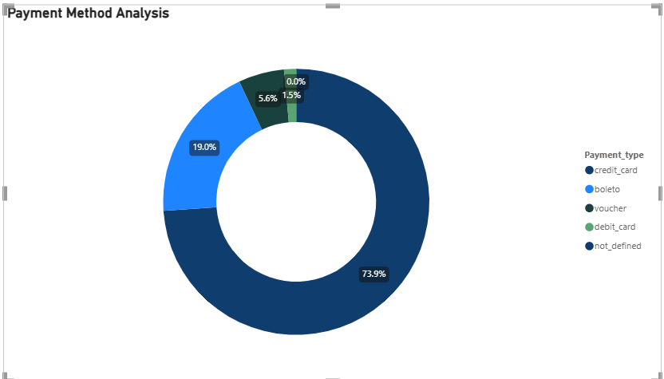

Explanation:
- ﻿Being the most frequently used payment method by customers, credit card accounted for 73.92% of the total count of orders.
- It is further followed by baleto which accounted for 19%.

- Question statement: Product Rating analysis: determine the top 10 highest rated products and the bottom 10 lowest-rated products using a bar or column chart.

Visualization:

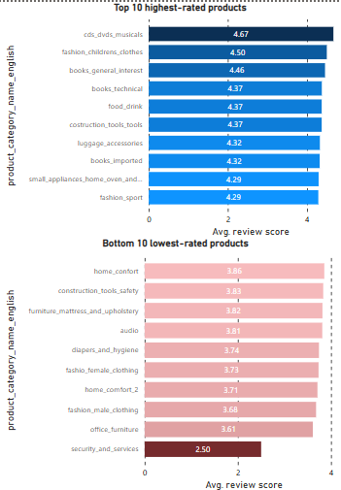
Explanation:
- Cds-dvds -musicals had the highest average review score (4.67).
- Cds-dvds musicals were 86.8% higher than security and services, which had the lowest average of review score (2.5).﻿﻿ ﻿﻿ ﻿
- ﻿﻿Across the top ten product categories, average of review scores ranged from 4.29 to 4.67.﻿﻿
- Across the bottom ten product categories, average review scores ranged from 2.5 to 3.86.
- Security and services product category had the lowest rating which is 44.1% lower than the second lowest-rated product category i.e., office furniture.

- Question statement: State-wise Sales Analysis: Identify and visually represent states with high and low sales, providing a clear understanding of regional sales performance.

Visualization:

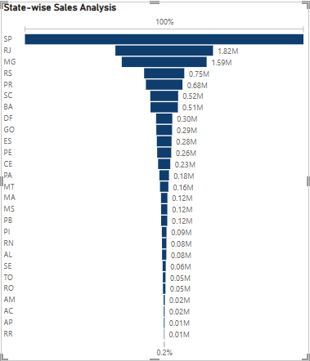

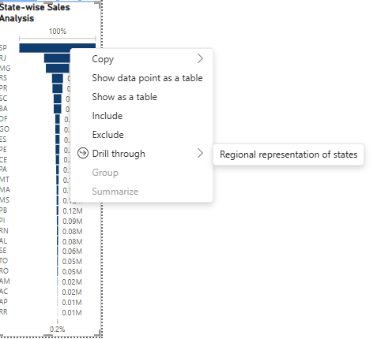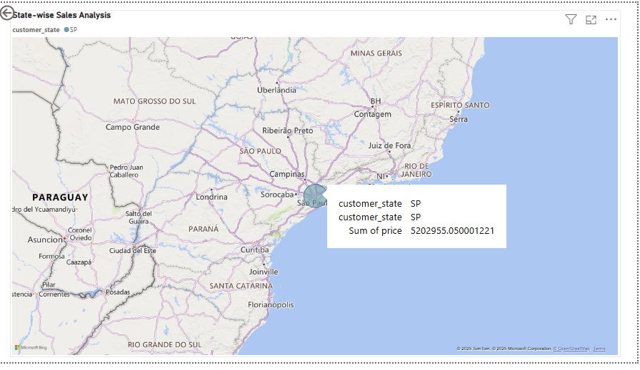

Explanation:
- ﻿﻿Sales: Price without taxes and freight charges is considered as sales amount.
- SP, being the state with highest sales, accounted for 38.28% of the total sales.﻿﻿ ﻿
- SP, RJ and MG accounted for around 62% of sales indicating high regional dependence of sales.

- Question statement: Seasonal Sales Patterns: Investigate and visualize any seasonal patterns (quarterly) or trends in sales data over the course of the year.

Visualization:

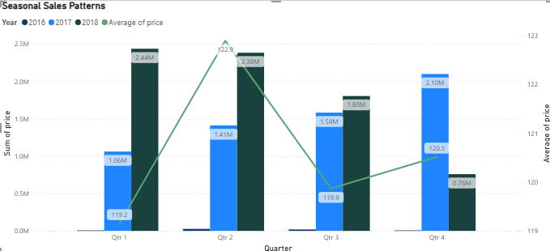

Explanation:
- The year 2018 had the highest total Sales at 7,386,050.80, followed by 2017 at 6,155,806.98 and the year 2016 accounted for the lowest total sales at 49,785.92.﻿﻿ ﻿
- ﻿First Quarter in the year 2018 made up to 17.94% of the total sales.
- ﻿2018 had the highest average sales at 1,846,512.70, followed by 2017 at 1,538,951.74 and 2016 at 12,446.48.
- During the year 2017, total sales increased as the quarters progressed; whereas in the year 2018, the total sales declined as the quarters progressed.
- The second quarter has highest number of sales across all years.
- The third and fourth quarters have lower sales, 2017 exhibited higher sales whereas, the total sales were very low in the year 2018 (possibly owing to higher number of delayed orders during this period).

- Question statement: Revenue Analysis: Determine the total revenue generated by ShopNest Store and analyze how it changes over time (yearly). Represent this information through suitable visuals to highlight trends and patterns.

Visualization:
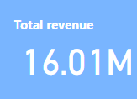
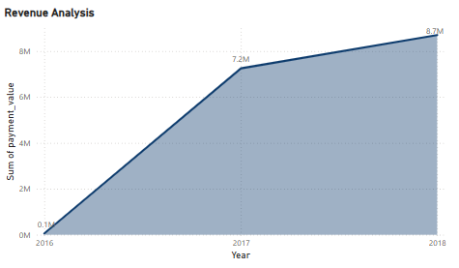

Explanation:
- Revenue is calculated as total payment received from the customers.
- Total revenue﻿ observed an increasing trend, resulting in a 14,555.36% (8,640,400.71) increase between 2016 and 2018.
- 16.01 M revenue was generated by ShopNest Store.
- Rate of revenue increase has reduced in 2017-2018 as compared to 2016-2017.

Image of the Dashboard:

